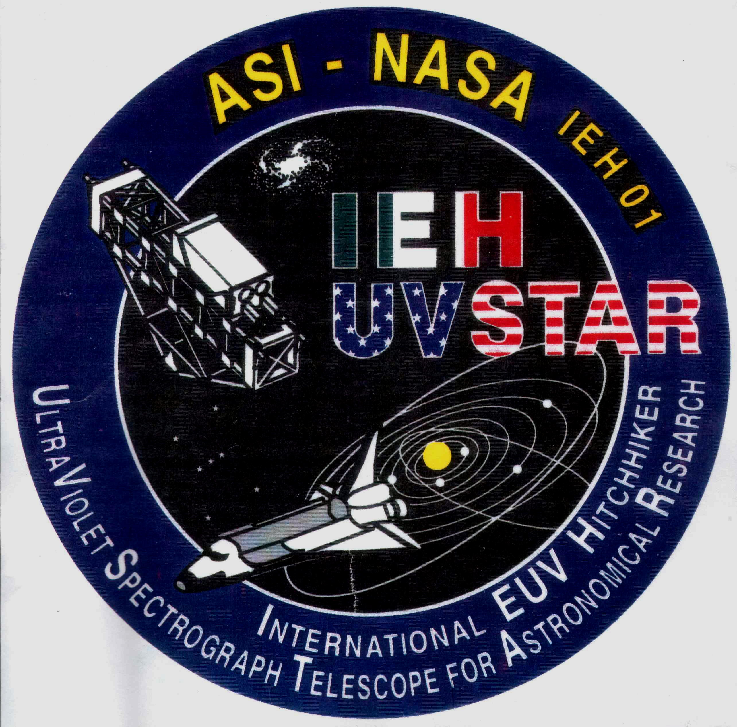

Ultraviolet Spectrograph Telescope
for Astronomical Research (UVSTAR)
UVSTAR, experiment was jointly developed by NASA and the Italian Space Agency (ASI). During the three IEH missions, use of the UVSTAR will be split between astronomical observations and Io plasma torus observations at Jupiter.
Dr. Lyle Broadfoot, University of Arizona, was the lead principal investigator for the Io plasma torus observations, while Dr. Roberto Stalio, University of Trieste Physics Dept, Italy was the lead principal investigator for the astronomical observations.
Dr. Broadfoot and his team at the University of Arizona Lunar and Planetary Laboratory were responsible for the development of the UVSTAR system, the mechanical design and test and integration, the electronics systems, and telescope optics, while Dr. Stalio and his team were responsible for fabrication of the UVSTAR mechanical system and the tracking and finding systems software.
STAR-LITE was the next generation UVSTAR. It has full gimbal capability to allow continuous observational capability while the Shuttle bay doors are open.

Instrument Fabrication and Flight Team Leaders
Principal Investigator Dr. Lyle Broadfoot
Mechanical Design Lyle Broadfoot
Electronic Support Reuben "Bud" Hill, Baja Technology
Software Support Kalynnda Berens, Michael Fitzgibbon
Mechanical Fabrication Robert Kingsley, University Research
Instrumentation Center

Dr. Broadfoot had a background in the mechanical and electrical trades before he graduated with his PhD from the University of Saskatchewan. He joined the Space Division of the Kitt Peak National Observatory in 1963 and was active in atmospheric research using rocket instrumentation. He developed instrumentation for the deep space missions, Mariner 10 (1973) and Voyager (1977). The Voyager experiment continues to return data from a distance of about 100 AU (Astronomical Units). During the last 20 years he has been working with the Shuttle as a space platform for atmospheric and astronomical observations. His experiment team has flown thirteen experiments on seven Shuttle flights. The instruments, GLO and STAR-LITE, were path finders for deployment of an instrument suite on the International Space Station (ISS). That plan was shelved while NASA redefines their capability. Space research today is done by teams of people, each member bringing a different expertise to the team.

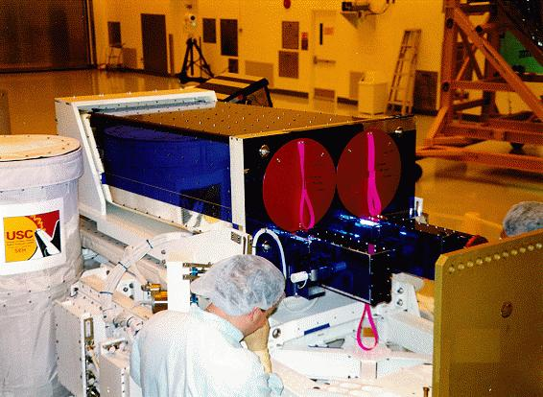
UVSTAR consists of a pair of telescopes and concave-grating spectrographs that cover the overlapping spectral ranges of 500-900 Å and 850-1250 Å. The telescopes use two 30 cm diameter off-axis paraboloids having a focal length of 1.4m. An image of the target is formed at the entrance slits of two concave grating spectrographs. The gratings provide dispersion and re-image the slits at the detectors intensified CCD's. The readout format of the detectors can be chosen by computer, and three slit widths are selectable to adapt the instrument to specific tasks.
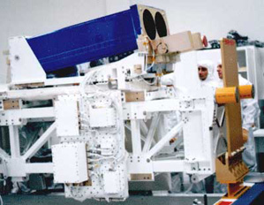
UVSTAR is a spectrographic telescope for observations of astronomical and planetary sources; it operates in the 500-1250 Angstrom (Å) waveband at approximately 1 Å resolution. An important feature of the experiment is its capability for long slit spectral imaging of extended sources such as planets, the Io plasma torus, planetary nebulae, supernova remnants, H II regions, and galaxies. These objects were observed during the missions.

UVSTAR installed on the IEH Bridge. The associated electronics boxes are assembled on the side panel. The blue protective tape covering the silver thermal tape will be removed just before the bridge is released to the KSC Shuttle integration team.
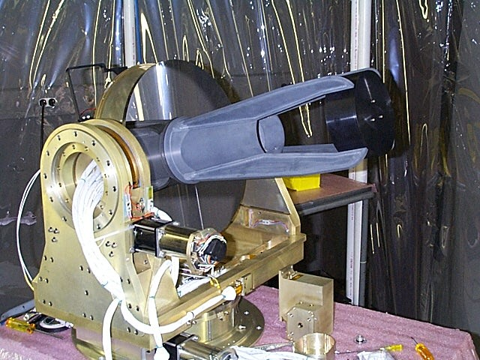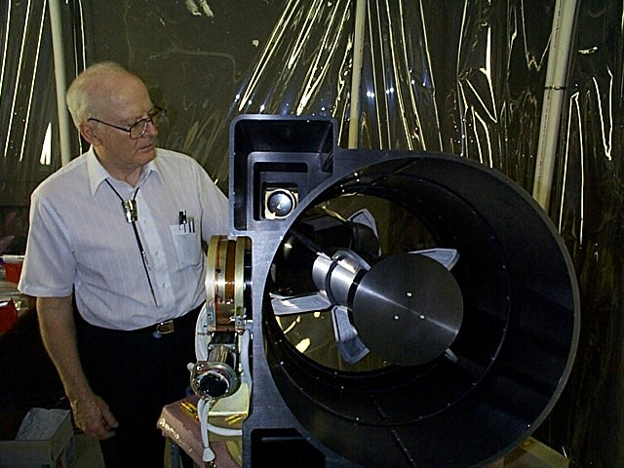
STAR-LITE is being assembled in a clean tent. This is a unique telescope being all metal. Since all components of the telescope have the same coefficient of expansion the telescope will stay in focus at all temperatures it will experience in flight.

Dr. Lyle Broadfoot is pictured here supervising the assembly of his most recent flight instrument, STAR-LITE, that flew along with John Glenn on the STS-95 mission.

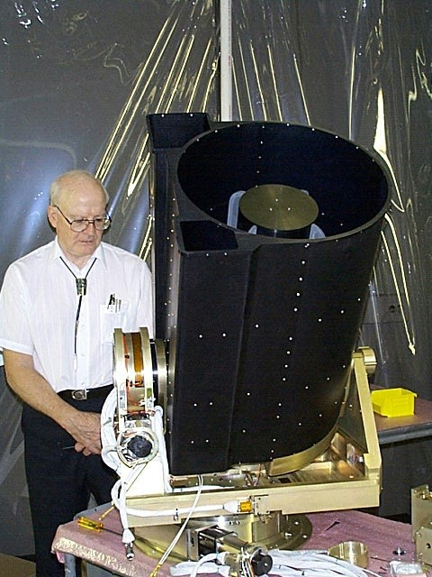
Here the light baffle has been installed as the instrument is being built up. STAR-LITE has the advantage that it can point any direction out of the Shuttle bay and does not require Shuttle support to acquire and track targets. UVSTAR flew three times. STAR-LITE flew once with UVSTAR on STS-95, the John Glen flight.

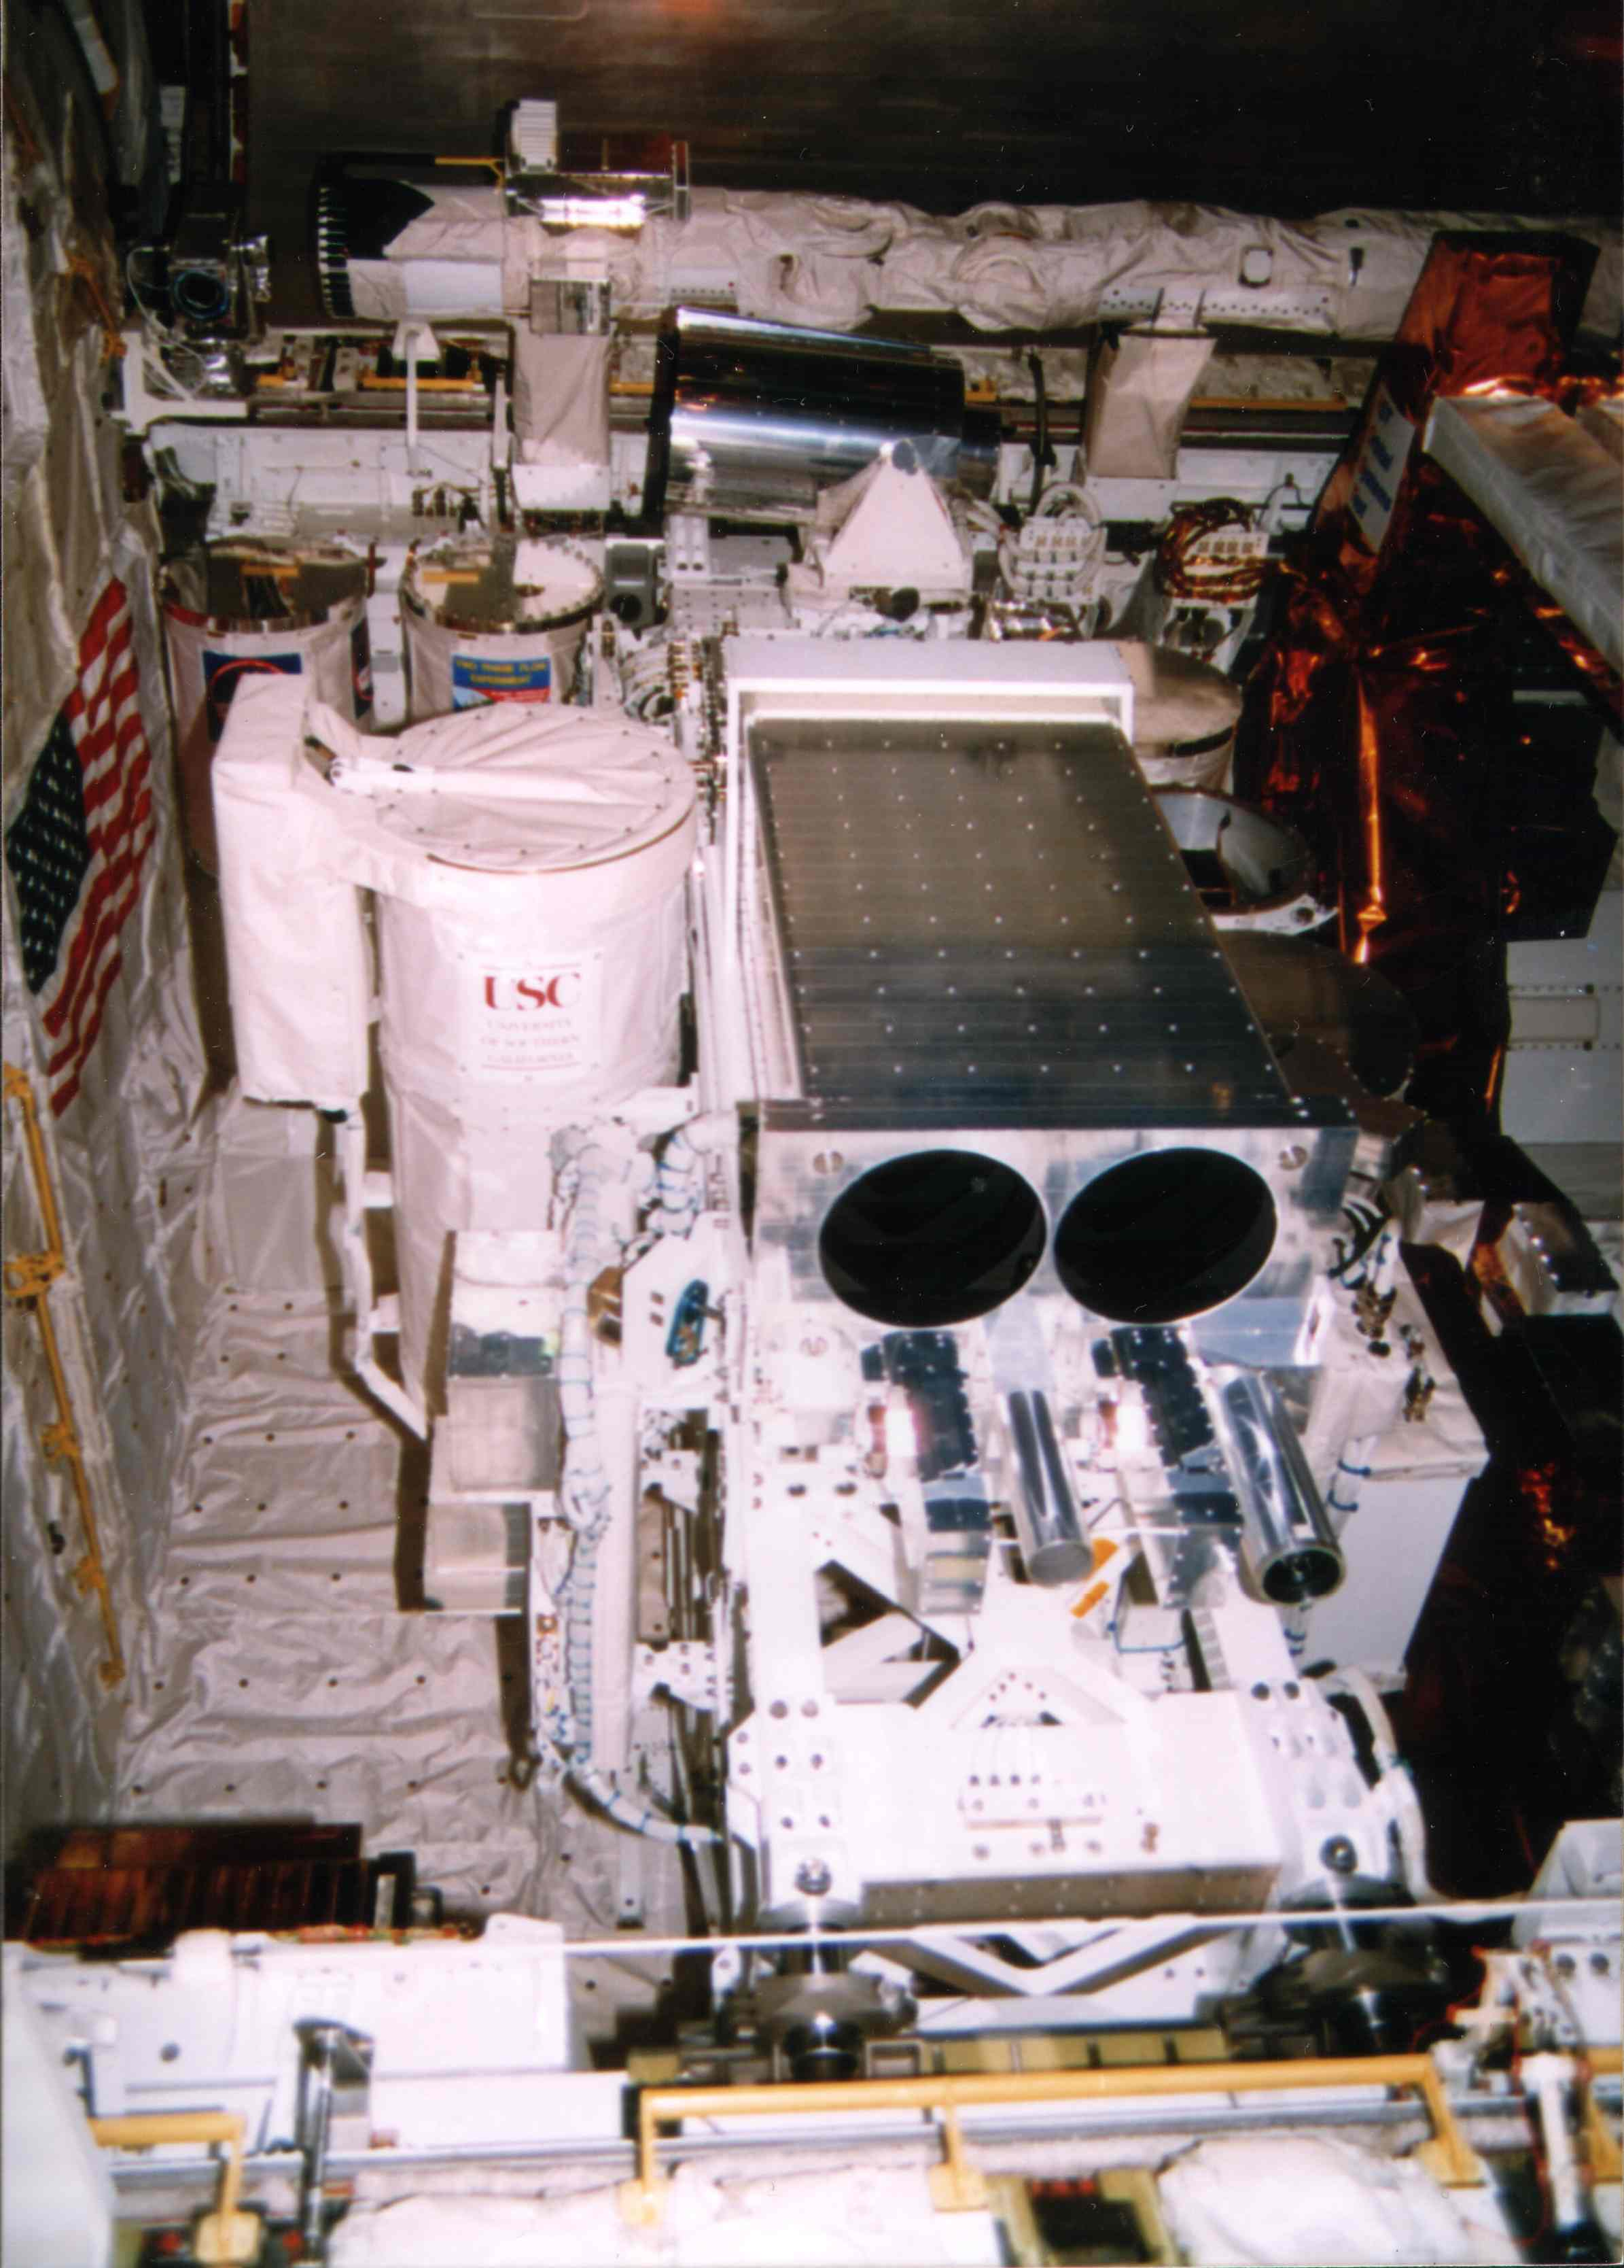
A view across the Shuttle bay. The Arizona instruments, UVSTAR, STAR-LITE, and EUVI, were installed in the Shuttle bay ready for flight. UVSTAR is in the foreground STAR-LITE on the other end of the bridge. The Canadian Arm is cradled along the sill in the background.
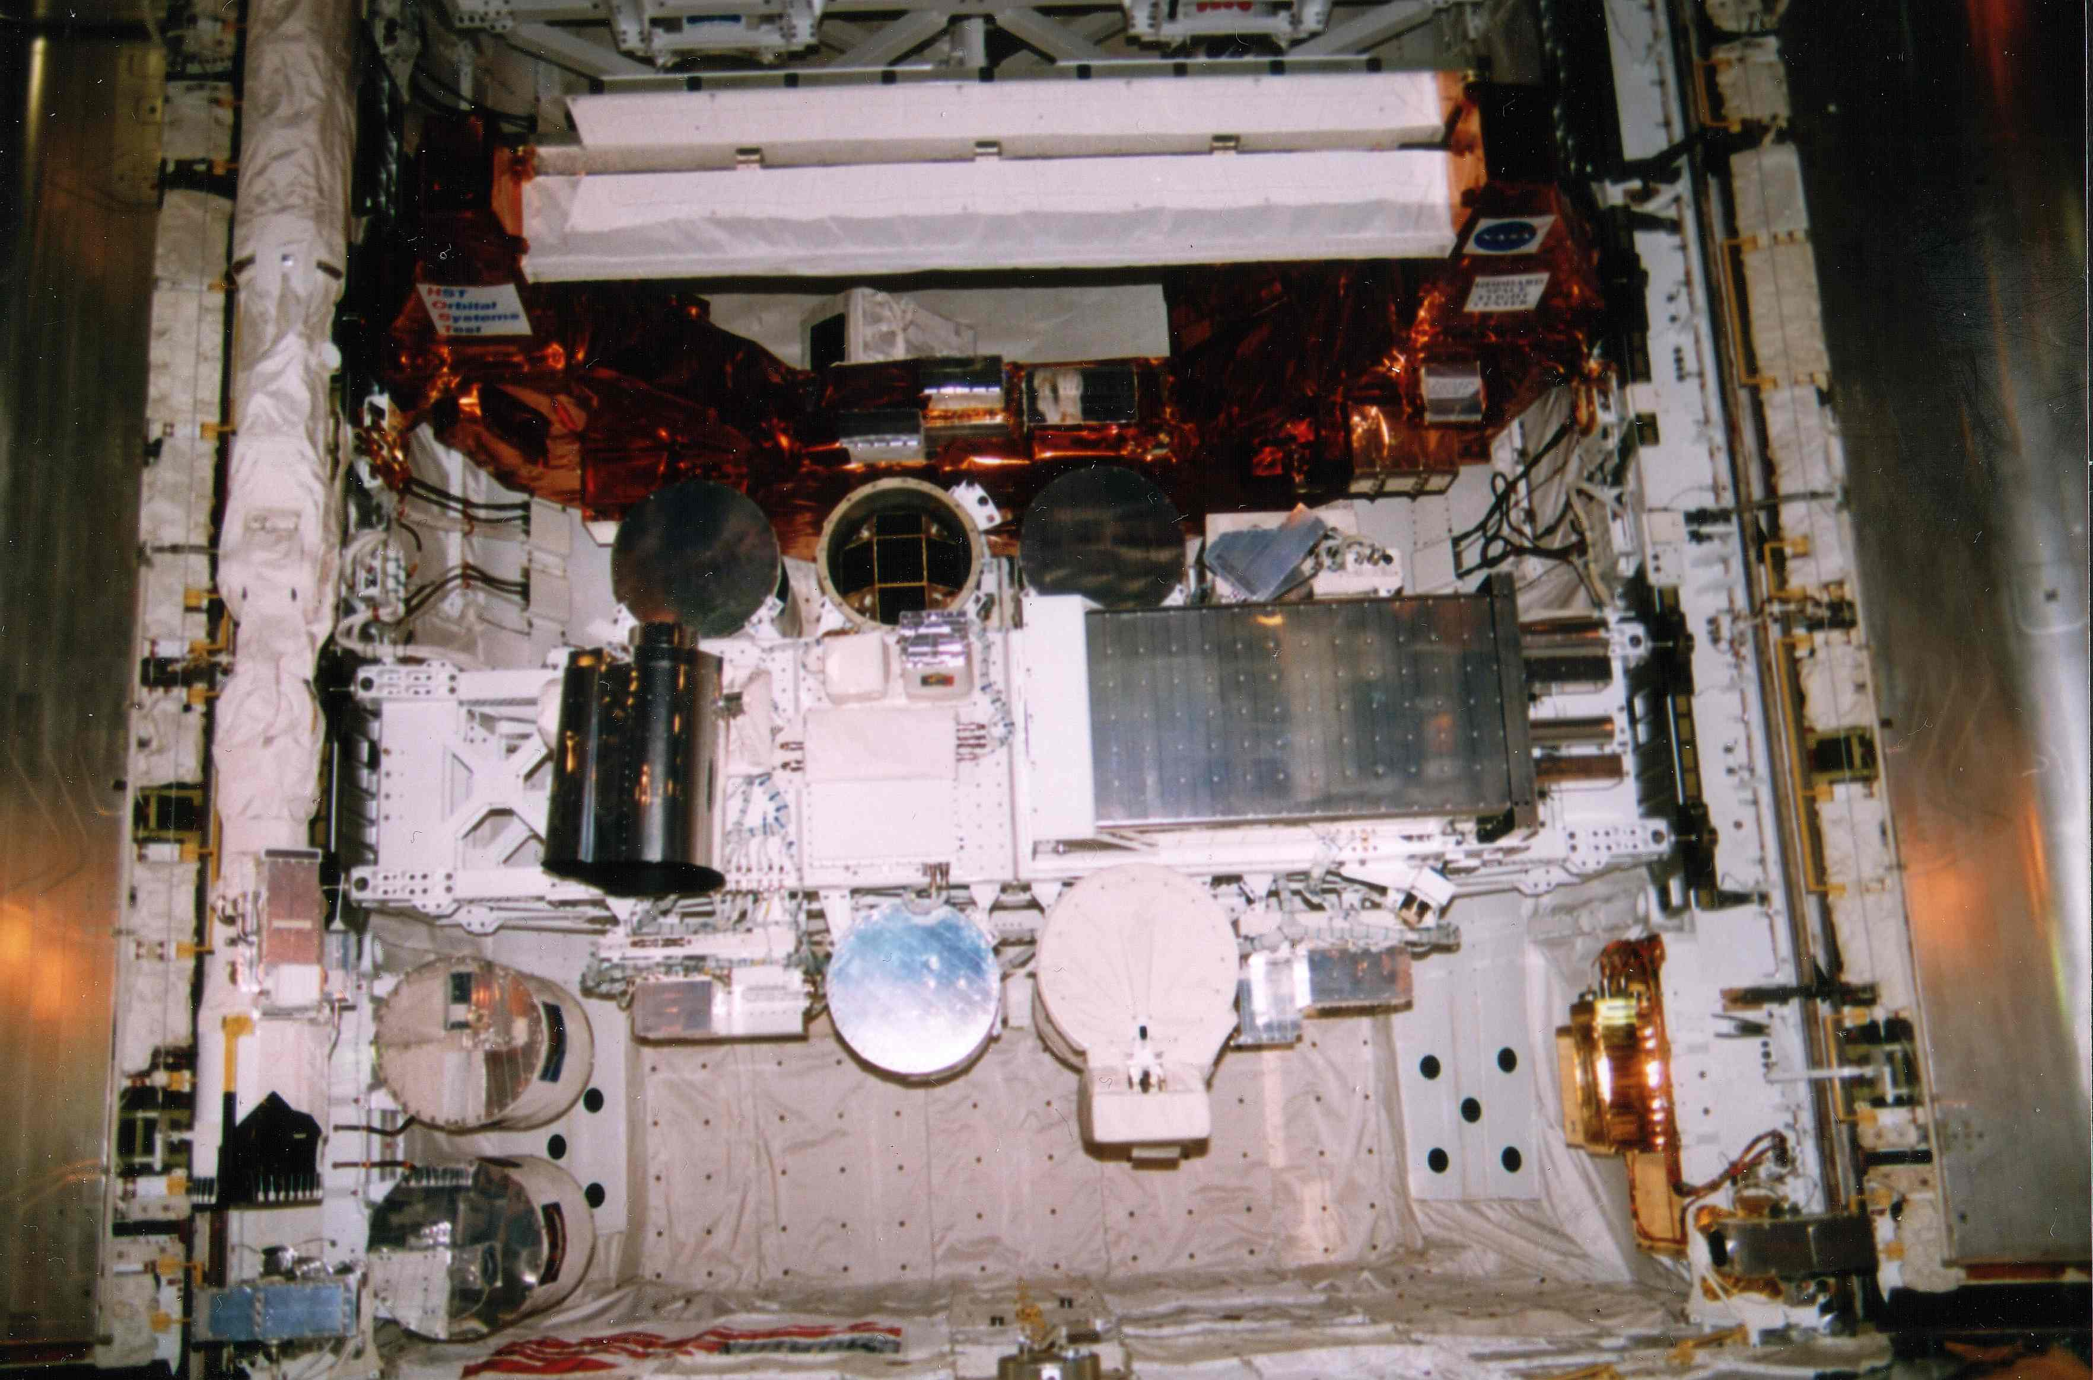
EUVI
STAR-LITE
UVSTAR

The Arizona instruments, UVSTAR, STAR-LITE, and EUVI, were installed in the Shuttle bay. In flight the Shuttle points the UVSTAR at the target. UVSTAR can then fine track on the target over ±3° in AZ and EL. STARE-LITE is fully gimbaled and does not need Shuttle assistance to track targets resulting in much more observing time on orbit.
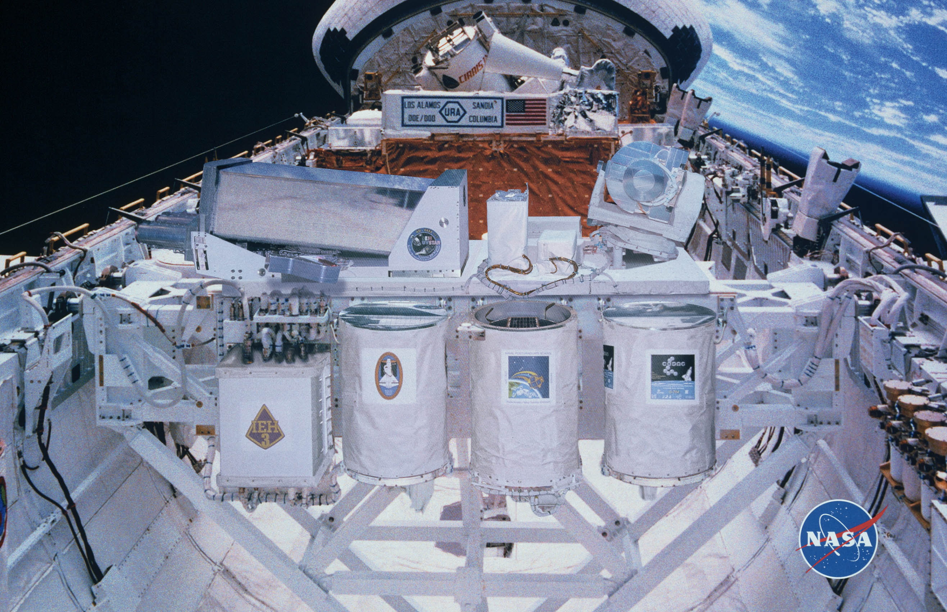

Here the International EUV Hitchhiker (IEH) Bridge is depicted in flight by the Goddard Space Flight Center graphic artists. The three Arizona instruments, UVSTAR, STAR-LITE and EUVI, are in the original photograph used here.

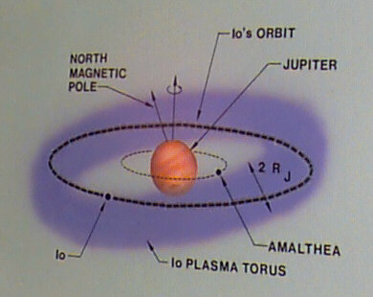
This is a graphic depiction of the target of interest for UVSTAR and STAR-LITE. The IO Plasma Torus is a donut shaped collection of ionized gas trapped by the magnetic field of Jupiter. It was discovered by the Voyager EUV Spectrograph in 1979. Dr. Broadfoot is the PI of that instrument that is still sending back data now 28 years after launch. .

