FRACTURING THE ICY POLAR CLIFFS OF MARS. S. Byrne¹, P. Russell², A. Pathare³, P. Becerra¹ and S. Mattson¹. ¹Lunar and Planetary Laboratory, University of Arizona, Tucson, AZ. (shane@lpl.arizona.edu) ²Smithsonian Institution, Washington, DC ³Planetary Science Institute, Tucson, AZ.

Introduction: The martian North Polar Layered Deposits (NPLD) and their southern counterpart are layered stacks of dusty water ice a few km thick and several hundred km across. The layers have long been thought to represent a climatic record akin to terrestrial ice cores [1,2] with dust content varying from layer to layer, but being minor overall [3]. The NPLD likely wax and wane in thickness with variations in orbital parameters and obliquity; however, strong local effects on erosion and deposition patterns can also be seen. The spiraling troughs that pervade the NPLD interior were initiated partway through NPLD history and have migrated poleward [4]. Chasma Boreale has persisted as a long-term feature within the deposits while other large depressions have been filled in by accumulation [5]. The study of these interior features and the layers they expose illuminates the overall history of NPLD and by extension that of climatic variation on Mars.
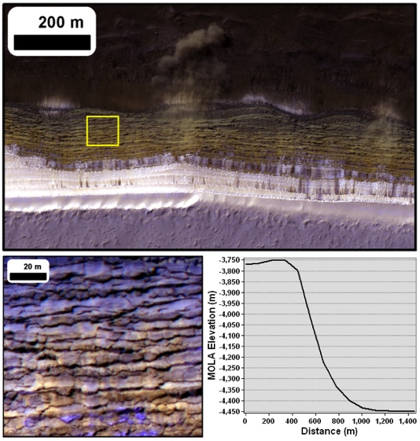
Figure 1. HiRISE image (PSP_007338_2640, L_{s} 34) of 70° scarp at 84°N 235°E with avalanche in progress [10]. Yellow box shows location of scarp texture in bottom left. MOLA topography of scarp at this location is shown in bottom right.
The NPLD margins in contrast have received less attention. In places, the NPLD are bounded by steep scarps of up to 800m in relief and 70° in slope (figure 1). These steep scarps typically overlie exposures of a sandy basal unit [6,7] and it may be that removal of this friable material is undermining the NPLD and leading to the steepness of these bounding scarps [8].
The steep equatorward facing orientation of thesecliffs mean that, in contrast to surrounding flat terrain, they defrost early and receive intense summertime insolation with a strong diurnal cycle and low incidence angles. They are also distinguished from troughs in the NPLD-interior by their unusual surface texture. These scarp faces appear heavily fractured with jagged slab-like fragments (figure 1) and lack the thick slumping lag deposits seen on the troughs [9].
Evidence for mass wasting of meter-scale blocks is common with fresh basal debris appearing even over the period of HiRISE operations [8]. Additionally, multiple frost and dust avalanches (figure 1) have been observed by HiRISE in early spring each year [10].
The absence of a thick sublimation lag and their unusual geometry mean these icy scarps are subject to high rates of ablation. Springtime avalanches likely scour the scarp face of sublimation lag formed the previous summer. However, the color and albedo of these cliffs in HiRISE images indicate that a dusty layer of some thickness exists on their surface.
Here, we examine the unique thermal environment of these scarps and the thermally-generated stresses they endure. We show fractures are easily generated and that scarp-curvature also likely leads to sheeting joints and possible exfoliation of slab-like fragments.
Thermal Behavior: We simulated the thermal behavior of these steep scarps with a standard 1D thermal model [e.g. 11-13]. The model is a semi-implicit thermal diffusion code with radiative boundary conditions at the top surface and negligible heat flow from beneath. The steepness of these slopes means that they exchange reflected and emitted radiation with surrounding flat terrain as well as open sky. We separately simulated the temperatures of the surrounding terrain (assumed to be dark sand, albedo 0.15, thermal inertia (TI) 225) to calculate the upwelling fluxes onto the scarp face. Downwelling radiation from the sky was assumed to be 4% of the noontime flux and adjusted downward for the portion of sky visible.
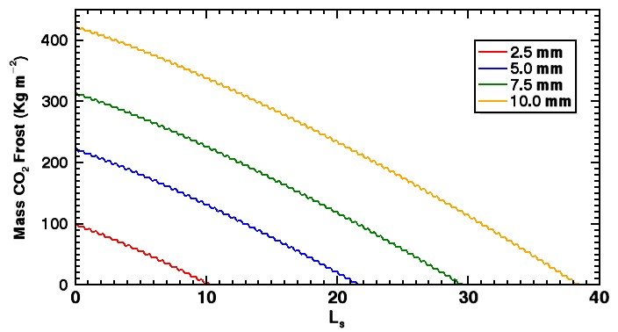
Figure 2. CO₂ frost on a 45° SW-facing slope of water ice with dust covering of different thicknesses.
The thermophysical properties of the scarpface were taken to be water ice at 200K (TI 2130) overlain by a thin dust cover (albedo 0.25, TI 85). The thickness of this dust cover is a crucial controlling factor on the thermal behavior of the ice it covers and it strongly affects the date on which the scarp losses its CO₂ frost cover (figure 2). HiRISE images of frosted and unfrosted scarps bracket this date and we choose a dust thickness of 5mm to agree with these constraints.
Water ice with a 5mm dust cover and surrounding flat terrain as described above form the standard case used in the discussion below. We record temperature at the ice-dust interface (e.g. figure 3) for combinations of slope (5°-70°) and aspect (southeast through west).
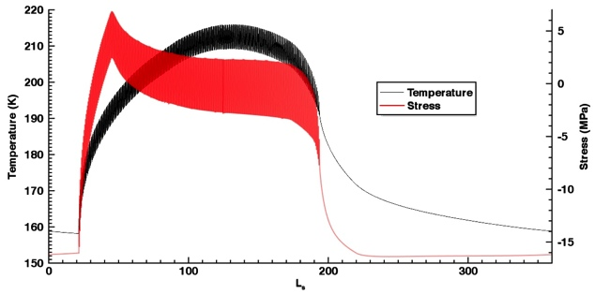
Figure 3. Example thermal behavior of water ice buried by 5mm of dust with a 45° SW-facing slope (black). Surface-parallel stress (positive indicates compression) are shown in red (right axis).
Mechanical Behavior: Thermal expansion and contraction of the ice generates compressive and extensional stresses parallel to the surface. If extensional stresses exceed the tensile strength of the ice then fractures may occur. We follow the approach of [14] to solve for the time varying stress in a viscoelastic solid.
Stress caused by expansion and contraction is opposed by elastic stress over short timescales and decays over longer timescales due to viscous effects. Surface-parallel stresses are assumed to be locally isotropic such that no lateral strain can occur and the ice surface is assumed to be traction free (the small overburden of 5mm of dust is ignored). The time evolution of surface-parallel stress (σ) can be calculated from the temperatures (T) using the differential equation:
$$\dot{σ}=\frac{σ}{E}\frac{dE}{dT}\dot{T}+\frac{E}{1-υ}\left(\frac{dα}{dT}\left(T-T_{o}\right)+α\right)\dot{T}-\left(\frac{σ}{\left|σ\right|}\right)\frac{EA_{o}}{1-υ}e^{{-Q}/{RT}}{\left(\frac{σ}{3}\right)}^{n}$$
where T_{o} is set to the mean temperature and the temperature-dependent Young’s modulus (E), Poisson’s ratio (ν), thermal expansion coefficient (α) and flow parameters A_{o}, Q, & n are taken from [15]. Numerical integration yields the stress history (e.g. figure 3).
During much of the northern summer diurnal temperature oscillations in the ice are large and associated stress can vary by several MPa and alternate between extensional and compressive (e.g. figure 3). Compressional stresses occur during warmer periods and are thus more effectively viscously relaxed than extensional stresses. Colder ice allows for the accumulation of greater extensional stress during cooling. Figure 4 shows the peak compressional and extensional stresses for different combinations of surface slope and aspect.
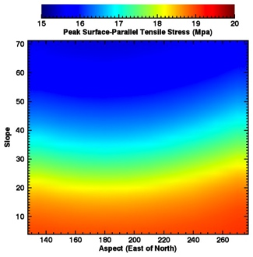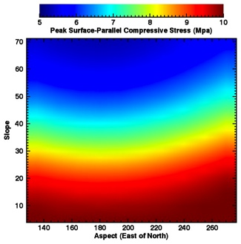
Figure 4. Effects of slope and aspect on peak surface-parallel extensional (left) and compressive (right) stresses experienced by water ice under 5mm of dust.
Discussion: The tensile strength of water ice ranges from 1-2 MPa. Even on the steepest south-facing slopes where the ice is warmest and relaxing fastest the peak extensional stress exceeds this by an order of magnitude (figure 4). Thus these steep scarps with thin dust covers cannot remain unfractured. These results apply to the top of the ice just below the dust cover. How deep these cracks penetrate depend on the thermal waves that cause them. The e-folding depth for the amplitude of the annual thermal wave is over 6m in water ice so fractures will penetrate several meters.
Once fractures have formed, surface-parallel strain is possible (through opening and closing of cracks) and stresses can be further reduced. The fracture spacing should decrease until all points on the scarp face are near enough to a crack to avoid further fracturing.
In addition to these fractures, surface-parallel compression, in concert with surface curvature, can generate extensional stresses below (and normal to) the surface [16]. This effect is thought responsible for large surface-parallel sheeting joints forming on terrestrial granitic domes. High compressional stresses on these martian scarps are relatively easy to generate and so only modest surface curvature is required to overcome the increasing pressure with depth [16]. We are currently investigating this effect with a 1m/pix digital terrain model constructed from a HiRISE stereo pair.
References: [1] Thomas et al., Mars, Univ. AZ Press (1992) [2] Byrne, Ann. Rev. Earth & Planet. Sci. (2009) [3] Grima et al., GRL 36 (2009) [4] Smith et al., Nature 465 (2010). [5] Holt et al., Nature 465 (2010) [6] Byrne & Murray, JGR 107 (2002) [7] Fishbaugh & Head, Icarus 174 (2005) [8] Russell et al., LPSC (2012) [9] Herkenhoff et al., Science 317 (2007) [10] Russell et al., GRL 35 (2008) [11] Mellon & Jakosky, JGR 98 (1993) [12] Aharonson & Schorghofer, JGR 111 (2006) [13] Dundas & Byrne, Icarus 206 (2010) [14] Mellon, JGR 102 (1997) [15] Mellon et al., JGR 113 (2008) [16] Martel, GRL 38 (2011).

