Long-term stability and volatile budget of Ceres

Introduction
In an overarching planetary context, Ceres is interesting because it occupies a unique hydrological niche in the solar system. There are two dominant was of cycling volatiles on a planetary body. One is the airless body model, for example the Moon and Mercury, where transport of volatile molecules occurs from ballistic jumps to a thermally trapped reservoir. The second is the seasonal cycle model, for example water on Earth and CO2 on Mars, where differences in solar insolation based on planetary geometry drives movement and stability of volatiles. Ceres, with a small but non-zero obliquity of ~4º (recently determined by the Dawn Spacecraft) represents an intermediate case, where its lack of atmosphere and possible seasonal variations fall between the two typical volatile cycle patterns for solid surface planetary bodies.
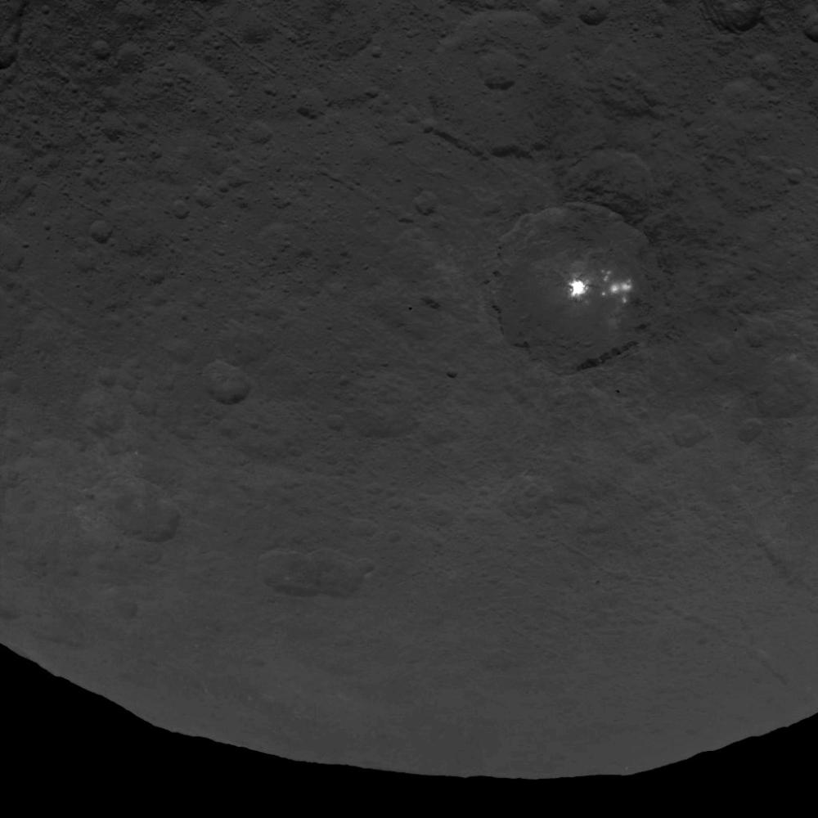
With the Dawn spacecraft going into orbit around Ceres this year (2015), there is a new opportunity to compare models of long-term volatile transport with observations of the surface. Already, the bright spots in the crater Occator (Figure 1) suggest that there may be near-surface ices on the asteroid. Free water was earlier confirmed on Ceres by observations of UV emission from OH⁻, a photodissociation product of water, around Ceres’ northern pole (A’Hearn and Feldman, 1992) and furthermore by the Herschel Space Observatory observation of sub-millimeter absorption features detected water vapor surrounding Ceres (Küppers et al., 2014). Other estimates based on density estimates and interior models suggest that Ceres should be ~25% water ice (McCord and Sotin, 2005).

Figure 1: Dawn Survey Orbit Image 11 shows the bright spots in Occator crater. Image credit: NASA/JPL-Caltech/UCLA/MPS/DLR/IDA

Previous thermal studies suggest that water ice should not be stable around Ceres’ equator (Fanale and Salvail, 1989), while shallowly buried ice could be possible over most of the surface (Schorghofer, 2008). New surface observations can help constrain these predictions of where ices should be on Ceres.
Incorporating volatile transport and landscape evolution models with a thermal model will better characterize the present volatile transport of Ceres with implications for long-term stability and budget for ices on the dwarf planet. The only previous modeling of Ceres’ frost budget (Fanale and Salvail, 1989) was affected both by the computational limits of the time but also the lack of a precise measurement of the obliquity and seasonal timing of perihelion of Ceres. Both of these factors contribute to seasonal frost variations that modern models can how handle. Combining thermal models (e.g. Dundas and Byrne, 2010), landscape evolution models (e.g. Howard 2007), and ballistic transport models (e.g. Killen and Ip, 1999) now can be combined with spacecraft observation to study the current frost balance of Ceres.
This secondary orals proposal summarizes the combination of thermal, landscape evolution, and volatile transport modeling and comparison to Dawn’s Visible/Near-IR Mapping Spectrometer (VIR) and Framing Camera that has been funded through a Dawn at Ceres Guest Investigator selected proposal (PI: Byrne) that also provides the author with access to data as a member of the science team.

Model Construction
Thermal model. The thermal model, when fully developed, will be a semi-implicit (Crank-Nicolson) model that will solve the thermal diffusion equation given the thermo-physical properties of the surface. Since Dawn has gone into orbit, more precise values for the obliquity, argument of perihelion, thermal inertia, albedo, and emissivity can be measured. These inputs will allow for calculations of temperatures in regions based on the solar insolation arriving at Ceres. Evolution of the orbital elements of Ceres throughout the Ceres year can be calculated from the NAIF SPICE toolkit, freely available for users.

Landscape evolution model. The landscape evolution model factors in the effects of topography on the surface temperature of Ceres. Due to the low obliquity (~4°), the likelihood of permanently shadowed regions is very high. While viscous relaxation could affect some landforms, high topographic relief at the poles remains likely because it will be minimally affected according to modeling conducted by Bland (2013). The landscape evolution model will help understand how topography affects shadows across Ceres’ surface, and thereby locating areas that are largely or permanently in shadow. These permanent shadows are areas where the temperature will be quite low and also serve as sinks for water molecules being transported across the surface. Therefore, the feedback between topographically shadowed areas and a global temperature map is accounted for in coupling these two models.

Transport model. The ballistic transport model (based on eg. Vogel, 1996; Butler, 1997; Killen and Ip, 1999) will use a Monte Carlo approach to track large numbers of molecules from each surface element over the course of a year on Ceres. We will assume that particles are lofted on a sub-orbital ballistic trajectories from surface element to surface element, and that they leave the surface with a Maxwellian velocity distribution based on the local surface temperature. Global temperature maps from the previous two models play a key role here in both determining the velocity distribution of the lofted particles as well as where the molecules can be trapped over different seasonal conditions.

Ultimately, the combination of these three models will provide new insight into the current distribution and stability of water ice on Ceres, with implications for present day water regime as well as for the long term sequestration of water ice in permanent shadows.

Citations

