THE POLES OF MARS, PAST AND PRESENT:
A HIGH-RESOLUTION OBSERVATIONAL STUDY OF THE MARTIAN POLAR REGIONS AND THEIR CONNECTION TO CLIMATE

by

Patricio Becerra

__________________________
Copyright © Patricio Becerra 2016

A Dissertation Submitted to the Faculty of the

DEPARTMENT OF PLANETARY SCIENCES

In Partial Fulfillment of the Requirements

For the Degree of

DOCTOR OF PHILOSOPHY

In the Graduate College

THE UNIVERSITY OF ARIZONA

2016

THE UNIVERSITY OF ARIZONA
GRADUATE COLLEGE

As members of the Dissertation Committee, we certify that we have read the dissertation prepared by Patricio Becerra, titled The Poles Of Mars, Past And Present, and recommend that it be accepted as fulfilling the dissertation requirement for the Degree of Doctor of Philosophy.

_______________________________________________________________________ Date: (Enter Date)
Shane Byrne

_______________________________________________________________________ Date: (Enter Date)
Adrian Brown

_______________________________________________________________________ Date: (Enter Date)
Alfred McEwen

_______________________________________________________________________ Date: (Enter Date)
Jon Pelletier

_______________________________________________________________________ Date: (Enter Date)
Peter Smith

Final approval and acceptance of this dissertation is contingent upon the candidate’s submission of the final copies of the dissertation to the Graduate College.

I hereby certify that I have read this dissertation prepared under my direction and recommend that it be accepted as fulfilling the dissertation requirement.

________________________________________________ Date: (Enter Date)
Dissertation Director: Shane Byrne

STATEMENT BY AUTHOR

This dissertation has been submitted in partial fulfillment of the requirements for an advanced degree at the University of Arizona and is deposited in the University Library to be made available to borrowers under rules of the Library.

Brief quotations from this dissertation are allowable without special permission, provided that an accurate acknowledgement of the source is made. Requests for permission for extended quotation from or reproduction of this manuscript in whole or in part may be granted by the head of the major department or the Dean of the Graduate College when in his or her judgment the proposed use of the material is in the interests of scholarship. In all other instances, permission must be obtained from the author.

SIGNED: Patricio Becerra

ACKNOWLEDGEMENTS

When I started the Ph.D. I knew it would be a long and difficult road. However, I thought that most of the difficulty would be academic. After all, it is most definitely a lot of hard work to try and become an expert in something you know little about when you begin. What I didn’t know is that this was not the most difficult part of it at all. Getting this degree has required an immense amount of sacrifice, in my case primarily taking the form of time away from my family and friends back in Peru. I can honestly say that I would not have been able to achieve this without the love and support of so many.
First and foremost, I have to thank my parents and my siblings. Thank you mom and dad for not allowing us to believe that our dreams were too big or too odd for our environment, for genuinely convincing us that we could do anything we wanted to, and providing us with the means to chase those dreams. Thanks dad for teaching me that there is no greater reward than that which comes from great sacrifice. Thanks mom for being my confidant and always making sure I know that you would support me no matter what. Thanks Carlita for being a constant inspiration, you are a world-class surgeon, and you continue to inspire me to be better every day. Thanks Andre for not just being my brother, but my best friend. I cherish the time you were “forced” to spend here in Tucson because of how close it brought us. I can’t wait to reminisce over those times at an Oscars party or some fancy Hollywood director thing with you some day.
I also want to thank my extended family for their love and support. I am lucky enough to still have three of my grandparents, who are a constant source of unconditional love and inspiration. To my uncles and cousins and nieces and nephews. You all make life worth living; I am convinced that we have the best family anywhere.
Thank you to my friends from home, you know you are more like brothers and sisters to me than friends, and I would never be where I am without you. Thank you for believing I could do this and pushing me to see it through to the end, and for always being there during my visits home; this road would have been so much rougher without seeing all of you often. Thank you especially to Fabi, you inspired me to continue on this path more than you will ever know. I’ve missed you dearly; wherever you are, I just want to tell you that I did it and I hope you’re proud.
I can honestly say that had I not joined a group of crazy kids who like to get up at four in the morning to ride bicycles or swim or run, I probably would have thrown in the towel. The UA Tricats and the Cycling team made life in Tucson infinitely better for me, they taught me discipline, and gave me lifelong friendships that I’ll always cherish. Thank you all.
To my friends and colleagues at LPL and ICEPIG. You are the only ones who truly understand what all this means. We have been through a lot together over the years, and it’s been a privilege to have you all as my colleagues and my Tucson family.
Thank you to my committee for your advice and support, especially to Jon, who told me I would do well in science during my first semester here. That has stuck with me all these years, and I hope I can live up to it in the future. Thanks Adrian for believing in me from the beginning and for providing me with so many opportunities to improve a scientist.
Finally, I want to thank my advisor Shane. I like to say that I was the first student you advised from start to finish (I’m pretty sure it’s true), and although this took a bit longer than we both expected, if I’m a competent scientist today, it is because you shaped me into one. Thank you for your patience, guidance, and for all the coconut pictures in Hawai’i. You are more than a mentor and a role model; you have become a true friend. Thank you.

DEDICATION
For Peru, my land, my home, my soul.

For all future astronomers, geologists, and planetary scientists from Peru and Latin America. May you never let anything discourage you from following your dreams. Our countries, and the world, need scientists like us to continue to dream.

Last but never least, for Fabi.

TABLE OF CONTENTS

LIST OF FIGURES 8

LIST OF TABLES 9

ABSTRACT 11

CHAPTER 1 Introduction and Background 14
1.1 A brief introduction to the nature of Mars’ polar deposits 16
1.1.1 Seasonal Caps 16
1.1.2 Residual Caps 17
1.1.3 Polar Layered Deposits 21
1.2 Polar cyclostratigraphy on Mars: the connection between the PLD and climate 23
1.3 Scope and Implications of this work 28

CHAPTER 2 The transient “Halos” of the SPRC and their implications for its mass-balance 31
2.1 Introduction 31
2.2 Methods 35
2.2.1 Image datasets 35
2.2.2 HiRISE measurements of width, brightness, and color of selected halos 38
2.2.3 CRISM spectral data analysis 40
2.2.4 Hapke reflectance model 42
2.3 Observations and results 43
2.3.1 Timing and location 43
2.3.2 Width and brightness 46
2.3.3 Composition and grain size 48
2.3.4. Reflectance model results 51
2.4. Discussion 54
2.4.1 Implications for the formation mechanism of halos 54
2.4.2 Conceptual model 56
2.4.3 Possibility of halos on other Mars years 61
2.4.4 Implications for mass-balance and history of the SPRC 63
2.5 Summary and Conclusions 64

CHAPTER 3 Mapping the stratigraphy of the NPLD using HiRISE Topography 67
3.1 Introduction and Background 67
3.2 Description of Data 71
3.3 Methods 73
3.3.1 Extraction of protrusion signals 73
3.3.2 Image analysis 76
3.3.3. Profile Correlation and Comparison 80
3.3.3.1 Dynamic Time Warping 80

TABLE OF CONTENTS – Continued

3.3.3.2 Statistical analysis by a Monte Carlo procedure 84
3.3.3.3 Comparing Protrusion Correlations to Brightness Correlations 86
3.4 Results 87
3.4.1 Discrete layer identification in individual sites 87
3.4.2 Correlation of profiles between sites 93
3.4.2.1 Correlations with pre-established layer traces 96
3.4.2.2 Correlations without pre-established layer traces 97
3.4.3 Protrusion vs. Brightness 107
3.4.4 Relative Accumulation Rates 109
3.5 Discussion 111
3.6 Summary and Conclusions 117

CHAPTER 4 Searching for a climate signal in the NPLD 120
4.1 Introduction 120
4.2 Methods 121
4.2.1 Stratigraphic profiles 121
3.3.2 Wavelet analysis 123
4.3 Results 127
4.4 Discussion 132
4.5 Conclusions 134

CHAPTER 5 Conclusions and Future Directions 136
5.1 Concluding Remarks 136
5.2 Future Work 139

APPENDIX A1 Hapke reflectance model 142

APPENDIX A2 Flow regime calculations for the SPRC halo conceptual model 146

APPENDIX B Supplementary figures for Chapter 3 148

APPENDIX C1 Further Details on the use of Wavelet Analysis 162

APPENDIX C2 Model of a climate-controlled stratigraphy 164

APPENDIX C3 Supplementary figures for Chapter 4 166

REFERENCES 172

LIST OF FIGURES

1.1 The units of the Polar Deposits of Mars 16
1.2 HST and HiRISE images of the various units of Mars’ polar deposits 16
1.3 Evolution of Mars’ north polar insolation and its FFT spectrum 25

2.1 HiRISE and CTX images of SPRC halos 33
2.2 Map of halo study sites on the SPRC 37
2.3 Example brightness profile of a halo 40
2.4 “Happy Face” Pit at various times 44
2.5 Temporal changes in albedo profiles 45
2.6 Temporal distribution of HiRISE and MOC images examined 46
2.7 Width of halos vs. orientation of pit walls 47
2.8 Maximum brightness of halos vs. orientation of pit walls 48
2.9 CRISM analysis of the Fabi site 49
2.10 HiRISE BG/RED profiles for sites Fabi and Lima 51
2.11 Hapke model results: Contour map of photometric properties for the Lima site 54
2.12 Schematic of conceptual model for the formation of SPRC halos 57
2.13 Model sublimation rates for slopes on the SPRC 61
2.14 HiRISE images of the Trujillo site during four Mars years 62

3.1 Topographic map of NPLD with study sites and HiRISE images of a trough wall 71
3.2 Illustration of the method for extracting protrusion profiles from a HiRISE DTM 76
3.3 Identifying protrusion peaks in HiRISE DTMs and orthoimages 78
3.4 Correlating stratigraphic profiles of sites along the same trough wall (N0 vs. N10) 79
3.5 DTW correlation between sites N0 and N10 83
3.6 Discrete mapping of high-protrusion beds in all study sites 90
3.7 Average thickness and separation of marker beds 92
3.8 Relative locations of identified high-protrusion layers in each study site 95
3.9 DTW correlation between sites N15 and N8 97
3.10 DTW correlation between sites N1 and N6 99
3.11 DTW correlation between sites N15 and N0 101
3.12 DTW correlation between sites N8 and N0 102
3.13 DTW correlation between sites N0 and N1 105
3.14 DTW correlation between sites N0 and N6 106
3.15 Comparison of correlations of protrusion and brightness profiles of sites N0 and N10 108
3.16 Relative accumulation rates vs. latitude 110
3.17 Correlated stratigraphic column of the Main Sequence 115

4.1 Stratigraphic profiles of sites N0 and N7 and their WPS 126
4.2 Insolation signal and its WPS 127
4.3 Model stratigraphic profiles and their WPS 134

B1 Comparison of N0 stratigraphic column with that of Fishbaugh et al. [2010] 148
B2.1 Same as Figure 3.4 but for N15 vs. N8 149
B2.2 Same as Figure 3.4 but for N1 vs. N6 150
B2.3 Same as Figure 3.4 but for N12 vs. N13 151
B2.4 Same as Figure 3.4 but for N9 vs. N11 152
B3.1 Tie-point constrained DTW cost-map for N15 vs. N8 153
B3.2 Same as Figure B3.1 but for N1 vs. N6 154
B3.3 Same as Figure B3.1 but for N15 vs. N0 154
B3.4 Same as Figure B3.1 but for N8 vs. N0 155
B3.5 Same as Figure B3.1 but for N0 vs. N1 155
B3.6 Same as Figure B3.1 but for N0 vs. N6 156
B4.1 DTW correlation between sites N12 and N13 157
B4.2 DTW correlation between sites N9 and N11 157
B5.1 Same as Figure 3.17 in the manuscript but for N15 vs. N8 159
B5.2 Same as Figure 3.17 in the manuscript but for N1 vs. N6 159
B5.3 Same as Figure 3.17 in the manuscript but for N8 vs. N0 160
B5.4 Same as Figure 3.17 in the manuscript but for N15 vs. N0 160
B5.5 Same as Figure 3.17 in the manuscript but for N0 vs. N1 161
B5.6 Same as Figure 3.17 in the manuscript but for N0 vs. N6 161

C3.1 Artificial sinusoid signal and its WPS 166
C3.2 Profiles and WPS for all sites not included in the main text 167

LIST OF TABLES

2.1 List of halo study sites 38
2.2 Hapke model results 53

3.1 Ancillary information of the HiRISE data of the 16 study sites in the NPLD 73
3.2 Results of the DTW-Monte Carlo correlation of protrusion and brightness profiles 109

4.1 Dominant periodicities in the NPLD, insolation and model signals and their ratios 131

ABSTRACT

The poles of Mars, much like Earth’s polar regions, are covered by kilometer-thick sheets of ice that interact with the Martian atmosphere and can record climatic changes in their stratigraphy. These polar caps are composed of several icy sections that interact with the Martian environment over different timescales. This dissertation describes my investigation of two of these units: The South Polar Residual Cap (SPRC), and the North Polar Layered Deposits (NPLD). The overarching theme of my work is to explore the connections between these caps and the current (SPRC) and past (NPLD) climate of Mars using a wide variety of data from spacecraft missions, and applying numerical models of surface properties and processes to interpret the observations.
The SPRC is a ~10 meter thick slab of bright carbon dioxide ice that is covered by pits and scarps formed by differential sublimation. It is unclear whether this cap is in a state of net accumulation or net ablation. During the summer of Mars Year 28 (2006/2007), The High Resolution Imaging Science Experiment (HiRISE) observed an apparent increase in brightness near the edges of these pits that had not been seen before, and was not seen since. I analyzed hundreds of images from HiRISE and the Mars Orbiter Camera (MOC), as well as data from the Compact Reconnaissance Imaging Spectrometer for Mars (CRISM) to search for compositional and/or grain-size changes in the ice that could explain these “halos”. I coupled my observations with numerical modeling of the spectral reflectance of the ice, to explore the effects of different ice grain sizes and minuscule dust inclusions on the observed brightness. I concluded that the features were caused by the occurrence of a global dust storm, after which the depositing dust actually acted to darken the SPRC. The halos were thus areas that had been kept relatively “clean” of the depositing dust, thanks to winds driven by enhanced sublimation from the pit walls. The fact that the halos did not show up in subsequent years means that they had not been exhumed, and that flat areas of the SPRC are in a state of net accumulation. It is likely that events like these result in new flat surfaces formed by snowfall driven by the depositing dust, which could explain the persistence of the cap throughout history.
The polar layered deposits (PLD) are kilometer-thick stratified dome structures composed of dusty water ice that make up the bulk of the polar caps. The layers that make up the PLD are thought to record climatic variations over timescales of millions of years, in a similar way to Earth’s ice caps. These caps are dissected by deep troughs that allow us to observe outcrops of their internal layers and map the stratigraphy. In the past, researchers have done this using layer brightness. However, remotely observed brightness has been shown to be affected by many external factors and may not represent an intrinsic property of the layers. Using Digital Terrain Models (DTM) made from HiRISE stereo images of NPLD outcrops, I mapped the change with depth of each layer’s topographic protrusion from the scarp slope, defining the stratigraphy with a property related to the layers’ resistance to erosion. I mapped the protrusion stratigraphy of 16 sites throughout the NPLD, and correlated the stratigraphic profiles from a subset of these sites, with Context Camera (CTX) images and signal-matching algorithms. This correlation combined topographic information with brightness information, resulting in an improvement of the current state of stratigraphic mapping of the NPLD, providing further evidence that layer sequences are continuous across the NPLD, and setting lower limits on relative accumulation rates for large sections of the cap.
In order to search for a connection between the Martian paleoclimate and the NPLD stratigraphic record, I identified overlapping periodicities in the stratigraphic structure and compared them to periodicities in the climatic history, represented by the change in insolation with time at the North Pole over the last 5 Myr. I found that the ratio of stratigraphic wavelengths is systematically lower than the ratio between dominant modes of oscillation of the north polar insolation. However, a similar wavelet analysis of synthetic stratigraphic profiles created with a simple climate-driven model of accumulation revealed that a detectable non-linear relationship exists between the variation of insolation on the North Polar region of Mars and the stratigraphic record preserved in the NPLD.
The dissertation is organized into four principal chapters and one final chapter with concluding remarks and future directions. Chapter 1 gives an introduction to Mars’ polar regions and to the history of research in astronomically forced climate change through cyclostratigraphy, along with a short summary of the scope and main questions of this study. Chapter 2 details my study of the SPRC halos. Chapter 3 deals with the stratigraphic mapping of the NPLD through high-resolution topography, and Chapter 4 presents the results of my search for an astronomical forcing signal in the NPLD stratigraphy.
Chapter 2 was published in the journal Icarus, in a special issue on the dynamic geologic processes of Mars and the science learned from continuous monitoring of these processes through remote sensing. Chapter 3 has undergone revisions for publication in the Journal of Geophysical Research, and is awaiting a final decision by the editor. A modified version of Chapter 4 has been submitted to Nature Geoscience.

CHAPTER ONE
Introduction and Background

Many of the most stark similarities and differences between Mars and Earth are exceptionally manifested in their polar regions. Mars and Earth have large polar caps composed of water ice that interact with their atmospheres and record changes in each planet’s climate over time [Byrne, 2009]. They both undergo cyclic variations in their orbital and rotational parameters that have an effect on their climate, and which govern the global distribution of ice, directly shaping the climatic record in the stratigraphy of the ice caps. However, the terrestrial climate system is more complex than its Martian counterpart, because Earth has a much thicker atmosphere, oceans and biological activity, giving it a host of surface-climate interactions that Mars lacks. Mars on the other hand, has massive seasonal caps of carbon dioxide ice that condense out about a quarter of its atmosphere at each pole during winter. In addition, the orbital changes that Mars experiences are much more extreme than Earth’s [Laskar et al., 2004a], which could mean that stratigraphic climate signals driven by these extreme changes are stronger and more easily detectable on Mars than on Earth.
These many similarities and contrasts between both planets that are so readily apparent in the polar regions make the poles of Mars an ideal subject of study in order to learn about the planet’s climate and its interactions with the surface and to compare the geological processes that have shaped the recent geological history of Mars to those that have shaped Earth’s.
The Martian polar deposits that we observe today, known as Planum Boreum in the north and Planum Australe in the South (Figure 1.1), are composed of a number of distinct units that respond to changes in climate on different timescales [Byrne, 2009]. As their name suggests, the seasonal ice caps exist only during the winter season at each pole, so their behavior is connected to climate on present-day Mars. The north and south polar residual caps (NPRC and SPRC) are relatively stable features on timescales of centuries, but spacecraft imaging of these units has observed interannual changes in their morphology that are affected by, and constrain the Martian climate on similar timescales. The North and South Polar Layered Deposits (NPLD and SPLD), which make up the bulk of the Martian polar ice content, are kilometer-thick dome-like structures of dusty water ice deposited in layers over timescales of a few million years (NPLD) to possibly a few tens million years (SPLD). These deposits record in their stratigraphy longer-scale climate variations in a way similar to their terrestrial analogs in Greenland and Antarctica [Hinnov, 2013].
Ever since the first explorations of the Martian polar regions [Murray et al., 1972], researchers hypothesized that periodic variations in the solar irradiation of the poles due to cyclic changes in the orbital (eccentricity, argument of perihelion [Murray et al., 1973]) and rotational (obliquity [Ward, 1973]) parameters of the planet have a profound effect on the Martian climate. On Earth, these orbitally-driven climate variations are known as Milankovitch cycles. However, a definitive connection between these periodicities and historical climate changes expressed in martian polar stratigraphy remains to be established, although recent exploratory missions and advances in analysis techniques have made significant advances in this regard.
This dissertation explores the connections between the material deposited on the surface of the poles and the climate conditions that drive its deposition. I specifically focus on observations of two polar units in order to study the current and past nature of this connection. Through studying changes in the appearance of the SPRC, I make a connection between interannual global climate events in the past few years of Mars exploration and the current status of the residual cap. By performing a detailed stratigraphic analysis of the NPLD, with higher resolution data and more advanced techniques than previous work, I shed more light on the nature of the link between Martian Milankovitch cycles that affected the paleoclimate of the last few million years and their expression in the geologic record.

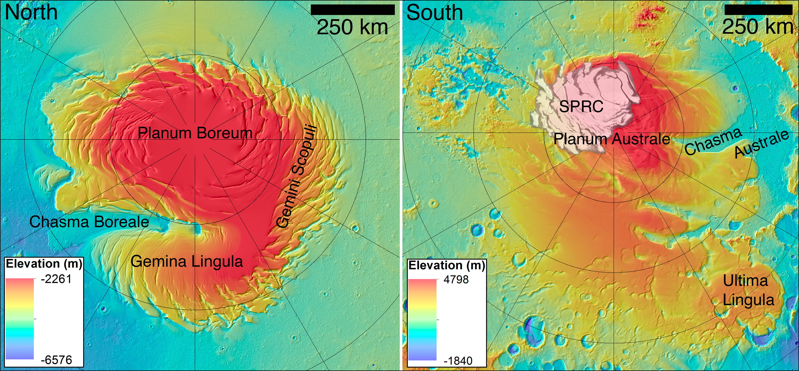
Figure 1.1. (Top) MOLA topographic maps of the polar regions of Mars with a few important geographic locations indicated. In the south-polar region, a MOC image of the SPRC is overlaying the topographic map. Parallels are drawn every 5º. (Bottom) SHARAD and MARSIS radar images showing the internal structure of the north and south polar domes respectively. The grey lines on the topographic maps represent the ground track of the radar sounding.

1.1 A brief introduction to the nature of Mars’ polar deposits
1.1.1 Seasonal Caps
In 1966 Leighton and Murray [1966] used models and observations of surface temperatures to hypothesize that the seasonal caps of Mars, whose annual growth and retreat was known since the 17th century drawings of Cassini, were composed of CO₂ ice. This was later confirmed by the Mariner 6 and 7 orbiters, which observed surface temperatures consistent with the presence of “dry ice” [Neugebauer et al., 1971].
The seasonal caps of Mars are formed at each pole during their respective fall and winter seasons through the condensation of up to 25% of the total atmosphere, which itself is composed of 95% CO₂ by volume [Titus et al., 2008], and sublimate back into the atmosphere during summer (Figure 1.2a). Consequently, just as the oceans control the terrestrial climate, the seasonal caps control the current climate of Mars. The latitudinal extent of these caps can vary regionally, but they have both been observed to reach latitudes as low as ~50º. Although both caps are compositionally dominated by CO₂ ice, the northern seasonal cap is now known to have an annulus of water ice that lines its outer edge [Kieffer and Titus, 2001, Wagstaff et al., 2008], whereas water ice is present only in small patches in the southern cap [Titus, 2005].

1.1.2 Residual Caps
The Residual Polar Caps (NPRC and SPRC) are the topmost polar deposits composed of the brightest and freshest ice that survives the summer sublimation of the seasonal caps each year. They are fundamentally different at each cap, with the NPRC being composed primarily of water ice and the SPRC of CO₂ ice.
The water ice NPRC [Kieffer et al. 1976], is darker than what would be expected from observations of ice sheets on Earth. Such a lower albedo could be caused by dust contamination or by larger ice grains. Spectroscopic observations by Langevin et al., [2005] showed that the NPRC ice is made up of large, dust-free ice grains. Fresh ice typically has a smaller grain size, and grains sinter into larger grains with time [Eluszkiewicz, 1993]. The presence of large grains in the NPRC ice thus implies that old ice is being exposed during the summer, which would mean that the cap is currently undergoing a net loss of material. At large scales of ~100 km, the NPRC looks smooth, however at scales of tens of meters it has a homogenous pitted texture (Figure 1.2b, [Thomas et al. 2000]).
The NPRC is commonly interpreted as the uppermost layer and current site of formation of the NPLD; however, in some areas it is observed to drape over NPLD layers exposed in the upper sections of troughs that dissect the polar deposits [Tanaka et al. 2008]. Although Tanaka [2005] inferred an upper age limit of 8.7 Kyr, corresponding to a decrease in north polar insolation that began ~20 Kyr ago as a result of changes in Mars’ argument of perihelion [Montmessin et al. 2007], other studies of the evolution of craters on the NPRC have concluded that it is an equilibrium surface and cannot be characterized by a single age [Galla et al., 2008], although it may have been entirely resurfaced only about 1.5 Kyr ago [Landis et al., 2016].
The SPRC is a slab of extremely bright CO₂ ice [Kieffer, 1979] that is offset from the pole and covers only a relatively small portion of the SPLD surface (Figure 1.1). It is on the order of a few meters thick [Byrne and Ingersoll, 2003; Tokar et al., 2003; Prettyman et al., 2004], and its stability depends on its capacity to maintain a high albedo. Bright surfaces generally reflect more sunlight than they absorb, so that a positive feedback is established in which the high albedo ensures that the surface remains cold enough on average to maintain stable ice and allow for new ice to be condensed, resulting in a positive mass balance. If areas of the SPRC were to become defrosted and expose the darker substrate, then the solar heat that would be stored in the subsurface would offset the condensation of CO₂ the following winter, and a negative mass balance in which more ice is sublimated than condensed would ensure the disappearance of the entire unit in a few hundred years [Jakosky and Haberle, 1990].
In the last few decades, high resolution images taken by the Mars Orbiter Camera (MOC, [Malin and Edgett, 2001]) on board the Mars Global Surveyor (MGS) and by the High Resolution Imaging Science Experiment (HiRISE, [McEwen et al., 2007]) on board the Mars Reconnaissance Orbiter (MRO), have revealed a wide variety of morphological features on the surface of the SPRC [Thomas et al., 2000, 2005, 2009]. These features are formed by the balance between sublimation and condensation of CO₂ ice and have no analog on Earth. They range from linear ridges (known as fingerprint terrain, Figure 1.2c) to flat-floored quasi-circular pits (dubbed Swiss cheese terrain, Figure 1.2d). The Swiss cheese pits have a wide range of sizes and morphologies and are embedded within ice slabs that have a thickness ranging from a few to about ten meters. The thicker ice slabs have been heavily eroded by sublimation, so in most places on the SPRC, only isolated amorphous mesas remain which can be covered by thinner slabs (some amorphous mesas are visible to the right of Figure 1.2c). These different slabs are interpreted as having formed during different episodes of CO₂ ice deposition, so that the thicker slabs represent older SPRC surfaces and thinner ones represent younger surfaces [Thomas et al., 2005]. Continuous monitoring of the edges of these pits has revealed that they retreat by several meters each year [Malin et al., 2001, Thomas et al., 2005] in response to sublimation of the walls [Byrne and Ingersoll, 2003b]. Because of the low altitude of the sun in the sky at these latitudes, slopes tend to absorb more sunlight. In addition, the walls of these pits are darker than the flat surfaces on top [Malin and Edgett, 2001], likely because they expose older ice that may have larger grains. This results in further enhanced sublimation with respect to the flat mesa tops. Bonev et al. [2008] modeled the response of the SPRC albedo to an enhancement in dust content from a planet-encircling dust storm, which are fairly common on Mars. They suggested that sublimation should be enhanced during years with these events, which agrees with measurements of differing pit expansion rates [Byrne et al., 2008] in dusty vs. non-dusty years.
Since flat surfaces on the SPRC remain bright all year, we can infer that CO₂ ice is being buried at a faster rate than grain growth reduces its albedo. This implies that these surfaces are in a state of net accumulation. It is unclear whether or not the volume accumulated can offset the volume ablated due to the erosive expansion of pits and other sublimation features. Thomas et al. [2016] used images from MRO’s Context Camera (CTX, [Malin et al., 2007]) to measure the overall mass balance of the SPRC in the last 40 years to be between -6 and +4 km3 per martian year. The uncertainty in the sign of these latest results demonstrates that the overall mass balance of the SPRC as a whole remains uncertain [Byrne, 2009].

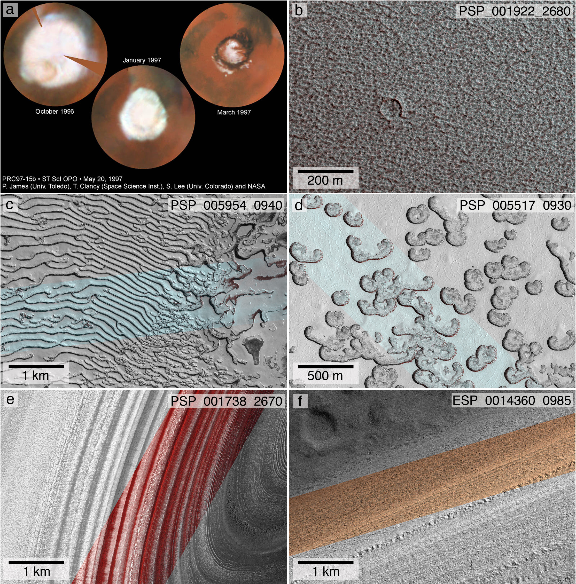
Figure 1.2. (a) Hubble Space Telescope images of the north polar region of Mars showing the retreat of the north polar seasonal cap. (b) False color HiRISE image of the NPRC showing its pitted texture and a rare impact crater. (c) Merged b/w and false color HiRISE image of fingerprint terrain on the SPRC. (d) Merged b/w and false color HiRISE image of one type of Swiss cheese terrain on the SPRC (other types are shown in Figure 2.1). (e) Merged b/w and false color HiRISE image of a trough on the NPLD exposing its layered structure (elevation increases toward the left). (f) Merged b/w and false color HiRISE image of a trough wall on the SPRC. Layers here are usually spaced farther apart than in the north.

1.1.3. Polar Layered Deposits
The NPLD and SPLD make up the vast majority of the topographic domes of Planum Boreum and Planum Australe [Byrne, 2009]. The total volume of the NPLD is ~1.14 million km³ [Smith et al., 2001], and that of the SPLD is ~1.6 million km³ [Plaut et al., 2007]. Together, both domes have a volume comparable to that of the Greenland ice sheet (~2.6 million km³).
The NPLD are about 1000 km across and about 3 km in thickness. One of the most striking features on Planum Boreum is the large canyon known as Chasma Boreale (~500 km long, 50 km wide, and 1-2 km deep, Figure 1.1), which divides the NPLD into a main structure centered over the pole and a lobe known as Gemina Lingula that lies between 85º and 80º N and is centered on 0ºE. The SPLD are of comparable size to the NPLD, but they extend farther equatorward in the form of a broad, lower-relief plateau between 90º and 270º E. A canyon analogous to Chasma Boreale known as Chasma Australe cuts into the main dome of the SPLD, but unlike the NPLD, the southern deposits are dissected by other canyons of similar size such as Promethei Chasma and Ultimum Chasma (Figure 1.1). The NPLD sit on the northern plains of Mars (Vastitas Borealis), which are younger and have a lower elevation than the southern highlands that host the SPLD.
Both PLD are dissected by a series of troughs that form an obvious spiral pattern in the NPLD, and a less obvious one in the SPLD (Figure 1.1). These troughs, first observed by Mariner 9 [Murray et al., 1972; Cutts, 1973], allow a view of the internal structure of the deposits, revealing the stratified configuration that gives the PLD their name, and demonstrating their similarity to stratified ice sheets on Earth (Figure 1.2e,f). Analysis of subsurface radar from the Shallow Radar instrument (SHARAD, [Seu et al., 2007]) has revealed that these troughs are likely analogous to terrestrial features known as cyclic steps [Smith et al., 2013], which are “quasi-stable, repeating, and upstream-migrating bed forms bounded by katabatic jumps.” Although currently it is topography that drives the direction of the katabatic winds on the PLD (and therefore the direction of the katabatic jumps, which are nearly perpendicular to the winds), it is believed that during the onset of the troughs the main driving mechanism was the Coriolis force due to the rotation of the planet, which is what caused the initial spiral pattern [Smith et al., 2013]. In the NPLD, the troughs were shown to be constructional long-lived features that migrated poleward through a combination of organized erosion and deposition in the last 2 Myrs [Smith and Holt, 2010], whereas the SPLD troughs appear to have formed on much older surfaces primarily through the removal of ice by katabatic winds [Smith et al., 2015]. It is these troughs that, given the current impossibility of analyzing ice core samples, provide us with the best way to remotely study the internal stratigraphy of the PLD.
The bulk composition of both PLD is dust-contaminated water ice [Cutts, 1973]. Different proportions of dust in the ice result in distinct strata. Radar transparency data from the Mars Advanced Radar for Subsurface and Ionosphere Sounding (MARSIS) on board ESA’s Mars Express mission provided upper limits on the bulk volumetric dust fraction in both PLD. Picardi et al., [2005] report a value of 2% dust for the NPLD and Plaut et al., [2007] found a value of 10% in the SPLD.
An important and still open issue is that of figuring out the length of time represented by the PLD stratigraphy. Accumulation rates for the NPLD have been estimated from stratigraphic studies as well as modeling [references], but without a robust estimate of surface age it is impossible to ascribe an absolute chronology to the entire preserved record. The SPLD surface is much older than the NPLD, so estimates of the age of those deposits are more uncertain.
Initial studies of crater counts on the SPLD from Viking data [Herkenhoff and Plaut, 2000] implied a surface age of ~10 to 20 Myr. More recently, MGS data from MOC and the Mars Orbiter Laser Altimeter (MOLA, [Smith et al., 2001]) improved the crater detection resulting in an age estimate of 30 to 100 Myr [Koutnik et al., 2002]. The much younger NPLD surface was initially estimated to be at most 120 Kyr old using Viking data [Herkenhoff and Plaut, 2000]. Landis et al., [2016] applied a new crater production function [Daubar et al., 2013] to a population of smaller craters with sizes between 10 and 350 m identified with HiRISE and CTX data [Banks et al., 2010], to propose a complete resurfacing of the NPLD as recently as ~1.5 kyr ago.

1.2 Polar cyclostratigraphy on Mars: the connection between the PLD and climate
The science of astronomically forced planetary climate began with the work of Milutin Milankovitch in 1941 [Milankovitch, 1941], who theorized that cyclic changes in the orientation of Earth’s rotational axis and the planet’s position with respect to the Sun, which affect the amount of solar radiation received at different locations on the planet, caused similar cyclic variations in the Earth’s climate. He postulated that these variations in insolation were the primary driver of the redistribution of ice on the planet, and therefore the cause behind the various ice ages that have occurred over the course of Earth’s history.
In the 1950’s and 1960’s evidence for astronomical forcing was found in the variation of oxygen isotopes in the biogenic marine sedimentary record [Emiliani, 1955, 1966]. The association of these records with changes in the Earth’s obliquity and precession [Hays et al., 1976; Berger, 1977] culminated with the development of an “orbital chronology” [Imbrie, 1984] and the construction of models of the astronomically driven evolution of insolation for the past several million years [Vernekar, 1972; Bretagnon, 1974; Berger, 1976, 1978]. In 1988, Fischer et al., [1988] coined the term “cyclostratigraphy” to describe sedimentary deposits that had periodicities corresponding to the so-called Milankovitch bands [Strasser et al., 2006]. After this, research on the topic advanced quickly, to the point of having detailed numerical solutions for the changes of the Earth’s insolation back to 50 Myrs [Laskar et al., 2004b, 2011].
Signals of astronomical forcing are manifested in cyclostratigraphic records as strata of similar characteristics that occur with periodic spacings (or wavelengths) in the record. Since the temporal evolution of insolation can be accurately known from the models mentioned above, these signals can be exploited and used as geochronometers [Hinnov, 2013]. The theory is that characteristic wavelengths in the stratigraphic records will directly correspond to periodicities in the astronomically forced insolation if the relationship between the two is linear. If one additionally knows an absolute age for a single strata, then the relationship can be used to construct a history of climate for the planet that would have resulted in the emplacement of the observed stratigraphic record. This correspondence is made more complex by non-linear relationships between insolation and stratigraphy.
The discovery of layering in the troughs of the PLD by Mariner 9 [Murray et al., 1972; Soderblom et al., 1973; Cutts, 1973] inspired the theory of astronomically forced climate change on Mars, but it wasn’t until MOC observations that details of the PLD stratigraphy were resolved [Malin and Edgett, 2001], and soon thereafter the first attempts at correlating Mars’ historical insolation signal to patterns in these deposits were published [Laskar et al., 2002], along with advanced solutions for the insolation of Mars back to 20 Ma (Figure 1.3a; [Laskar et al. 2004a]). In the absence of an absolute chronology for the observed stratigraphic record Laskar et al. [2002] speculated that the 250 m sequence that they analyzed represented ~500 Kyr of deposition.

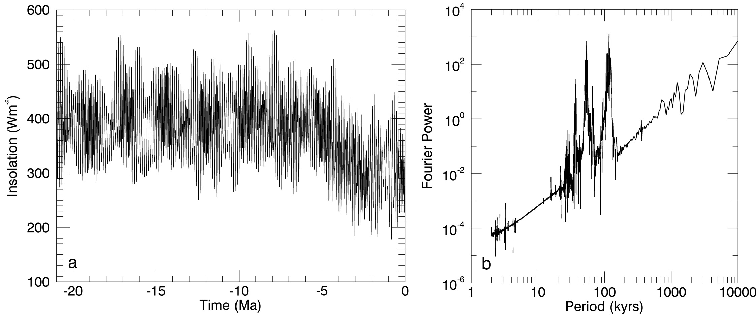
Figure 1.3. (a) Temporal evolution of the peak summertime insolation at the North Pole of Mars for the last 20 Myrs. (b) FFT Power Spectrum of the insolation signal. The large peaks in the middle of the spectrum denote periodicities at 51 and 120 Kyr, due to the cyclic variation of the planet’s argument of perihelion and obliquity respectively (see chapters 3 and 4).

Subsequent studies of the deposits with MOC imagery used spectral analysis to detect periodicities in the record. These techniques, primarily Fast Fourier transforms, decompose an arbitrary signal theorized to be forced by periodic functions, into its sinusoidal components, i.e. they transform a time/depth vs. amplitude signal into one of periodicity (expressed as frequency, period or wavelength of the driving functions) vs. power (Figure 1.3b). This power spectrum exposes the dominant periodicities, i.e. it shows the presence and strength of peaks or troughs in amplitude of the signal that repeat with a characteristic spacing, and which spacings are most prominent.
Using FFT on records of brightness measured by MOC, Milkovich and Head [2005] detected a characteristic wavelength of ~30 m between darker possibly dustier layers in the upper 300 m of NPLD. This result supported the Milankovitch interpretation of Laskar et al. [2002]. Perron and Huybers [2009] were the first ones to use the more advanced method of spectral analysis known as wavelet analysis (which I use and explain in Chapter 4) to detect changes with depth in the stratigraphic periodicities of the MOC brightness of NPLD trough walls. However, they were not able to confidently detect any stratigraphic periodicity over a significant depth range. They concluded that the NPLD either did not represent an astronomically forced cyclostratigraphy, or that the relationship between Mars’ historical insolation and the NPLD stratigraphy was highly non-linear and complex. The latter implies time-variable deposition rates of ice and/or dust.
With the arrival of MRO to Mars, high-resolution stereo images from HiRISE and subsurface radar data from SHARAD allowed an unprecedented view of the internal structure of the PLD. Using HiRISE, Herkenhoff et al., [2007] detected mantling deposits (possibly a dust lag from sublimation of water ice) on the walls of NPLD troughs, raising the question of whether or not the brightness of the layers was actually representative of the intrinsic layer properties, which would affect cyclostratigraphic studies that used brightness records. Fishbaugh et al. [2010a,b] then constructed the first stratigraphic column of a single site on the NPLD using morphologic and topographic characteristics, thanks to stereo observations by HiRISE, which allowed the construction of Digital Terrain Models (DTMs). Limaye et al., [2012] performed a similar study on three sites in the NPLD and three on the SPLD. Both Fishbaugh and Limaye again found periodicities that appeared to correspond to the ~30 m signal detected by Milkovich and Head [2005], supporting the notion that an orbital signal could be remotely detected. Sori et al., [2014] later used simulations of brightness profiles to evaluate the plausibility of an insolation signal being detected in a non-linearly constructed stratigraphy. They concluded that, if enough time is preserved, periodicities in the stratigraphy could indeed be detected, but that it was most likely not as straightforward as previous attempts had assumed.
In addition to the studies using optical imagery, radar observations by SHARAD were able to probe the internal structure of the PLD by discerning between depositional packets through changes in their dielectric constant, which is directly related to the dust content of the layers [Nunes and Phillips, 2006; Phillips et al., 2008; Putzig et al., 2009]. Phillips et al. [2008] reported four finely layered packages separated by homogeneous regions. They interpreted the radar reflections as dust-rich layers and the homogeneous regions as relatively dust poor. They suggested that episodes of high obliquity and eccentricity may generate the dusty meteorology necessary to deposit dust-rich layers and vice versa. Comparing the SHARAD observations with the insolation solution of Laskar et al. [2004a], leads to the conclusion that if the first homogeneous region relates to the most recent low in obliquity (∼800 Kya), then the average accumulation in each argument of perihelion cycle (51 Kyr) is ∼32 m, i.e., very similar to the results of Laskar et al. [2002] and Milkovich & Head [2005].
The most recent model of climate-forced stratigraphic deposition for the NPLD was constructed by Hvidberg et al. [2012]. This model builds a simulated stratigraphy by varying the deposition rates of ice and dust in the last 5 Myr according to surface temperatures derived from the insolation solution of Laskar et al. [2004a]. The authors constrain the free parameters of the model by attempting to fit their synthetic stratigraphy to that of the column mapped by Fishbaugh et al. [2010a]. Using these parameters and extending their solution to 10 Ma, their simulated NPLD begins to accumulate at ~4.2 Ma, consistent with previous models of global climate [Levrard et al., 2007]. In addition, their model reproduces the four packets of layers observed by SHARAD [Phillips et al., 2008].
The SPLD are more poorly studied than the NPLD. The temporal variation of Mars’ astronomical parameters is chaotic [Laskar et al., 2004a], so the length of an accurate solution is limited by imprecision in the current precession rates [Byrne, 2009]. Currently, insolation solutions can only be considered accurate back to between 10 and 20 Ma. The estimated surface age of the SPLD is at least 10 Ma and it could be as old as 100 Myrs [Koutnik et al., 2002]. This makes the identification of cyclostratigraphic signatures of orbital forcing in the SPLD a significantly more complex endeavor than it is for the NPLD. Nevertheless, as estimates of precession rates improve, and better data becomes available, the cyclostratigraphic study of the SPLD will naturally evolve with the goal of drawing a complete picture of astronomically forced polar deposition that describes the geologic history as far back as the time of emplacement of both units.

1.3 Scope of this study
In the previous subsection I have summarized recent advances in Mars Polar Science, which thanks in large part to the continued advancement of remote sensing with planetary exploration missions, has exponentially grown since the initial days of the Mariner and Viking spacecraft. Nevertheless, as is the case with any area of science, more solved problems give rise to even more questions yet to answer. The goal of my dissertation work was to investigate unanswered questions related to the connection between the Martian climate and surface in the past and in the present, by performing an observational analysis of two polar units individually.
On the SPRC, I researched interannual changes in brightness that may have been related to the onset of global dust storms over the last few years, the explanation of which may hold the key to understanding the mechanism by which the SPRC persists at relatively long timescales. I made use of data from HiRISE, the Compact Reconnaissance Imaging Spectrometer for Mars (CRISM; [Murchie et al., 2007]) and numerical models of the reflectance spectra of the surface of the SPRC. This research, detailed in Chapter 2, focuses on answering the following questions:
- What is the connection between interannual climatic variations and the changes in brightness of the SPRC?
- Can this connection teach us about the mechanisms by which the SPRC remains stable?

My study of the NPLD is centered on significantly advancing studies of its cyclostratigraphy. I redefined the stratigraphic mapping by using topographic properties in addition to brightness to describe the layers. My primary goal was to evaluate the possibility of finding a connection between astronomical forcing and NPLD deposition, to search for this connection, and to explore climate-forced depositional scenarios that may have led to the stratigraphic record that we observe today. I relied heavily on the HiRISE DTMs for these purposes. This research is presented in Chapters 3 and 4, and seeks to answer the following questions:
- Is the topographic expression of the layers continuous throughout the NPLD, suggesting a relationship with internal properties of the strata?
- Does using topographic quantities represent a significant improvement over using brightness to describe the stratigraphy?
- Is the stratigraphic record similar across the NPLD or have accumulation patterns varied locally?
- Is it possible to detect a correlation between the astronomically forced climate of Mars and the stratigraphy of the NPLD?
- What is the nature of that correlation, and what does it imply about the history of the NPLD?
Answering these questions can teach us a great deal about the history of the planet and the solar system. Moreover, the similarities between Mars and Earth and the relative simplicity of the Martian climate system compared to Earth’s, make Mars an ideal laboratory in which to study planetary climate change from the perspective of comparative planetology, and in so doing learning more about how similar processes affect Earth and other planets.

CHAPTER TWO
The transient “Halos” of the SPRC and their implications for its mass-balance

2.1 Introduction
The carbon dioxide South Polar Residual Cap (SPRC) [Kieffer, 1979] of Mars varies in thickness from approximately two to ten meters [Byrne and Ingersoll, 2003; Thomas et al., 2000], and is concentrated between 84ºS and 89ºS latitude, and between 220ºE and 50ºE longitude. The SPRC contains a large number of erosional scarps and flat-floored, quasi-circular pits embedded in its ice slabs (initially described by Thomas et al., [2000] and informally known as “Swiss-cheese terrain” [Malin and Edgett, 2001] because of their appearance when observed from orbit). The depths that these features have eroded into the SPRC ice slabs range from less than a meter up to ten meters, and in some places allow the water ice underlying the SPRC to show through [Bibring et al., 2004; Byrne and Ingersoll, 2003; Titus et al., 2003].
Thomas et al. [2005, 2009] performed a detailed geologic mapping of the SPRC using images acquired by the Mars Global Surveyor (MGS) Mars Orbiter Camera (MOC) [Malin and Edgett, 2001], and the High Resolution Imaging Science Experiment (HiRISE) [McEwen et al., 2007] aboard the Mars Reconnaissance Orbiter (MRO). They identified four distinct depositional units, each with characteristic erosional patterns, and with different total surface coverage over the SPRC (Figure 1 in Thomas et al. [2009]). The inclined walls of the erosional pits in all of these units retreat by 2 to 4 m per Martian year, depending on the particular depositional unit [Malin et al., 2001; Thomas et al., 2009]. This erosional evolution seems to suggest that the SPRC is in the process of disappearing, and that the Martian climate is changing [Malin et al., 2001]. In fact, based on these retreat rates, and the spatial density of the pits, the entire SPRC should disappear within about a century. However, a landscape-evolution model [Byrne, 2011] has been suggested for the SPRC, in which pits form spontaneously due to imbalances in the energy budgets of different areas of the surface, caused by intrinsic surface roughness. This model does not require climate change, but instead necessitates ongoing accumulation of ice on flat surfaces with inter-annual variability in the deposition rate in order to form a recurring SPRC.
Unlike the retreat rates of sloped surfaces such as pit walls, the mass-balance of flat surfaces on the residual cap is extremely difficult to measure from images, so we must rely on the analysis of changing brightness patterns in order to extract information from the flat inter-pit mesas. Here we report on ephemeral albedo features that appeared on the SPRC immediately after a midsummer global dust storm: a large number of the pits and scarps characteristic of the SPRC were seen to exhibit a bright decameter-scale “halo” around their edges (Figure 2.1). These albedo halos appeared during the southern-summer of Mars Year (MY) 28, at ~L_{s} 270º - 280º (L_{s} is solar longitude, it is used to measure the time of year on Mars, and it represents the position of the planet in its orbit relative to north vernal equinox, defined as L_{s} = 0º; according to the convention of Clancy et al. [2000], MY 1, began on April 11th, 1955), and disappeared later that same summer between L_{s} 330º and 340º. We observed the halos on all geologic units mapped by Thomas et al. [2009], although their appearance and intensity differed slightly from one unit to another. The most easily visible and measurable halos were seen in Unit B (Figures 2.1 a-d, g in this work; Figure 10c and 15b in Thomas et al. [2009], also display noticeable halos). The halos were observed only during one out of eight Mars years for which observations at high enough resolution exist.

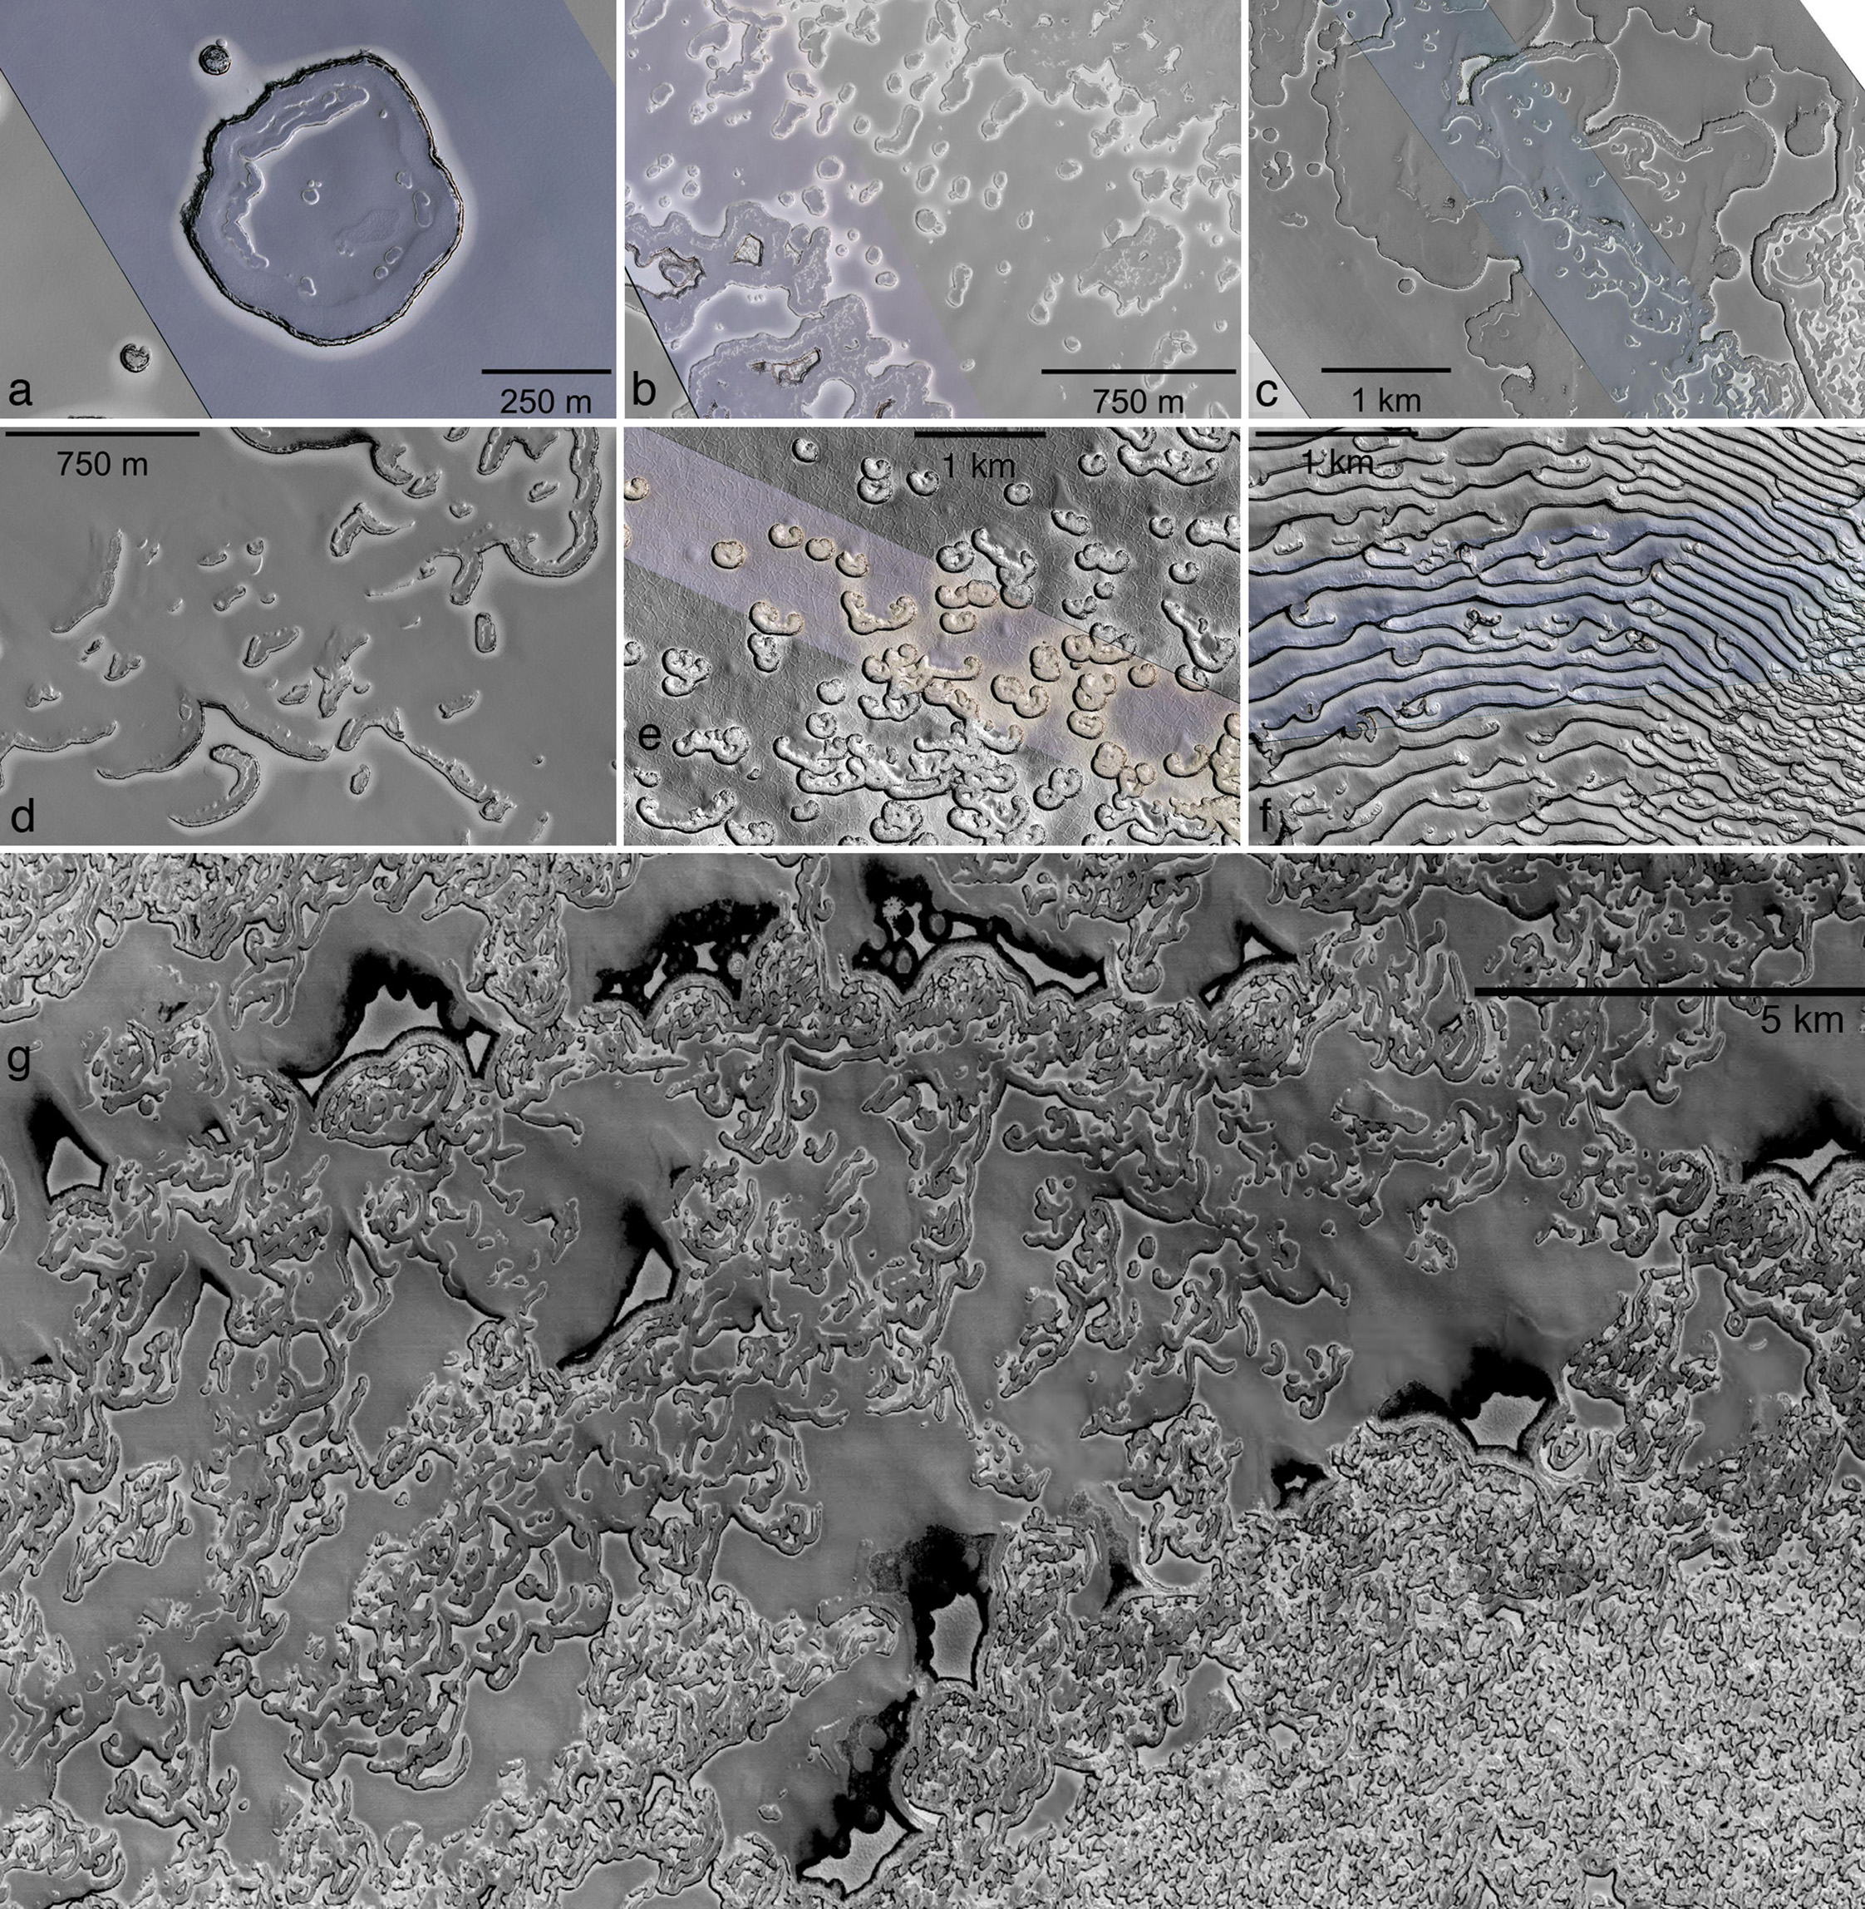
Figure 2.1. Examples of HiRISE (a-f), and CTX (g) images of eroded terrain on the SPRC exhibiting halos. (a-d) PSP_004989_0945, PSP_005002_0945, PSP_004765_0940, PSP_004858_0940. Halos on Unit B of Thomas et al. [2009]. (e) PSP_005043_0930. Unit A1 displayed faint halos that were difficult to measure because of comparable brightness changes in the terrain due to small-scale topographic relief. (f) PSP_005576_0940. Fingerprint terrain in Unit A2, showing a faint brightness difference between areas close to the edges of the scarps, and areas farther away. (g) P11_005227_0937_XN_86S003W. Larger-scale CTX image of a halo-covered region. Halos are visible on the isolated mesas of Unit A0, and around the smaller pits and depressions of Unit B.

This particular year, MY 28, was marked by a global dust storm that began near Mars’ perihelion (L_{s} 252º), in the middle of southern summer. The timing of the halos suggests that their appearance could have been related to this event, which affected the overall mass balance of the SPRC. These anomalous dust-storm years are expected to result in increased overall ablation of the SPRC [Bonev et al., 2008], but they have also been suggested to play an important role in the preservation of the residual cap through the reduction of surface roughness by increased snowfall replacing direct freezing of ice onto the surface [Byrne, 2011]. Hayne et al. [2014] have shown that snowfall is consistent over the SPRC during winter, and contributes between 3% and 20% by mass of the seasonal CO₂ deposition. In addition, the amount and importance of snowfall for newly deposited ice is probably variable from year to year, as there is evidence that cold spot activity in the south polar cap can be affected by global dust storms [Cornwall and Titus, 2012].
We present results from an observational analysis of the SPRC halos that were obtained through the examination of spacecraft data in combination with a reflectance model of the SPRC surface based on Hapke theory [Hapke, 2012]. Our goal is to provide a thorough characterization of these features, detailing their size, shape, location, time of appearance and disappearance, composition, and dependence on insolation, as well as to hypothesize a formation mechanism and describe the implications of their existence on the mass-balance of the SPRC.
We have demonstrated that the effects of a near-perihelion global dust storm on the residual cap are significant, and such events do not happen regularly. The study of the halos’ transient existence helps characterize the mass balance of the SPRC during such anomalous years, providing valuable insight that could help explain the cap’s persistence in the Martian south-polar region.

2.2 Methods
2.2.1 Image datasets
The primary objective of our image analysis was to constrain the timing and location of halos on the residual cap. For this purpose we performed a survey and analysis of data from three imaging instruments: the Narrow Angle Camera of the Mars Orbiter Camera (MOC) on Mars Global Surveyor (MGS), the High Resolution Imaging Science Experiment (HiRISE), and the Context Camera (CTX) [Malin et al., 2007], both on board the Mars Reconnaissance Orbiter (MRO).
Due to its large image swath (~30 x ~160 km) and high-resolution (6 m/pixel) widespread coverage of the Martian south-polar region [Malin et al, 2007], the CTX dataset was used initially to search for evidence of halos throughout the SPRC. CTX has achieved nearly 100% coverage of the SPRC each year between MY 28-31. During our search we used CTX images from all available years to check the entire surface of the SPRC looking for halo-covered regions in which the SPRC material displayed noticeable brightening on the edges of erosional pits and scarps (Figure 2.1g).
After the initial CTX survey, we used the sparser, but higher resolution data of HiRISE and the MOC Narrow Angle Camera to observe certain regions of the cap more closely, and select specific pits in smaller areas that are best suited for further analysis and characterization. HiRISE has a maximum resolution of 25 cm/pixel, and an image swath width in its RED detector of 5 km from an altitude of 250 km, which make it optimal for examining meter to decameter-sized surface features. Most importantly, the relative uncertainty between two pixel values in one image is less than 2%. Therefore, it is ideal for a thorough analysis of minor brightness differences such as the halos. HiRISE acquires images using three detectors that correspond to three color bands: The blue-green (BG) band (400–600 nm), the RED band (550–850 nm), and the Near Infrared (NIR) band (800–1,000 nm) [McEwen et al., 2007; Delamere et al., 2010]. The MOC Narrow Angle Camera has a spatial resolution of up to 1.4 m/pixel and a swath width of up to 2.9 km, with a single panchromatic band [Malin and Edgett, 2001]. Our complete dataset comprises 732 HiRISE images spanning four southern springs and summers from MY 28 to 31, between L_{s} 180º and 360º, and 175 MOC images from MY 24 – 27 over the same L_{s} range that overlap areas in which HiRISE and CTX observed halos.
Based on our survey of these datasets, we selected 9 sites on the SPRC on which to perform a quantitative observational analysis. These sites were chosen based primarily on the temporal density of imaging coverage in the area, with consideration given to sampling a wide longitudinal range. In addition, we eliminated sites with terrain where it would have been difficult to measure halo properties, such as polygonal troughs in the flat surroundings (as in Unit A1 of Thomas et al. [2009], Figure 2.1e), or closely spaced parallel scarps where, although halos were present, they were difficult to distinguish from the underlying geomorphology (as in Unit A2, Figure 2.1f). The locations of our selected sites are shown in Figure 2.2, and their informal names and geographic coordinates are listed in Table 2.1.

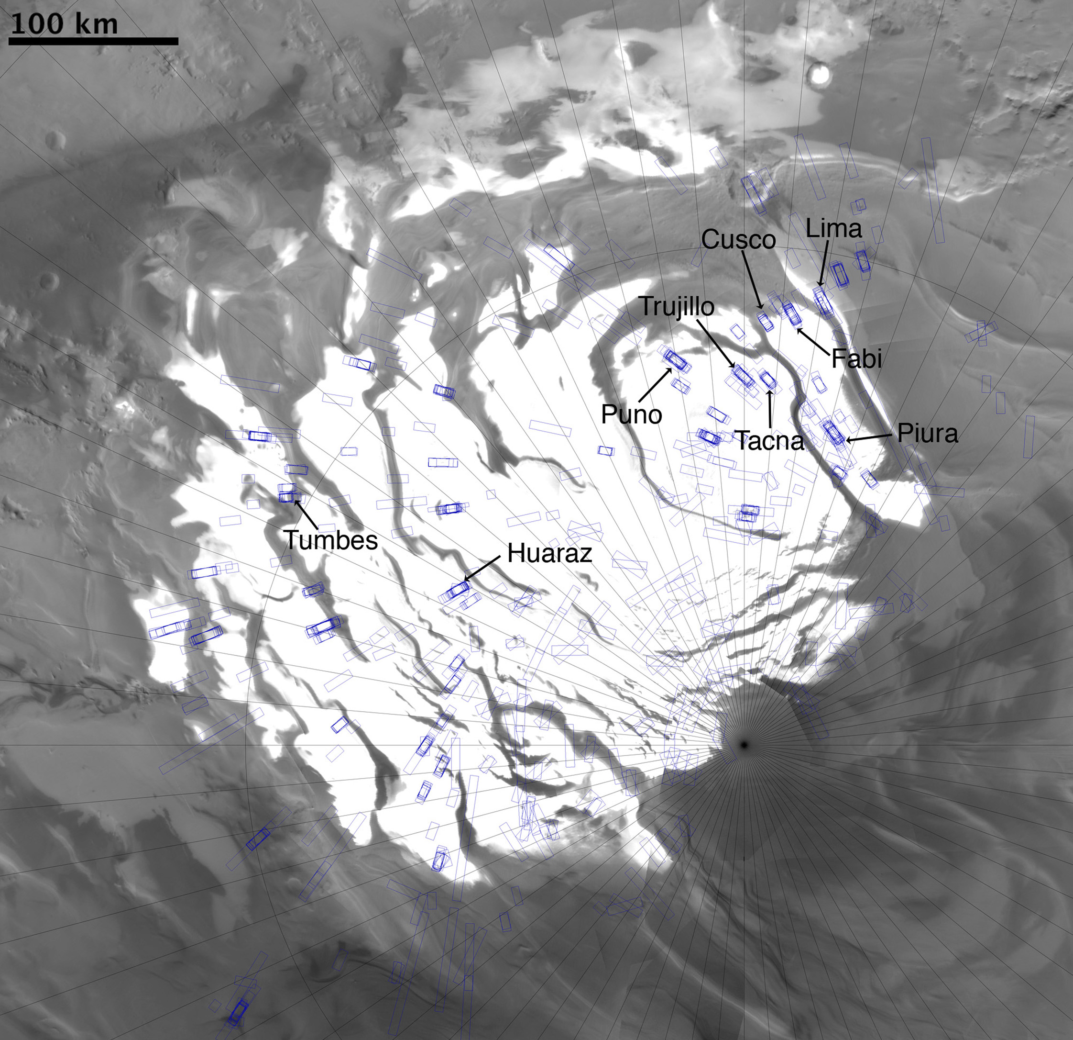
Figure 2.2. MOC Wide Angle Camera Mosaic of the SPRC with HiRISE image stamps superimposed (blue rectangles). Meridians and Parallels are spaced every 5º. The zero Meridian is pointing upward. The locations of the sites selected for analysis along with their informal names are shown.

We examined the images using the map-projection tools of the Java Mission-planning and Analysis for Remote Sensing (JMARS) geospatial information system (GIS), developed by the Mars Space Flight Facility at Arizona State University. This suite of software tools allowed us to easily search for overlap between the various datasets, simultaneously search different Mars Years of observation with one or more datasets, and map-project the images onto wide-angle mosaics in order to easily locate the areas of the cap that we were examining and constrain a location for the appearance of halos.

Table 2.1. List of sites selected for detailed analysis. The left three columns list the informal names given to the sites, and their center latitude and longitude. The right two columns list the number of HiRISE images taken in MY 28 between L_{s} 279º and 331º.

Site Name | Center Latitude | Center Longitude | Number of HiRISE MY 28 images | L_{s} of images with halos. 279º < L_{s} < 340º
Trujillo | -86.3 | 0.1 | 3 | 286,303,331
Cusco | -85.7 | 2.8 | 2 | 288,298
Tacna | -86.3 | 3.6 | 2 | 283,323
Fabi | -85.7 | 6.3 | 2 | 288,298
Lima | -85.5 | 10.2 | 4 | 285,299,309,315
Piura | -86.7 | 15.4 | 1 | 284
Tumbes | -84.8 | 298.8 | 2 | 320,325
Huaraz | -86.7 | 297.8 | 2 | 293,317
Puno | -86.1 | 350 | 4 | 282,289,292,315

2.2.2 HiRISE measurements of width, brightness, and color of selected halos
HiRISE images at our chosen study sites were analyzed in order to extract quantitative information about the brightness and size of the features we identified as halos, and how these properties vary with time of year, position on the cap, and aspect of the adjacent pit walls with respect to north. We imposed an important criterion in order for an observed scarp-adjacent brightness difference to be classified as a halo: the brightness difference was required to be present adjacent to walls oriented at any and all aspects with respect to north, within one image. This excludes brightness changes that represent a different phenomenon than the halos. For example, an albedo rise on the ice adjacent to the sun-facing walls of a pit that is absent next to the sun-opposing walls suggests that it is most likely due to a slight inward dip of the surrounding surface as it approaches the edges of the walls, and is not, like the halos, a feature that is independent of the morphology of pit edges. We have observed this inward dip of the ice around the majority of erosion features on the SPRC.
Once we had selected specific halos for analysis, we used Exelis Visual Information Solutions’ Environment for Visualizing Images (ENVI) to measure the width and maximum brightness of the halos. We extracted one-dimensional profiles of I/F values (measured intensity (I) divided by the solar irradiance when the incidence angle is zero (F), such that I/F = 1 for a perfectly diffuse reflector that is normally illuminated) from the edge of a pit or scarp on a HiRISE image, out to a point within the surrounding plateau that appeared to have a uniform brightness. These I/F values were then converted to Lambert Albedo (A_{L}) by dividing them by the cosine of the incidence angle. We plotted A_{L} of the HiRISE RED band (550-850 nm) against distance away from the scarp edge, and fit a Gaussian curve to the brightness profile (Figure 2.3). Using these fits, we measured the peak value (representative of the maximum halo brightness), and the full width at half maximum of the Gaussian (representative of the halo width from the edge of the wall). This process was repeated for different orientations of scarp walls in an image, ranging from 0º aspect, meaning that the wall faces north, to 360º, in intervals of approximately 30º. For this reason, near-circular pits like the one at Fabi (Figure 2.3) were preferred over irregular erosion patterns such as those seen in parts of sites Cusco (Figure 2.1c) and Puno (Figure 2.1d), due to the fact that the former contained all pit wall aspects in equal abundance and from a single pit.
In order to look for differences in color between areas close to pit walls, where the halos were seen, and areas farther away, we used A_{L} profiles taken from all three HiRISE bands. Ice with deposited atmospheric dust will have a lower albedo at BG wavelengths than at RED wavelengths. Therefore, a lower BG/RED ratio signifies a dustier section of the ice, whereas a higher ratio implies a lower amount of dust contamination for that area [Delamere et al., 2010].

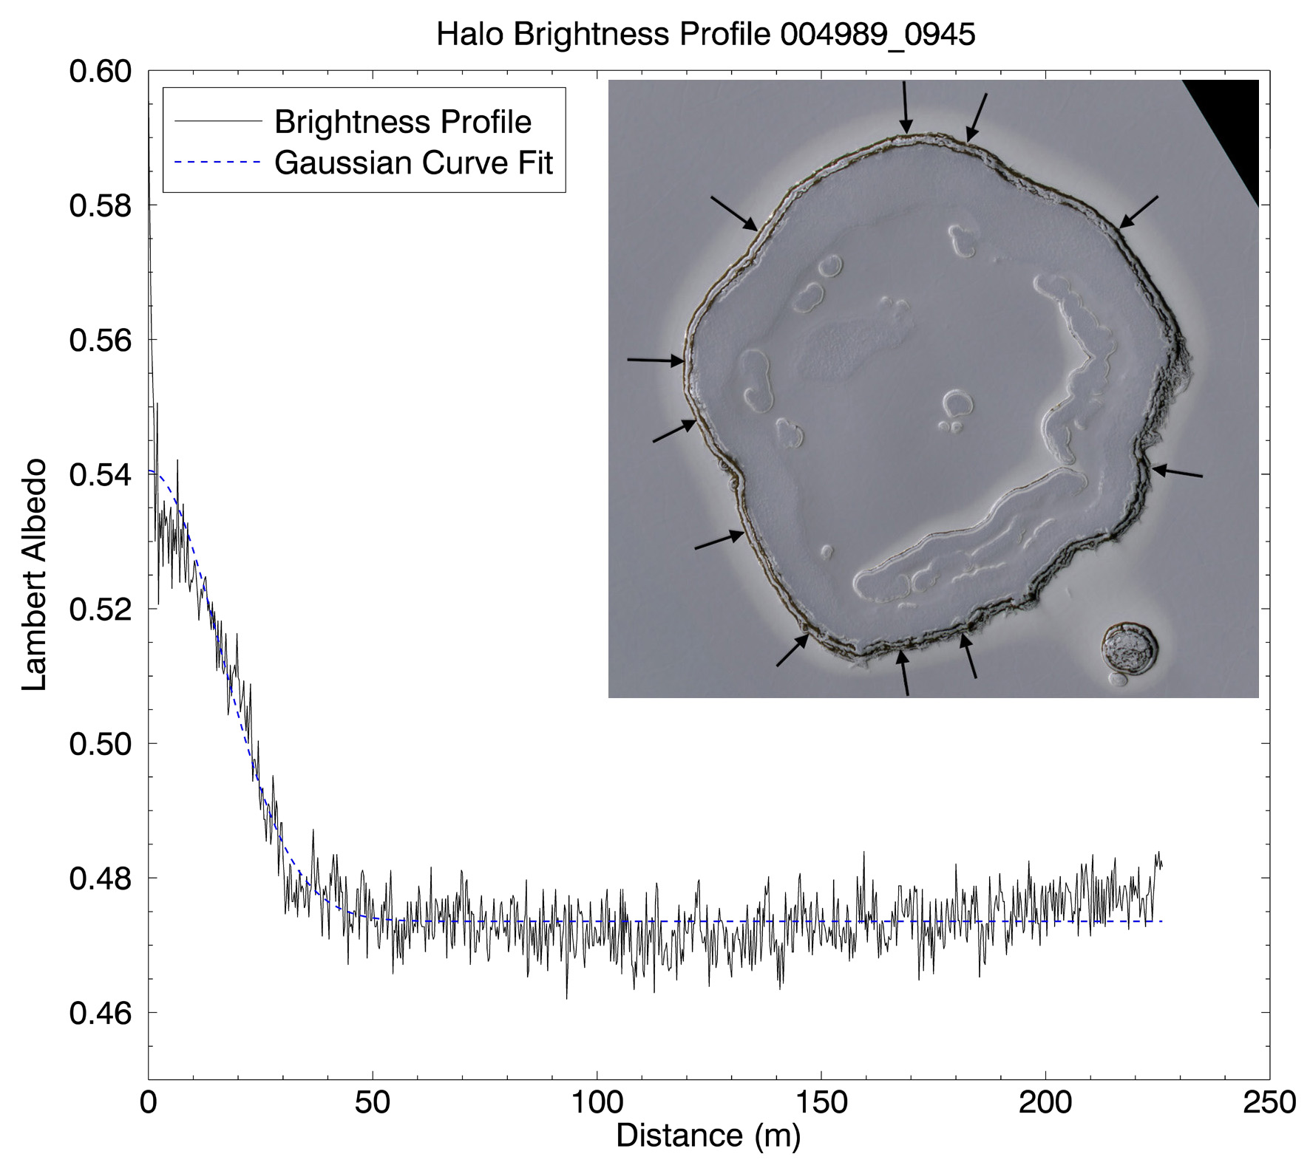
Figure 2.3. Example of a brightness profile taken from the “Happy Face” pit at the Fabi site (PSP_004989_0945). The circular shape of this pit allowed profiles to be taken at every possible orientation of the pit walls (top right corner – large pit diameter is ~500 m). The plot shows the Lambert albedo of a brightness profile in the HiRISE RED band vs. distance from the edge of the scarps. We fit a Gaussian curve and determined the maximum brightness and the width of the halo (FWHM) for each profile on every image analyzed.

2.2.3 CRISM spectral data analysis
In order to compare the composition of the ice in the halos with that of the surrounding SPRC surface, we examined data products acquired by MRO’s Compact Reconnaissance Imaging Spectrometer for Mars (CRISM) [Murchie et al., 2007]. In particular, we used spectra from the CRISM IR array, which samples a wavelength range from 1.0013 μm to 3.9368 μm in 438 channels (6 nm sampling). Our goal with the spectral analysis was twofold: 1. Test for the presence of contaminants such as water ice and/or dust within the CO₂ ice, which could be responsible for the albedo difference observed at the halos. 2. Examine the difference in band depth of characteristic CO₂ bands between the halos and the plains, and use this as a proxy for relative CO₂ ice grain size, to determine whether the albedo difference could be caused by a difference in ice grain size.
To explore compositional differences, we compared a spectrum taken from a pixel within a halo with one taken from the surrounding plains. We looked for two absorption bands in the spectra that are typically used as a diagnostic to determine the presence of CO₂ ice. These are centered at 1.435 μm (shoulder points at 1.38 and 1.47 μm), and at 2.28 μm (shoulder points at 2.2 and 2.4 μm). To determine whether or not water ice was present as a significant contaminant, we looked for two IR bands characteristic of water ice, centered around 1.5 μm and 3.0 μm.
We assumed dust to have the atmospherically derived spectrum from Wolff et al. [2009]; this dust has a strong effect on the visible albedo, but is spectrally neutral in the near IR. Therefore we based our estimates of dust presence on the measurements of HiRISE color ratios interpreted through our spectral model, which is presented in the following subsection.
Spectral band depths are a measure of absorption, and can be used to determine ice grain sizes. We measured the 1.43 μm band depth following the formula given in Clark and Lucey [1984], which normalizes the reflectance of the band (R_{b}) and the spectral continuum (R_{c}), to the spectral continuum: (R_{c} – R_{b}) / R_{c}. We utilized this quantity as a proxy for ice grain size, measuring it in areas adjacent to pit edges where halos were seen, and in areas distant from the pits. We calculated the band depth throughout CRISM IR images taken at the time of the halos, and constructed band depth maps that show the value of the specified band depth at each pixel. These maps were then used to compare these values at different parts of the CRISM image, in particular, comparing pit-adjacent band depths to surrounding band depths.

2.2.4 Hapke reflectance model
We constructed a surface reflectance model based on Hapke reflectance theory [Hapke, 2012] in order to find ice compositions and grain sizes that could self-consistently explain the albedos, colors, and spectral features of the halos. Our model primarily followed the examples of Roush [1994], and Warell and Davidsson [2010], and neglected atmospheric extinction and scattering. We used this model, along with the HiRISE [Delamere et al., 2010] and CRISM [Murchie et al., 2007] band-pass coefficients to simulate HiRISE brightness in each band and CRISM spectra. We attempted to reproduce the reflectance of a particulate mixture of CO₂ ice, water ice, and dust that would match the HiRISE RED channel Lambert Albedo, HiRISE BG/RED color ratio, and CRISM 1.43 μm band depths observed at the halos and in the surrounding SPRC ice. The principal equations and assumptions needed for the implementation of our model are discussed in more detail in Appendix 1. An in-depth description of Hapke theory can be found in Hapke [2012].
We used as few free parameters as possible to simulate the spectrum, so our model consists of a combination of only carbon dioxide ice, water ice, and dust (and their independent grain sizes) in an intimate mixture. The real and imaginary indices of refraction of H₂O ice were taken from Warren [1984], CO₂ ice indices were obtained from Hansen [2005], and dust indices from Wolff et al. [2009].
The model outputs I/F between 0.35 μm and 4 μm, at a resolution of 1 nm. After convolution with the instrument response curves, we obtain simulated I/F values for all three HiRISE bands and for all CRISM wavelengths in both the CRISM S (shortwave 0.3 – 1 μm), and L (1 – 4 μm) channels (see Appendix 1). Finally, we use these I/F values to calculate HiRISE RED A_{L} (dividing by the cosine of the incidence angle), HiRISE BG/RED ratio, and CRISM 1.43 μm band depths. We ran the model for incidence angles of 65º, 70º, 72º, and 75º, which are representative of the incidence angles of the images we selected for analysis (varying the incidence angle within this range had negligible effects on the results).

2.3 Observations and results
2.3.1 Timing and location
Our initial survey of images of our selected sites taken over 8 Mars Years, described in Sections 2.1 and 2.2, showed that halos were only present on the SPRC during a small portion of southern summer in MY 28 (Figures 2.4, 2.5). Although several images on MY 30 and 31 displayed an increase in brightness on flat areas adjacent to sun-facing pit walls compared to the surrounding plains (Figure 2.4 shows two examples of this on MY 30, L_{s} 300º, and on MY 31, L_{s} 288º), these albedo rises did not fit the halo criterion explained in Section 2.2 and can instead be attributed to inward dipping terrain near the pit wall. These examples were therefore not counted as halos.

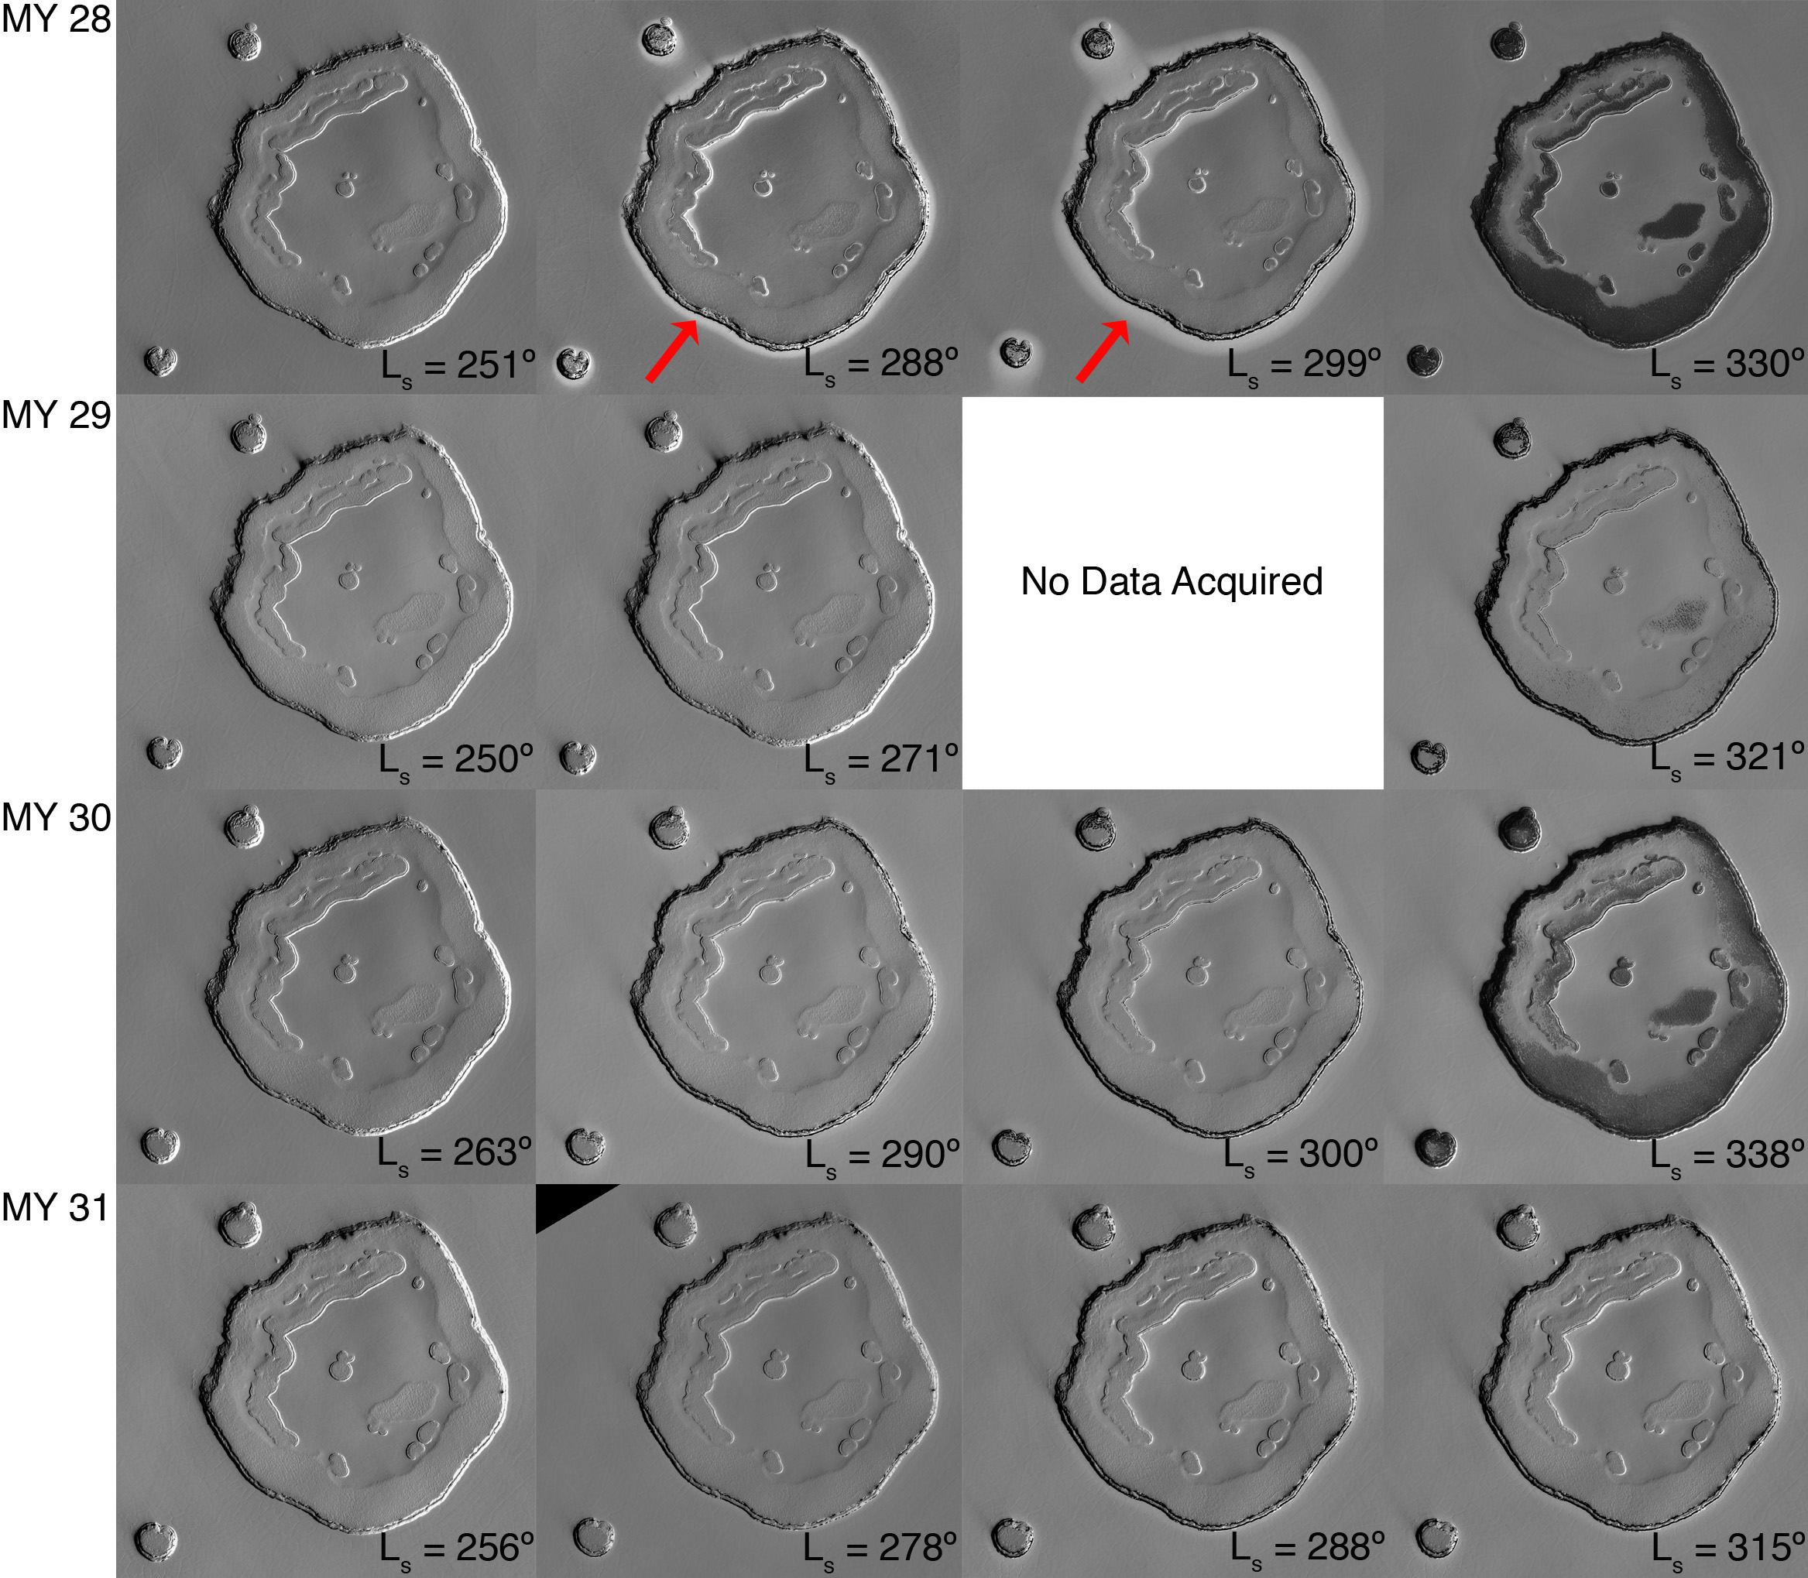
Figure 2.4. “Happy Face” Pit at the Fabi site imaged by HiRISE at four different times of year during MY 28 (PSP_004000_0945, PSP_004778_0945, PSP_004989_0945, PSP_005701_0945), MY 29 (ESP_012808_0945, ESP_013243_0945, ESP_014311_0945), MY 30 (ESP_021880_0945, ESP_022447_0945, ESP_022658_0945, ESP_023515_0945), and MY 31 (ESP_030570_0945, ESP_031005_0945, ESP_031216_0945, ESP_031796_0945). Red arrows in the top two center panels denote the halos around this pit. On MY 28, the halo is first observed on L_{s} 288º, which appears to be the time the pit walls begin to defrost. It is visible on L_{s} 299º, and is no longer visible at L_{s} 330º. We did not observe halos on the SPRC in images from any other MY.

The earliest that halos appeared in MY 28 was Ls 279º, which seems to coincide with the time that the pit walls begin to defrost, exposing older, darker ice layers (Figure 2.4). With increasing L_{s}, the halos grew in width and relative brightness difference to their surroundings. By L_{s} 290º, most large mesas on the cap displayed prominent halos around the edges of the erosional depressions. Although the overall albedo of the entire SPRC, including the halos, darkened with time, the relative difference between the albedo of the halos and that of the surrounding ice increased (Figure 2.5).

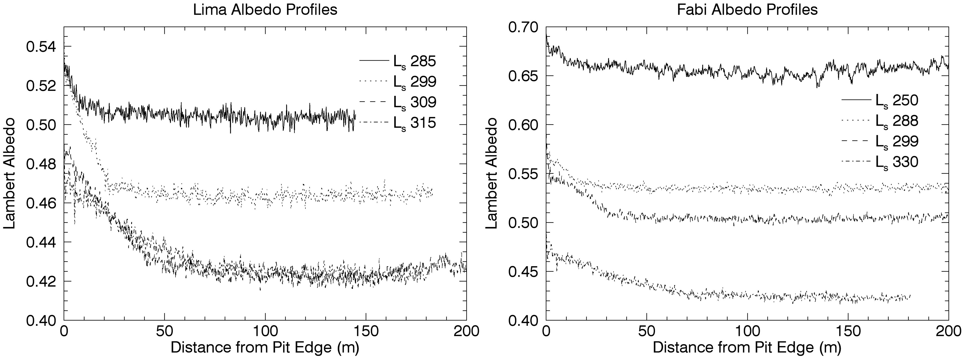
Figure 2.5. Temporal changes in the MY 28 albedo profiles taken from two of our selected sites. The profiles shown here for each of the two sites were measured from the same orientation of the scarp wall, during different times of the year. The Lima site (left) had more frequent HiRISE coverage during the time of the halos, so the growth in width and relative brightness difference is more easily visible. The Fabi site (right) displays the large drop in the albedo of SPRC from before the dust storm (L_{s} 250º) to after the dust storm when halos were already present (L_{s} 288º). These profiles were taken from a sun-facing wall, so a slight increase in albedo close to the walls is visible even when the halos were not present (L_{s} 250º, 330º).

The timing of disappearance of the halos was between L_{s} 325º and 331º (Figures 2.4 and 2.6). The earliest MY 28 images that did not show any halos in locations where they had been observed previously were taken in L_{s} 325º; and the longest-lived halos were observed in an image taken on L_{s} 331º. Figure 2.6 is a plot of the temporal distribution of all HiRISE and MOC images that we examined, and it clearly shows that the “halo season” of MY 28, between L_{s} 279º and 331º, is the only time when we observed halos in the data. This observation of a restricted timing for the existence of these features reduced our dataset in the 9 selected sites to 22 HiRISE images taken during this season, on which we performed the detailed analysis described in Section 2.2. The corresponding site name and solar longitude of acquisition of these images is shown in the two rightmost columns of Table 2.1.

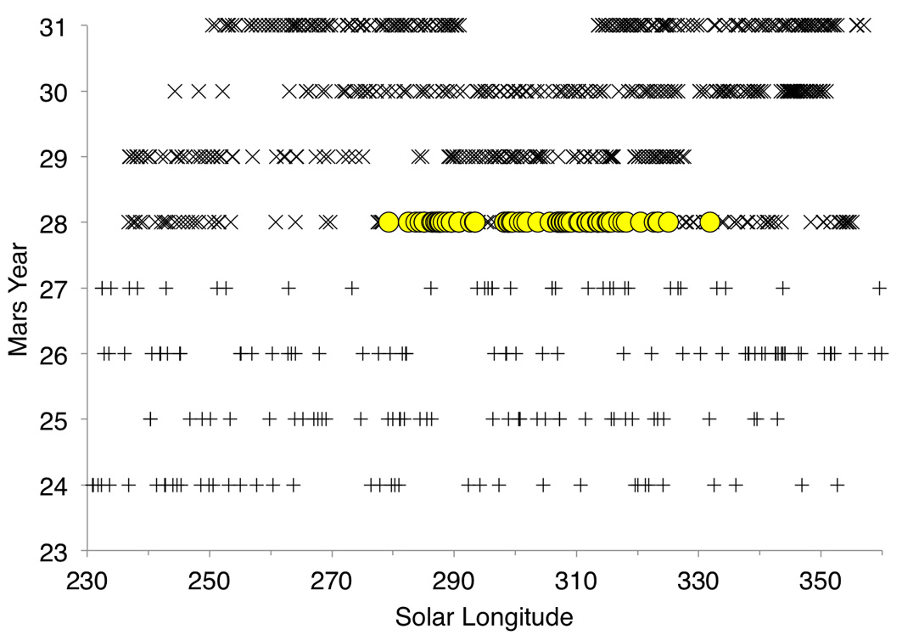
Figure 2.6. Temporal distribution over MY and L_{s} of all HiRISE (X) and MOC (+) images examined. The yellow dots represent those images in which halos were seen. The gap in observations at L_{s} 330º - 360º in MY 29 was due to MRO going into safe mode, and the gap at L_{s} 290º-315º of MY31 was due to solar conjunction.

2.3.2 Width and brightness
Halos in all images of our selected sites were examined using the method described in Section 2.2. All analyzed sites displayed similar behavior, and selected results of our observations are shown in Figures 2.7 and 2.8. These figures show the variation of halo width and maximum brightness with orientation of the scarp wall.
The average width of the halos (±2σ) is 12.14 ± 1.44 m during L_{s} 280º – 295º, 32.96 ± 4.02 m at L_{s} 295º – 305º, and 55.48 ± 6.98 m at L_{s} 305º – 340º. In 16 of the 22 images, the widest halos were observed adjacent to the edges of equator-facing (north-facing) scarps (Figure 2.7), while four cases showed the widest sections adjacent to sun-facing walls, and two cases adjacent to other wall orientations.

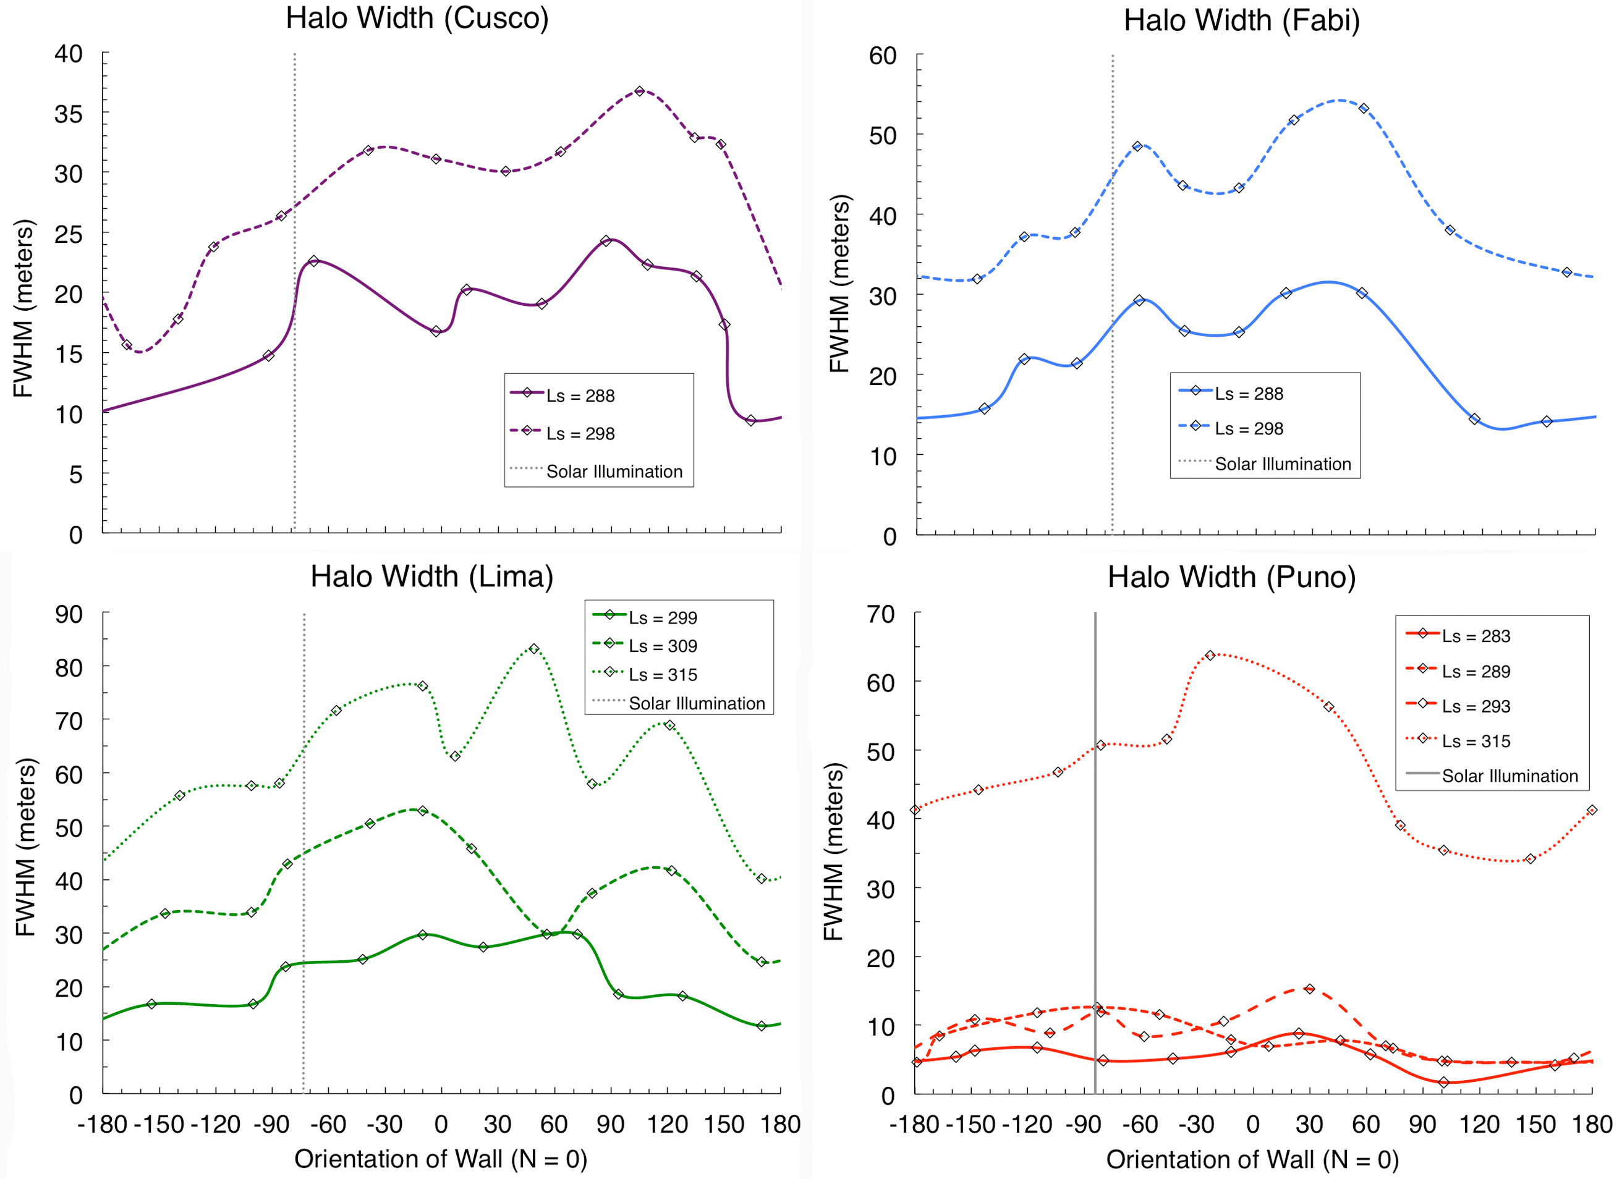
Figure 2.7. Variation of the width of halos with orientation of the pit walls (north-facing wall = 0º) for pits on four selected sites on the SPRC. The halos appear wider on the edges of equator-facing walls.

Figure 2.8 shows the dependence of maximum brightness with orientation. In general (±2σ) the halos were 4 ± 0.3 % brighter than the surroundings during L_{s} 285º – 295º, 7 ± 0.7 % brighter between L_{s} 295º – 305º, and 8 ± 0.6 % brighter at L_{s} 305º – 330º. In all images, the brightest portions of the halos were observed adjacent to sun-facing walls. However, images of these sites before and after the halos in MY 28, and in later years when the halos were not present, show a similar relationship between terrain brightness and solar azimuth, indicating that this trend could be due to the inward sloping of the surface close to the edges of the pits, and not a property of the halos themselves.

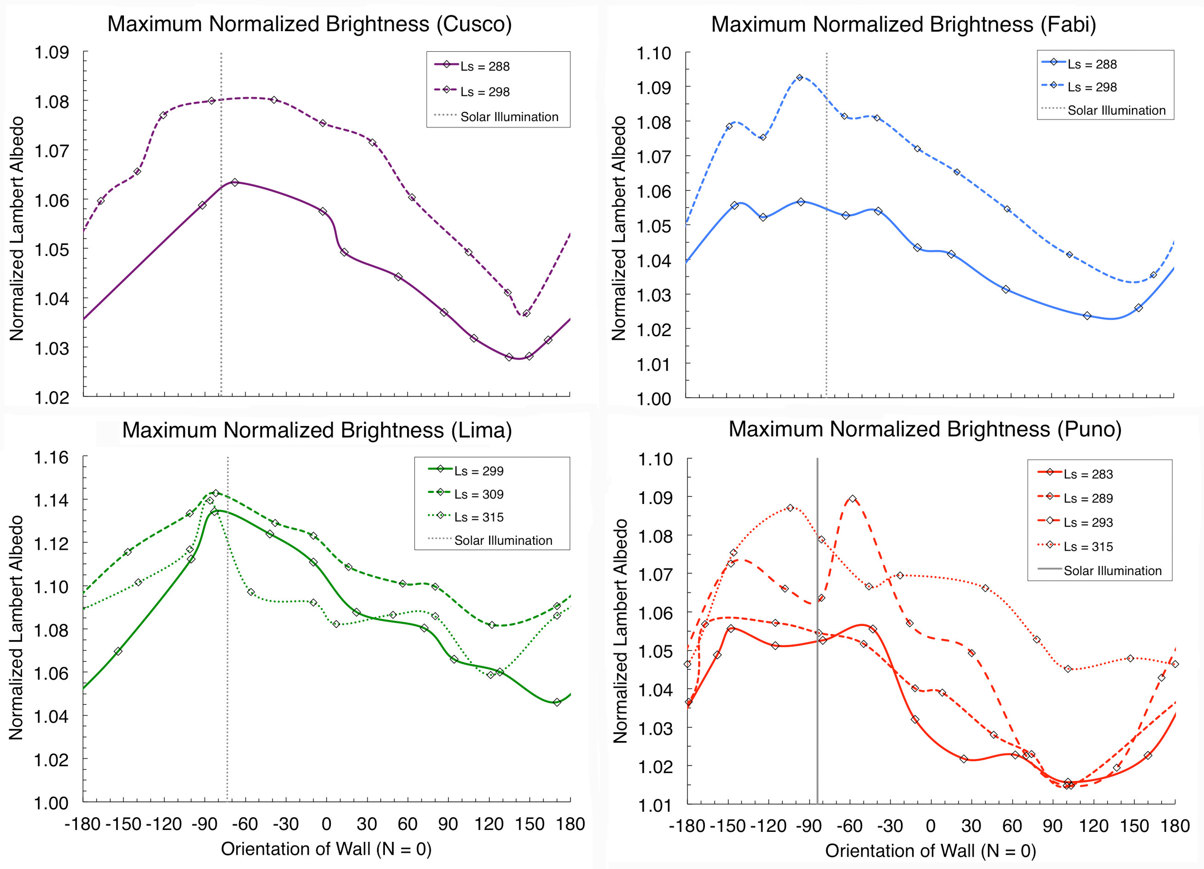
Figure 2.8. Variation of the maximum brightness of the halos with orientation of the pit walls (north-facing wall = 0º) for pits on four selected sites on the SPRC. The albedo has been normalized to the average brightness of the flat terrain distant from the pit walls. The brightest sections of the halos appear to be on the edges of sun-facing walls.

2.3.3 Composition and grain size
The albedo differences observed between the halos and the surrounding SPRC terrain may be caused by differences in the amount of impurities within the CO₂ ice, by differences in the ice grain size, or by other effects upon the surface photometric function, such as sub-pixel, supra-grain-size textures. Therefore, the composition of the halos constrains the processes that could have led to their appearance. If the halos and the surrounding SPRC plains are composed of essentially pure CO₂, then a difference in the grain sizes of the ice must be responsible for their brighter appearance. However, if water-ice impurities and/or a higher degree of dust contamination are present in the surroundings, then these impurities are more probable explanations for the observed albedo contrast.
Figure 2.9a shows two CRISM spectra from Fabi at L_{s} 299º, when the halos were observed in the HiRISE data. Spectra taken from areas near scarp walls (0-40 m) were compared to those taken from regions relatively far from the walls (100 – 500 m) in the surrounding plateaus (Figure 2.9b). The spectra from both areas show the same general shape and display the characteristic absorption bands of CO₂ ice at 1.435 μm and 2.28 μm. In addition, the complete absence of the broad water ice absorption bands at 1.5 μm and 3.0 μm, rule out any contamination by H₂O larger than 1% by volume [Brown et al., 2010, Brown, et al., 2012].

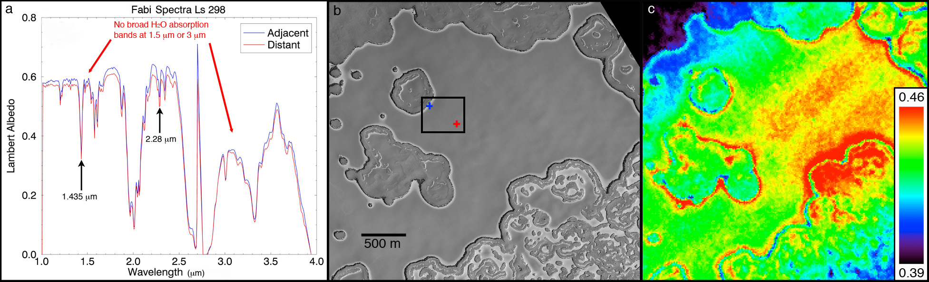
Figure 2.9. (a) CRISM IR spectra of halos (adjacent, blue), and surrounding plains (distant, red) on the Fabi site at L_{s} 299º. Spectra were taken from individual pixels of CRISM image (FRT00007353). The 1.435 μm and 2.28 μm absorption bands characteristic of CO₂ ice are indicated. No evidence of water ice is observed, as evidenced by the lack of broad 1.5 μm and 3.0 μm absorption bands [Brown et al., 2010]. (b) HiRISE image of the Fabi sit at L_{s} 299º (PSP_004989_0945). The blue and red crosses within the box indicate the specific locations from which the spectra in (a) were taken. (c) 1.43 μm band depth map of the same CRISM image from (a). Higher (redder) values correspond to deeper bands, which imply larger CO₂ ice grains. In general, the locations of the halos seen in (b) have deeper band depths than their surroundings.

Could this albedo difference be a product of grain size differences in the CO₂ ice? Smaller ice grains absorb less light and therefore appear brighter than larger ice grains. The band depths of the CO₂ ice absorption features for the ice within the halos were measured to be around 0.4 (1.435 μm) and 0.12 (2.28 μm). According to Figures 2a and 2b from Brown et al. [2010], this corresponds to 3-5 mm spectroscopic grain sizes for CO₂ ice. Figure 2.9c shows a band depth map of the portion of the Fabi site displayed in 2.9b. Similar maps were made for all selected sites at all available observation times. The maps display a range of band depths, corresponding to a range of grain sizes. In general, our band depth maps display deeper bands wherever halos are observed in the corresponding HiRISE image. This means that the halos are not systematically smaller grained than their surroundings, which is what we would expect if the mechanism that caused them were simply a grain size difference in the ice. We cannot say that the halos are systematically larger-grained, since the maps displayed deep bands in other areas of the image, and showed complicated band depth patterns. The map in Figure 2.9 in particular has an overall tendency for high band depths in a diagonal band across the image (bottom left to top right). However, this is an artificial effect caused by the presence of a dark band in the center of CRISM images that is a result of gimbal rotation, and should be ignored. Based on our observations of higher band depths corresponding to halo locations across all sites, we can confidently conclude that the albedo difference observed as halos was not caused by the presence finer grained frost.
To test for a dust-driven albedo difference we looked at color differences in the HiRISE data. Color ratio profiles for sites Fabi and Lima are shown in Figure 2.10. We found that 8 out of our 9 study sites (especially those with well-developed halos later in the season) had a 0.5 to up to 4% increase in the BG/RED ratio close to the walls. This rise in “blueness” approximately coincided with the width of the observed halos, which makes the halos consistent with dust deficits.

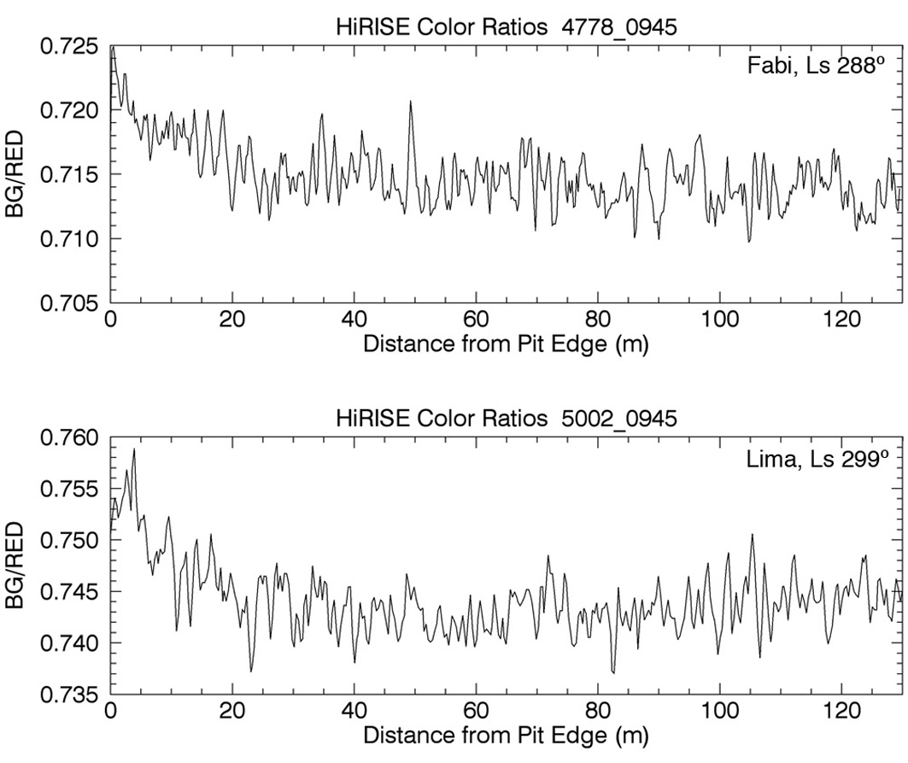
Figure 2.10. HiRISE BG/RED profiles for sites Fabi and Lima. Most sites showed at least a 1% increase in this color ratio at the halo locations with respect to the surrounding terrain.

2.3.4 Reflectance model results
The principal objective of our Hapke model was to explore the possibility that small differences in dust content between two areas of the cap could give rise to comparatively large differences in albedo, such as those manifested in the halos.
As water ice in the SPRC was ruled out by the CRISM observations, this component, although built into our model, was not included in the surface reflectance simulations. Thus, the free parameters in the model are: 1. Grain size of CO₂ ice particles. 2. Grain size of dust particles. 3. Volumetric dust content. We ran the model for the following parameter space: CO₂ grain sizes ranging from 0.5 mm to 50 mm, dust volumetric content ranging from 0% dust (i.e. pure CO₂ ice), to 1% dust, and dust grain sizes ranging from 1 to 20 μm. We assumed isotropic scattering from the surface (see Appendix 1), and neglected all atmospheric contributions on the scattering of sunlight. Atmospheric scattering can change the albedo and color of the terrain observed, but its effect is not expected to differ over short length scales. This modeling effort is restricted to comparing halos to adjacent terrain, and assumes the atmosphere has affected both terrains equally. The absolute values reported in Table 2.2 should therefore be interpreted with caution; however, the relative differences between halo areas and their surrounding terrain (i.e. the fact that halos are areas with less dust) are robust.
To compare the measured values from spacecraft observations with the model output, we plotted all modeled RED AL, BG/RED, and CRISM 1.43 band depths as a function of dust volume content and CO₂ ice grain size as a contour map for a particular dust grain size, and then shaded the region between those contours that matched the observed values for each site at the halo and at the surrounding ice (Figure 2.11). The shaded areas were changed to match the observed values at each time of year for each site. In many cases there was no self-consistent solution that could simultaneously explain the albedos, colors and band depths of the halos for a particular dust grain size. We therefore varied the dust grain size between 1 – 20 μm and found that solutions were only possible for dust grain sizes between 10 and 20 μm depending on the time of year. Figure 2.11 illustrates the range of dust contents and CO₂ grain sizes that, with a grain size of 15 μm, simultaneously explain the albedo, color, and band depths observed at site Lima at L_{s} 299º. Our results for sites Cusco, Fabi, and Lima are shown in Table 2.2. We will use Lima as the prototype site to explain these results, as it has the most temporally dense HiRISE and CRISM coverage over the halo season.

Table 2.2. Hapke model results of the free parameter combinations that matched the observed values of albedo (HiRISE RED), color (HiRISE BG/RED), and 1.43 band depth (CRISM) for sites Cusco, Fabi, and Lima.

Site Name | L_{s} | CO₂ grain size (mm) | Dust content: Halo (%) | Dust content: Surroundings (%) | Dust size (um)
Cusco | 288 | 8 - 8.5 | 0.025 ± 0.001 | 0.026 ± 0.001 | 10
Fabi | 288 | 8.5 - 9.5 | 0.02 ± 0.001 | 0.028 ± 0.001 | 9.0 - 10.0
Fabi | 298 | 9.0 - 10.0 | 0.03 ± 0.005 | 0.03 ± 0.005 | 14.0 - 16.0
Lima | 285 | 8.0 - 9.0 | 0.03 ± 0.005 | 0.03 ± 0.005 | 8.0 - 9.0
Lima | 299 | 8.0 - 10.0 | 0.03 ± 0.005 | 0.05 ± 0.001 | 14.0 - 17.0
Lima | 309 | 5.5 - 8.0 | 0.06 ± 0.005 | 0.08 ± 0.001 | 16.0 - 20.0
Lima | 315 | 6.5 - 8.0 | 0.065 ± 0.005 | 0.085 ± 0.005 | 19.0 - 22.0

The model shows a decrease in albedo as higher dust contents are added, and is able to identify a self-consistent set of parameters that together define the composition of the SPRC surface at the time of the halos. The model values that match the observations indicate that a dust difference of just a few hundredths of a percent by volume can give rise to the higher albedos seen at the halos. For instance, at L_{s} 300º (Figure 2.11) the parameters found to replicate the observations at Lima are CO₂ grain sizes of 8-10 mm, dust grain sizes of 14-17 μm, and a difference in dust content of 0.02% between halos and surroundings. At L_{s} 310º, when the halos are most prominent in the Lima site, the dust content is 0.05% at the halos, and 0.08% at the surrounding areas. The dust content seems to increase with L_{s}, indicating that more dust is being deposited as time passes. This is true both within the halos themselves and over the rest of the SPRC, but the halos are always found to have smaller dust contents than their surroundings. This agrees with observations that show all SPRC surfaces getting darker with time, but the halos darkening more slowly (Figure 2.5).

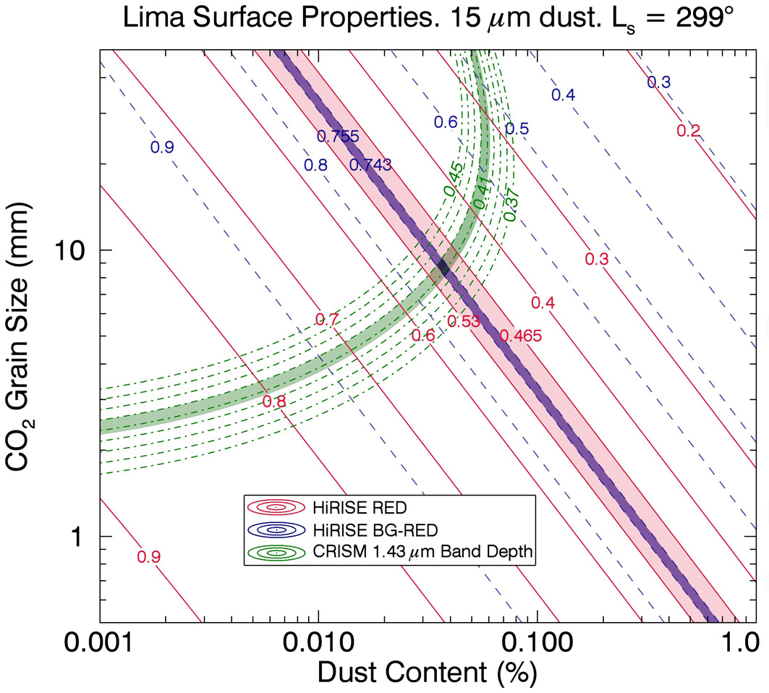
Figure 2.11. Example of a contour map of surface photometric properties for the Lima site from our Hapke reflectance model. The shaded regions indicate the observed values of each of the three parameters (RED, BG/RED, 1.43 m band depth) for this particular time of year (L_{s} 299º). The intersection of the shaded regions limits the composition of the surface to a particular combination of CO₂ grain size, dust content, and dust grain size. This particular map corresponds to 15 μm dust grains, which in this case produced the best fit to the observations.

2.4. Discussion
2.4.1 Implications for the formation mechanism of halos
Analysis of the HiRISE profiles allowed us to obtain important measurements that characterize the SPRC halos. We observed that the halos have widths of decameters and are widest when adjacent to equator-facing (north-facing) walls. At areas close to the South Pole (~87ºS), north-facing slopes spend more time in the sunlight than equivalent south-facing slopes, so that cumulative insolation is greater for the former. The fact that in most cases the widest sections of halos are adjacent to north-facing walls, points to a connection between halo formation and insolation. The time of appearance of the halos also supports this argument, as it was observed to coincide with the defrosting of the pit walls (Figure 2.2), which leads to a jump in sublimation rates because of the sudden decrease in albedo of the walls. In addition, the time at which the halos disappeared in MY 28 (~L_{s} 325º - 331º) seems to indicate that they are being covered by new CO₂ frost condensing as the fall approaches.
The observation that the brightest sections of the halos were seen adjacent to sun-facing walls could imply that the maximum brightness changes position during a single Martian day, as the sun changes azimuth. However, the presence of the same albedo trend in images with no halos suggests that this is an ever-present characteristic of the terrain surrounding the pits, and not of the ephemeral halos.
We initially considered three possible scenarios to explain the appearance of halos: 1. They are a product of contamination by small impurities of water ice either within the halos themselves or in the surroundings. 2. The halos are a result of finer-grained CO₂ frost that is either being freshly deposited onto areas of the surface adjacent to scarps, or left exposed by lower sublimation rates at areas a few tens of meters from the scarp, compared to those farther away. 3. Halos appear because of a difference in dust content between pit-adjacent surfaces and the rest of the SPRC.
Analysis of CRISM spectra and band depth measurements ruled out the first two theories. As seen in Figure 2.9a, the spectrum taken from a halo pixel is almost identical to that taken from a surrounding pixel. Both spectra show characteristic CO₂ ice absorption bands, and a lack of water ice bands, ruling out water ice contaminants. Figure 2.9c shows that the band depths actually increase in areas adjacent to pit walls. In a pure CO₂ ice surface, this would mean that the halo areas are darker than their surroundings rather than brighter, and thus these data seem to rule out an explanation based on ice grain size.
We are thus left with the third possible scenario, which has dust as the central driver for the appearance of halos. The HiRISE color data support the theory that the halos are formed due to a dust-content difference between the ice on the halos and the ice elsewhere in the SPRC, indicated by bluer ice close to the pits. In addition, our Hapke model seems to indicate that a small difference in dust content would result in the observed albedo difference. A difference in dust content as small as two to three hundredths of a percent volume is capable of producing the albedo, color, and band depth differences observed between the halos and their surroundings. Therefore, from our spectral analysis and modeling we infer that the halos are a result of a widespread darkening of the SPRC, rather than local brightening. This darkening was somehow prevented from being as pronounced in areas close to scarp walls as everywhere else on the cap.

2.4.2 Conceptual model
The effect of general SPRC darkening with certain areas kept brighter has not been observed before or since MY 28, indicating that some unique event occurred during the summer of MY 28 that prompted the SPRC darkening and the appearance of halos around erosional scarps. The one major difference between the southern summer of MY 28 and other years is the presence of a near-perihelion (~L_{s} 252º) planet-encircling dust storm. Bonev et al. [2008] have shown that sublimation rates in the SPRC increased immediately after the dust storm occurred. In addition to this unusually vigorous sublimation, there is a higher amount of dust expected to be present in the near-surface atmosphere. With this in mind, we propose a formation model for the halos, which explains their unique appearance in MY 28, and is shown schematically in Figure 2.12.

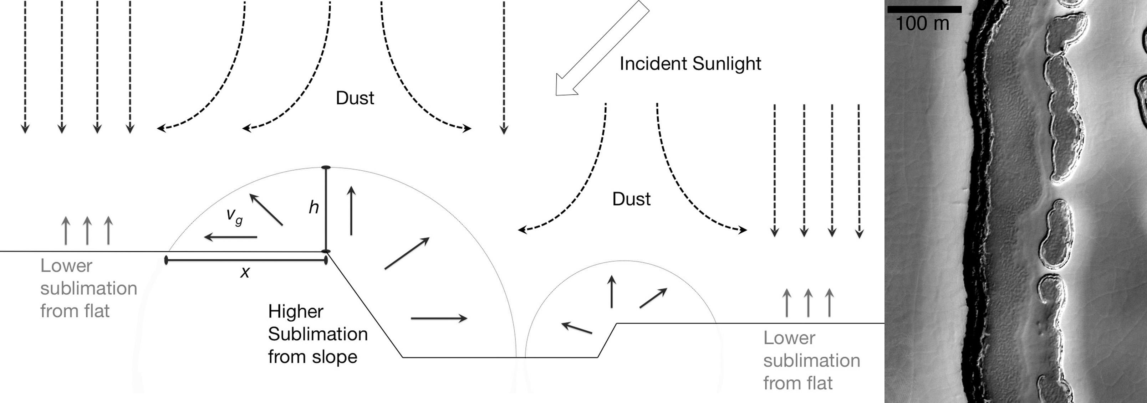
Figure 2.12. Schematic of our conceptual model for the formation of SPRC halos (left). The higher sublimation rate on a slope due to lower solar incidence angles raises the partial pressure of CO₂ in the local near-surface atmospheric layer. This pressure difference creates a sublimation-driven outflow of gas that blows settling dust grains away from the slope and keeps areas near the edges of pits relatively dust-free with respect to the surroundings. Wherever steep opposing walls were observed, halos were seen atop both mesas (right: slice of PSP_004989_0945).

Solar incidence angles tend to be lower for slopes than for flat surfaces near the polar regions. Therefore, the sunlit walls of erosional pits and scarps have a higher peak CO₂ ice sublimation rate than the flat surrounding plains, which results in a sublimation-driven outflow of gas from the walls of the scarps. The peak daily sublimation rates happen at sun-opposing walls. During the time of year when halos were seen, these peak sublimation rates are about 4 to 5 times greater than the flat surface values. Because of the Sun’s azimuthal motion however, all wall orientations have higher sublimation rates than flat surfaces at some point during the Martian day. If at the time of year of the most vigorous sublimation (which would happen immediately after the walls defrost in the middle of southern summer, ~ L_{s} 270º) there was also an unusual amount of dust being deposited onto the surface (as would be the case after a global dust storm) this “sublimation wind” would have prevented some of the atmospheric dust from depositing in areas near pit walls, leaving these sections “cleaner” relative to the surrounding SPRC ice. In MY 28, as dust continued to settle everywhere on the SPRC with increasing L_{s}, this process continued in areas close to the scarp. The result was that the entire cap, including the halo areas, was darker later in the year, but more dust was being prevented from settling in areas close to pit walls, so that the brightness difference between halos and their surroundings was enhanced (Figure 2.5). In addition, it is likely that as time passed, early-deposited dust was removed from the surface immediately adjacent to the outer halo edges, resulting in an expanding halo area and wider observed halos (Figure 2.5). Although this sublimation-driven effect occurs every year, MY 28 is the only year in the recent past in which a significant amount of dust was deposited during this season.
The distance a settling dust particle can be pushed away from a scarp wall should be proportional to the CO₂ sublimation rates calculated from a thermal model of the surface based on simple energy balance. Therefore, we can get an idea of the plausibility of the process described above by using modeled sublimation rates as a proxy for wind speed to deduce what size dust particles are required to form halos of about 33 m in width (average width of a halo in the middle of the halo season).
The settling of particles through a medium can be governed by turbulent flow, in which drag forces are caused by the deflection of the air stream around the particle, or by low-velocity laminar flow, in which viscous forces dominate and determine the drag [Melosh, 2011]. The transition from one regime to another is defined by a dimensionless quantity known as the Reynolds number. In the case of a Martian dust particle settling through a boundary layer of the atmosphere, we determined that laminar flow dominates (see Appendix 2). Therefore, we use the Stokes’ flow velocity [Melosh, 2011] for the laminar regime to estimate the settling velocity (v_{s}) of dust particles:
$v_{s}=\frac{1}{18}\frac{\left(σ-ρ\right)d^{2}g}{η}$ (2.1)
Here, ρ is the atmospheric density (~0.02 kg/m3), d is the dust grain size, η is the viscosity of the atmosphere (~1.3×10⁻⁵ Pa.s), σ is the density of the dust particle (~2700 kg/m³), and g is the acceleration due to gravity on Mars (3.7 m/s²). Typical Stokes’ velocities for micron-sized particles are on the order of 4×10⁻⁵ m/s.
We assume that the particle is horizontally coupled to the gas and that it begins to be affected by the sublimation wind at a certain height (h) from the ground (Figure 2.12). The time it takes the particle to fall to the ground by Stokes’ flow (h/v_{s}), multiplied by the velocity of the sublimating gas (v_{g}) pushing the particle, should equal the distance traveled by the particle before it settles on the ice (x):
$\frac{h}{v_{s}}v_{g}=x$ (2.2)
This distance should therefore be comparable to the width of the halos, and increases as grain size decreases.
If we consider a surface area of 1 m² on the wall of a pit, and assume that half of the sublimated gas flows outward from the pit in every direction through a layer of thickness h (Figure 2.12), then the velocity of the sublimating gas depends on the rate of sublimation of CO₂ from the wall (dm/dt):
$v_{g}=\frac{1}{2}\left[\frac{(\frac{dm}{dt})}{ρ}{\left(h\right)}^{-1}\right]$ (2.3)
Combining equations (4.1) – (4.3) and rearranging terms gives an expression for the particle size (d) required to form a halo of width x by this mechanism:
$d=\sqrt{\frac{9η(\frac{dm}{dt})}{ρxg(σ-ρ)} }$ (2.4)
Using a simple energy balance model, we calculated the CO₂ ice peak sublimation rates (dm/dt) for north and south-facing walls of various slope angles. Figure 2.13 shows the changes in sublimation rate for a 50º slope. For the time the halos were observed, the modeled sublimation rate is ~0.0005 kg s⁻¹m⁻².

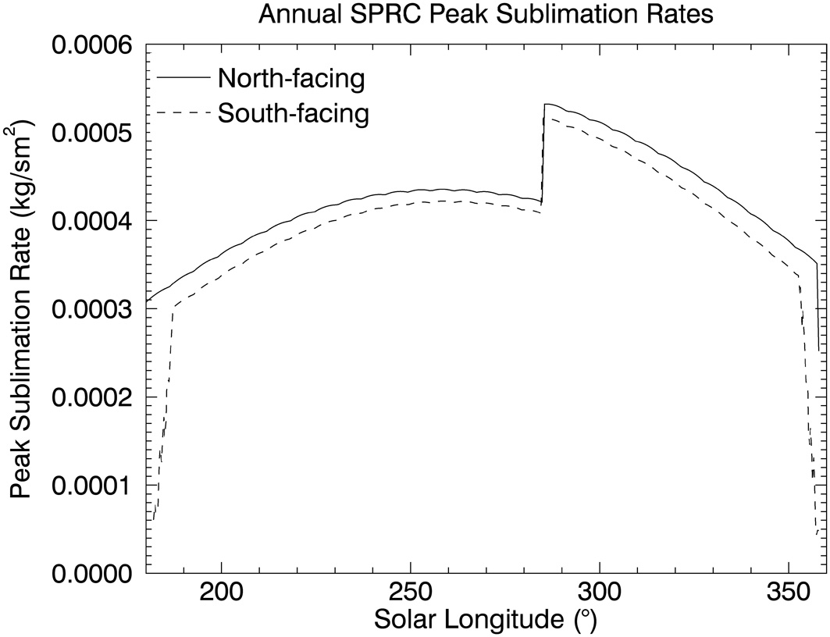
Figure 2.13. Modeled sublimation rates for north (solid line) and south-facing (dashed line) slopes on the SPRC. The abrupt jump in sublimation rate at L_{s} 285º corresponds to the change in albedo due to the defrosting of the pit walls, which exposes older, darker ice.

This sublimation rate is for a one square meter patch of ice from a wall. The walls on the SPRC pits are at least a few meters tall in most cases, so the sublimation rate can be ~5 times higher than the quoted value, which would make d about 2-3 times larger. However, it is likely that the real sublimation values are not exactly the daily peak rates that we use here. We use this value for the sublimation rate in equation (4.4), and find that the dust grain size necessary to produce 33-meter halos at the current modeled sublimation rates is ~3 μm. This value is quite reasonable for Martian atmospheric dust [Wolff and Clancy, 2003], but smaller than the grain sizes we found to be present on the surface from our reflectance model. The Hapke model is well suited to explore relative grain size differences and dust contents, but is less reliable for calculations of absolute grain sizes [Souchon, et al., 2011, Zhang and Voss, 2011, Helfenstein and Shepard, 2011]. In addition, spectroscopic grain sizes do not necessarily match physical grain sizes. We can therefore infer that the higher sublimation rates during the summer of MY 28 coupled with the dust settling from the atmosphere due to the midsummer global dust storm would be adequate conditions for halos to form.
Although this calculation has simplified reality in many respects, the broad agreement between the particle sizes, sublimation mass fluxes and halo widths shows this theory of halo formation to be reasonable.

2.4.3 Possibility of halos on other mars years
Our work on the halos has shown that the residual cap darkened by up to 8% due to the dust storm, i.e. the halos were not due to local brightening. An 8% reduction in albedo is significant and may make the difference between net accumulation and net ablation for that year. HiRISE observations confirm that after the halo occurrence at the end of summer in MY 28, the residual cap defrosted more extensively than usual (Figure 2.14). We suggest that the halos disappeared because they were covered by condensing seasonal CO₂ frost at the onset of fall. Figure 25.4 in Titus et al. [2008] shows CO₂ ice accumulation beginning around L_{s} 330º, which is the time the halos begin to disappear, and they are completely gone by ~ L_{s} 335º.

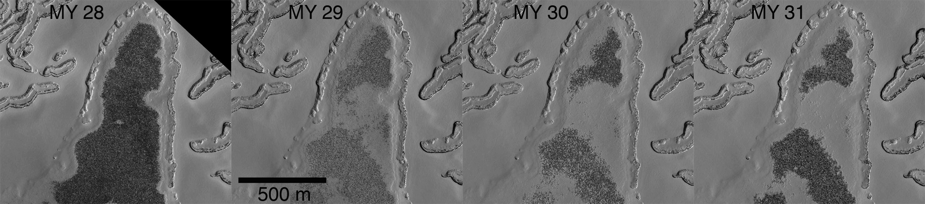
Figure 2.14. Section of the SPRC at the Trujillo site during four different Mars years. Defrosting after the MY 28 dust storm and halos was more pronounced than in later years, meaning that the cap recovered from a year with stronger than usual sublimation rates.

As explained in the above sections, halos require settling dust to form and so are not expected in non-dust-storm years. Two other Mars years with global dust storms deserve special mention here. MY 9 had a late-southern-summer dust storm similar in timing to that of MY 28 and the Mariner 9 spacecraft observed the SPRC immediately afterward. The images show a variegated cap (Figure 3 in Thomas et al. [2013]), with areas that are currently covered in frost all year appearing dark (Mariner 9 image resolution is too coarse to see decameter-size halos, but we expect them to have been present). The MY 9 appearance suggests that, like MY28, there was also widespread defrosting in response to the dust storm. In MY 12 the Viking orbiters showed the cap had fully recovered, was again completely frosted (Figure 3 in Thomas et al. [2013]) and appeared similar to generic non-storm years. HiRISE imagery shows a similar (but less severe) sequence of events on the residual cap after the MY 28 dust storm (Figure 2.14): widespread thinning of frost was observed, was largely reversed one Martian year later, and ice continued to accumulate over subsequent years.
The other special year is MY 25, which had a global dust storm during southern spring rather than southern summer. MOC was observing the residual cap at the time and no halos were observed that year. These observations may suggest that spring sublimation is too weak to create an outward flow of gas from the pit walls sufficiently strong to deflect falling dust grains i.e. halos did not appear because the cap was coated evenly with dust. This is consistent with thermal modeling, which shows slower sublimation rates from pit walls during the spring when they are covered with bright seasonal frost (Figure 2.12).

2.4.4 Implications for mass-balance and history of the SPRC
What do the halos tell us about the mass-balance of the SPRC? The timing of their disappearance indicates that they most likely were buried by seasonal frost by the end of MY 28. There are other processes that could affect the albedo of the surface and manifest as the halos disappearing, but we consider these to be unlikely. Dust sinking into the ice could raise the albedo of the surface, thereby changing the albedo of the surroundings to that of the halos, and erasing the brightness difference. Although this process could be effective near solstice when insolation is high, the halos disappear in late summer, when incidence angle and insolation is low, and when new deposition is expected [Titus et al., 2008]. Thermal metamorphism and ice pore infilling [Eluszkiewicz et al., 1993, 2005] could also have an effect on the surface albedo. However, there is no reason to assume that these processes would affect ice closer to pit walls differently than everywhere else on the cap, given that both areas are composed of CO₂ ice at the same temperature.
The fact that the halos were not exhumed during the late summer of MY 29 shows that the flat surfaces in the SPRC underwent net accumulation during MY 29. In addition, since they were not exhumed in any subsequent year, the net mass-balance over MY 29-31 was also positive. The situation on the SPRC in non dust-storm years appears to be one of net accumulation on flat surfaces even while the steeply inclined walls of the pits retreat several meters per year through ablation.
MY 28 may have been a year of net ablation for flat surfaces, as the cap was darker. Modeling of the effects of near-solstice global dust storms also suggests that these events should lead to net ablation [Bonev et al. 2008]. Nevertheless, the SPRC recovered in the following years (Figure 2.14). It showed a similar recovery in the years after the MY 9 dust storm, evidenced by the fact that areas defrosted during Mariner 9 observations had re-frosted by MY 12 when observed by Viking. MY 25 saw a global dust storm near spring equinox (while seasonal accumulation was still in progress). However, MOLA radiometry observations show that the SPRC had a brighter appearance during summer of MY 25 compared to preceding and following years with no dust storms [Byrne et al. 2008], indicating that the MY 25 dust may have been buried in the seasonal frost and not exhumed in late summer, implying another year of positive mass balance.
One model of SPRC behavior [Byrne, 2011] suggests that flat surface accumulation and ablation of retreating pit walls is ongoing and leads to a transitory, but regenerating ice cap, in agreement with observations presented here. In that model, surface roughness leads to pit generation and a recovering SPRC becomes possible only if surface roughness is smoothed. Byrne [2011] speculate that these smoothing events are linked to enhanced snowfall in the winter that postdates global dust storms; this aspect of the model is consistent with, but not proven by, what has been presented here.

2.5. Summary and Conclusions
We explained the discovery and analysis of previously unknown albedo features on the Martian SPRC, which we have dubbed “halos”. The SPRC darkened everywhere due to a global dust storm during late MY 28; however, sections of ice adjacent to the edges of erosional pits darkened to a lesser degree. We defined the SPRC halos to be these sections that remained relatively bright with respect to the rest of the cap. Analysis of HiRISE imaging shows that they are up to 8% brighter than the surrounding ice, and are larger when adjacent to equator-facing walls. In eight Mars Years of observations, the halos were observed only during midsummer of MY 28 between L_{s} 280º and 330º, indicating a possible relationship between the appearance of these features and a global dust storm that occurred in MY 28 near Martian perihelion (L_{s} 252º). This theory was investigated by analyzing IR spectra from the CRISM instrument, and color ratios from HiRISE. The spectra showed that both the halos and their surroundings are primarily composed of CO₂ ice, while the color ratios showed bluer ice in the halos, which is indicative of lower dust contents. Spectral modeling with Hapke theory confirmed that a self-consistent set of CO₂ ice grain sizes and dust contents can explain the albedo difference of the halos and their deeper CO₂ ice absorption bands. Although the halos have larger ice grain sizes (Figure 2.10), they are deficient in dust, which makes them brighter and bluer than the surrounding ice. An analysis of the settling rates of dust particles in the Martian atmosphere is consistent with settling dust particles being pushed away from halo zones by a sublimation-driven wind.
There are two important conclusions to be drawn:
- The single-time, ephemeral occurrence of the halos indicates that the layer of ice that darkened as a result of the dust storm and surrounded the halos, was not exhumed in subsequent years, implying a positive mass balance for flat surfaces on the SPRC during MY 29, and net positive mass balance from the end of MY 28 through the end of MY 31.
- In order for halos to form on the SPRC, special conditions must be met that require the presence of an unusual amount of dust in the atmosphere at the correct time of year. This not only darkens the cap through the settling of dust, but also increases the sublimation rates through an increase in atmospheric heating [Bonev et al., 2008].
Our work clearly illustrates the importance of the continuous monitoring of the Martian Polar regions. Anomalous dust storm years like MY 28 may hold the key to the persistence of the south polar residual cap and at a minimum have resolved the question of whether the flat surfaces of the cap are currently accumulating or not. The SPRC likely contains many dust layers from global dust storms that have occurred over its accumulation and may one day present an important historical record for core sampling.

CHAPTER THREE
Mapping the stratigraphy of the NPLD using HiRISE Topography

3.1 Introduction and Background
One of the longest-standing questions in Mars polar science was recently re-affirmed at the 5th International Mars Polar Science and Exploration Conference: “What chronology, compositional variability, and record of climatic change is expressed in the stratigraphy of the PLD?” [Clifford et al., 2013]. To answer this question, the first step is to describe the stratigraphic record in the deposits with depth-varying quantities that relate to the internal properties of the layers, which are connected to climate conditions at the time of deposition. Once a reliable description of the record exists, it can be used to set constraints on layer-accumulation models [Hvidberg et al., 2012]. The accurate description of the stratigraphy has been limited in the past due to the lack of layer-scale topographic data and insufficient remote sensing coverage of the PLD.
Since their discovery, researchers have characterized the exposed layers of the PLD by their brightness, assuming a connection between the bright and dark stripes visible in the trough walls and variations in relative dust content among the layers. Such variations may reflect changes in Mars’ orbital and rotational parameters, which affect climate and deposition rates of ice and dust [Murray et al., 1973; Cutts and Lewis, 1982; Laskar et al., 2002; Levrard et al., 2007]. Past studies that explored the relationship between brightness-based stratigraphy and variations in Mars’ orbital and axial parameters focused on cyclostratigraphic analyses of continuous depth profiles of brightness, or “virtual ice cores” of the NPLD (Figure 3.1) extracted from Mars Orbiter Camera (MOC) [Malin and Edgett, 2001] images and Mars Orbiter Laser Altimeter (MOLA) [Smith et al., 2001] topography. [Laskar et al., 2002] and [Milkovich and Head, 2005] found that the layers in the upper 300 m of the NPLD display a quasi-periodic signal where brightness varies with depth with a periodicity of ~30 m. This was interpreted to correspond to an insolation cycle resulting from the precession of the argument of perihelion every 51 kyr, suggesting that these upper deposits accumulated in the last 0.5 Myr. [Perron and Huybers, 2009] performed a similar study of the NPLD and found a periodic bedding signal with a wavelength of 1.6 m, which they argue could have an orbital origin. However, they concluded that both the origin and implications of the signal are unclear, due most likely to the complicated non-linear nature of the time-depth relationship of the stratigraphy and to the abundant noise present in the signal.
As a result of the unprecedented detail of the images acquired by the High Resolution Imaging Science Experiment (HiRISE) [McEwen et al., 2007] on board the Mars Reconnaissance Orbiter (MRO), it is now established that an exposed layer’s measured brightness is affected by slope, frost retention, surface texture, and a sublimation lag deposit that slumps over the exposures (Figure 3.1c; [Herkenhoff et al., 2007]]; [Fishbaugh et al., 2010b]]). Therefore, it is not clear how strongly apparent brightness relates to intrinsic properties of the layers. The stereo capabilities of HiRISE have allowed the construction of Digital Terrain Models (DTMs) that provide topographic maps with a vertical resolution as high as 1 m/pixel [Kirk et al., 2008; McEwen et al., 2010]. These DTMs (Figure 3.1d) can be used to analyze the topographic properties of individual exposed layers, measure their thickness, and explore new stratigraphic quantities that may be better related to intrinsic layer characteristics. [Fishbaugh et al., 2010a]] created the first high-resolution stratigraphic column of the NPLD based on morphological properties, analyzing shaded relief maps from a HiRISE DTM and categorizing layers based on texture and apparent protrusion from trough walls. The authors likely identified the structures responsible for both the 30 m and the 1.6 m signals referenced above. [Limaye et al., 2012]] made similar stratigraphic columns based on NPLD layer thickness, provided the first high-resolution stratigraphic measurements of layers in the SPLD, and performed spectral analysis of brightness and slope measurements for both PLD, confirming past observations.
Evidence for the continuity of NPLD layers as expressed in the exposed trough walls, was initially suggested by Malin and Edgett [2001], who identified a thick, hummocky stratum in three MOC images > 100 km apart, which they called a “marker bed”. Fishbaugh and Hvidberg [2006] visually identified and correlated sequences of layers that contained this original marker bed, and other morphologically similar beds. [Phillips et al., 2008]] identified radar reflectors within the NPLD using the Shallow Radar (SHARAD) instrument [Seu et al., 2007], which are interpreted to be stratigraphic layers. These reflectors were observed to be approximately continuous and uniform across hundreds of kilometers within the NPLD [Phillips et al., 2008; Putzig et al., 2009], and may be correlated to the visible stratigraphy exposed in NPLD outcrops [Christian et al., 2010]. These observations imply that NPLD layers are laterally continuous and form a coherent record of depositional conditions.
In this study, we work towards a comprehensive description of NPLD stratigraphy. We utilize HiRISE DTMs to create continuous stratigraphic columns based on the relative protrusion of NPLD layers from the face of a trough wall, which can be taken as a proxy for the layers’ resistance to erosion [Ritter et al., 2002]. We seek to answer three key questions: (1) Is the topographic expression of the layers, measured as protrusion of the NPLD exposures, continuous throughout the NPLD, suggesting a relationship with internal properties of the strata? (2) Does the use of this property represent a significant improvement over using apparent brightness to describe the stratigraphy? (3) Is the stratigraphic record similar across the NPLD or have accumulation patterns varied locally?
Our coverage of the NPLD with HiRISE DTMs, along with the near-complete imaging coverage by MRO’s Context Camera (CTX) [Malin et al., 2007], has allowed us to not only build protrusion-based columns at different sites throughout the NPLD, but also to trace and correlate stratigraphic sequences hundreds of kilometers apart using a combination of traces of visible layers and signal matching algorithms. In addition, we estimate the relative accumulation rates between these areas based on the separation distance between specific layers. The continuous nature of the signals allows for future spectral analysis to compare dominant periodicities in the stratigraphy with temporal changes in Mars’ orbital and rotational parameters. The NPLD exposures that are referenced in this paper cover Planum Boreum 1 and Planum Boreum 3 units of [Tanaka et al., 2008], which lie above a darker, sandy unit known as the Basal Unit (BU) [Byrne and Murray, 2002; Fishbaugh and Head, 2005].

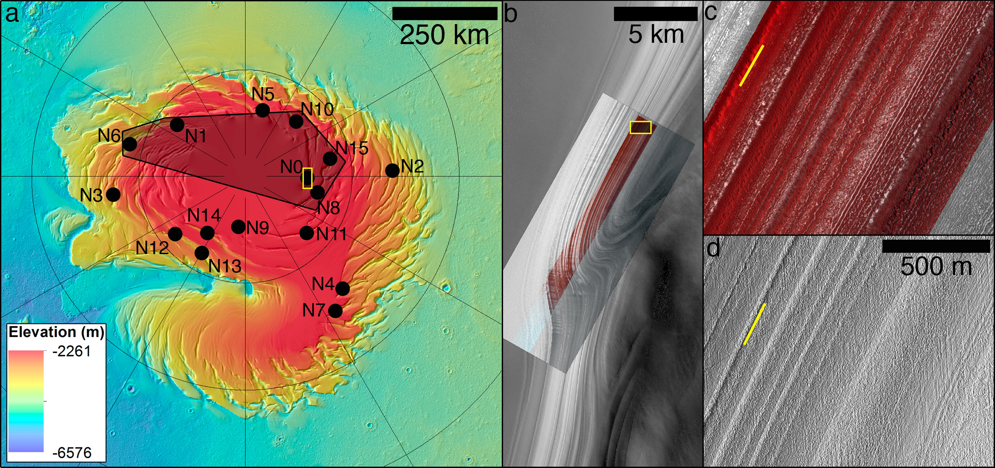
Figure 3.1. (a) MOLA topographic map of the north polar region of Mars. Our study sites of exposed NPLD layers are indicated with black dots. Latitude and longitude grid lines are spaced by 5º and 30º respectively. The shaded area denotes the validity of the stratigraphic column presented in section 5. (b) Area around site N0 (highlighted in yellow in (a)). The background is CTX image P18_008093_2670_XN_87N260W, overlain by the merged RED and color HiRISE image PSP_001738_2670. Illumination is from the bottom right. (c) HiRISE color image of the section highlighted in yellow in (b), featuring the slumping sublimation-lag deposits that affect the apparent brightness of exposed layers. Illumination is from the bottom right. (d) Shaded relief map of the section shown in (c) constructed from the DTM of site N0 and showing the topography this area. The yellow lines underline the same bed in (c) and (d).

3.2 Description of Data
The data used for this study are images (HiRISE and CTX) and topography (built from HiRISE stereo pairs) of exposed layers in the equatorward-facing side of spiral troughs in the NPLD, also called the high side [McEwen et al., 2007]. The HiRISE RED band images over this region typically have a scale of 31 – 33 cm/pixel, and a swath width of ~6 km [McEwen et al., 2007]. The CTX camera [Malin et al., 2007] has a much wider swath of ~30 km with a resolution of 6 m/pixel. Thanks to this larger image footprint, CTX has achieved nearly 100% coverage of the Martian North Polar region in the 9 years since MRO has been in orbit. These images allow us to trace individual layers from one HiRISE image to another along the same trough wall, allowing for a confident correlation of stratigraphic sequences.
Stereo pairs are acquired as closely spaced in time as possible in order to minimize differences (illumination, albedo, frost, etc.) that could cause difficulties in DTM production. The DTMs we used all have a horizontal scale (grid spacing) of 1 m, except for one, which was made using images with 2x2 pixel binning, and has a 2 m grid spacing (Table 3.1). The estimated vertical precision is typically <1 m, and <2 m for the binned pair [Sutton et al., 2015]. Orthorectified images (orthoimages) are produced at each site, corresponding to each of the source images that make up a stereo pair. These images are a true “map-view” rendition of the terrain, with topographic and camera distortions removed, and which match the DTMs pixel for pixel. We use these images to provide context when analyzing shaded relief renditions of the DTMs, to define the visible appearance of a protruding layer in the DTM, and to compare brightness-based stratigraphic mapping to one based on topography. The above procedure for making DTMs and orthoimages is explained in detail in [Kirk et al., 2008]. At the time this study began, there were seven HiRISE DTMs of exposed NPLD layers publicly available. We constructed nine more for a total of 16 study sites, which are numbered and shown in Figure 3.1a. Details of each site and DTM are given in Table 3.1.
Our main objective when choosing study sites was to maximize geographic coverage. The sites we selected for DTM creation were chosen based on the availability of stereo pairs at the time, and on their distribution throughout Planum Boreum. We also targeted specific locations for stereo imaging that were convenient because of the nature of the exposure (e.g. apparent lack of unconformities [Tanaka and Fortezzo, 2012]), and/or because of their position relative to preexisting DTMs, in order to facilitate layer-tracing with intervening CTX coverage (e.g., we targeted sites N10 and N15 because they are located along the same trough wall as N0 and N8 respectively; see Figure 3.1).

Table 3.1. Details of the HiRISE data used at each of the 16 study sites. The DTM name contains the HiRISE names of both stereo pairs (the first number starting with 0 is the stereo-1 name, and the second is the stereo-2 name). The Solar separation angle is the angle formed by two rays connecting the target site with the sun's position at the time of the stereo-1 observation and at the time of the stereo-2 observation.

Site Name | DTM Name | Stereo 1 L_{s} (º) | Stereo 2 L_{s} (º) | Solar Separation Angle (º) | Vertical Precision (m/pixel) | Center Latitude of Profile | Center Longitude (E) of Profile
N0 | DTEPC_001738_2670_001871_2670 | 147.94 | 153.25 | 29.68 | 1 | 87.11 | 93.52
N1 | DTEPC_001390_2660_001563_2660 | 134.45 | 141.08 | 37.96 | 1 | 86.25 | -127.75
N2 | DTEPC_001462_2630_001580_2630 | 137.19 | 141.74 | 19.91 | 1 | 83.12 | 94.7
N3 | DTEPC_001652_2640_001640_2640 | 144.08 | 144.55 | 31.4 | 1 | 83.82 | -82.76
N4 | DTEPC_010008_2630_009969_2630 | 125.56 | 127.01 | 14.17 | 1 | 83.07 | 41.1
N5 | DTEPC_010030_2670_010532_2670 | 127.83 | 147.08 | 26.4 | 1 | 86.87 | 162.96
N6 | DTEPC_010198_2645_010014_2645 | 127.23 | 134.14 | 15.28 | 1 | 84.59 | -107.5
N7 | DTEPC_018870_2625_018910_2625 | 128.72 | 130.22 | 11.49 | 1 | 82.47 | 34.44
N8 | DTEPC_019210_2665_019158_2665 | 141.66 | 139.65 | 18.36 | 1 | 86.52 | 80.96
N9 | DTEPC_027034_2680_027246_2680 | 105.11 | 112.63 | 25.55 | 1 | 87.95 | -6.04
N10 | DTEPD_035572_2665_036008_2665 | 95.39 | 110.69 | 21.76 | 2 | 86.6 | 137.5
N11 | DTEPC_035628_2660_035919_2660 | 97.34 | 107.53 | 22.69 | 1 | 86.21 | 46.04
N12 | DTEPC_035869_2660_035949_2660 | 105.77 | 108.6 | 21.99 | 1 | 85.88 | -49.29
N13 | DTEPC_036013_2660_035605_2660 | 96.54 | 110.87 | 18.78 | 1 | 85.1 | -31.63
N14 | DTEPC_036132_2665_035777_2665 | 102.53 | 115.13 | 25.47 | 1 | 86.75 | -42.15
N15 | DTEPC_009980_2660_009967_2660 | 125.97 | 125.49 | 4.74 | 1 | 85.95 | 101.96

3.3 Methods
    - Extraction of Protrusion Signals
The topographic property we analyze here is a measure of how much a layer protrudes from the surrounding trough wall. We took profiles of layer protrusion vs. depth by first extracting the geographical and elevation data from the DTM into one-dimensional topographic profiles. The profile directions were chosen so that the profiles were as close to perpendicular as possible to the layers that are visible in a shaded relief view of the DTM and in the orthoimage although in some cases we were limited by the shape of the DTM edges or linear artifacts that result from jitter in the creation of the DTM. In the latter case, we had to choose profiles oriented parallel to these linear artifacts to avoid crossing them and mistaking them for a protruding layer. Once we extracted the topographic profile, we fit a line within a localized window along the profile curve and measured the vertical distance between the topography and the linear fit at the center of the window (Figure 3.2b). This difference is the value of protrusion at each point of the profile. When we “slide” the window along the entire curve, the result is a depth-dependent protrusion profile for that site [Byrne et al., 2011]. The size of the window allows us to tune how we visualize protruding sections of the trough wall at different wavelengths. If the window is too small, long-wavelength protrusions that can represent thick, resistant beds, are more difficult to pick out in the profile; if the window is too large, long wavelengths dominate and it becomes more difficult to distinguish individual beds. However, the relative shape of the signal, i.e. the elevations of peaks in the signal and their relative amplitudes, is not sensitive to small changes in window size. We used a window of 350 m in horizontal length for all sites.
To search for possible errors in the elevation of protrusion peaks in the signal, we tested measuring protrusion as the horizontal distance between the topographic profile and the linear fit at each window center. We found no significant differences in the normalized horizontally measured protrusion compared to the normalized vertically measured protrusion. In the results presented here, we measured protrusion vertically in all profiles.
The layer exposures display a significant amount of roughness along the strike of the trough wall at the scale of the layers. This roughness makes it difficult to pick out layers in one-dimensional topographic profiles [Fishbaugh et al., 2010a] and translates into noise in a protrusion signal. To address this, we took five elevation profiles from each DTM separated from each other along strike by 10 meters (Figure 3.2a), calculated the protrusion for each of them individually, and then took the mean of the five protrusion profiles. This average of five adjacent protrusion profiles is the representative profile for a particular site (Figure 3.2c).
There are a number of different properties that can be extracted from the topographic information in the DTM that could be related to the internal composition of the strata, each with its own advantages and disadvantages. For example, instantaneous slope could be used instead of protrusion. In Figure 3.2d, we show a profile of mean instantaneous slope that can be compared to the protrusion profile of Figure 3.2c. Slope has the advantage of exposing short wavelength periodicities that are dampened in the protrusion profile due to the way protrusion is calculated. However, although the largest, most protruding beds are still easily distinguishable in the slope profile, some high protrusion beds (e.g. below -2710 m) that were identified in the HiRISE images are much less easily recognized. In this study, we use protrusion to facilitate the visual correlation of thick, prominent beds through different locations.

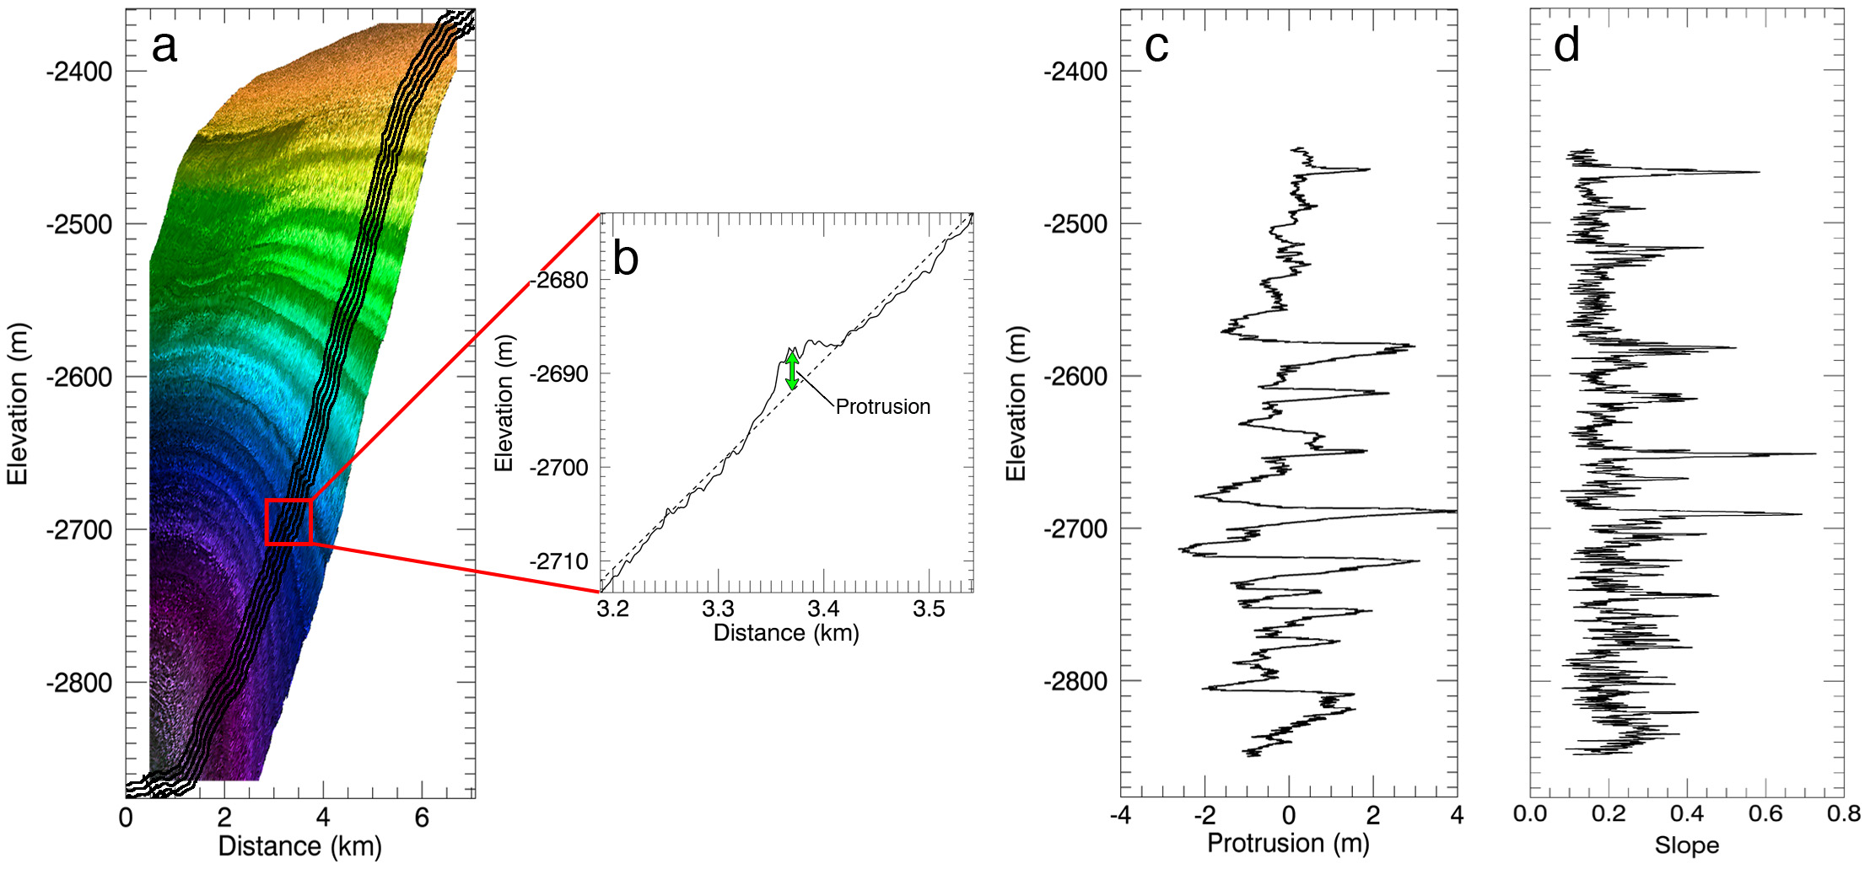
Figure 3.2. Illustration of the method for extracting protrusion profiles from a HiRISE DTM. (a) Elevation profiles used to calculate protrusion (black lines) plotted over a vertically exaggerated (10x) perspective 3D view of the DTM of site N0 (layers extend into the page). The average slope of the high side of NPLD troughs is typically only a few degrees. (b) A local fit window is moved down the profile so that protrusion is evaluated as the vertical difference between each point in the profile (solid line) and the linear fit (dashed line) at the window center. (c) Final mean protrusion profile for site N0, which results from averaging the protrusion of the five profiles in (a). (d) Mean profile of instantaneous slope, which results from averaging the resampled instantaneous slope of the five topographic profiles shown in (a).

    - Image Analysis
We identified individual prominent layers and layer sequences in the protrusion profiles and matched them to prominent layers visible in the HiRISE orthoimages and in the DTM shaded relief maps. Locating individual prominent beds in the profiles that can be easily identified in HiRISE and CTX data is a key step in the correlation of two sites that are located on the same trough but are separated by hundreds of kilometers (see section 3.4.2).
A discrete, protruding, and therefore resistant layer is defined here as a prominent peak in the protrusion signal (Figure 3.3a). This detection must be accompanied by an examination of the DTM and the corresponding orthoimages in order to avoid identifying noise or jitter artifacts. Because the focus of this work is on the continuous signals and their correlation through different sites, we mapped only the most protruding layers in the profiles: those with a protrusion peak value higher than ~0.5 m above the surrounding signal. We compared our stratigraphic mapping of site N0 with the original stratigraphic column for this site [[Fishbaugh et al., 2010a], allowing for continuity with previous stratigraphic mapping, and for a comparison of their morphological description of layers with our method. We found that in most cases, the most protruding strata in a protrusion profile correspond to the layers that [Fishbaugh et al., 2010a] term “marker beds” (because of their similarity to the original Marker Bed of [Malin et al., 2001]). This is expected, as [Fishbaugh et al., 2010a] describe these layers as having an “easily recognized, prominent (protrude from other layers) morphology, with hummocky, corrugated texture on their edges, and often a lower albedo than the surrounding layers”. [Fishbaugh et al., 2010a] also identified sets of thin, erosionally resistant layers between the marker beds. These sets and the individual thin layers within them are resolved in HiRISE images. In the protrusion profiles, thin layer sets are usually identifiable as a broad protrusion peak with smaller peaks within it, but the thin layers themselves are not distinguishable from noise. Thus, we classified thin layer sets based on their identification in the profile as a high-protrusion bed and a subsequent inspection of the corresponding image and shaded relief map, which revealed the finer scale structure. This exposes a weakness in our metric, in that it is not particularly diagnostic of fine scale structure such as thin beds; therefore, our analysis is based primarily on the identification of marker beds throughout all sites. Figure B1 in Appendix B shows a comparison between the column of [Fishbaugh et al., 2010a] and the sequence of prominent layers we identified in our protrusion profile at site N0.

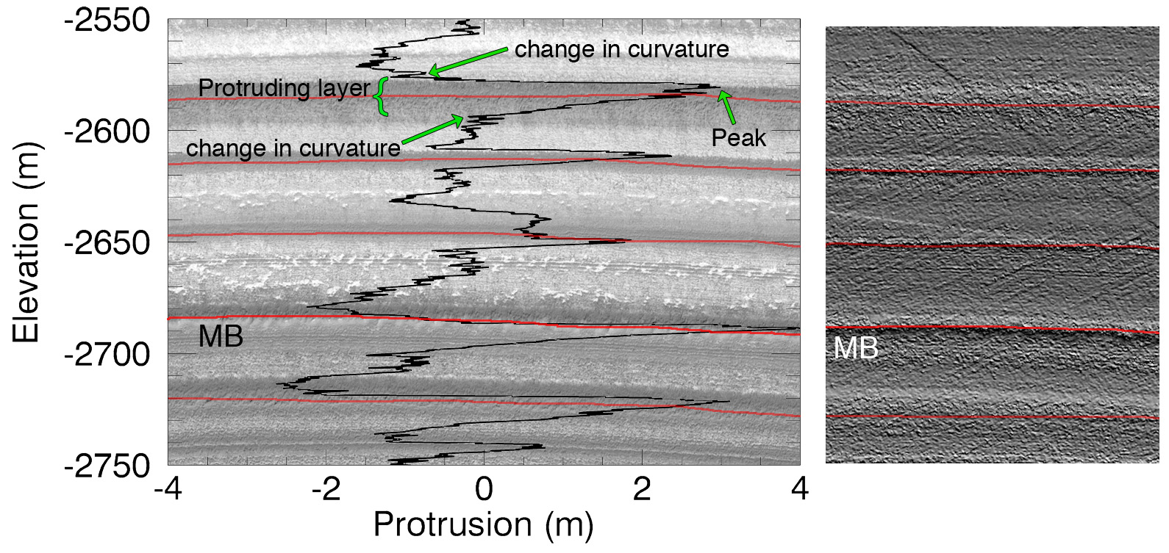
Figure 3. (Left) Protrusion profile of site N0 plotted over the corresponding portion of the orthoimage of HiRISE product PSP_001738_2670 (illuminated from the bottom). The original Marker Bed [Malin and Edgett, 2001] is noted (MB), and other relevant marker beds are traced. (Right) Shaded relief visualization of the N0 DTM with the same protruding marker beds traced.

Our goal when mapping the protrusion at each site was to be able to correlate these profiles to each other in order to build a stratigraphic column that describes the largest area possible. When two sites lie along the same trough, the initial step in correlating layer sequences was to trace protruding beds in the HiRISE data at one site, and map them along intervening CTX images of the trough wall to the other site. This method provides a reliable correlation, as the resolution in both datasets is high enough that we can be confident in our tracing. Some subjectivity is nevertheless involved, as we relied primarily on the brightness and appearance of the layers to trace them within the CTX images.
To perform these traces we noted the elevations of selected peaks in the protrusion profile at one site, and used them to find the corresponding layers in the HiRISE images and DTMs and in the CTX images. We then traced these layers through CTX coverage – and with intermediate HiRISE coverage when available – to the other site in the same trough. Figure 3.4 shows the details of the layer traces in the trough that contains sites N0 and N10.

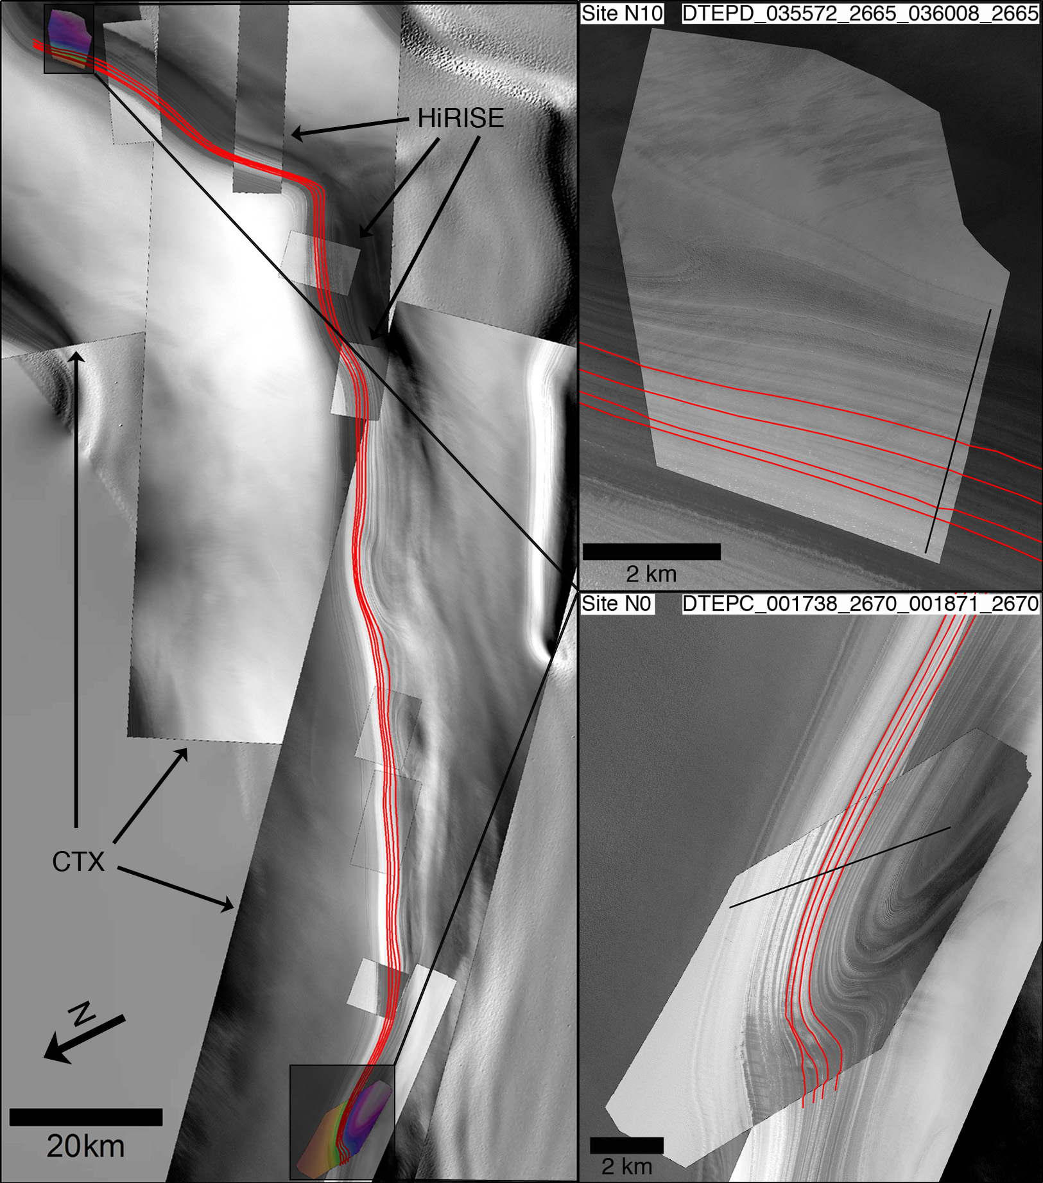
Figure 3.4. Example of the method for correlating stratigraphic profiles from two sites that lie along the same trough wall using ESRI’s ArcGIS. (Left) Complete view of the trace of four high-protrusion beds from site N0 to site N10 (see Figure 3.1a for locations). These beds are traced through CTX and HiRISE images rendered between the two sites. (Right) Close-up of the orthoimages at sites N10 (illumination from the top right corner) and N0 (illumination from right) rendered over CTX images, with a view of the layers traced and where they intersect the profiles. Similar figures for all sites that share a trough wall are in Appendix B (Figure B2).

    - Profile Correlation and Comparison
      - Dynamic Time Warping Algorithm
In the study of terrestrial paleoclimate records, signal-matching techniques based on dynamic programming (a class of algorithms used in optimization programs in which a problem is subdivided into multiple sub-problems) have been used to explore the relationship between two time-series with uncertainties in their time dimension [Lisiecki and Lisiecki, 2002; Tomasi et al., 2004; Haam and Huybers, 2010]. These algorithms maximize the cross-correlation or covariance between two time-varying signals by adjusting the time dimension, effectively tuning the signals to each other to see how well they match, and analyzing the statistical value of the match. In the case of the NPLD, depth is related to time, but since this relationship is non-linear, depth cannot directly be used to determine age. [Milkovich and Head, 2005] used the Match 1.0 program of [Lisiecki and Lisiecki, 2002] to correlate MOC depth-brightness profiles taken from different locations on the NPLD. The signal-matching method we used is known as Dynamic Time Warping (DTW) [Sakoe and Chiba, 1978]. This algorithm was first applied to a geological problem by [Haam and Huybers, 2010] to improve statistical measurements of the relationships between terrestrial paleoclimate records, and later used by [Sori et al., 2014] to demonstrate the feasibility of identifying an orbital signal in NPLD stratigraphy. [Sori et al., 2014] applied DTW to tune a simulated brightness profile of the NPLD to the time-varying insolation function of [Laskar et al., 2004a], and then tested the statistical significance of the tuning.
In our study, the DTW algorithm stretches or contracts the depth dimension of a protrusion signal in order to search for the optimal match between it and another signal that is kept fixed. Figures 3.5a and 3.5b show an example of the output of our version of the DTW algorithm when used to correlate profiles from sites N0 and N10. In this instance, the profile from N10 was tuned to the profile from N0. The goodness of match for a particular tuning is measured by the covariance between the fixed signal and the tuned signal, so that the optimal match is given by the tuning that results in the maximum covariance (C_{MAX}). The tuning procedure consists of calculating the squared difference, or “cost,” between each point in the evaluated signal with every point in the fixed signal. This calculation results in a matrix of squared differences (colored square portion in Figures 3.5a and 3.5b), known as the cost matrix, which represents the costs of all possible matches between the two signals. The goal of the algorithm is to find the path through the cost matrix from the lower left corner to the upper right corner that incurs the lowest average cost. This lowest-cost path represents the manner in which the evaluated signal must be tuned for it to have the maximum possible covariance with the fixed signal, and is represented by the black line running through the cost matrices in Figures 3.5a and 3.5b. Figure 3.5c is a plot of the tuned version of the N10 profile (red line) over the original N0 profile. It shows which parts of the N10 profile needed to be adjusted more to match N0, indicating possible differences in relative accumulation between each site.
The comparison between two protrusion profiles that lie along the same trough wall is guided by the initial observational correlation obtained from layer tracing in the images. This has several important implications that distinguish our use of this algorithm from that of [Sori et al., 2014]. In order to use our prior knowledge (from layer traces) of which layers in one profile should match which layers in the other, we first use a modified version of the algorithm in which a minimum of one, and a maximum of two, arbitrary, user-selected points within both signals could be forced to match. Forcing a match of these “tie-points” results in a cost matrix that is split into several sub-matrices to match sections of a profile to the corresponding sections in another (Figure 3.5a). We then use this information to crop the profiles at the points indicated by the lowest-cost path. For example in Figure 3.5a, where we used two tie-points (peaks MB and MB+3), the lowest-cost path covers all of the N10 profile (horizontal plot directly underneath the cost matrix), but only a portion of N0 (vertical profile directly to the left of the cost matrix) – from -2500 m to -2750 m – so we truncated the N0 profile between these elevations. Finally, we run the DTW algorithm without the tie-point requirement on the truncated profiles to create a single cost matrix that correlates only the relevant portions of each profile. In this step, the ends of the cropped profiles are assumed to match, we let the algorithm choose the best match between these two sections, and evaluate whether or not the match is the same as what we traced in the CTX images, not just along the tie-point layers but along all layers traced. This serves as a test of the method and, when the correct match is achieved, allows us to intelligently interpolate between the major peaks that we identified and traced in the images. We applied this algorithm to all the pairs of sites we correlated, selecting one site to provide the fixed profile, and the other to provide the profile to be tuned.

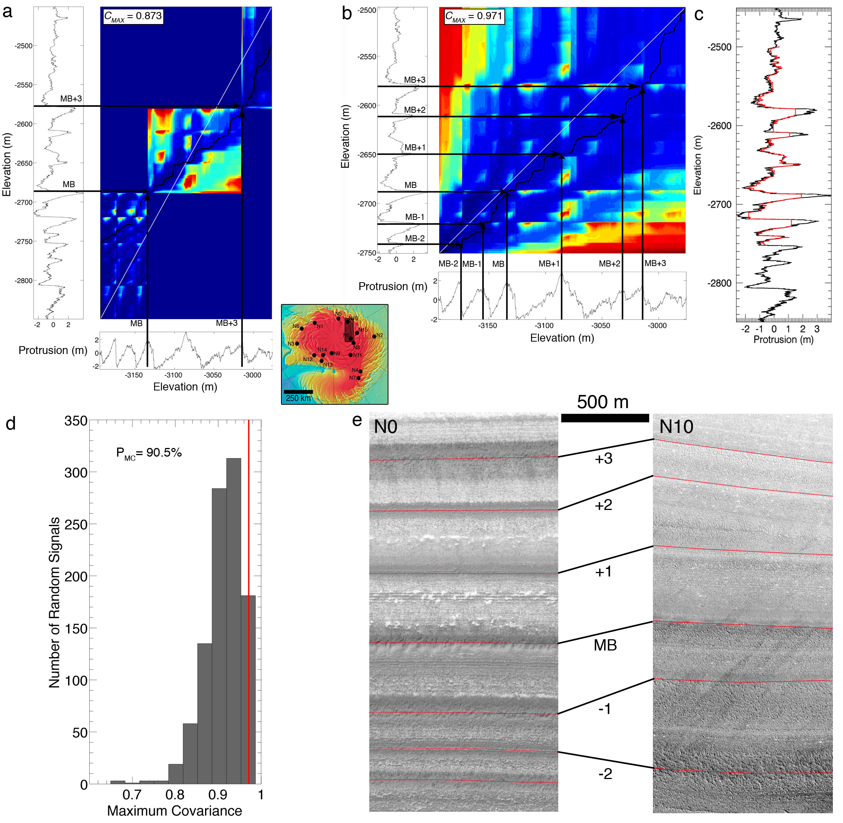
Figure 3.5. (a) DTW Cost Matrix that results from comparing N0 to N10 (locations shown in inset map), with N0 (left vertical plot) remaining fixed and N10 (bottom horizontal plot) allowed to be tuned. The rectangular, color-coded region corresponds to the cost matrix, in which warmer colors represent areas of higher cost. The black line through the matrix shows the path that incurs the lowest average cost. Two high-protrusion beds, MB and MB +3 (see section 4.2), were forced to match at the locations in the profiles that correspond to the image-based matches, resulting in a split cost matrix that matches sections of the profiles below the first fixed point (MB), between the points, and above the second fixed point (MB + 3). The maximum covariance (C_{MAX}) of the optimal tuning, including the sections that are outside the range of the complete match, is displayed in the top left corner. (b) Same as (a) but only comparing the sections of each profile that overlap according to (a). (c) Tuned version of the profile from N10 (red line) plotted over the entire profile from N0 (black line). (d) Histogram of the distribution of the value of C_{MAX} for the correlation of random signals to the N0 profile (vertical profile in (b)). The C_{MAX} of the correlation with the N10 data is 0.971 (vertical red line), which is greater than the C_{MAX} for 90.5% of random signals. (e) HiRISE orthoimages showing the relationship between the layers matched in (b). Illumination is from the bottom in both images.

      - Monte Carlo Statistical Analysis
The DTW algorithm outputs the maximum covariance between a tuned protrusion profile and a fixed one, but not the statistical significance of that best match. In other words, we do not know whether a random signal with similar spectral and statistical properties as the tuned profile could achieve a similar maximum covariance with the fixed signal. As in [Sori et al., 2014], we needed to test the null hypothesis that a good correlation could be achieved between a certain fixed protrusion signal and a random signal, and that the maximum covariance between the two real signals was no better than one obtained by chance. We did this using a Monte Carlo procedure in which a large number of randomly generated protrusion records that have the same spectral properties and are statistically similar to the evaluated profiles were tuned to match the fixed profile of each pair we want to test. We used Fourier filtering to generate 1000 random profiles with the same power spectrum as the data but with randomized phases, and normalized them to have the same variance as each evaluated profile. We then applied the DTW algorithm to the random series comparing them to each fixed profile, and obtaining a value of C_{MAX} for each random profile for a total of 1000 C_{MAX} per run. Comparing the distribution of these values of C_{MAX} to that obtained with the pair of real signals assesses the quality of the match between the real data. This comparison results in a confidence level for rejection of the null hypothesis, expressed as the percentage of tuned random profiles that have a smaller C_{MAX} with the fixed signal than the real tuned profile. The histogram of the values of C_{MAX} for the random profiles in the comparison between N0 and N10 is shown in Figure 3.5d, along with the Monte Carlo percentage (P_{MC}). If this percentage is close to 100% then the match between the two protrusion profiles is better than nearly all matches between the random signals and the fixed profile, and we can have confidence in that match. If it is close to 50% then the opposite is true, and a randomly generated signal has an equal chance of matching the fixed profile (N0 in Figure 3.5) as the evaluated profile (N10 in Figure 3.5).
Signal-matching algorithms such as DTW are in essence an automated way of comparing prominent features in a signal to prominent features in another signal and finding the way in which the two could be related that requires the least modification of one of the signals. These algorithms are limited to the scale of the prominent features that are being compared, which in this case, is that of the high-protrusion beds. This means that the correlations presented in the results section cannot be used to relate individual thin layers from one profile to another, but matches between particular high-protrusion beds and even sets of thin layers that may appear as a single protrusion peak in both signals can be considered reliable.
Another caveat of DTW involves the presence of periodicities in the signals. Previous researchers (Laskar et al. [2002], Milkovich and Head [2005], Fishbaugh et al. [2006, 2010ab]) have argued that the NPLD stratigraphic record contains quasi-periodic components, perhaps due to orbital forcing. The presence of periodic forcing means that a section of stratigraphy that corresponds to a certain time period may appear similar to another section that represents a different time period. The random profile model that we use attempts to account for this by producing signals that have the same spectral properties as the data. However, the DTW-Monte Carlo algorithm should ideally be used when a correlation has been independently pre-established between two sequences. In our case, we do this with CTX layer-tracing as explained above.
Our method can test whether or not previously established correlations (such as those of Fishbaugh and Hvidberg [2006]) are reliable by using those very correlations as constraints. The method can confidently rule out correlations that are likely to be unreliable, but due to the caveats explained above, it cannot confirm whether a correlation is uniquely correct unless layers have been specifically traced from one site to another. Herein lie the usefulness and the weakness of applying such signal matching algorithms to the NPLD. Although the method cannot be used independent of any information, once a connection has been made through visual correlation, the algorithm is able to interpolate the correlation in the rest of the stratigraphic depth range at the scale of the features being used as constraints. We discuss this further in section 5.

      - Comparing Protrusion Correlations to Brightness Correlations
One of the main motivations of this study is to test the hypothesis that stratigraphic analysis using topographic data – particularly layer protrusion – is better suited for describing NPLD layers than an analysis based on layer brightness.
We extracted profiles of brightness from the orthoimages that matched the exact ground tracks of the protrusion profiles and similarly averaged five brightness profiles separated by ~ 10 m along strike in order to reduce noise. We then performed the DTW – Monte Carlo procedure on the same pairs of sites we correlated using protrusion. We express brightness as I/F, which is the measured intensity (I) divided by the solar irradiance when the incidence angle is zero (F), such that I/F = 1 for a perfectly diffuse reflector that is normally illuminated. A comparison between the confidence level of the brightness pair and that of the protrusion pair quantifies the quality of one approach over the other. We call the protrusion-based confidence parameter P_{PMC} and the brightness-based parameter P_{BMC}. It is important to stress that in order to establish an initial correlation between protrusion profiles we trace layers using CTX images as explained above. This involves matching a protrusion peak with the layer it represents in the CTX image, i.e. with that layer’s brightness as seen by CTX. Therefore, a better protrusion-based correlation (i.e., P_{PMC} ~ 100% and P_{BMC} ~ 50%) does not imply that protrusion is a better stratigraphic quantity than brightness if both are used in isolation. Rather, it highlights the need for using topographic information in tandem with brightness information to obtain the best description of the stratigraphy.

  - Results
    - Discrete Layer Identification in Individual Sites
Here we present results of the discrete stratigraphic mapping that we performed on each of our 16 study sites individually (Figure 3.6), using the methods described in sections 3.3.1 and 3.3.2. For any given profile, we labeled the beds with the site name followed by a layer identification number, with the deeper layers having higher numbers (e.g. N2.0 is the topmost layer in site N2. See Figure 3.6). This nomenclature is only valid for each individual site.
Fishbaugh et al. [2010b] mapped the layers at site N0 using the same DTM that we use here, and defined a nomenclature around the original Marker Bed (MB), observed by Malin et al. [2001]. We mapped the protrusion peaks at this site and compared and matched them to the layers identified by Fishbaugh et al. [2010b]. In addition, using the CTX tracing and signal-matching methods explained above, we correlated layer sequences in five sites (N1, N6, N10, N8, and N15) to the sequence mapped at N0, the results of which are detailed in the following sections. The sequence of high-protrusion beds in N0 that was correlated across these sites is seen in the top left panel of Figure 3.6a, and is highlighted in yellow in all the sites in which we observed it. The layers in this sequence are labeled both with our site-specific nomenclature and with the MB ± n labels of Fishbaugh et al. [2010b]. We refer to this sequence from N0.0 to N0.11 as the Main Sequence. The relationship between our nomenclature at site N0 and Fishbaugh et al.’s scheme of MB ± n is shown in the right panel of Figure B1 in Appendix B.
In some cases, we identified layers within the Main Sequence in one site, but not in another that also contained the Main Sequence. We interpreted these “missing” layers as candidates for localized unconformities. These are delineated in Figure 3.6 by a red line in the appropriate profiles, and are labeled UC ± n depending on their stratigraphic location above or below MB. Like the MB ± n, this labeling is consistent throughout all correlated sites. The discontinuous layers that correspond to unconformities at other sites are highlighted in red.
We also identified thin layer sets with high protrusion, i.e. the entire set protrudes from the wall and appears in the profile as a thick protrusion peak with embedded smaller peaks (e.g. N5.3; each layer in the set is on the order of 1 m in thickness). These sets were also identified in the profiles as individual high-protrusion beds and are highlighted in blue in Figure 3.6.
Following the description in [Fishbaugh et al., 2010a], the strata that are classified as marker beds are more resistant and darker than the surrounding strata, and usually display a corrugated, hummocky texture. We found a large variability in their morphology and brightness, so our classification of a highly protruding bed as a marker bed was based primarily on the protrusion profile, followed by a corroboration of the requirements of Fishbaugh et al. [2010b] in the orthoimages. We found a few cases in which a wide protrusion peak corresponded to two resistant layers adjacent to each other, as viewed in the orthoimages. In these cases we classified these layers as separate beds, using the orthoimage to delineate the limit between the two layers. (e.g. layers N4.3 and N4.4, and layers N6.1 and N6.2; Figure 3.6a).
We measured the average thickness of marker beds (defined as the trough-to-trough vertical extent of its corresponding protrusion peak in the signal) throughout all sites to be 12 ± 6 m. Our measurements are nearly consistent with those measured by [Fishbaugh et al., 2010a] at site N0, who found a variability in that site of 1.6 to 16 ± 1.4 m (we found 4 to 19 ± 3.16 m at that site; this error comes from propagating the ~1 m HiRISE precision error and a conservative ~2 m observer error in the measurement of layer elevations in the protrusion profiles). We must note that layer thickness is an ambiguous measurement that could be influenced by the erosive resistance of thin layers that protect a thick section of weaker layers below it. In such a case, the protrusion metric is more related to the caprock resistance than the thickness of the layers. We measured the average separation distance between marker beds, throughout all sites, to be 28 ± 15 m. This number is roughly consistent with previous measurements by [Fishbaugh and Hvidberg, 2006] and [Fishbaugh et al., 2010a].

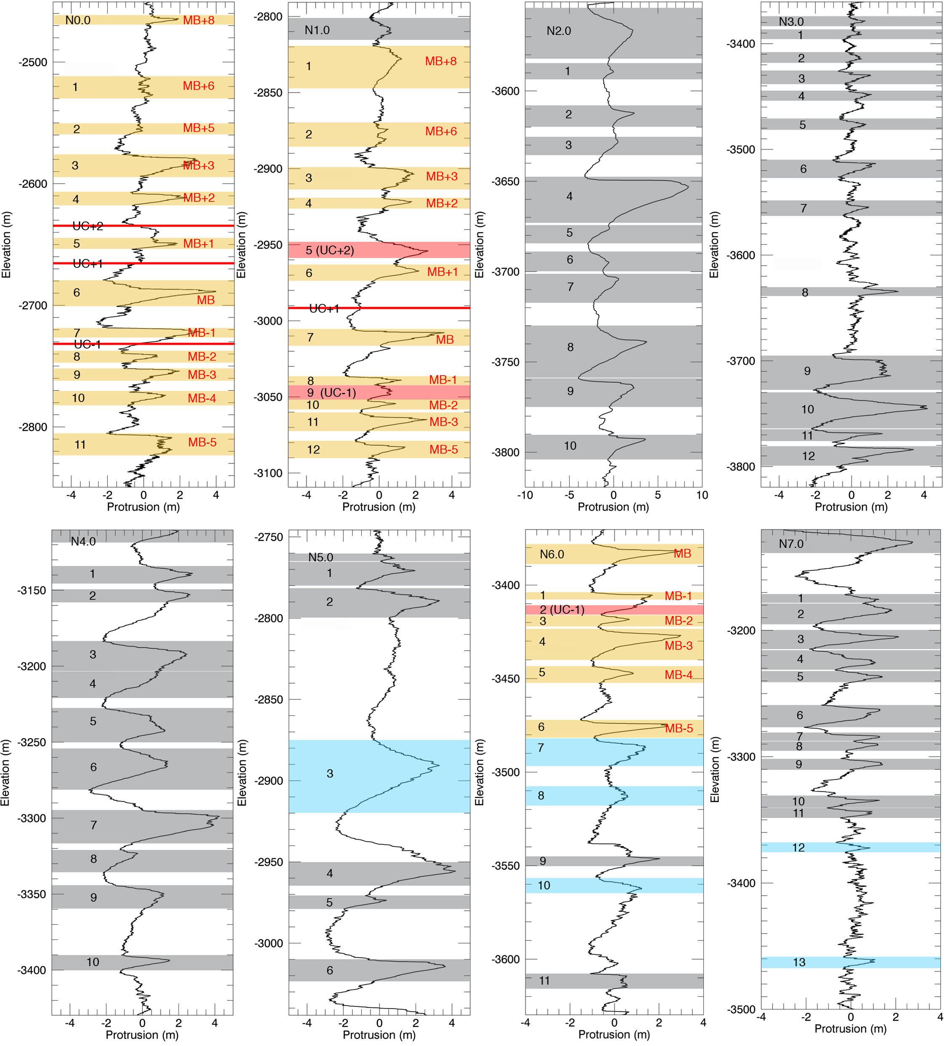
Figure 3.6a. Discrete mapping of prominent protrusion peaks for study sites N0 – N7. The layers are labeled according to their site-specific nomenclature (see text). Peaks highlighted in yellow represent layers previously identified by [Fishbaugh et al., 2010a] in site N0. We call this sequence of layers the Main Sequence, and it is identified here in all sites that were correlated to N0 (section 4.2.). The labels in red indicate the names of the Main Sequence layers in the nomenclature of Fishbaugh et al. [2010b]. Solid red lines represent candidates for localized unconformities within the Main Sequence. The protrusion peaks highlighted in red mark layers that were identified within the Main Sequence in one site but not in others that also contained the Main Sequence. The MB ± n nomenclature is valid through the six correlated sites (i.e., MB in N0 is the same layer as MB in N10). Peaks in grey represent prominent layers that were mapped only at each individual site. Peaks in blue represent thin layer sets mapped in each site. Grey and blue peaks are only valid for each individual profile and may not be related to grey and blue peaks in other profiles.

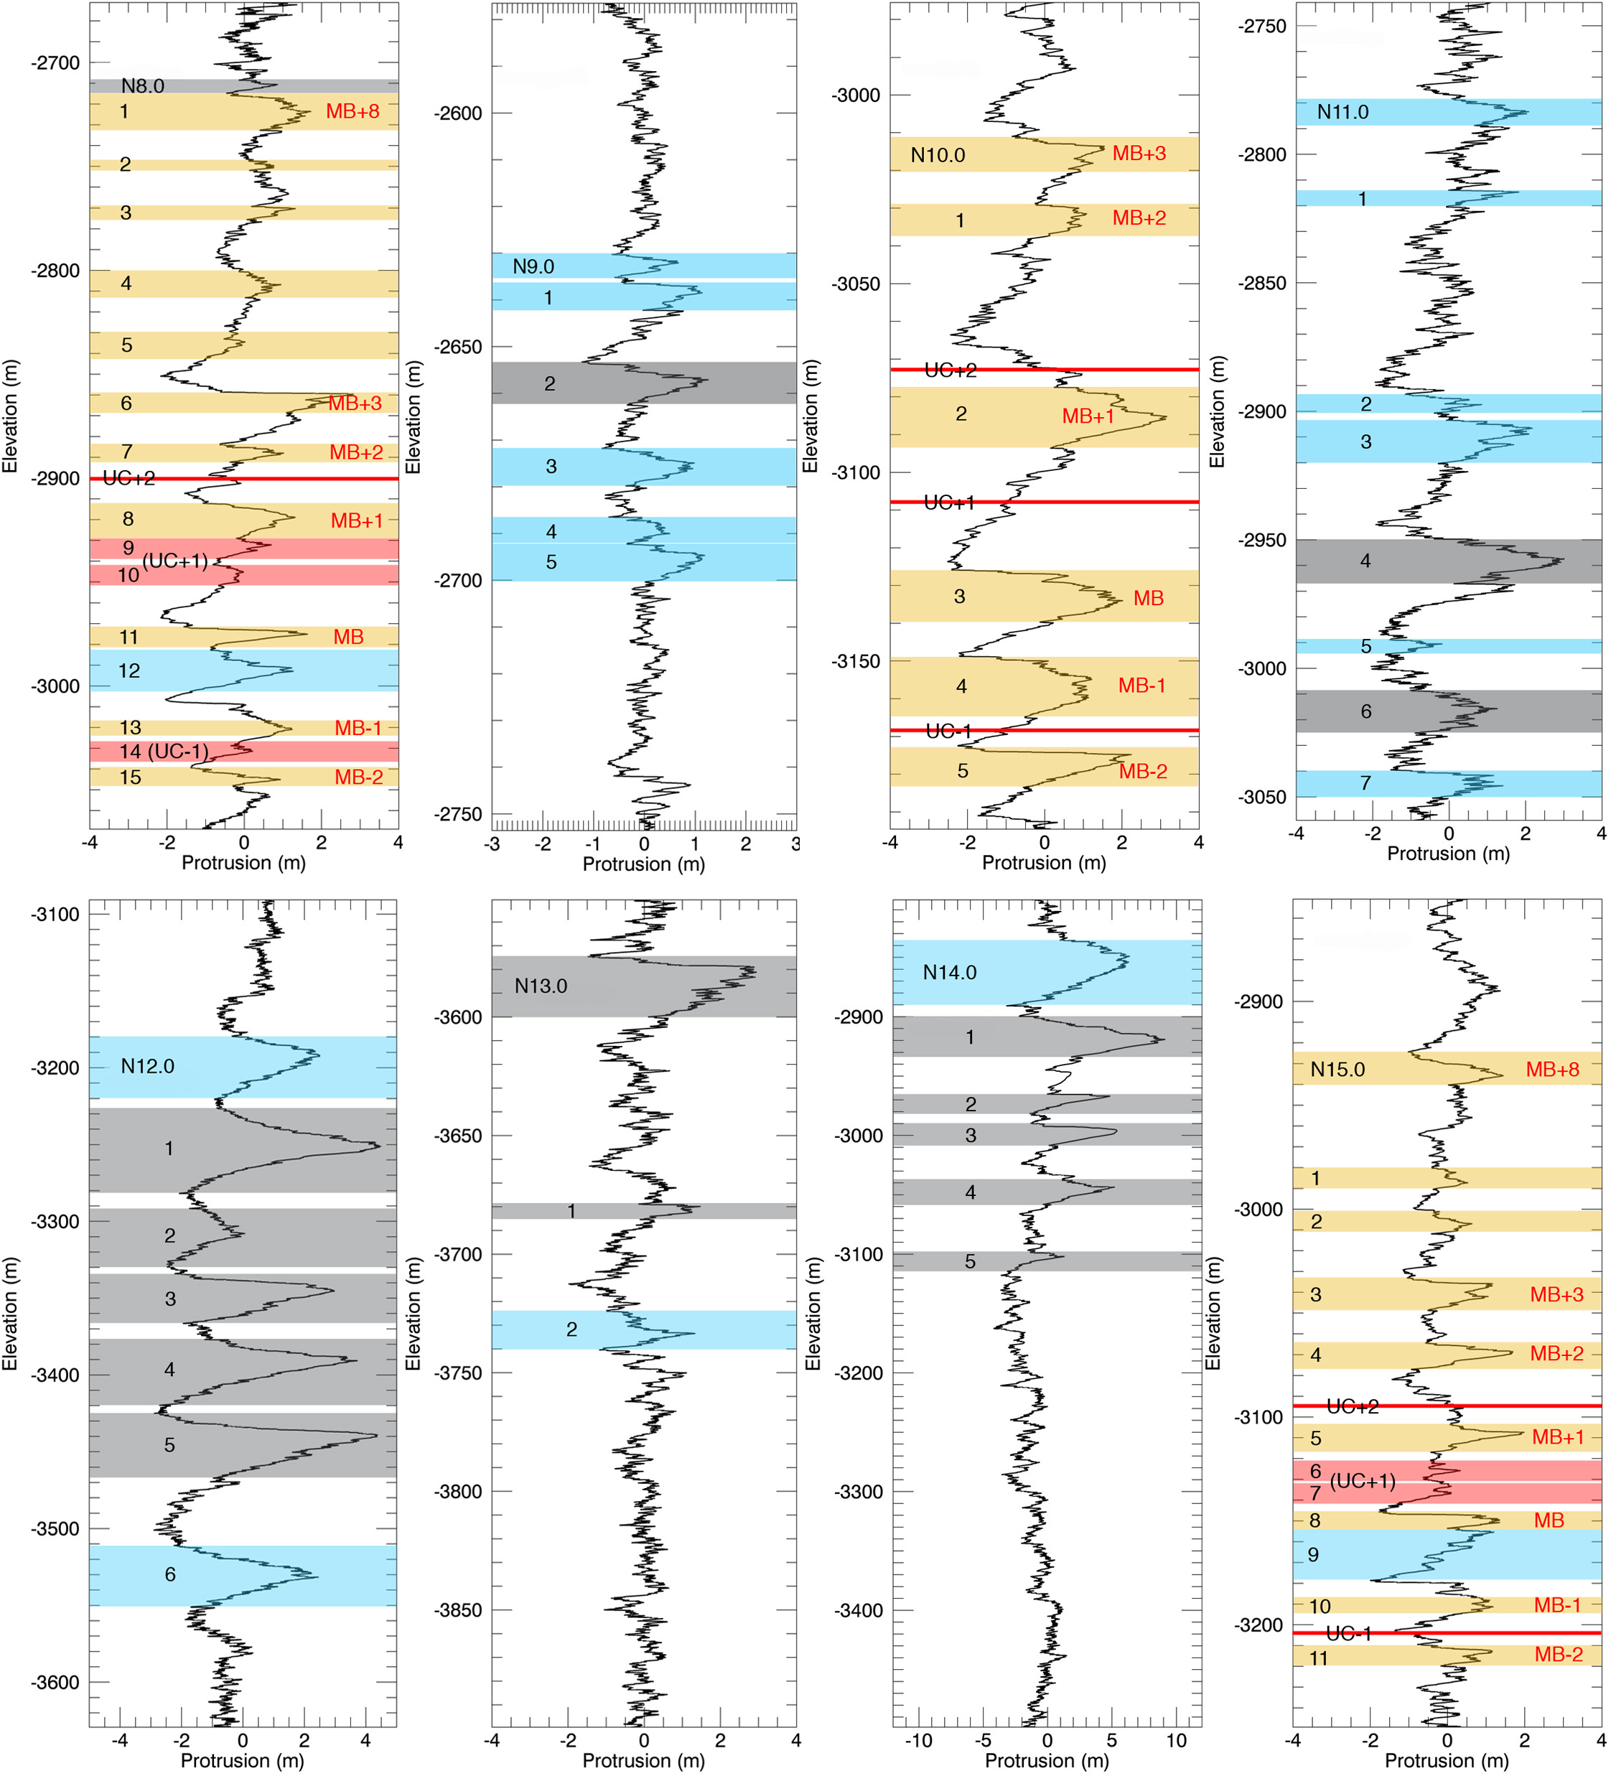
Figure 3.6b. Same as Figure 3.6a but for study sites N8 – N15.

Fishbaugh et al.'s, [2010a] mapping of the stratigraphy at site N0 exposed a weak trend of thinning of the layers with depth. We measured the thickness of layers in the N0 protrusion profile, and we found no such trend at this site. Our measurements of marker bed thickness throughout all sites also displayed no statistically significant trend with elevation (Figure 3.7a) or latitude (Figure 3.7c). Similarly, we also found no trend in average marker bed separation with elevation (Figure 3.7b) or latitude (Figure 3.7d). Attempts at a simple linear regression fit of the data displayed in Figure 3.7 gave values of the r² statistic lower than 0.05 for all four cases.

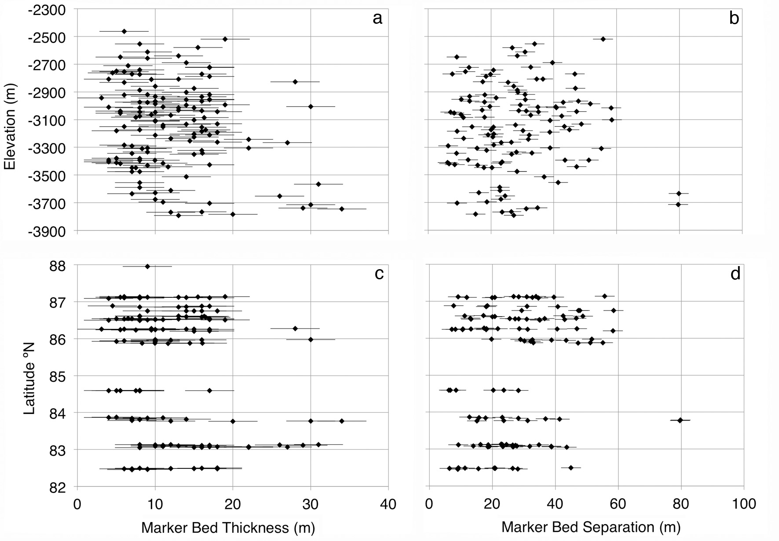
Figure 3.7. (a) Average marker bed thickness vs. elevation for all sites. (b) Average separation between marker beds vs. elevation for all sites. (c) Average marker bed thickness vs. latitude for all sites. (d) Average separation between marker beds vs. elevation for all sites. Error bars = 3.16 m, and come from propagating the ~1 m HiRISE precision error and a ~2 m observer error.

    - Correlation of Profiles between Sites
We attempted to correlate six sites, grouped into seven pairs. These pairs were selected because they are located in the same trough (so we could trace the layers in CTX), or because they had prior correlations established by Fishbaugh and Hvidberg [2006]. In two of these pairs (N0 vs. N10, N15 vs. N8) we were able to successfully trace prominent layers from one site to the other using CTX images. In these cases we effectively know what the “correct” match is supposed to be before we run the DTW algorithm, so these correlations can inform how best to use the confidence levels associated with the Monte Carlo procedure. At N0 vs. N10, the DTW – Monte Carlo method found the correct match (i.e., the same one found through layer-tracing) with a P_{PMC} = 90.5%, and at N15 vs. N8, it found the correct match with a P_{PMC} = 97.6%. Based on these results, we consider a correlation to be reliable when P_{PMC} ≥ 90%. When 75% < P_{PMC} < 90%, we consider the match suggestive and seek additional confirmation from other means. This creates a relative scale of confidence in stratigraphic matches. As we pointed out in Section 3.3, the statistical model and test is not perfect, and any strong periodic components in the stratigraphy may cause a false match. Therefore, the most reliable correlations are those for which we were able to trace at least one layer and have P_{PMC} ≥ 90%. Other pairs can have variable confidences based on the nature of the pair and the result of the DTW procedure and Monte Carlo test.
Tracing layers was not possible in the other five pairs of sites (N1 vs. N6, N8 vs. N0, N15 vs. N0, N0 vs. N1, N0 vs. N6). This was either because the sites are in separate troughs or, as is the case with N1 vs. N6, because the exposed strata in the trough wall between the individual sites were too eroded or modified to trace continuously from one site to the other. For these five pairs, we considered past correlations that Fishbaugh and Hvidberg [2006] obtained using MOC images and MOLA topography and evaluate the reliability of those matches. Because our procedure is most reliable with prior information relating the sites that are being correlated, we do not attempt to correlate all sixteen of our study sites, but rather only those that have been connected in the CTX data or that have a prior relationship established from past work. In future studies, “layer tracing” for the other sites could come from radar data taken by SHARAD [Christian et al., 2013].
We discuss the details of each correlation in the two following sub-sections, and the split cost matrices of the first run of the DTW for each pair (analogous to Figure 3.5a) are in Figure B3 of Appendix B. For simplicity, all pairs that include N0 use the MB ± n nomenclature of Fishbaugh et al., [2010b]. In addition to the pairs shown here, we tested two other pairs of sites that share a trough wall (N12 vs. N13, and N9 vs. N11). However, as with N1 vs. N6, the exposures between these two pairs of sites have suffered significant modification (Figures B2.3, and B2.4). Layer tracing was unreliable, and our tuning procedure did not yield a statistically significant match when applied without prior information. We show the results of these two pairs in Figure B4 of Appendix B.
A complete visualization of all our correlations, along with the locations of all high-protrusion beds identified in the previous section is shown in Figure 3.8. Figure 3.8a focuses on the Main Sequence layers that have been correlated throughout various sites. Figure 3.8b shows the position of all identified high-protrusion beds in all sites with respect to the correlated Main Sequence layers. These figures are a 2-D representation of a 3-D structure, so they must be used in tandem with the map of Figure 3.1 in order to grasp the relative 3-D positions of the sites and sequences. Table 3.2 lists the values of C_{MAX} and P_{PMC} for each correlated pair.

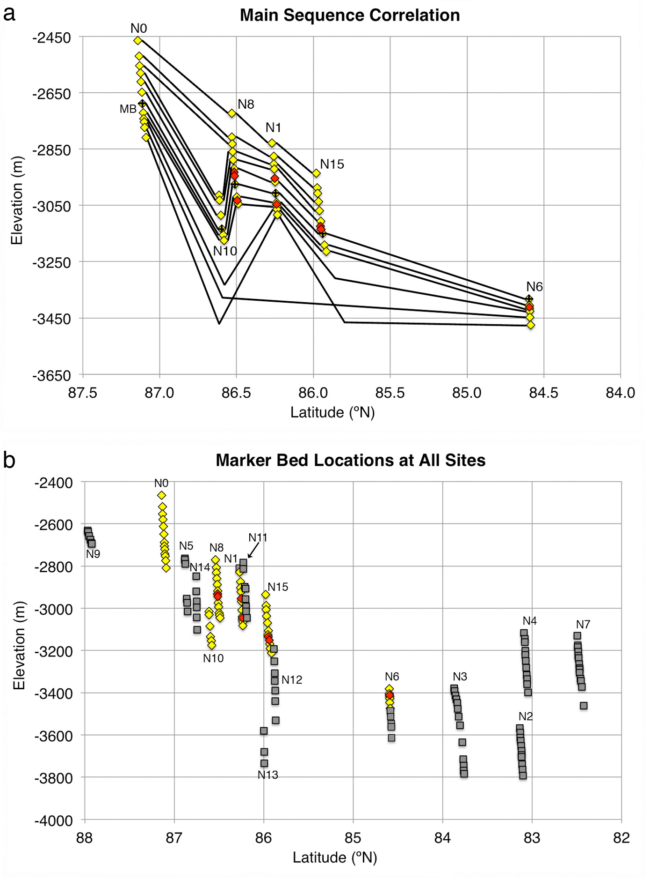
Figure 3.8. Relative locations of identified high-protrusion layers in each study site. Main Sequence layers are marked in yellow. Layers identified in only some Main Sequence sites are marked in red (see Figure 3.6). (a) Correlation of Main Sequence layers. The location of MB in each site is indicated. (b) Location of high-protrusion beds identified at each site. Layers in the Main Sequence are plotted as diamonds and follow the same color scheme as (a). All other layers are plotted as grey squares.

      - Correlations with pre-established layer traces

N0 vs. N10
We traced four high-protrusion beds (MB+3 through MB) between N0 and N10 (Figure 3.4). We used the elevations of two of these beds (MB+3 and MB) in each profile as two tie-points for the first step of the DTW analysis (Figure 3.5a). We then isolated the portion of the N0 profile that matches N10 in the cost-map of Figure 3.5a, and ran the DTW algorithm again, forcing only the ends of the profiles to match and letting the algorithm match protrusion peaks on its own. The resulting cost-map is shown in Figure 3.5b. The values of C_{MAX} (0.971) and P_{PMC} (90.5%) here (Table 3.2) suggest that this is a reliable correlation. In addition, four of the major protrusion peaks correlated by the algorithm were matched in the same way as the four layers that we traced in the images (Figure 3.4 and Figure 3.5e). We therefore consider this match to be reliable, and the N0 profile should be representative of this trough wall, as N10 is just a subset of it.

N15 vs. N8
These two sites are relatively close to each other in the same trough wall, and their DTMs cover a similar range of elevation, so we were able to trace seven high-protrusion layers in the images between them (Figure B2.1). These traces linked layer N15.3 to layer N8.6 and layer N15.8 to layer N8.11. We used the elevations of these beds as tie-points for the first step of DTW (Figure B3.1), selected the portions of the profiles that we expected to match based on those results, and ran the DTW algorithm again on these sections. The result (Figure 3.9a) was a C_{MAX} = 0.967, with a P_{PMC} = 97.6%, implying high confidence in the correlation. To further constrain the reliability, we compared the matches between protrusion peaks made by the DTW with the layer matches in the CTX images. We found that the algorithm correctly matched the seven layers that we traced. The morphology and appearance of the layers in the HiRISE orthoimages is shown in Figure 3.9b.

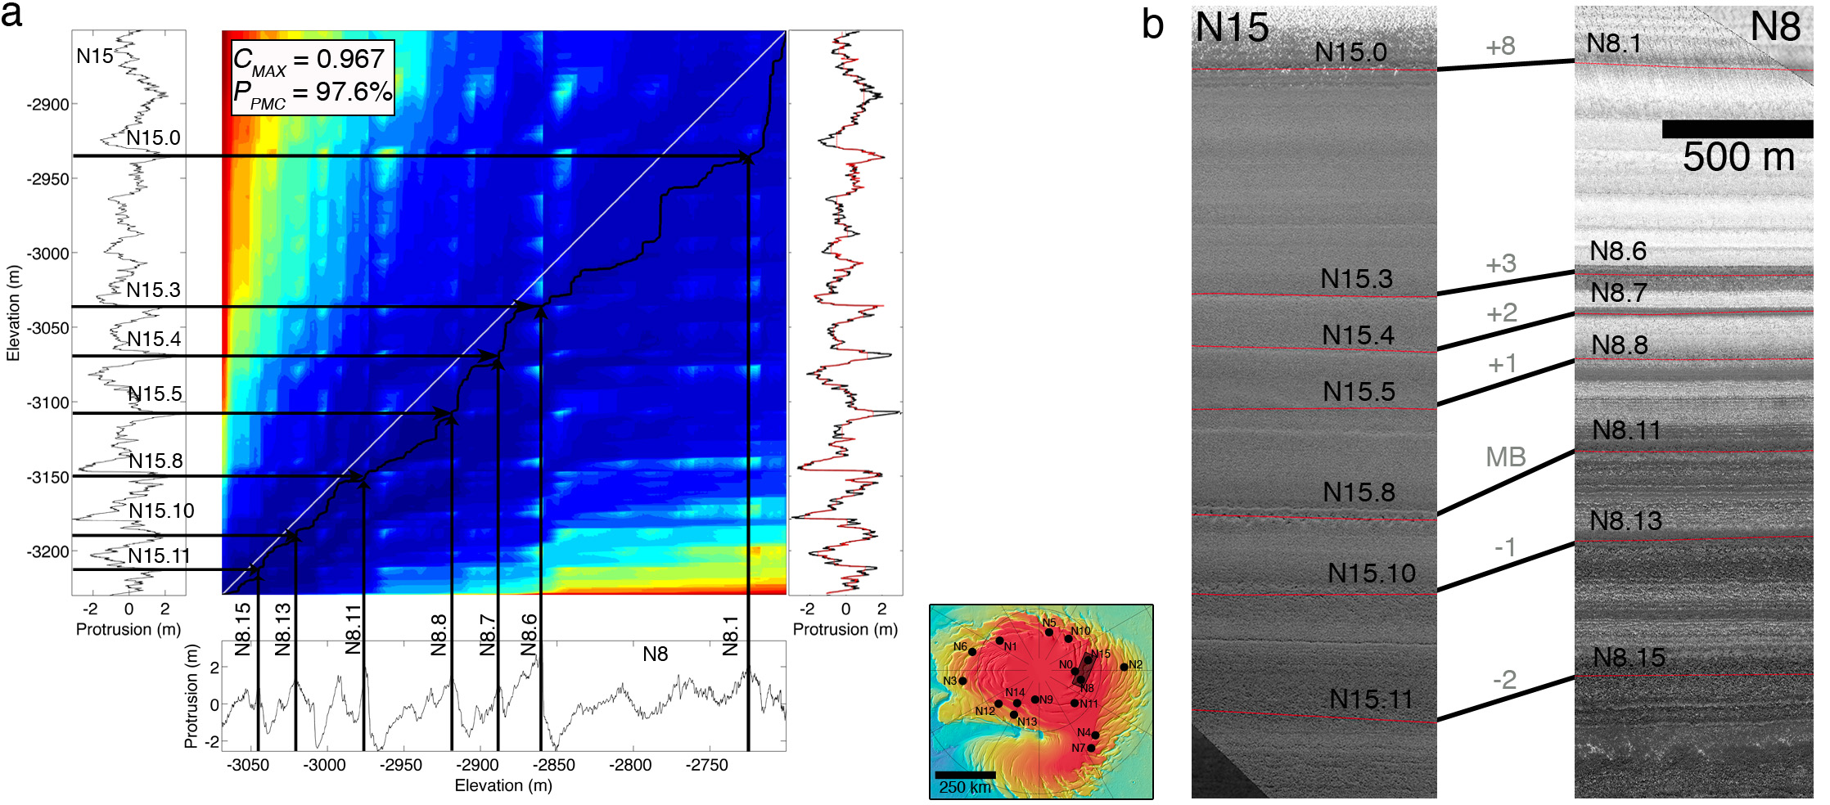
Figure 3.9. Correlation of sites N15 vs. N8 (location is shown in the inset in between 9a and 9b) (a) DTW cost-map of the correlation of N15 (left vertical profile) vs. N8 (bottom horizontal profile) including only the truncated profiles based on tie-points from the CTX tracing (Figure B3.1). The maximum covariance and the Monte Carlo parameter are shown in the top left corner of the cost matrix. Black arrows indicate matches between individual Main Sequence beds. The vertical plot on the right shows the tuned N8 profile (red line) plotted over the fixed N15 profile (black line) (b) Zoomed view of the HiRISE orthoimages with the same layers as (a) indicated (N15 illuminated from the bottom left, N8 illuminated from the bottom). Since these two sites were later correlated to N0, we show the MB ± n nomenclature in grey.

      - Correlations without pre-established layer traces

N1 vs. N6
The trough that contains N1 and N6 has a large feature between the two sites where the exposure of the layers is interrupted. This appears to be material that was emplaced after the trough was formed (Figure B2.2) making it impossible to complete the layer tracing here.
We therefore attempted the correlation using the layer matches of Fishbaugh and Hvidberg [2006]. We identified prominent layers in both the HiRISE data and the MOC images in order to connect our traces with what they call the Lower Layer Sequence (Figure 3b of [Fishbaugh and Hvidberg, 2006]), and used this to correlate the protrusion sequences in sites N1 to those at N6. According to their results, layer N1.7 corresponds to N6.0, and both are surface expressions of the main marker bed MB. We used this match as a single tie-point between the profiles (Figure B3.2), and applied the two steps of the DTW algorithm. The value of C_{MAX} in this case is 0.982, with a P_{PMC} = 95% (Figure 3.10a).
A comparison of the HiRISE orthoimages of these two sites side by side provides an additional constraint and is shown in Figure 3.10c. The correlation requires that sequence N1.7 – N1.12 match N6.0 – N6.5. These sequences appear morphologically similar in the images, and every individual layer match is of the same type (marker bed to marker bed). Based on these arguments, we corroborate the result of [Fishbaugh and Hvidberg, 2006] in this case.
As a test of the method, we attempted the correlation without the tie-point constraint. The result was a C_{MAX} = 0.951, and a P_{PMC} = 55.6% (Figure 3.10b). This example displays the necessity of independent correlations to complement feature-based signal-matching algorithms such as the one used here, or the Match 1.0 algorithm used by Milkovich and Head [2005]. The match between the complete signals with no prior information gives a high covariance, but there is no statistical value attached to it, i.e. such a result could have also been achieved at random.

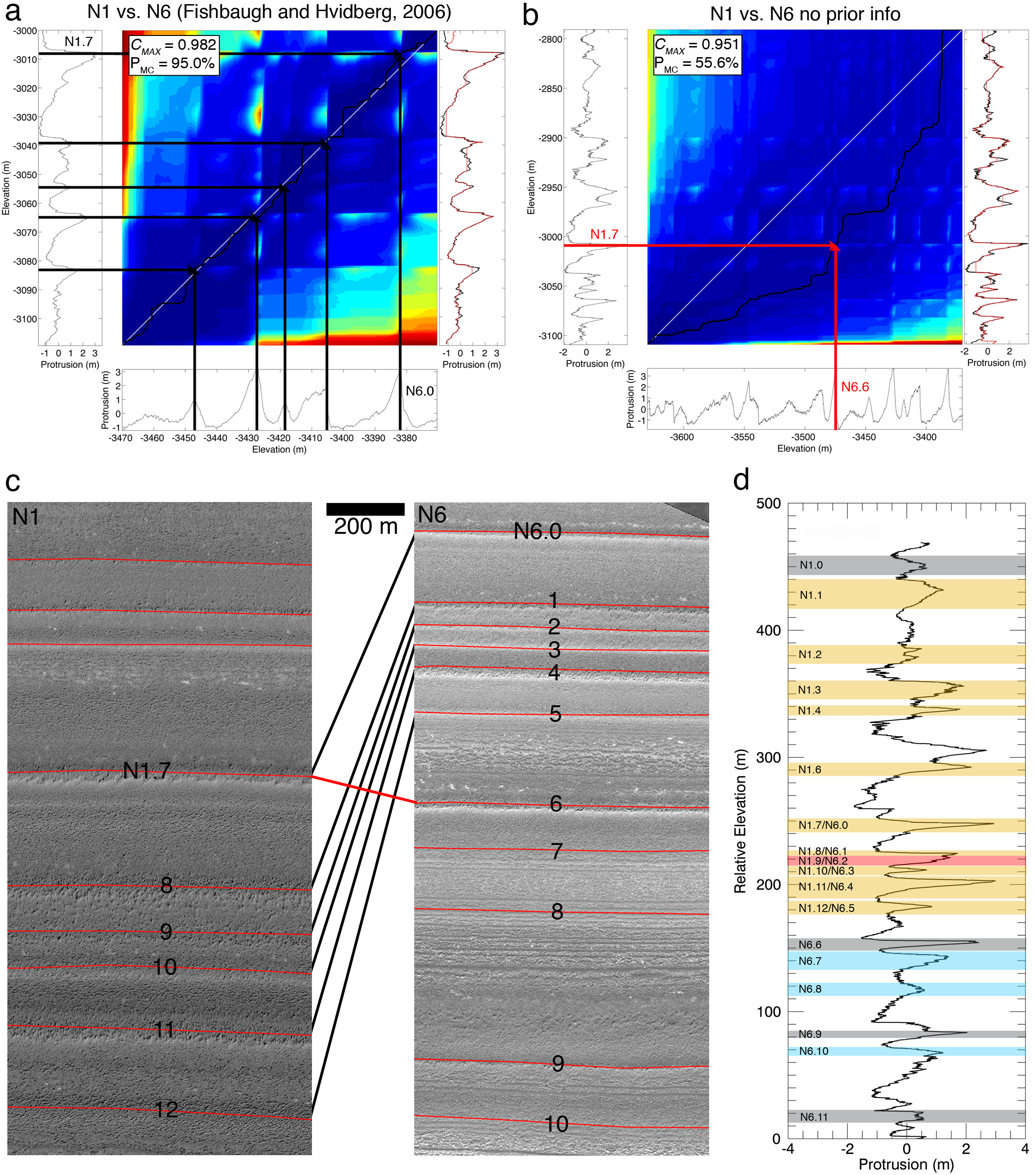
Figure 3.10. (a) DTW correlation of N1 vs. N6 using information from Fishbaugh and Hvidberg [2006]. Matched layers are indicated with black arrows. In the first step of the DTW, N1.7/N6.0 was used as a tie-point (see Figure B3.2). The vertical plot on the right shows the truncated and tuned N6 profile (red line) plotted over the truncated and fixed N1 profile (black line). (b) DTW correlation of N1 vs. N6 using complete (non-truncated) profiles and no prior information. The vertical plot on the right shows the full tuned N6 profile (red line) plotted over the full fixed N1 profile (black line). (b) Zoomed-in view of the HiRISE orthoimages at these sites (In N1 illumination is from the top right, in N6 it is from the bottom left). The connections between layers (black lines) correspond to the correlation on the left panel of (a). (c) Combined protrusion profile of N1 and N6 using the correlation on the left in (a). These two sites were later correlated with site N0, so Main Sequence layers in this profile are highlighted in yellow.

Following this correlation, the lower third of the N1 profile coincides with the upper third of the N6 profile. We can therefore combine the two profiles to produce a larger, continuous stratigraphic column that is applicable throughout the trough wall that includes the two sites. Figure 3.10d is a plot of the combined protrusion profiles.

N15 vs. N0 and N8 vs. N0
Sites N15 and N8 both lie in a trough that is adjacent to that which contains N0 and N10, so direct layer traces cannot be made here and again we use the information from Fishbaugh and Hvidberg, [2006]. Nevertheless, in this particular case we have a correlation between each pair of sites that we trust based on the CTX layer traces and the matching algorithm. So if we confidently tie any site from one pair to any site from the other, we can tie all four profiles together into a single record for both troughs.
In the case of N15 vs. N0, Fishbaugh and Hvidberg, [2006] matched layers N0.3 and N0.6 (MB+3 and MB) to layers N15.3 and N15.8. Using these two connecting points to crop the profiles (Figure B3.3), our correlation between N15 and N0 gives a maximum covariance of 0.96, and a P_{PMC} = 92.9% (Figure 3.11a). In addition, just as Fishbaugh and Hvidberg [2006] did with MOC images, an examination of the morphology of the layers in HiRISE orthoimages (Figure 3.11b) and shaded relief maps supports the same correlation found by the algorithm.

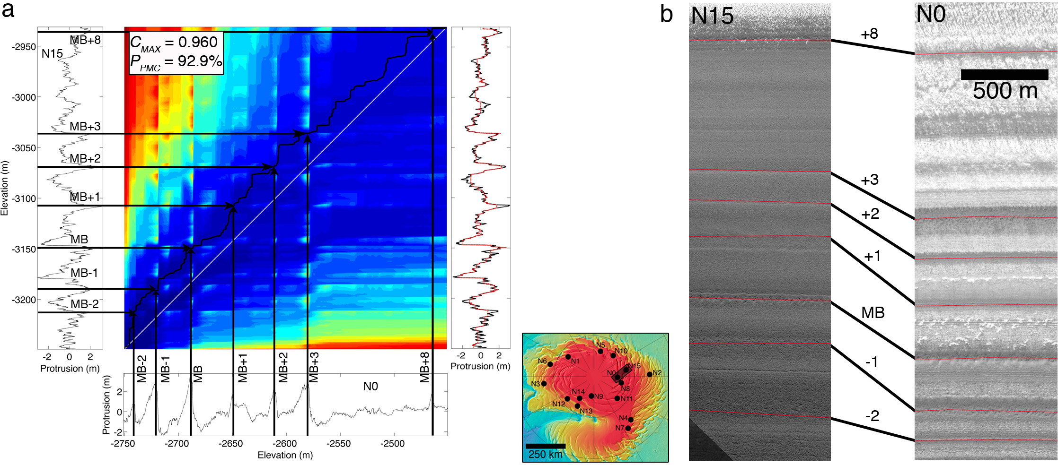
Figure 3.11. (a) DTW cost map for the correlation of N15 vs. N0 including only the truncated profiles based on tie-points (Figure B3.3) from the correlation of [Fishbaugh and Hvidberg, 2006]. Black arrows indicate matches between Main Sequence beds. The vertical plot on the right shows the tuned N0 profile (red line) plotted over the fixed N15 profile (black line). (b) HiRISE orthoimages of both sites with matched layers traced.

To correlate sites N8 and N0 we also used the constraints set by Fishbaugh and Hvidberg [2006]. Once again we first forced layers MB and MB+3 to match layers N8.6 and N8.11 (Figure B3.4), truncated the profiles and then re-ran the algorithm to obtain the cost-map shown in Figure 3.12a. In this case however, the result is a P_{PMC} of 75.7%, which falls short of the 90% threshold. However, we can confidently match N15 to both N0, and N8 and so connect protrusion peaks at the latter two sites through N15. This exercise suggests that the N0 vs. N8 correlation suggested by the DTW algorithm is in fact correct. Furthermore, the orthoimages of the correlated sequence (Figure 3.12b) seem to support the obtained match. We ascribe the lower confidence score to stronger periodic components of the N8 signal that may be more similar to those of N0. With a stronger periodic component it is easier for the random signals to match the data well.

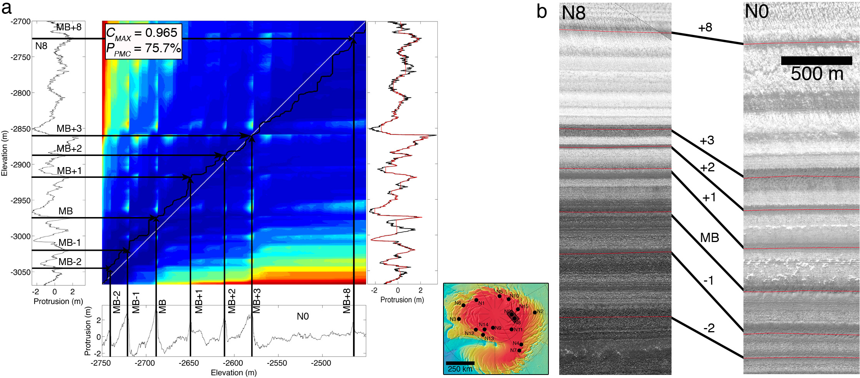
Figure 3.12. Same as Figure 3.11, but for N8 vs. N0.

The correlation between these two pairs of sites is an example of how multiple DTMs can be used progressively with independent corroboration from image data to obtain a match between various stratigraphic profiles regardless of location, extending the validity of a certain stratigraphic column to larger portions of the NPLD.

N0 vs. N1
These two sites are across the NPLD from each other (~ 370 km apart across the pole). Fishbaugh and Hvidberg [2006] identified a separate sequence in site N1 than the one they mapped in N0. Site N0 – and the sites here correlated to it – contain a section of stratigraphy that they call the Upper Layer Sequence (ULS), and N1 (and N6) contain their Lower Layer Sequence (LLS). The link between these sequences is the original Marker Bed (MB) of Malin and Edgett [2001], which the authors map as the lowermost layer of the ULS. In Image 4 of their Figure A1, they map the ULS in site N0 and include MB. They also map MB above the LLS in their Image 10 (Figure 3 in their paper), which corresponds to our site N1. After we had confidently identified MB in our images and protrusion profiles of sites N0, N10, N8 and N15, we found the layer that Fishbaugh and Hvidberg, [2006] identify as MB in the HiRISE DTM and orthoimages of site N1 and identified its elevation in the corresponding protrusion profile, where we had mapped it as bed N1.0. We used this information as the initial tie-point, i.e. in the first step of the procedure we tie MB in site N0 to N1.0 in site N1 (Figure B3.5). This results in a comparison between a lower section of N0 (below MB), and an upper section of N1 (N1.0 to N1.7). Applying the DTW technique on the truncated sections results in a maximum covariance of 0.921, with a P_{PMC} = 59.4%. This is not a satisfactory correlation, and it means that a random signal has a nearly equal chance of matching this lower sequence of N0 than does N1. In addition, the correlation matches a high-protrusion layer in N0 (MB-2) to a low-protrusion (and thus unmapped) layer in N1, suggesting that the algorithm cannot find a plausible correlation in this case. The cost map is shown in Figure 3.13a, and the relevant sections of the orthoimages, with the links between layers that would result from this correlation are shown in Figure 3.13b. This result implies that the correlation between these sites that matches MB to N1.0 is incorrect.
Examination of the two complete protrusion profiles reveals that they appear very similar to each other. The layers seen in the orthoimages (Figure 3.13d) also seem to match based on morphology and relative position. Because of this observation, we decided to test the correlation between the two complete profiles without any prior information from tie-points, remembering that in such a correlation the DTW may output a high-confidence result that may not be real. The result from this exercise, shown in Figure 3.13c, was a covariance of 0.971 and a P_{PMC} = 97.7%, the highest confidence of any pair we compared. In addition to the apparent high statistical confidence of this correlation, the translation of this match to the orthoimages, seen in Figure 3.13d, shows a similar morphology between the layers matched, suggesting that the match proposed is plausible. As a consequence of the results of this analysis, we propose that the correlation seen in Figure 3.13c, matching MB to layer N1.7 rather than N1.0 is acceptable as a replacement for the previously established relationship by Fishbaugh and Hvidberg [2006].
This new correlation relies heavily on the DTW algorithm and the statistical value given to its result without any tie-points or independent information. As we have explained above, the limitations of the algorithm imply that because of this lack of independent links, we cannot assert that this new correlation is correct with the same level of confidence as other correlations (e.g., N0 vs. N10), and a high degree of uncertainty is inherently present. Any future research performed relying on this correlation should take this uncertainty into account. Nevertheless, for the purposes of this study, we accept this correlation, and tie the sequence correlated in sites N0, N10, N8 and N15, to the sequence in N1 shown in Figures 3.13c and 3.13d.

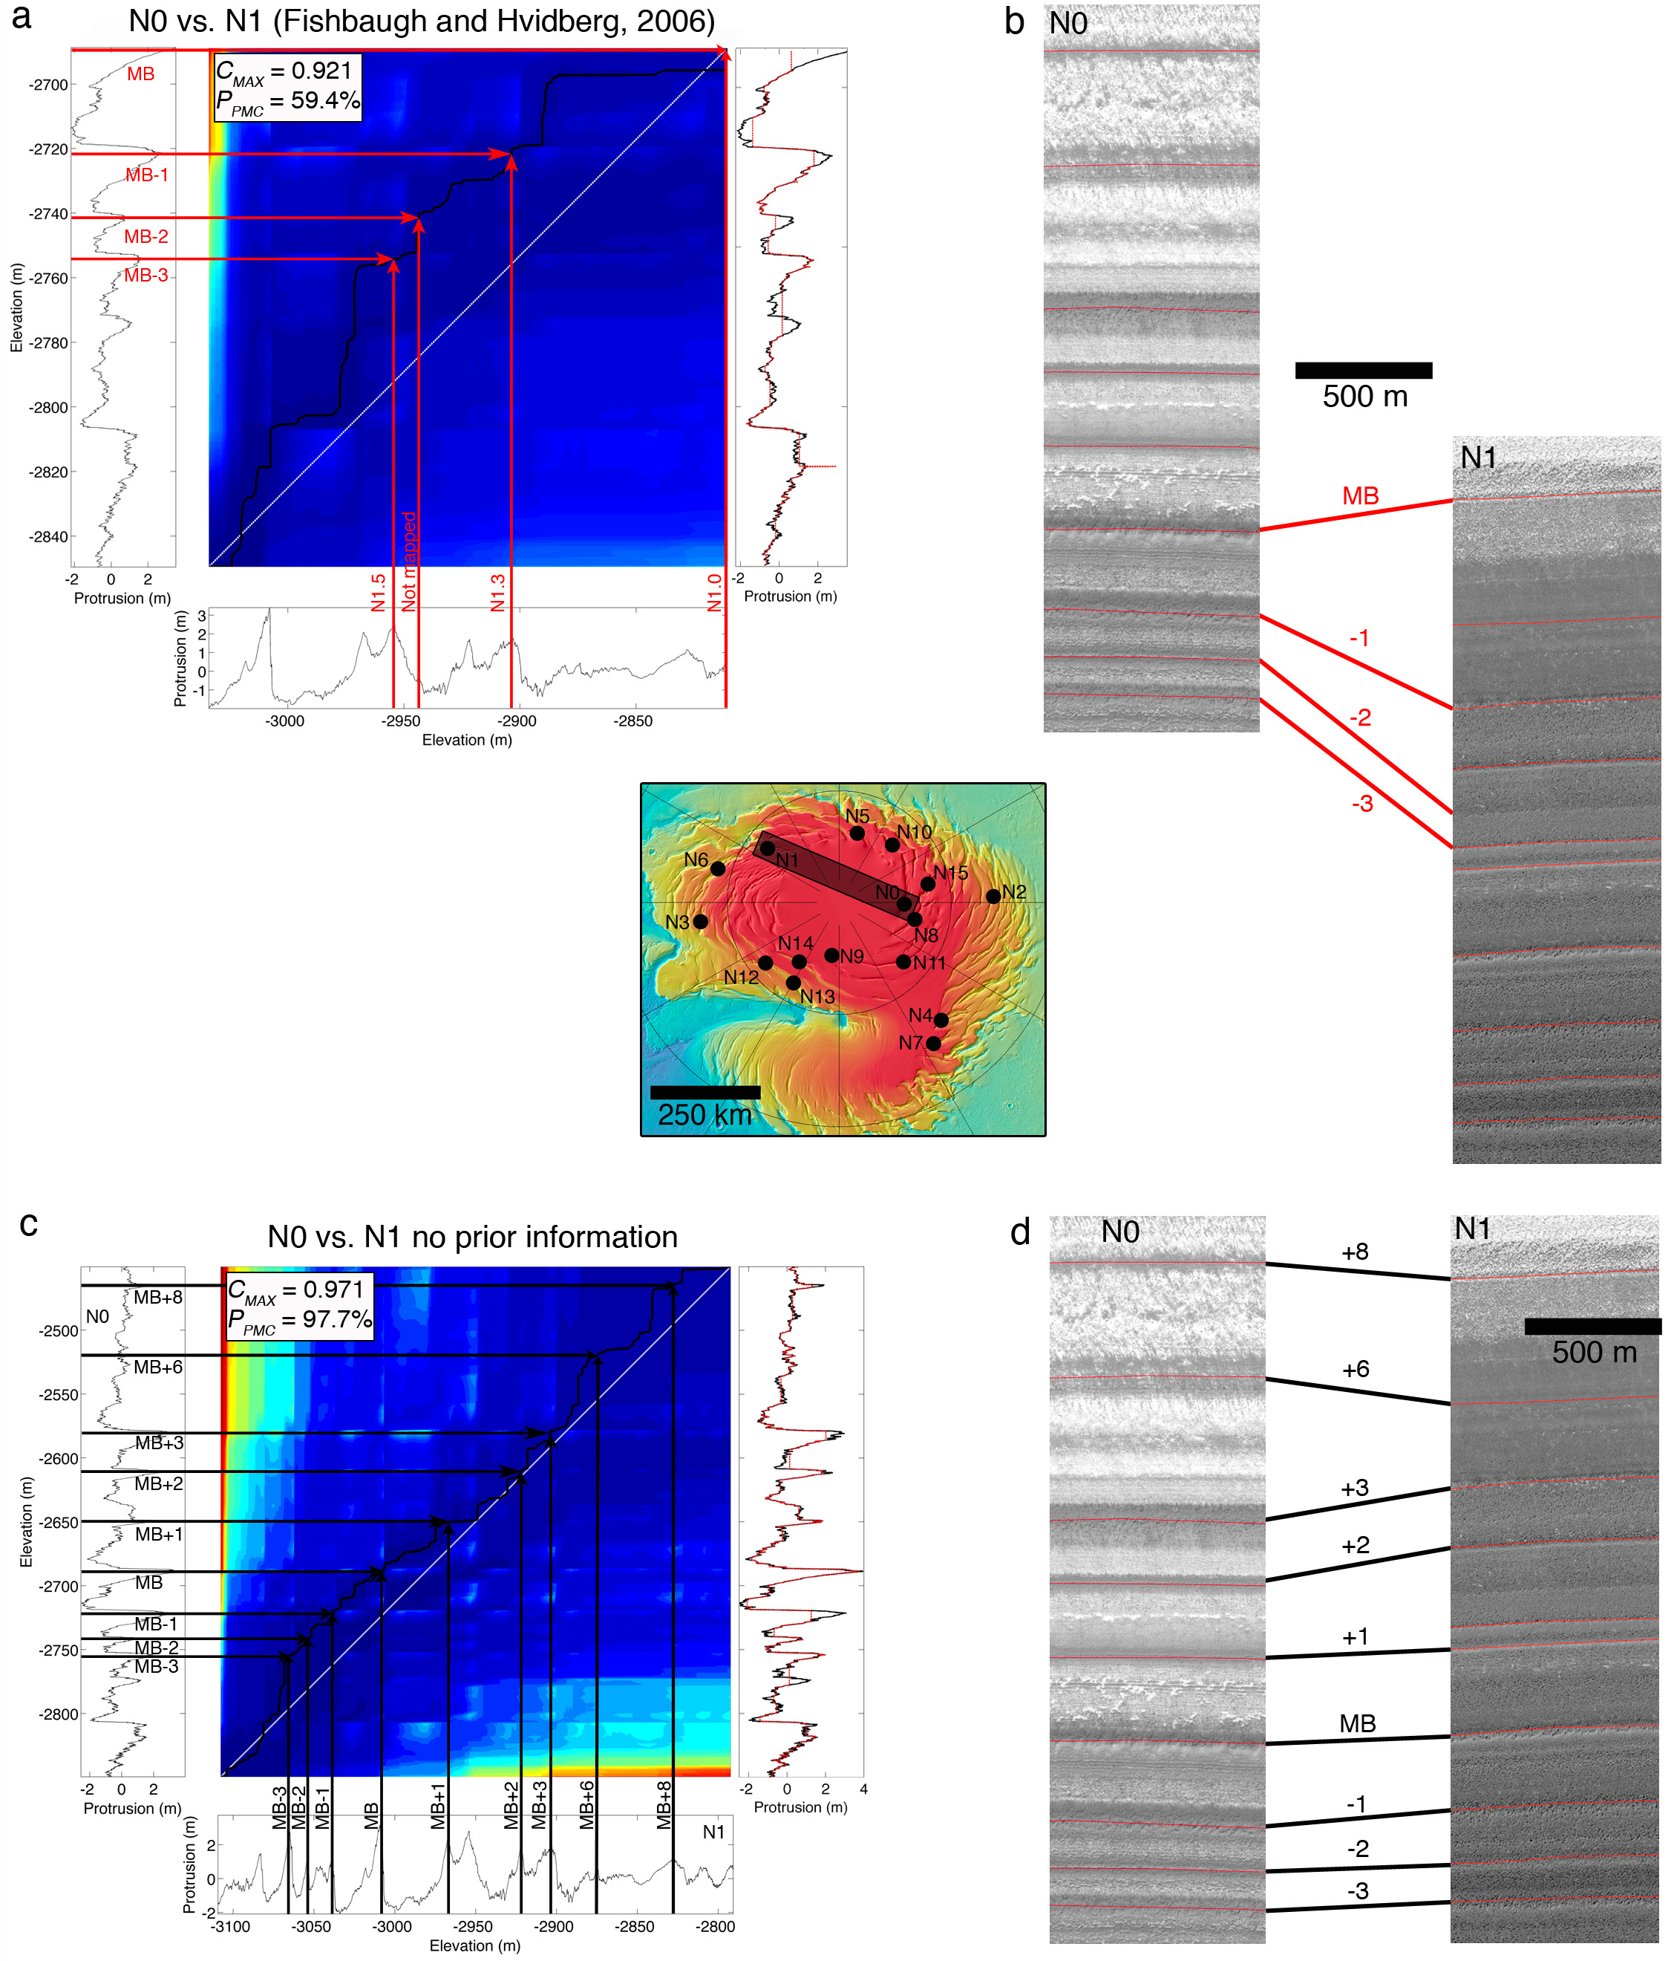
Figure 3.13. Correlations of N0 vs. N1. (a) DTW cost map of N0 vs. N1 based on the sections of each profile that would match according to the correlation of the MB layer in both locations by Fishbaugh and Hvidberg [2006]. The vertical plot on the right shows the tuned N1 profile (red line) plotted over the fixed N0 profile (black line) (b) Comparison of HiRISE orthoimages of N0 and N1 based on the match given by (a). Layers that should match according to (a) are connected with black lines. (c) DTW cost map of N0 vs. N1 with no prior information given to the algorithm, i.e. profiles are assumed to represent a similar section of stratigraphy. The vertical plot on the right shows the differently tuned N1 profile (red line) plotted over the fixed N0 profile (black line) (d) Comparison of HiRISE orthoimages of N0 and N1 based on the match given by (c). Layers that should match according to (c) are connected with black lines.

N0 vs. N6
The correlation of this pair is based on those of N0 vs. N1 and N1 vs. N6, discussed above. We used the information from those correlations to inform the comparison between N0 and N6. In order to select the portions of each profile that we assume should match, we used the N0 vs. N1 correlation of Figure 3.13c, and the N1 vs. N6 correlation of Figure 3.10a. The result is shown in Figure 3.14. Although the confidence of this correlation is 89.5% and therefore below our threshold of 90%, we observed the error between 100 runs of the algorithm for the same pair (i.e., each run applying the DTW with the data and the Monte Carlo test with 1000 random signals) to be ~1%, meaning that this correlation could still be considered reliable. In addition, as with all previous cases, we can corroborate the plausibility of the match shown in Figure 3.14a by comparing the morphology and relative stratigraphic position of the matched layers in the orthoimages, which we do in Figure 3.14b.
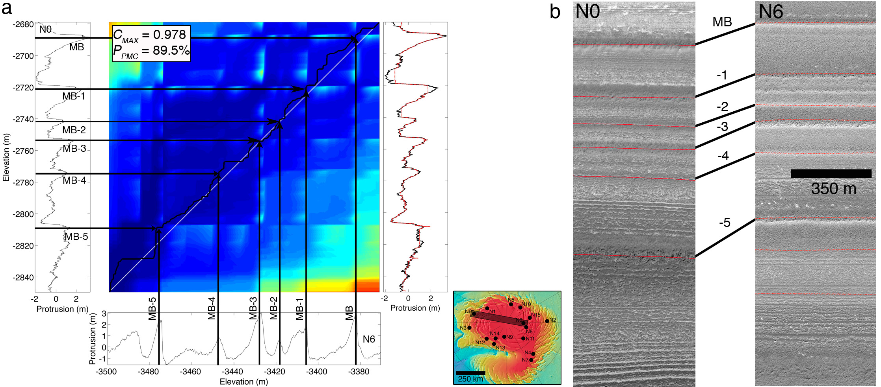
Figure 3.14. Same as Figures 3.11 and 3.12 but for N0 vs. N6.

With the last two correlations, we have extended the validity of the Main Sequence beyond the area bounded by the N0 and N8 troughs, to the trough of N1 and N6. Of these six sites, the two sites that are farther from each other are N6 and N15, separated by ~550 km. The area of the convex hull that includes all of these locations is ~66000 km². This is the minimum possible area for which we propose the Main Sequence to be a valid stratigraphic column, and it represents ~9% of the total area of the NPLD.

    - Protrusion vs. Brightness
Figure 3.15 shows the results of comparing a correlation of protrusion profiles (Figure 3.16a) to one of brightness profiles (Figure 3.15b) for the same-trough case of sites N0 – N10. The brightness profiles of Figure 3.15b were extracted from the same ground tracks on the trough as the N0 and N10 protrusion profiles. We also used the same constraints in this correlation as we do to correlate protrusion in 15a, i.e. we truncate the brightness profiles at the same locations in depth as the protrusion profiles, meaning that the brightness profiles are also “guided” by the CTX-based layer tracing that informed which sections of stratigraphy should be compared and tested to match. In site N0, high-protrusion beds correspond well to local minima in the brightness signal, consistent with previous findings that marker beds tend to have lower albedo [Fishbaugh et al. 2010b]. However, this correspondence is not as obvious in all sites (Figure B5).
As mentioned above, we consider the protrusion-based correlation for this pair reliable (Figure 3.15a, and Figure 3.5b) since it gave a P_{PMC} = 90.5% and the match proposed by the algorithm is the same as that observed in the CTX traces. The brightness correlation not only gave a P_{BMC} = 54.6%, implying an equal chance of being obtained at random, but it also obtains an incorrect layer-match as judged by the traced layers in the CTX images. This suggests that the correlation of these particular sites with protrusion signals and DTW constrained by CTX traces is more consistent than using brightness profiles constrained in the same way. It does not imply that protrusion alone is a better metric than brightness alone, we view both as unreliable without the information provided by layer tracing.

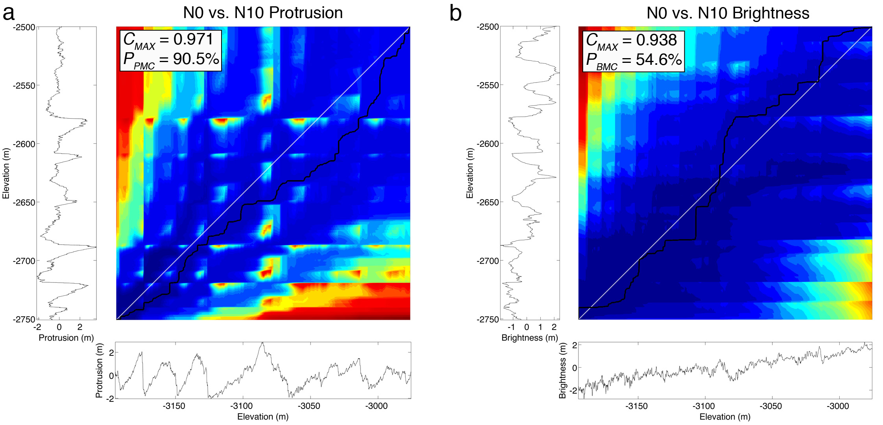
Figure 3.15. (a) Output of the correlation between the protrusion profiles of sites N0 and N10. (b) Same as (a) but for brightness profiles instead of protrusion. Brightness (I/F) is relative to the mean and normalized to unit variance. The same sections of stratigraphy are being compared. These were selected based on the CTX traces of layers MB+3 and MB in each site.

The results of this analysis for all pairs are listed in Table 3.2, and the protrusion and brightness cost maps for the remaining six pairs are included in the SOM (Figure B5) along with an explanation of the analysis of each pair. The values of P_{PMC} listed in Table 3.2 correspond to the high-confidence correlations for each case shown in the previous section. Six out of seven correlations, (all except N8 vs. N0) had a P_{PMC} > 90% within the 1% simulation error. Five of seven pairs obtained a low P_{BMC} of <75%. The remaining two cases (N15 and N8 vs. N0) had a P_{BMC} > 98%, implying an extremely low chance of these matches being obtained at random. However, in those cases the algorithm picked a different match from the ones based on CTX mapping and the Fishbaugh and Hvidberg, [2006] study, whereas for the same comparisons it picked the correct match when using protrusion instead.

Table 3.2. Results of the DTW-Monte Carlo correlation of protrusion and brightness profiles from the seven pairs of sites detailed in the text. P_{PMC} is the Monte Carlo parameter for comparisons of protrusion, and P_{BMC} is for brightness. Values in boldface indicate correlations that exceed the 90% threshold for confidence. The sixth column from the left indicates whether or not the protrusion correlation matches the brightness correlation at each site. Distances between sites represent the length of the shortest straight line drawn between two sites in ArcGIS, and are therefore approximate. The rightmost column lists the figures in the paper and the SOM associated with each comparison.

Site Pair | Protrusion |  | Brightness |  | Correlations match? | Distance between sites (km) | Notes | Figures
 | C_{MAX} | P_{PMC} (%) ± 2% | C_{MAX} | P_{BMC} (%) ± 2%
N0 vs. N10 | 0.971 | 90.5 | 0.938 | 54.6 | No | 145 | Same trough | 3.5 and 3.15
N15 vs. N8 | 0.967 | 97.6 | 0.873 | 70.1 | No | 90 | Same trough | 3.9 and B5.1
N1 vs. N6 | 0.982 | 95.0 | 0.945 | 50.2 | No | 136 | Same trough | 3.10 and B5.2
N15 vs. N0 | 0.96 | 92.9 | 0.950 | 98.5 | No | 55 | Adjacent troughs | 3.11 and B5.3
N8 vs. N0 | 0.965 | 75.7 | 0.988 | 99.0 | Partially | 75 | Adjacent troughs | 3.12 and B5.4
N0 vs. N1 | 0.971 | 97.7 | 0.934 | 54.5 | No | 370 | Across the NPLD | 3.13 and B5.5
N0 vs. N6 | 0.978 | 89.5 | 0.856 | 18.7 | No | 490 | Across the NPLD | 3.14 and B5.6

    - Relative Accumulation Rates
The stratigraphic correlation of different locations on the NPLD allows us to estimate relative accumulation rates between correlated sites [Fishbaugh and Hvidberg, 2006]. Because we specifically selected sites that did not include any known unconformities [Tanaka and Fortezzo, 2012], we can interpret a difference in separation between two layers in one site versus another to be related to geographical differences in accumulation rates at that scale. We defined the Main Sequence to be comprised of layers MB+8 through MB-5, but since not all sites that we correlated contain this entire set, we estimate relative accumulation rates for three adjacent subsequences: MB+8 – MB+3, MB+3 – MB, and MB – MB-2. The only subsequence present in all six correlated sites is MB – MB-2. To a first order approximation, the average accumulation rate of one site relative to another for each subsequence is equivalent to the ratio of vertical separations between the uppermost and lowermost layer of each subsequence [Fishbaugh and Hvidberg, 2006]. Since there is no timescale associated to these measurements, the vertical separations are equal to the average accumulation rate for that subsequence multiplied by time. We normalize these measurements to the separation of each pair of marker beds at site N0.
Our results are summarized in Figure 3.16. Each point in Figure 3.16 represents the separation in elevation between the top and bottom layers of that particular subsequence. The error bars here are again propagated from the measurement error of each layer’s elevation. These plots show that there is a non-trivial variability of up to a factor of ~2 in accumulation rates throughout all subsequences. Although we don’t have enough correlated sites to confidently observe a trend in relative rates with latitude, the MB – MB-2 subsequence appears to show a decreasing accumulation rate with latitude when excluding site N8, as does MB+3 – MB when excluding N0. The MB – MB-2 subsequence is below the Marker Bed, and as such would belong to the LLS of Fishbaugh and Hvidberg [2006], for which they similarly found a decrease in accumulation rates with distance from the pole.

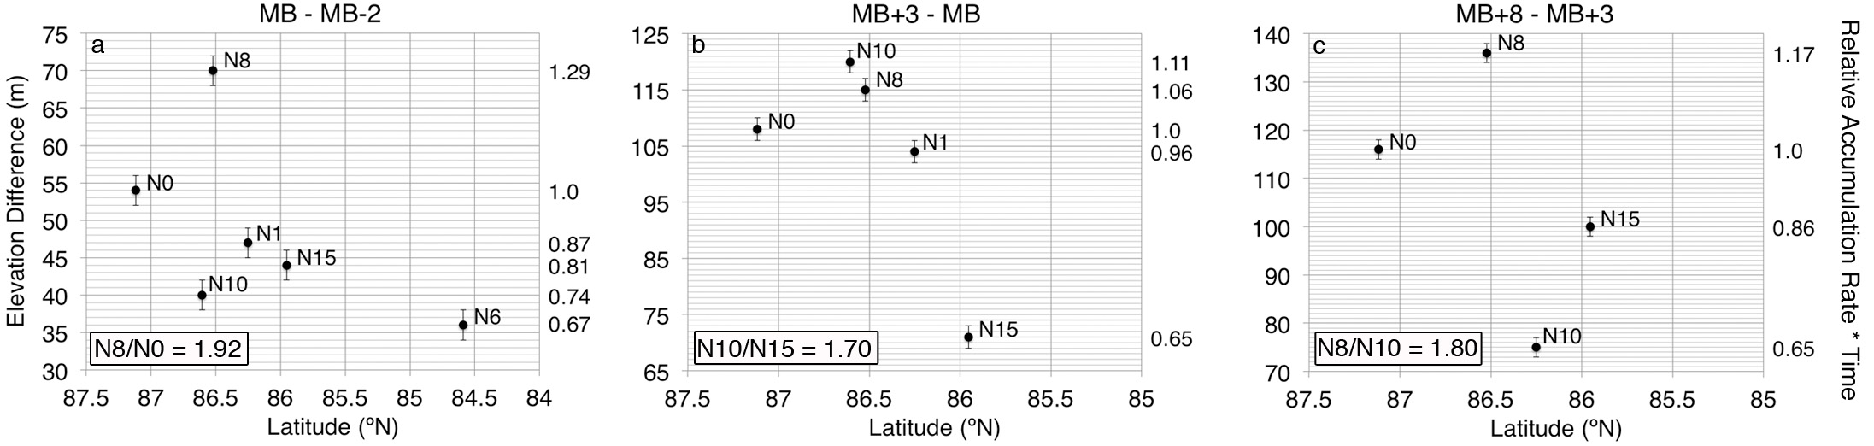
Figure 3.16. Relative accumulation rates vs. latitude for the sequence of layers from (a) MB to MB-2 (b) MB+3 to MB and (c) MB+8 to MB+3 for all sites that included each subset of the Main Sequence. The left vertical axes show the measured value of the separation difference between the two edge layers of each subsequence. The right vertical axes show the relative accumulation rate with respect to the separation difference at site N0. The boxes at the bottom left of each plot indicate the largest ratio of relative rates between two sites for each subsequence.

  - Discussion
Our analysis of the topographic signal of protruding NPLD layers has yielded results that confirm many of the observations of previous studies, and in one case challenge the results of past efforts to correlate stratigraphic signatures from different areas of the NPLD.
Our results show that the topographic expression of the layers is a necessary measurement that, when used in combination with layer tracing in images, is well suited to describe the stratigraphy. Applying the same signal-matching technique and the same statistical analysis to protrusion signals and brightness signals from the same locations shows that layer protrusion is a property that appears to be continuous through hundreds of kilometers along a trough wall and in some cases across troughs and across Planum Boreum. In six out of seven protrusion-based correlations we found matches between the signals with high statistical confidence, and in both pairs for which we knew the correct relationship between the layers the algorithm output the correct correlation with high statistical confidence. When we attempted to correlate brightness in these two pairs the correct correlation was not found and the matches that the algorithm did find did not have high statistical confidence. This fact alone implies that topographic properties such as protrusion, when constrained by image-based layer mapping, are a better stratigraphic descriptor than layer brightness alone. This analysis suggests that correlating protrusion profiles from different locations using DTW constrained by layer traces in images is a more robust method of correlation than using brightness profiles with DTW constrained in the same way. It does not imply that protrusion alone is a better metric than brightness alone, as brightness is being used and trusted to perform the traces in the images, which constrain the signal-matching method in both metrics. However, it does expose a weakness of correlating brightness signals with feature-matching algorithms such as DTW, and it suggests that although brightness can yield accurate information in some cases, the combination of brightness from high-resolution imagery with high-resolution topographic data is the best way to define the stratigraphy.
The differences between our measurements of the thickness of marker beds compared to those of Fishbaugh and Hvidberg, [2006] and Fishbaugh et al., [2010a] are most likely due to the fact that our results are based primarily on the protrusion profiles, and we only use the images for reference. Our method has the advantage of being easily applied to large numbers of DTMs in a semi-automated way, but it has the disadvantage that we may be classifying closely spaced resistant layers as a single marker bed because the protrusion data are lower resolution than the HiRISE images. For the purposes of cyclostratigraphic analysis, the measurement of layer width is less important than separation, and our measurements of separation do agree with past studies.
We measured the average separation between highly protruding beds to be 28 ± 15 m. This characteristic value has been observed by nearly every study on NPLD stratigraphy since the observations of MOC. It corresponds to the range of dominant brightness wavelengths of 24 – 35 m observed by Milkovich and Head, [2005] and Milkovich et al., [2008]. Fishbaugh et al., [2010a] measured a similar average separation at site N0, identifying, at this site, the physical expression of the geologic features responsible for this periodicity. In addition, Christian et al. [2013] measured similar wavelengths when analyzing SHARAD data, showing that this periodicity is present in the internal stratigraphy and likely to be real, and not just a characteristic of exposed strata. We have identified these features throughout all 16 of our study sites, thus confirming the physical manifestation of this periodicity as observed by previous authors in central Planum Boreum. The area covered by these 16 sites, in which this periodicity exists, is about 285000 km², or about 40% of the total area of the NPLD.
The discrete identification of layer sequences in the protrusion profiles coupled with the stratigraphic correlation of a subset of our study sites allowed us to identify a number of layers that appeared within the Main Sequence in some sites but not in others, and thus to speculate on the possible existence of local unconformities. Layer N1.9, located between MB-1 and MB-2 in site N1, is observed in sites N6 and N8 (N6.2, N8.14) but not in sites N0, N10 or N15, so we identify a candidate local unconformity at these sites, labeled UC-1 (Figure 3.6). The vertical separation between MB-1 and MB-2 is similar throughout all sites (~15 – 20 m). Layers N8.9 and N8.10 are identified as high-protrusion beds in site N8 and N15 (N15.6 and N15.7), located immediately below MB+1 at these sites. These peaks are not observed in sites N0, N1, and N10, so we mark a candidate unconformity UC+1 here. Again in this case, the separation between MB and MB+1 is similar in all sites (~ 45 – 50 m). In these cases, it is possible that differential deposition (which has been shown to exist with radar-based studies [Smith et al., 2013; Smith and Holt, 2015]) resulted in similar separation distances at the sites with the candidate unconformities. This would mean that certain areas of the NPLD have a wider range of accumulation rates with the same mean as other areas. The similarity in layer separations indicates that the mean accumulation rate is similar in all sites, yet some have erosional episodes. We speculate that the these locations have the same mean accumulation rates over long timescales, but they contain erosional episodes when other locations are accumulating at lower rates, and they accumulate quickly when other locations are accumulating at more modest rates. We observe a slightly different scenario in site N1, where we identified layer N1.5 immediately above MB+1, did not identify this layer in any other sites, and the separation between MB+1 and MB+2 throughout the study sites varies by 10 – 15 m. N1 is the farthest away from all other sites (except N6, in which we didn’t map the upper Main Sequence), so it is possible that one side of the NPLD experienced a regional erosional episode that did not occur near the location of N1. A similar argument can be made for the non-detection of layers MB-4 and MB+5 in site N1. It is reasonable to expect that the larger the geographical distance between two sites, the more discrepancies in the stratigraphic record will appear, likely due to geographical differences in depositional and erosional episodes.
The most important result of our mapping efforts is the detection of the Main Sequence (or significant portions of it) in six out of sixteen sites. From our correlation of the stratigraphy at these sites, we can infer that the Main Sequence represents a stratigraphic column that is valid at least for the area between 87º and 84º N and between 60º and 250º E (Figure 3.1a). In Figure 3.17, the column of layers drawn in yellow is the Main Sequence, and we propose this column represents the stratigraphic relationships at all locations that were correlated to N0, which as we mentioned in the previous section, amounts to about 9% of the total area of the NPLD. Since site N6 was successfully correlated to sites N1 and N0, and it includes layers that are stratigraphically below the Main Sequence, we include these layers in Figure 3.17 as a possible extension of the Main Sequence beneath layer MB-5.

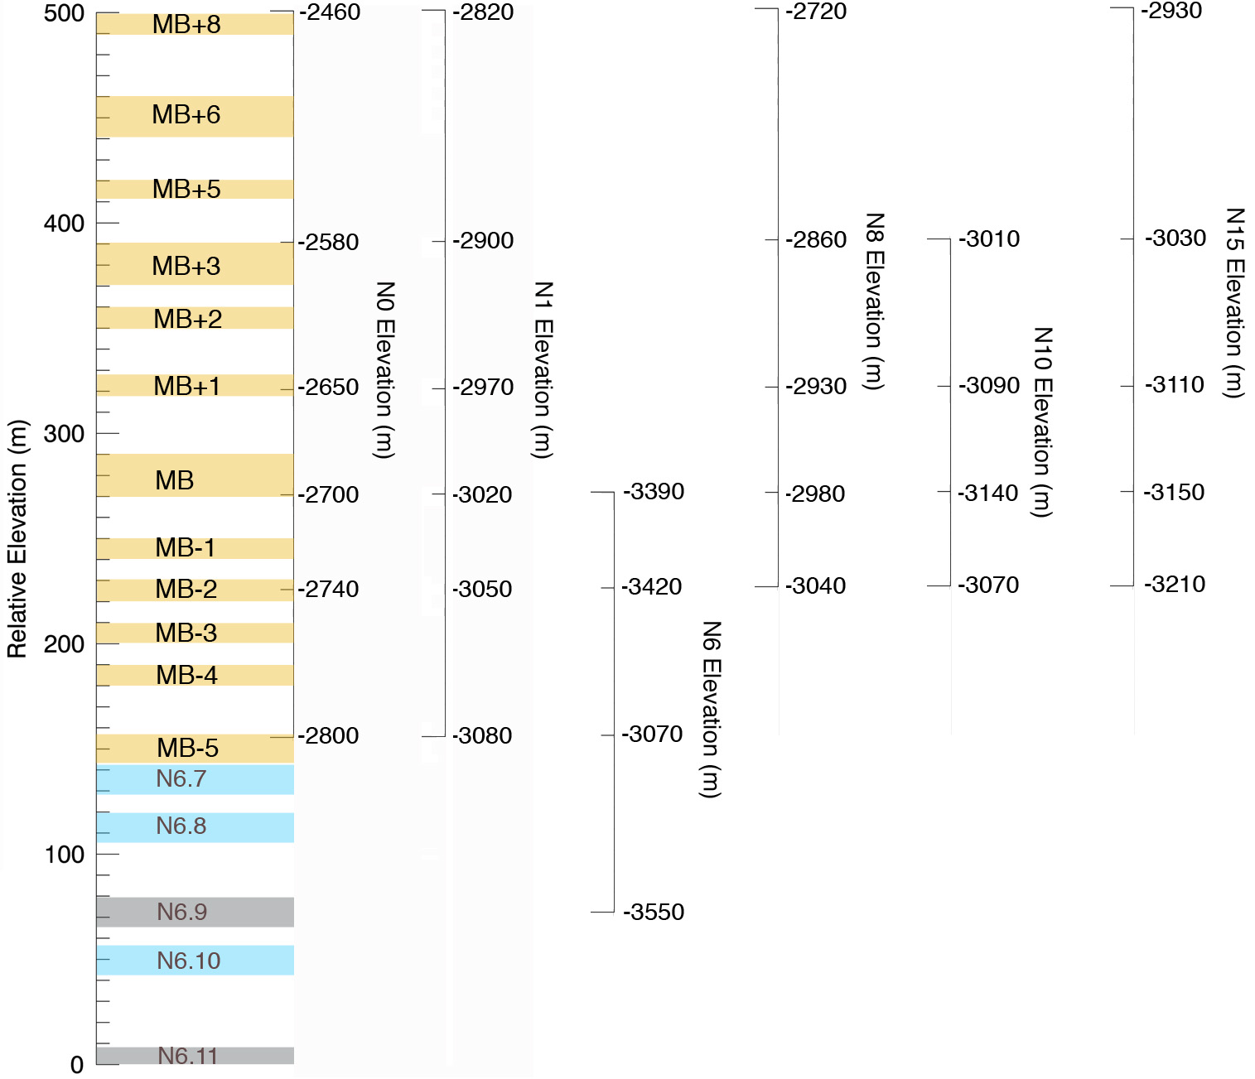
Figure 3.17. Stratigraphic column for the study area comprised by the six sites we correlated. This column shows the relative elevation of the Main Sequence layers and their locations in each of the correlated sites. The site-specific axes to the right of the relative elevation column are not to scale, and are just meant to show the approximate locations of layers in each correlated site with respect to the relative elevation column. Colors have the same meaning as in Figure 3.6.

We have also provided estimates of the average net relative accumulation rates of mapped stratigraphic sequences through different regions of the NPLD. The relatively small variations in accumulation rate between sites suggest a spatial continuity of layer deposition throughout the region we have studied. Nevertheless, we have shown that the difference in relative accumulation can reach up to a factor of two between some locations, implying at least some geographical heterogeneity in accumulation and ablation of the NPLD. The variability in relative accumulation implied by our results is valid at the scale of the separation distances between the layers measured, and therefore the values we present here represent average relative rates for each sequence mapped. An effect of the non-linearity of the stratigraphic record could mean that there are higher or lower accumulation rates at shorter depth scales that, over the scale of the sequences mapped here, average to the observed values of relative accumulation. The possible presence of unconformities in the Main Sequence, explained above, could be evidence of this. In addition, these values must be taken as lower limits for the NPLD, as SHARAD studies that cover much larger regions of the NPLD, and include areas like Gemina Lingula or the margins of the NPLD, have shown that the thicknesses of some layers vary by as much as 50 m, implying much larger geographic changes in deposition rate. Therefore, we expect that as the area of the region of study increases, the range of relative accumulation rates will also increase.
Our correlation method provides a quantitative way to relate stratigraphic sequences from across the NPLD to each other. Nevertheless, an important limitation of the DTW-Monte Carlo method exists due to the periodic nature of the deposits. As we explained in the methods section, if the layered deposits are caused by a periodic temporal variation of the orbital and rotational parameters of the planet, then it is expected that two different sections of the stratigraphy that were formed at different times will have similar signals regardless of the property used to describe them. Our correlation results show that the DTW could output a statistically significant match for two sequences that are both forced by the same insolation signal but that perhaps do not represent the same time interval. In our study, we have been able to correlate sites from different troughs by comparing our method with indirect, previously established relationships between two sites. Another method is required in order to ensure that the correct sections of stratigraphy are being compared in these cases. This method could in principle be visual inspection of isolated sites. Unfortunately, similarity in the morphological appearance of different marker beds, thin layer sets, and even entirely different sequences of layers make it difficult to correlate layers in different troughs when relying only on visual inspection to identify sequences. Therefore, a priori matches in these cases are difficult to achieve, and can be unreliable. The best way to piece together correlations from different parts of the NPLD would be to obtain DTMs at more locations that share a trough wall with the sites that we have already correlated in this study, and incrementally correlate more sites until a complete stratigraphic picture is constructed. An example of this approach was achieved here when correlating the stratigraphy of the N0-N10 trough, to that of the N8-N15 trough. The construction of a single stratigraphic cross-section, correlating all 16 sites, and resulting in a complete description of the NPLD stratigraphy, is an issue that is outside the scope of this paper and will require more data. We are currently addressing this issue in follow-up studies.

  - Summary and Conclusions
Our study describes the stratigraphy of the NPLD using high-resolution topography of layer exposures. We have extracted protrusion-based, one-dimensional stratigraphic profiles for 16 sites in the NPLD, and have successfully correlated six of these sites, resulting in a stratigraphic column that is applicable to at least 9% of the surface area of the NPLD. We can draw three principal conclusions from our work, related to the initial questions posed in the introduction:
- The combination of image analysis from CTX and HiRISE with a DTW algorithm to match depth-varying signals shows that the protrusion of exposed layers is laterally continuous throughout hundreds of kilometers across the NPLD. Consequently, we conclude that the topographic expression of the layers reveals a property (relative resistance to erosion) that is related to layer composition throughout the entirety of a particular layer.
- A description of the stratigraphy that combines protrusion as seen by HiRISE, and brightness as seen by CTX and HiRISE, represents a significant improvement over one based solely on layer brightness. The results of comparing the correlations of protrusion profiles to brightness profiles with the same constraints based on traced layers suggests that protrusion is more consistently continuous over long distances when provided with independent constraints. This implies that observed brightness is more affected than topography by extrinsic factors that change its value over different locations across the NPLD. This does not mean that remotely measured brightness has no relation to the underlying physical properties of the layers, as if this were the case, no banded layers would be observed in the images. Rather, it suggests that the relationship between these properties and brightness is more complex than the one they have with topography.
- The correlation of various protrusion signals over our region of study within the NPLD shows that relative accumulation rates at any given epoch vary geographically by up to a factor of two. However, this value is likely a lower limit for the NPLD as a whole. This has important implications for future efforts to model the formation of the deposits, as the lateral variation of accumulation rates complicates the modeling of processes that drive this formation.
In the future, our continuous protrusion profiles can be studied with cyclostratigraphic analysis techniques such as Fourier or wavelet transforms in order to explore the connection between the NPLD stratigraphy and orbital/rotational-driven variations in climate [Hvidberg et al. 2012]. This connection cannot currently be made in a straightforward manner because of the non-linearity of the time-depth relationship in the NPLD [Perron and Huybers, 2009; Hinnov, 2013]. However, performing spectral analysis on these topographic signals and studying their relationship with the spectral signature of climatic signals such as insolation or historical surface temperature would be a good next step to test the degree of non-linearity and provide constraints for future modeling efforts.

CHAPTER FOUR
Wavelet analysis of NPLD stratigraphy and the search for a climate signal

4.1 Introduction
The layered structure of the PLD is believed to be the result of disparities in the accumulation of ice and dust, which have long been hypothesized to be controlled by shifts in insolation that arise from changes in Mars’ orbital parameters (in particular the changes in its argument of perihelion and obliquity, with periods of ~51 kyr and ~120 kyr respectively [Murray et al., 1973; Toon et al., 1980; Cutts and Lewis, 1982; Howard et al., 1982; Laskar et al., 2002; Thomas et al, 1992]. Although the theory that the PLD were formed through orbital forcing has been postulated since the first spacecraft observations of Mars, a direct connection between orbital history and polar deposition has yet to be accurately constrained, and remains one of the most important questions in Mars polar science today [Clifford et al., 2013].
Terrestrial paleoclimate records have similarly been connected to changes in Earth’s orbital configuration, but the extent to which these changes control glacial variability remains an open issue in terrestrial paleoclimatology [Hays et al., 1976; Perron and Huybers, 2009]. However, the current Martian climate system is much simpler than Earth’s because Mars has a much thinner atmosphere, no biology, and no oceans. Additionally, any orbitally-driven climate signal should be stronger on Mars compared to Earth because obliquity variations on Mars have a much larger amplitude [Laskar et al., 2004a]. Thus, although global events like dust storms complicate the relationship between climate and stratigraphy [Pollack, 1979; Toon et al., 1980; Haberle, 1986; Zurek and Martin, 1993], an accurate correlation of insolation to polar stratigraphy is possible if enough time is preserved in the stratigraphy [Sori et al., 2014].
In this chapter we present results of an analysis of topography-based and brightness-based stratigraphic profiles of the NPLD layer exposures with wavelet transforms and compare periodicities in the stratigraphy to those found in the historical insolation signal at the NPLD. We interpret the relationship between these two through comparison with periodicities of synthetic stratigraphies from past models of NPLD accumulation [Hvidberg et al., 2012]. Given the variability of results from previous spectral analyses, our study is motivated by the following questions: 1. Is it possible to detect a correlation between Mars’ orbitally-forced climate and the stratigraphy of the NPLD as expressed in the various properties obtained from remote sensing of its layers? 2. What is the nature of that correlation, and what does it imply about the history of the NPLD?

4.2 Methods
4.2.1 Stratigraphic Profiles
At each of the 16 study sites shown in Figure 3.1, we analyzed three types of stratigraphic profiles: layer protrusion, local slope, and layer brightness vs. depth. We extracted the topography-based profiles (protrusion and slope) from DTMs derived from HiRISE stereo imagery [Sutton et al., 2015]. The horizontal post-spacing within these DTMs is 1 m. Coupled with a typical scarp slope of ~10°, this yields a typical vertical resolution of ~18 cm. To extract the brightness profiles, we used data from the orthorectified HiRISE images that are a by-product of DTM production. These images represent “map-view” renditions of the terrain, with topographic and camera distortions removed, and which match the DTMs pixel for pixel.
The profiles of layer protrusion and brightness are the same ones we discussed in chapter 3. We measure local slope as the first derivative of the same 1D topographic profiles. Here, “local” means that the slope is measured in a segment the size of two pixels in the HiRISE DTM (approximately ± 1 m). Again to reduce noise, we average slope values from five adjacent parallel profiles. Figures 4.1a and 4.1c show the protrusion and slope profiles for study site N0. An important difference between these two properties is that protrusion limits the range of topographic wavelengths that appear in the profile, damping the amplitude of the shortest and longest wavelengths. This has the effect of focusing the analysis to search for periodicities within a smaller wavelength interval, and although the same high-resistance beds can be identified in both protrusion and slope profiles, sequences that repeat with wavelengths of 10s of meters are more easily detected in protrusion profiles.
The climate signal with which we compared the stratigraphic periodicities is the peak daily insolation, calculated from the orbital solutions of Laskar et al., [2004a] at 85ºN and L_{s} = 90º (L_{s} is solar longitude, which measures time on Mars. It is the angular position of the planet with respect to its north vernal equinox, defined as L_{s} = 0º [Clancy et al., 2000]). They provide the orbital elements and insolation every 1000 years for the past 20 Myr. For comparison with our stratigraphic profiles, we use the portion of the solution from 0 to 2 Ma. Levrard et al. [2007] showed that it is unlikely that the NPLD could have existed during the period of high obliquity before 5 Ma. Given that the NPLD troughs we study here only expose about 10 – 20% of the NPLD stratigraphic record, comparing our profiles with a 2 Ma insolation signal is reasonable. In Figure 4.2 we show this solution from 0 to 5 Ma, to highlight the fact that the periodicities of the insolation are relatively consistent throughout this time period, so choosing a different 2 Myrs interval within the last 5 Myrs would not affect our results.

4.2.2. Wavelet Analysis
In order to search for periodicities in the stratigraphic signal, we use wavelet transforms to decompose a time-dependent signal into its components in time-frequency space, determining not only the dominant modes of time-variability, but also how those modes vary in time [Torrence and Compo, 1998]. In the case of NPLD stratigraphic profiles, a depth-varying signal is decomposed into depth-wavelength space, and the results are shown as a 2D image of spectral power. We use this image to identify the dominant wavelengths or spacings between periodic layers in the stratigraphy and how they vary with depth.
The wavelet transform is calculated through the convolution of the signal with a wavelet function. The wavelet power spectrum (WPS, e.g., Figure 4.1b) is the square of the real portion of the transform [Torrence and Compo, 1998]. The ability to detect spectral power at specific depths distinguishes wavelet analysis from other spectral analysis techniques such as Fast Fourier Transforms (FFT), which only expose dominant modes of variability in the signal as a whole and do not take into account variation of these modes with depth. Although there are other tools for extracting local-frequency information from a signal, such as the Windowed Fourier Transform (WFT), these tools impose into the analysis a scale that biases the results when the signal has a wide range of dominant frequencies. Wavelet analysis is a scale-independent method, and is therefore superior to the WFT for the signals we analyzed. Further details on our application of wavelet analysis, including our choice of wavelet and scaling parameters can be found in the supplementary information.
There are many commonly used wavelet functions, each suited to answer different questions. All wavelets are functions of a non-dimensional time/depth parameter that have zero mean and are localized in both time/depth and frequency space [Torrence and Compo, 1998]. For our analysis, we used the Morlet wavelet, which consists of a sine wave modulated by a Gaussian. We chose this wavelet primarily due to its high resolution in frequency space, which is necessary in order to distinguish changes in dominant wavelengths along the depth of the protrusion profile. The non-dimensional frequency parameter of the wave is chosen so that the average of the wavelet itself is zero, which for a Morlet wavelet has a value of 6 [Farge, 1992; Torrence and Compo, 1998]. The continuous wavelet transform of a discrete signal x_{n} is defined as the convolution of x_{n} with a scaled and translated version of ψ₀(η) [Torrence and Compo, 1998]. If one varies the wavelet scale (s) and translates the convolution along the depth dimension, the result is 2D amplitude (power) vs. the scale and vs. depth (e.g. Figure 4.1b). Thus, a range of scaling parameters must be chosen such that all frequencies present in the record are sampled. This is accomplished by choosing the smallest resolvable scale to be a multiple of the time/depth resolution. Here, the time resolution of the insolation signal dt is 1000 yr, which is adequate to resolve all known orbital periodicities [Laskar et al., 2004a]. The depth resolution of the stratigraphic profiles dz is 0.1 m (we resampled the DTM vertical resolution to 0.1 m to obtain a larger number of points in the signal). The smallest resolvable scale (at the Nyquist frequency of the signal) is twice this value, and the largest scale is chosen as the power-of-two multiple of this that is closest to the number of elements in the time/depth series. A detailed explanation of wavelet analysis can be found in [Torrence and Compo, 1998]
In order to be confident that the periodicities in the WPS of a given signal are significant, we must assess the probability that a signal with similar periodicities could be produced at random. To estimate how likely this is, a random background noise signal is assumed to modulate the real signal. Paleoclimate records tend to follow a red-noise background [Mann and Lees, 1996], in which power increases with wavelength. This is true for the topographic profiles and for the brightness profiles [Perron and Huybers, 2009]. In all profiles at all sites, we found that FFT power increases with wavelength and levels off at the longest wavelengths. This is consistent with the simplest red noise distribution, modeled as an autoregressive process of order 1 (AR(1)), so such a distribution could be assumed to modulate the data.
We therefore test the null hypothesis that the time series has a mean power spectrum given by the discrete Fourier power spectrum of an AR(1) process [Gillman et al., 1963]. If a peak in the WPS is significantly above this background spectrum, we identify it as a true feature with a certain confidence level. We test for such significance using a Monte Carlo procedure in which we construct 10000 AR(1) series that are statistically similar to the data and calculate their WPS. This analysis allows us to draw contours of confidence on the WPS of the data, above which we consider power to be significant. Following previous studies [Torrence and Compo, 1998; Perron and Huybers, 2009], we assume significance when features in the real WPS have higher power than 95% of the simulated AR(1) profiles. The black curves in Figure 4.1b show the 95% confidence contours for the protrusion profile shown in Figure 4.1a.
Sharp isolated peaks in the stratigraphic profiles produce significant power at that depth at all wavelengths (e.g., see the peak at ~ -2690 m in Figures 4.1a and 4.1b). We tested simple sinusoid signals with similar peaks added and found the same flat bands of significant power at all wavelengths (Fig. C3.1 in Appendix C3). These sharp peaks do not appear in the random signals, so the data always appear to have significant power at these locations. Consequently, we do not interpret bands where significant power occurs at all wavelengths to be representative of real periodicities, and instead focus on sections that have high power at specific wavelengths and longer depth intervals.

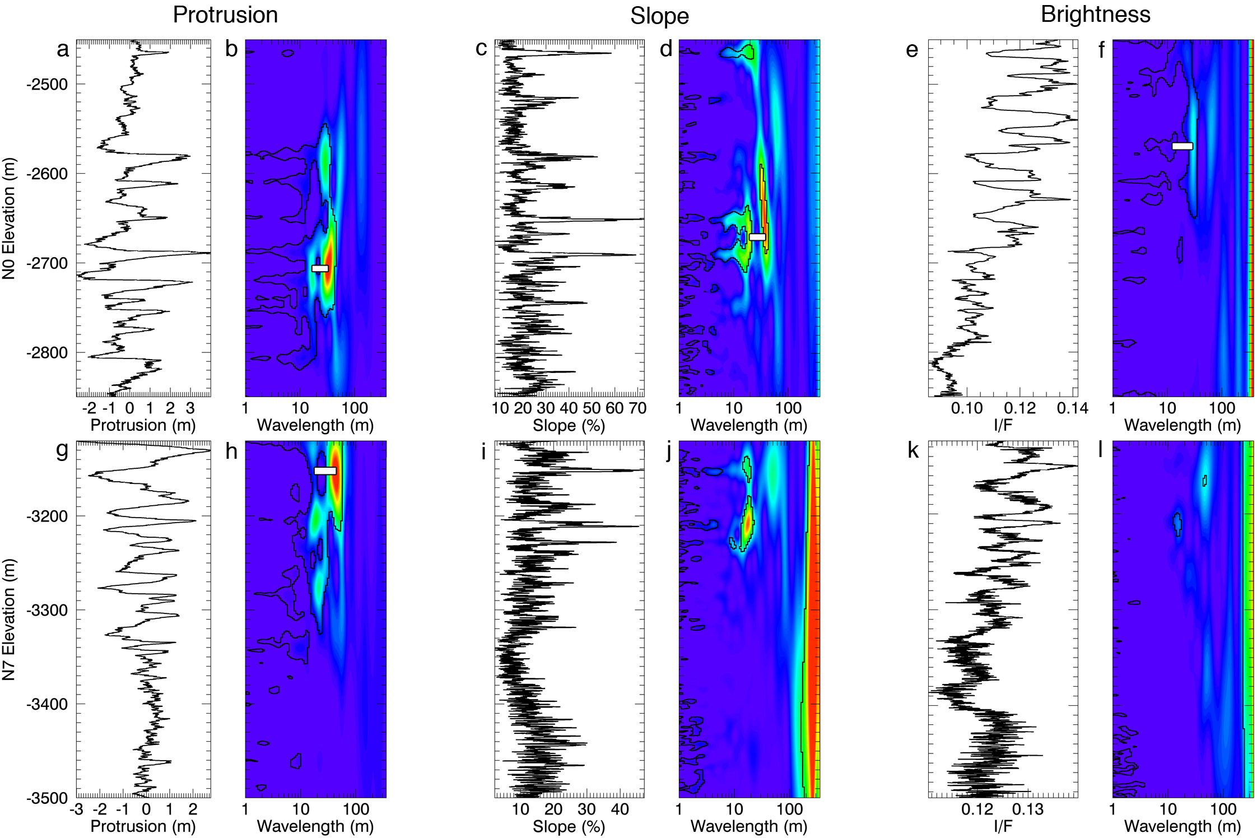
Figure 4.1. Stratigraphic profiles and WPS of sites N0 and N7. In all cases warmer colors signify higher power, and the black lines delineate the 95% confidence contours for red noise. (a) Protrusion profile of site N0. (b) WPS of 4.1a. The white bar represents a ratio between dominant wavelengths of 1.94. (c) Local slope profile of site N0. (d) WPS of 4.1c. White bar = ratio of 2. (e) I/F profile of site N0. (f) WPS of 4.1e. White bar = ratio of 2.4. (g – l) Same as 4.1a – 2f but for site N7. White bar in 2h = ratio of 2.53.

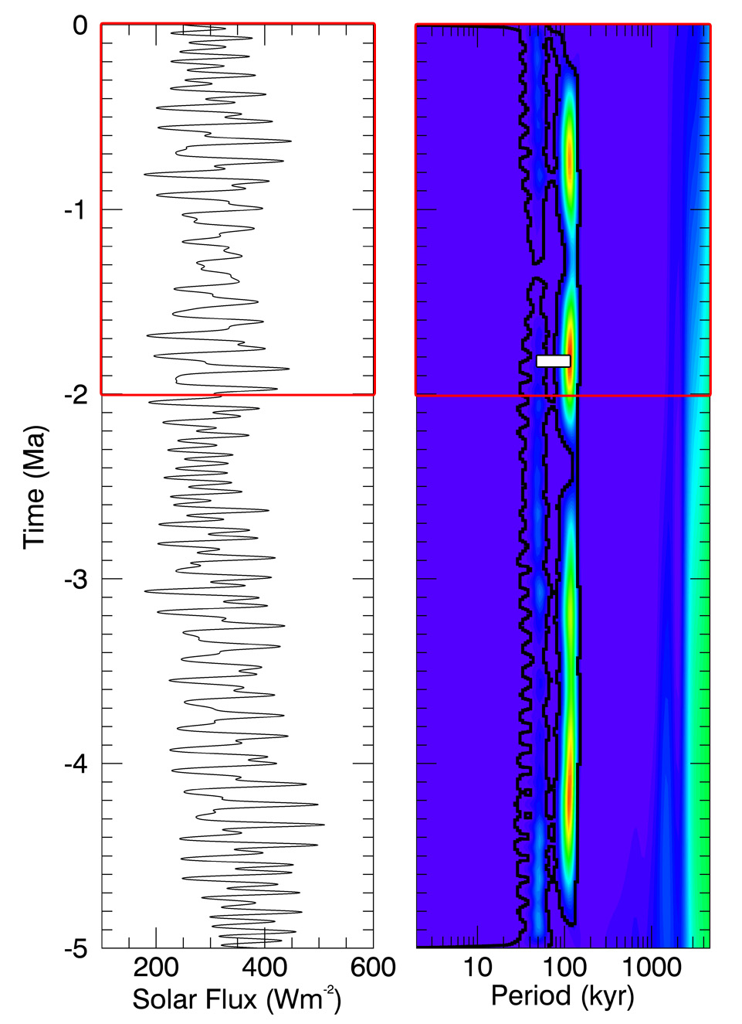
Figure 4.2. Variation of the peak solar flux on the Martian surface at 85ºN over the last 5 Myr (left), and its WPS (right). As explained in the text, we used only the portion of the signal over the last 2 Myr (indicated by the red squares) for the comparison with the stratigraphic profiles. The white bar on the WPS image indicates a ratio of ~2.3 between the dominant periodicities of ~51 kyr due to the precession of the argument of perihelion, and of ~120 kyr due to the variation of the planet’s obliquity.

4.3 Results
The fundamental limitation to deciphering the climate record in the NPLD stratigraphy is that there is no absolute chronology with which to associate the record [Perron and Huybers, 2009]. A robust estimate of accumulation rate therefore requires the detection of at least two dominant bedding wavelengths with a ratio that is diagnostic of known orbital periods. For example, the ~5:1 ratio of the precession to eccentricity cycles of Earth has been observed in the rock record [House, 1995; Schwarzacher, 2000]. On Mars, [Lewis et al., 2008] used this approach to relate a 10:1 ratio of stratigraphic wavelengths in outcrops at Becquerel crater to the ratio of the ~120 kyr obliquity period to its modulation timescale of ~1.2 Myr. This analysis results in the translation of stratigraphic cycles to a relative timescale (e.g. [Lewis et al., 2008] estimate that the outcrop they measured at Becquerel crater was deposited over roughly 12 Myr). In the case of the NPLD, inferred accumulation rates can be converted into an absolute age of the observed stratigraphy if one assumes that the uppermost layer is very young, for which there is evidence on the basis of crater size-frequency analysis [Landis et al., 2016].
At each site, we measure the most dominant overlapping wavelengths that exceed 95% confidence from the WPS and calculate the half width at half maximum (HWHM) of the corresponding peaks in wavelet power. The latter quantity represents the uncertainty in the identification of these wavelengths. We restrict ourselves to depth intervals that include at least two full wavelengths, e.g. a 30 m signal must have significant power over a depth range of at least 60 m to be considered for further analysis (we henceforth refer to this as the 2λ criterion). This threshold was selected so as to include several periodicities in slope and brightness that are only valid for short sections of the stratigraphy. For site N0 (Fig. 2b) the dominant wavelengths are 33 ± 7.29 m and 17 ± 2.35 m over depth ranges -2630 m to -2750 m (~5 wavelengths) and -2670 m to -2810 m (~7 wavelengths), respectively (measured at an elevation of -2710 m). The ratio of the long to short dominant wavelength at this site is 1.94 ± 0.51 and is indicated in Fig. 2b by the white horizontal bar.
The results for all significant wavelengths throughout all sites are summarized in Table 4.1. All protrusion profiles except three (N10, N11, and N13) have two overlapping significant wavelengths detected according to the criteria explained above As shown in Figures 4.1a-f and explained above, site N0 has overlapping significant periodicities in all three datasets, so while it exemplifies the results of our method well, it does not represent a typical case within our sample of 16 sites. Figures 4.1g-l show the analysis of all three properties for site N7, which is a more typical case than N0. At N7, we only identified one significant wavelength that met the 2λ criterion in the slope profile, and there were no dominant wavelengths detected in the brightness profile that exceeded 95% confidence for any meaningful depth range. Figures analogous to Figure 4.1 for all other sites are included in Figure C3.2 of the Appendix C3.
In 13 out of 16 protrusion profiles we identified pairs of dominant wavelengths that meet our criteria for identification. The mean ratio of these is 1.96 ± 0.15. In the slope dataset, three valid ratios were found with a mean of 1.94 ± 0.44. There are only two brightness profiles found to have any significant periodicities with a mean ratio of 2.21 ± 0.64. The mean ratio of all measured profiles of any type is 1.98 ± 0.15, and the median is 1.92 ± 0.11.
In addition to the dominant wavelengths reported in Table 4.1, a number of short wavelengths between 1 and 5 m exceed the 95% confidence level in the slope and brightness profiles, as seen in Figures 4.1d,f,j,l. However, these wavelengths appear to be significant only in small pockets comparable in depth-range to the size of the wavelengths themselves. This result is consistent with the study of Perron and Huybers, [2009], which used brightness profiles measured from Mars Orbiter Camera (MOC) images. They found that the only signal to exceed the 95% confidence level for red noise was centered on a wavelength of ~1.6 m, and also in small pockets of depth within the profile (see their Figure 4). Our results indicate that topographic datasets (particularly protrusion) allow for the detection of additional dominant wavelengths not readily apparent in the brightness datasets.
The two dominant modes of oscillation of the insolation signal that correspond to the obliquity (~120 kyr) and precession of the argument of perihelion (~51 kyr) are clearly visible in the WPS image of Figure 4.2. In order to compare equivalent quantities, we measured the peak periodicities and their uncertainties using the same methods applied to the stratigraphic wavelengths (Table 4.1). The ratio between the measured dominant periods is 2.3 ± 0.44, indicated by the white bar in WPS image (Figure 4.2).
We can draw a number of important results from our analysis. First, the topographic profiles allowed us to discover periodicities that are not apparent in the profiles of layer brightness that we examined using the same techniques. In the former, we found sections of stratigraphy that have significant power at more than one wavelength. Although both long and short dominant wavelengths have a significant spread in their values, their ratio is similar over many locations on the NPLD. This ratio of dominant periodicities in the stratigraphic record is systematically lower than that of the dominant frequencies in the insolation record. This result implies either (a) that the proposed orbital cycles of periods 51 and 120 kyr are not the main control of NPLD formation (although no other candidate periodicities in Figure 4.2 are apparent) or (b) that a non-linear relationship between time and depth in the NPLD leads to a lower ratio in the stratigraphy. Finally, significant power may also be present at 1-5 m wavelengths as previously shown by Perron and Huybers, [2009], although it is not continuous throughout the entire vertical range of the stratigraphy

Table 4.1. Dominant periodicities and their ratios of stratigraphic profiles of the NPLD, of the insolation signal, and of the three stratigraphic models that we tested. See text for explanation of uncertainty calculations. A more detailed table is included in Appendix C3 that shows the elevation ranges of each dominant wavelength in the stratigraphic profiles.

Protrusion Profile | Long wavelength signal |  |  | Short wavelength signal |  |  | Ratio of dominant wavelengths
 | Wavelength (m) | Error (m) | Number of wavelengths in depth range | Wavelength (m) | Error (m) | Number of wavelengths in depth range | Ratio | Propagated Error
N0 | 33 | 7.29 | 3.64 | 17 | 2.35 | 8.24 | 1.94 | 0.51
N1 | 48 | 7.91 | 3.33 | 27 | 2.93 | 2.59 | 1.78 | 0.35
N2 | 42 | 6.58 | 3.45 | 23 | 3.05 | 6.09 | 1.83 | 0.37
N3 | 42 | 7.34 | 4.05 | 18 | 2.86 | 4.44 | 2.33 | 0.55
N4 | 51 | 5.53 | 4.90 | 29 | 5.98 | 7.59 | 1.76 | 0.41
N5 | 59 | 12.20 | 3.22 | 31 | 9.40 | 3.55 | 1.90 | 0.70
N6 | 68 | 10.78 | 2.50 | 27 | 6.70 | 7.41 | 2.52 | 0.74
N7 | 48 | 12.59 | 2.08 | 19 | 4.94 | 10.53 | 2.53 | 0.93
N8 | 54 | 9.07 | 2.96 | 27 | 5.63 | 7.78 | 2.00 | 0.54
N9 | 17 | 3.84 | 4.12 | 9 | 1.23 | 5.00 | 1.89 | 0.50
N12 | 71 | 10.91 | 2.11 | 41 | 5.79 | 10.00 | 1.73 | 0.36
N14 | 70 | 14.70 | 3.00 | 40 | 7.84 | 2.75 | 1.75 | 0.5
N15 | 30 | 3.35 | 7.67 | 20 | 3.65 | 12.00 | 1.50 | 0.3
Mean | 48.69 | 2.56 |  | 25.23 | 1.47 |  | 1.96 | 0.15
Slope Profile
N0 | 38 | 6.37 | 2.63 | 19 | 2.91 | 4.47 | 2.00 | 0.45
N1 | 27 | 4.31 | 2.41 | 14 | 2.22 | 2.14 | 1.93 | 0.43
N6 | 17 | 10.03 | 3.53 | 9 | 1.70 | 7.78 | 1.89 | 1.17
Mean | 27.33 | 4.21 |  | 14.00 | 1.35 |  | 1.94 | 0.44
Brightness Profile
N0 | 29 | 4.09 | 6.90 | 12 | 5.72 | 5.83 | 2.42 | 1.20
N2 | 20 | 3.28 | 3.50 | 10 | 1.63 | 3.50 | 2.00 | 0.46
Mean | 24.50 | 2.62 |  | 11.00 | 2.97 |  | 2.21 | 0.64
Insolation | Period (kyr) | Error (kyr) |  | Period (kyr) | Error (kyr)
 | 115 | 16.40 |  | 50 | 6.50 |  | 2.30 | 0.44
Stratigraphic Model
Constant ice deposition | 59 | 11.30 | 16.95 | 27 | 4.05 | 37.04 | 2.19 | 0.53
Constant dust deposition | 63 | 9.05 | 15.87 | 33 | 4.74 | 24.24 | 1.91 | 0.39
Variable ice and dust Deposition | 67 | 10.40 | 8.96 | 34 | 5.71 | 5.88 | 1.97 | 0.45

4.4 Discussion
In order to interpret our results and test whether a non-linear relationship between insolation and PLD accumulation could plausibly lead to lower ratios in observable stratigraphic periodicities relative to orbital periodicities, we apply wavelet analysis to synthetic stratigraphic profiles created with a climate-forced model of NPLD formation developed by Hvidberg et al., [2012]. In this model, the annual net deposition rate of ice is controlled by the north polar surface temperature, and the annual net deposition rate of dust depends on the temperature difference between the north pole and the equator. Surface temperatures are calculated by a local energy balance using the time-dependent insolation solution of Laskar et al., [2004a]. Material is deposited in the model through the addition of the ice and dust deposition rates. Using the best fit model parameters found by Hvidberg et al., [2012], we evaluated three accumulation scenarios that result in three different stratigraphic profiles: one in which ice deposition rate is constant but dust deposition rate varies with time, one in which the reverse is true, and one in which both dust and ice deposition rates vary with time. An explanation of our application of the model is included in the supplementary information, and details of the model algorithm and parameter selection can be found in the paper of Hvidberg et al. [2012].
The dominant wavelengths of the synthetic stratigraphies are shown in the last three rows of Table 4.1 and in Figure 4.3. The WPS of the stratigraphy formed by a constant ice deposition rate differs very little from that of the insolation, displaying a ratio of 2.19 ± 0.53 (Figure 4.3a). Scenarios with varying ice deposition rate have spectral signatures that are similar to that observed in the stratigraphic data, with ratios of 1.91 ± 0.39 (constant dust deposition rate) and 1.97 ± 0.45 (variable dust deposition rate). This implies that a variation of ice deposition rate is necessary to produce the observed stratigraphy through climate forcing, while changes in the deposition of dust appear to have only a minor effect on the spectral signature of the resulting stratigraphy.
From this analysis it is clear that different scenarios of accumulation forced by the same periodic climate signal can result in spectrally distinct stratigraphies. The history of accumulation that the model of Hvidberg et al., [2012] suggests correctly predicts the spectral characteristics we measured within NPLD stratigraphy. Here, we use this model to show that the observed difference between the periodicity ratios of the insolation and the stratigraphy can be reasonably attributed to a non-linear time-depth relationship. However, future research is needed to know if other historical solutions would also correctly predict the same spectral characteristics.
The two scenarios that are spectrally similar to the data have ice deposition rates that vary between -0.37 mm/yr and 0.70 mm/yr (negative ice deposition rates result in removal of previously deposited ice layers and a dust lag from previously deposited dust layers). Hvidberg et al., [2012] estimate that the stratigraphic column of site N0, which they use to constrain their best fit set of parameters, corresponds to the section between ~150 and ~550 m in depth of the model stratigraphy that results from varying both deposition rates. They therefore date this column to extend from ~990 ka to ~ 200 ka. It is likely that these numbers provide a reasonable age estimate for the correlated locations discussed in chapter 3.

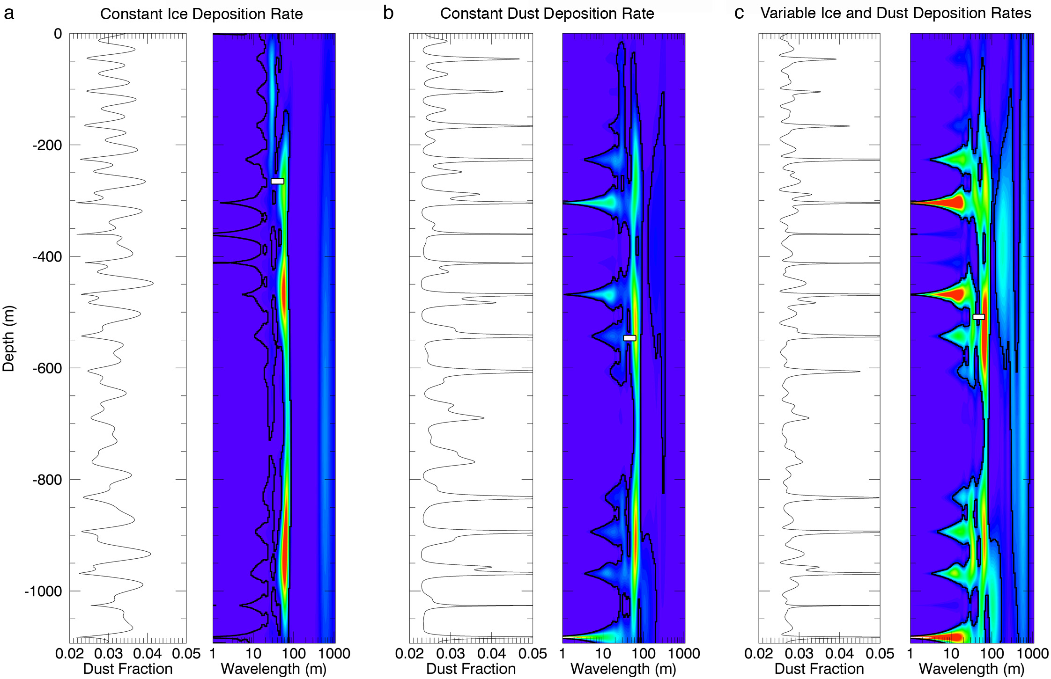
Figure 4.3. Synthetic stratigraphic profiles created with the model of Hvidberg et al. [2012], and their wavelet spectra. (a) Model with constant ice deposition rate but time-varying dust deposition rate. White bar = ratio of 2.19. (b) Model with constant dust deposition rate but time-varying ice deposition rate. White bar = ratio of 1.91. (c) Model with both ice and dust deposition rates varying with time. White bar = ratio of 1.97.

4.5 Conclusions
Although different locations across the NPLD display different pairs of dominant periodicities, the ratio of these pairs is systematically lower than the ratio of the insolation periodicities. If the NPLD are formed primarily as a result of orbital forcing, then these results show that the relationship between time and depth must be non-linear. In addition, the geographic variation in periodicities indicates that deposition rates can be spatially variable while still being driven by the same climatic forcing. Our results show that while a link between climate and stratigraphy requires a variable ice deposition rate, observations are consistent with either a constant or variable dust deposition rate. This is perhaps unsurprising as dust makes up less than 5% of the NPLD [Grima et al., 2009]. The same result may not hold for the SPLD, where dust concentrations are more significant [Zuber et al., 2007; Wieczorek, 2008].
The characteristic ratio between stratigraphic wavelengths that we have observed can be used to test the results of future modeling efforts, as any climate-driven model of NPLD formation will have to reproduce dominant wavelengths in the stratigraphy that have similar ratios to those that we have observed.

CHAPTER FIVE
Conclusions and Future Directions

5.1 Concluding remarks
The work presented in this dissertation had the overarching goal of exploring the relationship between the Martian surface and climate over two distinct timescales. Through a comprehensive observational analysis coupled with numerical models of surface properties, I investigated interannual brightness variations in the Martian SPRC. With extensive stratigraphic mapping and advanced signal analysis techniques, I redefined the stratigraphic structure of the NPLD and explored its connection with Martian paleoclimate. With the results from these investigations explained in detail in the previous chapters, we can now submit answers to the initial motivating questions posed in section 1.3:
- What is the connection between interannual climatic variations and the changes in brightness of the SPRC?
Our results indicate that a very small difference in dust content will manifest itself as an observable difference in the surface albedo. Therefore, the connection between seasonal changes in climate and the SPRC surface seems to be based on the conditions that govern the amount of dust in the atmosphere and the time of deposition of this dust onto the surface. In other words, we should expect brightness changes on the SPRC when global or even large regional dust storms are observed near the perihelion of Mars.
After the publication of Chapter 2 in the journal Icarus, continued HiRISE monitoring of the SPRC showed that the halos reappeared after the summer of MY 32, which in fact had been affected by a dust storm. These observations provide support for the mechanism of formation that I have proposed as a result of my investigation.
- Can this connection teach us about the mechanisms by which the SPRC remains stable?
Yes. The single-time, ephemeral occurrence of the halos indicates that the layer of ice that darkened as a result of the dust storm and surrounded the halos, was not exhumed in subsequent years, implying a positive mass balance for flat surfaces on the year after the halos appeared. Given the most recent observations mentioned above, a positive mass balance of the SPRC should be expected on MY 33.
The SPRC has been observed to ablate during a darkening-event driven by dust storms, and to later recover and even increase its net ice budget through the deposition of new CO2 ice on formerly defrosted surfaces, causing an overall smoothing of the cap. This behavior indicates that the environment after large dust events may provide the necessary conditions for enhanced snowfall. This means that the SPRC requires these large events in order to survive over long timescales. Although this model of stability is not proven here, the observations are consistent with such a model.
- Is the topographic expression of the layers continuous throughout the NPLD, suggesting a relationship with internal properties of the strata?
An analysis of high-resolution imagery and topography combined with signal-matching algorithms suggests that the protrusion of exposed layers is laterally continuous throughout the NPLD. The topographic expression of the layers therefore reveals an intrinsic property of layers (relative resistance to erosion) that is related to their internal composition.
- Does using topographic quantities represent a significant improvement over using brightness to describe the stratigraphy?
A description of the stratigraphy that combines trough wall topography and brightness represents a significant improvement over one based solely on layer brightness. Comparing the correlations between protrusion profiles to those between brightness profiles suggests that layer protrusion is more consistently continuous over long distances. Observed brightness appears more affected by extrinsic factors that change its value over different layer exposures across the NPLD. This does not mean that remotely measured brightness has no relation to the underlying physical properties of the layers, as if this were the case, no banded layers would be observed in the images. Rather, it suggests that the relationship between these properties and brightness is more complex than the one they have with topography.
- Is the stratigraphic record similar across the NPLD or have accumulation patterns varied locally?
The correlation of stratigraphies from different sites over our region of study within the NPLD shows that relative accumulation rates at any given epoch vary geographically by up to a factor of two. However, this value is likely a lower limit for the NPLD as a whole. The variability in periodicities detected in these stratigraphies also supports the conclusion that accumulation patterns vary geographically.
- Is it possible to detect a correlation between the astronomically forced climate of Mars and the stratigraphy of the NPLD?
I showed in chapter four that it is possible to detect this correlation. The detection of a systematically lower ratio of periodicities in the stratigraphy compared to that in the insolation solution suggests that if the NPLD are formed as a result of astronomical forcing, then the relationship between time and depth must be non-linear.
- What is the nature of that correlation, and what does it imply about the history of the NPLD?
My comparison of the periodicities detected in the stratigraphic data with different scenarios of climate-controlled models of stratigraphic build-up shows that while a link between climate and stratigraphy requires a variable ice deposition rate, observations are consistent with either a constant or variable dust deposition rate.

5.2 Future work
Although the work presented here signifies an important contribution to Mars Polar Science, many questions still remain. A detailed model of the evolution of the SPRC has remained elusive, as well as a complete picture of the evolution of polar geology and the relationship between both polar caps.
The primary goal of research on Mars’ SPRC is to establish a theory for its formation and stability over time. I have shown here the importance of continuous monitoring in order to advance our understanding of its geology and interactions with the atmosphere. This monitoring must continue, as the development of the field relies heavily on analysis of temporal changes of the surface in images and other data. Modeling like that of Byrne [2011], constrained by these continued observations of the SPRC, will be crucial in to construct a complete theory of evolution and stability for the SPRC.
The overarching objective of my NPLD work is to define in the detail the nature of the astronomical forcing of the stratigraphy, and thereby build a comprehensive model of formation and evolution of both polar layered deposits. An obvious future step to further this goal must be to apply the techniques used on the NPLD to the SPLD. Further constraints on the evolution of polar insolation on the south pole before 20 Myrs will be necessary to achieve this goal. However, the data and techniques already exist to observationally study the SPLD and map its stratigraphy in a way similar to what was presented here in Chapter 3.
In the absence of ice cores from the PLD, their comprehensive stratigraphic description will require a combination and correlation of all datasets available. The optical and radar-based stratigraphies have predominantly been studied in isolation. The difficulty in individually tying these records to Martian insolation cycles is reminiscent of issues experienced decades earlier in terrestrial climate science, in which orbital climate forcing was ultimately confirmed by the correlation of sedimentary, geochemical and paleomagnetic records. Therefore, the integration of the available Martian datasets will be necessary in order to build a complete climate record for the NPLD and later for the SPLD. In general, both radar and optical layers are assumed to result from varying amounts of silicic impurities in the water ice that makes up the deposits. So correlating both datasets will require modeling synthetic stratigraphies (such as the model I applied in chapter four) that mimic the various types of datasets. The integration of optical, topographic, and radar data would then result in a quantitative stratigraphic record of dust fraction vs. depth at high resolution and this stratigraphic record can then be used to constrain models of layer accumulation. The final result of combining these diverse datasets with accumulation models will be a comprehensive, dated stratigraphic model of the NPLD that fully describes the climate history responsible for their formation.
Approaching these problems from the perspective of studying the past and present climate in order to relate the two and build a history of planetary evolution will advance not only Mars Science, but also provide a basis for comparative planetology with the evolution of Earth, Venus and even exoplanetary systems discovered in the future that may be similar to ours

APPENDIX A1
Hapke reflectance model

Hapke [2012] developed a series of equations to calculate the reflectance of a particulate surface given known properties and assumptions about the solid phases composing the surface based on Mie scattering theory. In the case of the SPRC, the mixtures composing the surface are intimate mixtures, and represent a surface in which the individual components exist as separate grains but are mixed at a scale fine enough for single photons to interact with both types of material. Our implementation of this model is largely based on the work of [Roush, 1994]. We neglect atmospheric extinction and scattering in the calculation of the I/F values.
The spectral reflectance of an intimate mixture is based on the bidirectional reflectance, given by:
$r\left(i,e,g\right)=\left(\frac{w}{4π}\right)\left(\frac{μ_{0}}{μ_{0}-μ}\right)\left\{\left[1+B\left(g\right)\right]P\left(g\right)+H\left(μ_{0}\right)H\left(μ\right)-1\right\}$ (A1.1)
where w is the average single scattering albedo of the mixture, and depends on composition and grain size, μ₀ is the cosine of the incidence angle i, and μ is the cosine of the emission angle e. B(g) is the function describing the opposition surge, which we assume to be equal to zero since the phase angle of our observations is always greater than 50º. We assume isotropic scattering, and thus the phase function P(g) is equal to 1. $H\left(μ_{0}\right)$ and $H\left(μ\right)$ are Chandrasekhar’s [1960] H-functions, given by:
$H\left(x\right)=\frac{1}{1-(1-γ)x[r_{0}+\left(1-\left(\frac{r_{0}}{2}\right)-r_{0}x\right)ln⁡(\frac{1+x}{x})]}$ (A1.2)
defined by the albedo factor: $γ=\sqrt{1-w}$, and the diffusive reflectance: $r_{0}=\frac{1-γ}{1+γ}$
This approximation for the H-functions (from equation 8.57 of Hapke [1993]) was chosen because it estimates H(x) more accurately for extremely bright surfaces.
As we assume that the dust and ice in the SPRC are intimately mixed, the average single scattering albedo for the mixture is given by equation 10.46 of Hapke [2012]:
$w= \frac{\left(\sum_{j}^{n}{\frac{M_{j}Q_{S_{j}}}{ρ_{j}D_{j}}}\right)}{\left(\sum_{j}^{n}{\frac{M_{j}Q_{E_{j}}}{ρ_{j}D_{j}}}\right)}$ (A1.3)
where M_{j}, ρ_{j}, D_{j} are the mass fraction, solid density, and diameter of the j^{th} particle, and n is the total number of components in the mixture. Brown et al. [2008] used a similar approach. Q_{Ej} is the extinction efficiency of the j^{th} particle, which is equal to 1 for particles much larger than the wavelength, as is the case here (equation 7.41, Hapke [2012]). Q_{Sj} is the scattering efficiency of the j^{th} particle, and is defined by:
$Q_{s}=S_{e}+\left(1-S_{e}\right)\frac{\left(1-S_{e}\right)Θ}{1-S_{e}Θ}$ (A1.4)
S_{e} and S_{i} are the external and internal reflection coefficients:
$S_{e}=\frac{1}{2}\left({\left|R_{∥}\right|}^{2}+{\left|R_{⊥}\right|}^{2}\right)$ (A1.5)
S_{i} is defined by integrating the expression for S_{e} over all angles (excluding internal reflection). Where $R_{∥}$ and $R_{⊥}$are the Fresnel reflection coefficients polarized parallel and perpendicular to the incident sunlight, respectively. These are given by:
${\left|R_{⊥}\right|}^{2}= \frac{{\left(\cos\left(\frac{g}{2}\right)-u\right)}^{2}+v^{2}}{{\left(\cos\left(\frac{g}{2}\right)+u\right)}^{2}+v^{2}}$ (A1.6a)
${\left|R_{∥}\right|}^{2}=\frac{{\left((n^{2}-k^{2})cos\left(\frac{g}{2}\right)-u\right)}^{2}+{(2nk\cos\left(\frac{g}{2}\right)-v)}^{2}}{{\left((n^{2}-k^{2})cos\left(\frac{g}{2}\right)+u\right)}^{2}+{(2nk\cos\left(\frac{g}{2}\right)+v)}^{2}}$ (A1.6b)
where
$u=\sqrt{\frac{1}{2}\left(n^{2}-k^{2}-\sin\left(\frac{g}{2}\right)+\sqrt{\left({\left(n^{2}-k^{2}-\sin\left(\frac{g}{2}\right)\right)}^{2}+4n^{2}k^{2}\right)}\right)}$ (A1.7a)
and
$v=\sqrt{\frac{1}{2}\left(-(n^{2}-k^{2}-{sin⁡(\frac{g}{2}))+\sqrt{\left({\left(n^{2}-k^{2}-\sin\left(\frac{g}{2}\right)\right)}^{2}+4n^{2}k^{2}\right)}}\right)}$ (A1.7b)
The real and imaginary parts of the complex index of refraction for each component are n and k respectively, and taken from previous work (see Section 2.4).
Θ is the internal transmission coefficient of each particle:
$Θ=\frac{r_{1}+exp⁡(-〈D〉\sqrt{α\left(α+s\right)})}{{1+r}_{1}exp⁡(-〈D〉\sqrt{α\left(α+s\right)})}$ (A1.8)
where r₁ is:
$r_{1}=\frac{(1-\sqrt{α/{(α+s)}})}{(1+\sqrt{α/{(α+s)}})}$ (A1.9)
α is the absorption coefficient, which is related to the imaginary index of refraction and the incident wavelength through the dispersion relation:
$α={4πk}/λ$ (A1.10)
and s is the volume scattering coefficient, which we assume to be 10⁻¹⁷ for minimal internal scattering [Roush, 1994].
Finally, the mean photon path length $〈D〉$ is related to the grain diameter D, and n and k by:
$〈D〉=\frac{2}{3}\left(n^{2}-\frac{\sqrt{n^{2}-1}}{n}\right)D$ (A1.11)
The bidirectional reflectance is then transformed to I/F by multiplying it by π  (assuming isotropic scattering), and later to Lambert Albedo by dividing I/F by the cosine of the incidence angle (μ₀)
The model outputs I/F values for all wavelengths from 0.35 to 4 m, at a resolution of 1 nm. This range encompasses all CRISM and HiRISE channels. The final step in the model is to transform these I/F values to HiRISE and CRISM responses. To do this, we convolve the model I/F function with weighting factors for each band, which account for band response, quantum efficiency of the detector, solar spectrum, and mirror efficiency [Delamere et al., 2010; Murchie et al., 2007].

APPENDIX A2
Flow regime calculations for the SPRC halo conceptual model

The ratio of inertial to viscous forces, known as the Reynolds number, determines the transition from turbulent to laminar flow:
$Re=\frac{ρvd}{η}$ (A2.2)
Here, ρ is the density of the atmosphere, v is the velocity of the particle relative to the atmosphere, d is the grain size of the particle, and η is the viscosity of the atmosphere. When this number is low, inertial forces are weak compared to viscous forces, and the laminar regime dominates over turbulence.
We calculated the terminal velocity of a test dust particle 10 μm in size settling in the Martian atmosphere in both the turbulent and laminar regime, to evaluate the Reynolds number and decide on the correct value for the particle’s velocity in our calculations.
The terminal velocity due to turbulent flow is given by:
$v_{t}= \sqrt{\frac{4}{3}\frac{(σ-ρ)dg}{C_{D}ρ}}$ (A2.2)
in which σ is the density of the dust particle, g is the acceleration due to gravity, and C_{D} is the empirical constant known as the drag coefficient (~0.4 for a sphere, over a wide range of velocities).
The terminal velocity in the laminar regime is given by the Stokes velocity:
$v_{s}=\frac{1}{18}\frac{\left(σ-ρ\right)d^{2}g}{η}$ (A2.3)
We used typical Martian values for all the parameters in the above equations: ρ = ~0.02 kg/m³, d = ~10 μm, η = ~1.3e-5 Pa.s, σ = (~2700 kg/m³), and g = 3.7 m/s².
Solving the two velocity equations gives v_{t} = 4 m/s and v_{s} = 0.004 m/s. Substituting these values into equation (A2.1) gives Reynolds numbers of 6$×$10⁻², and 6$×$10⁻⁶ respectively, both of which are significantly smaller than 1. Therefore, we can be confident that the settling of micron-sized dust particle on Mars is dominated by Stokes flow, and that equation (A2.3) is the correct expression to use.

APPENDIX B
Supplementary Figures for Chapter 3

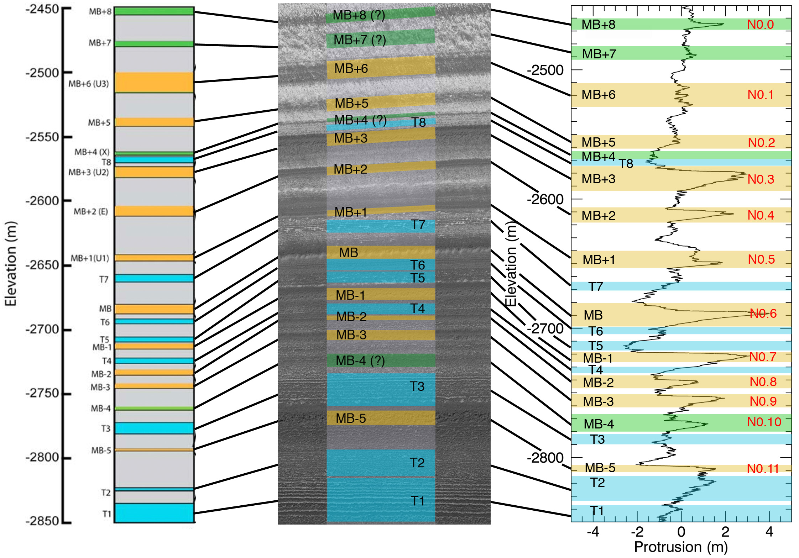

Figure B1. Comparison of the stratigraphic column of site N0 made by Fishbaugh et al. (2010) with our protrusion profile of site N0. In their paper, yellow bands indicate layers definitively classified as marker beds, blue bands indicate thin layer sets, and green bands indicate possible marker beds. (Left) Original column from Figure 1 of Fishbaugh et al (2010). (Center) Portion of HiRISE image PSP_001738_2670, with the corresponding layers labeled. (Right) Protrusion profile of site N0. The locations of the layers classified by Fishbaugh et al. (2010) are indicated. Colors follow the same scheme as the left and center panels. The Fishbaugh et al. (2010) nomenclature, including thin layer sets and possible marker beds, is written in black text on the left side of the plot. Our site-specific nomenclature for site N0 is written in red on the right side of the plot.

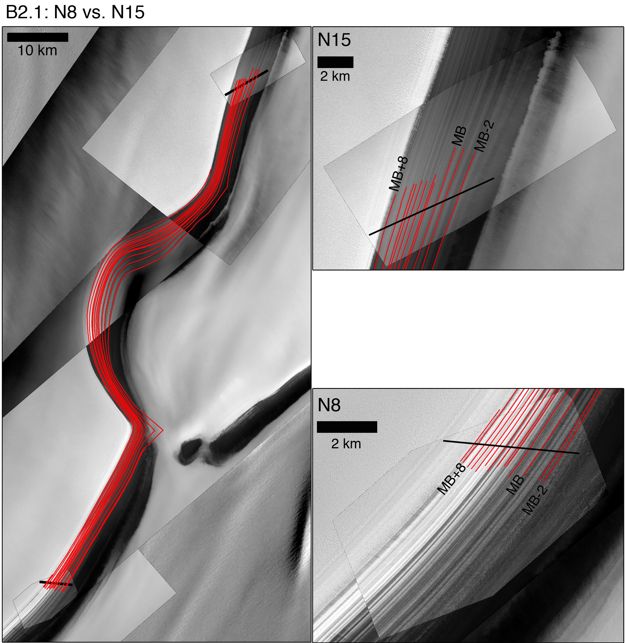

Figure B2.1. Same as Figure 3.4 but for N8 vs. N15.

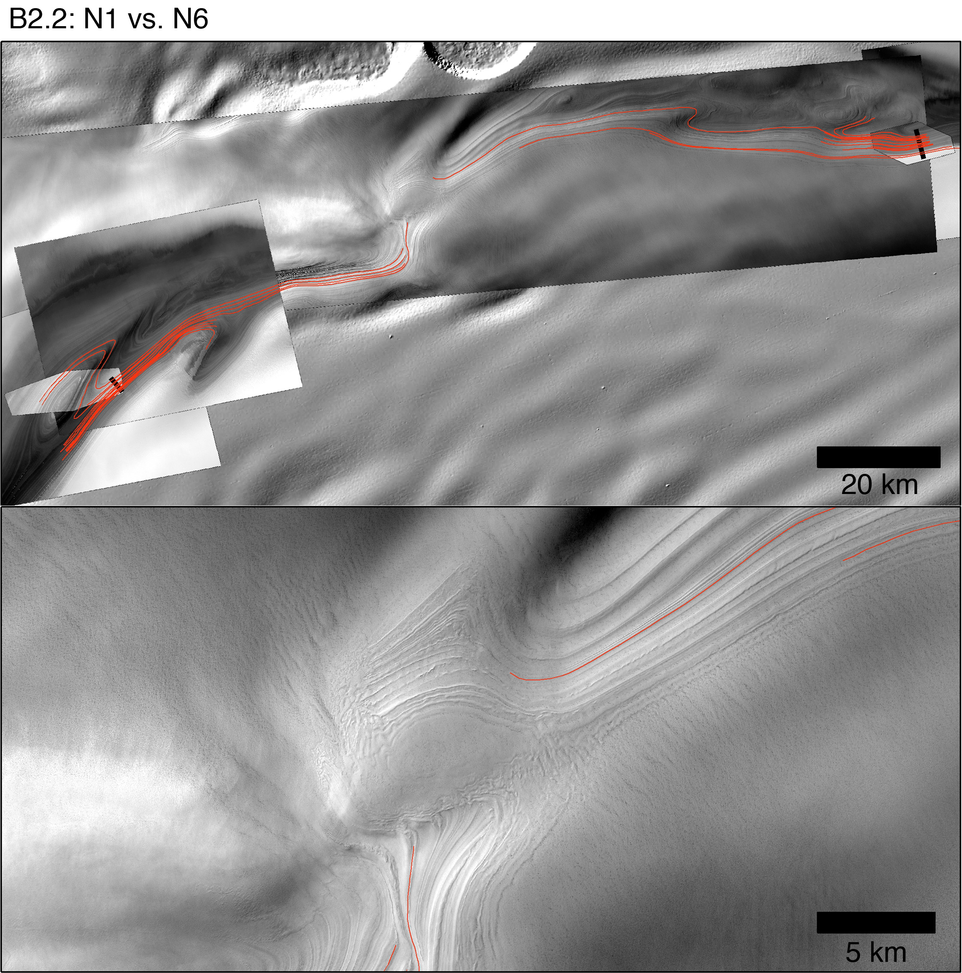

Figure B2.2. N1 vs. N6. The bottom panel is a zoomed-in view of the feature in between the two sites that made it impossible to complete the layer tracing

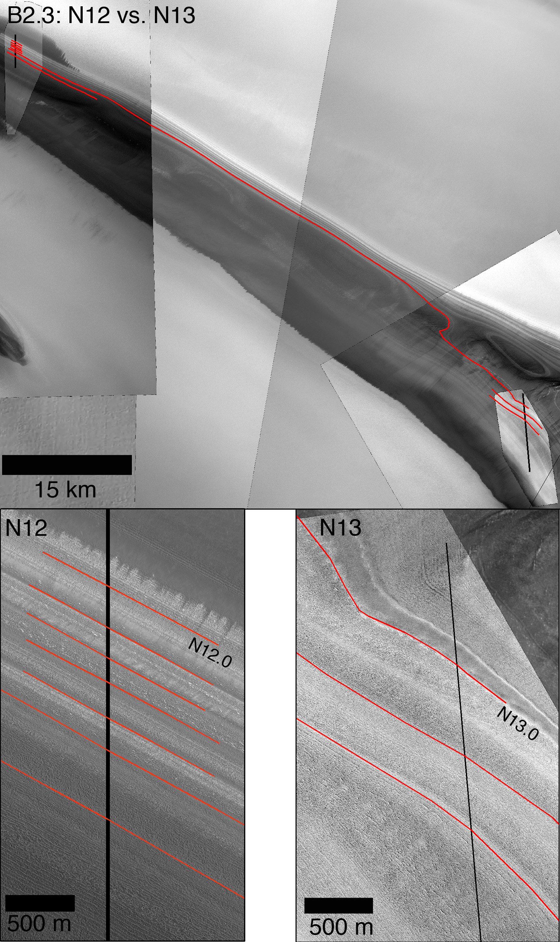

Figure B2.3. N12 vs. N13. The view of the layers in between the two sites was not good enough for reliable traces to be made.

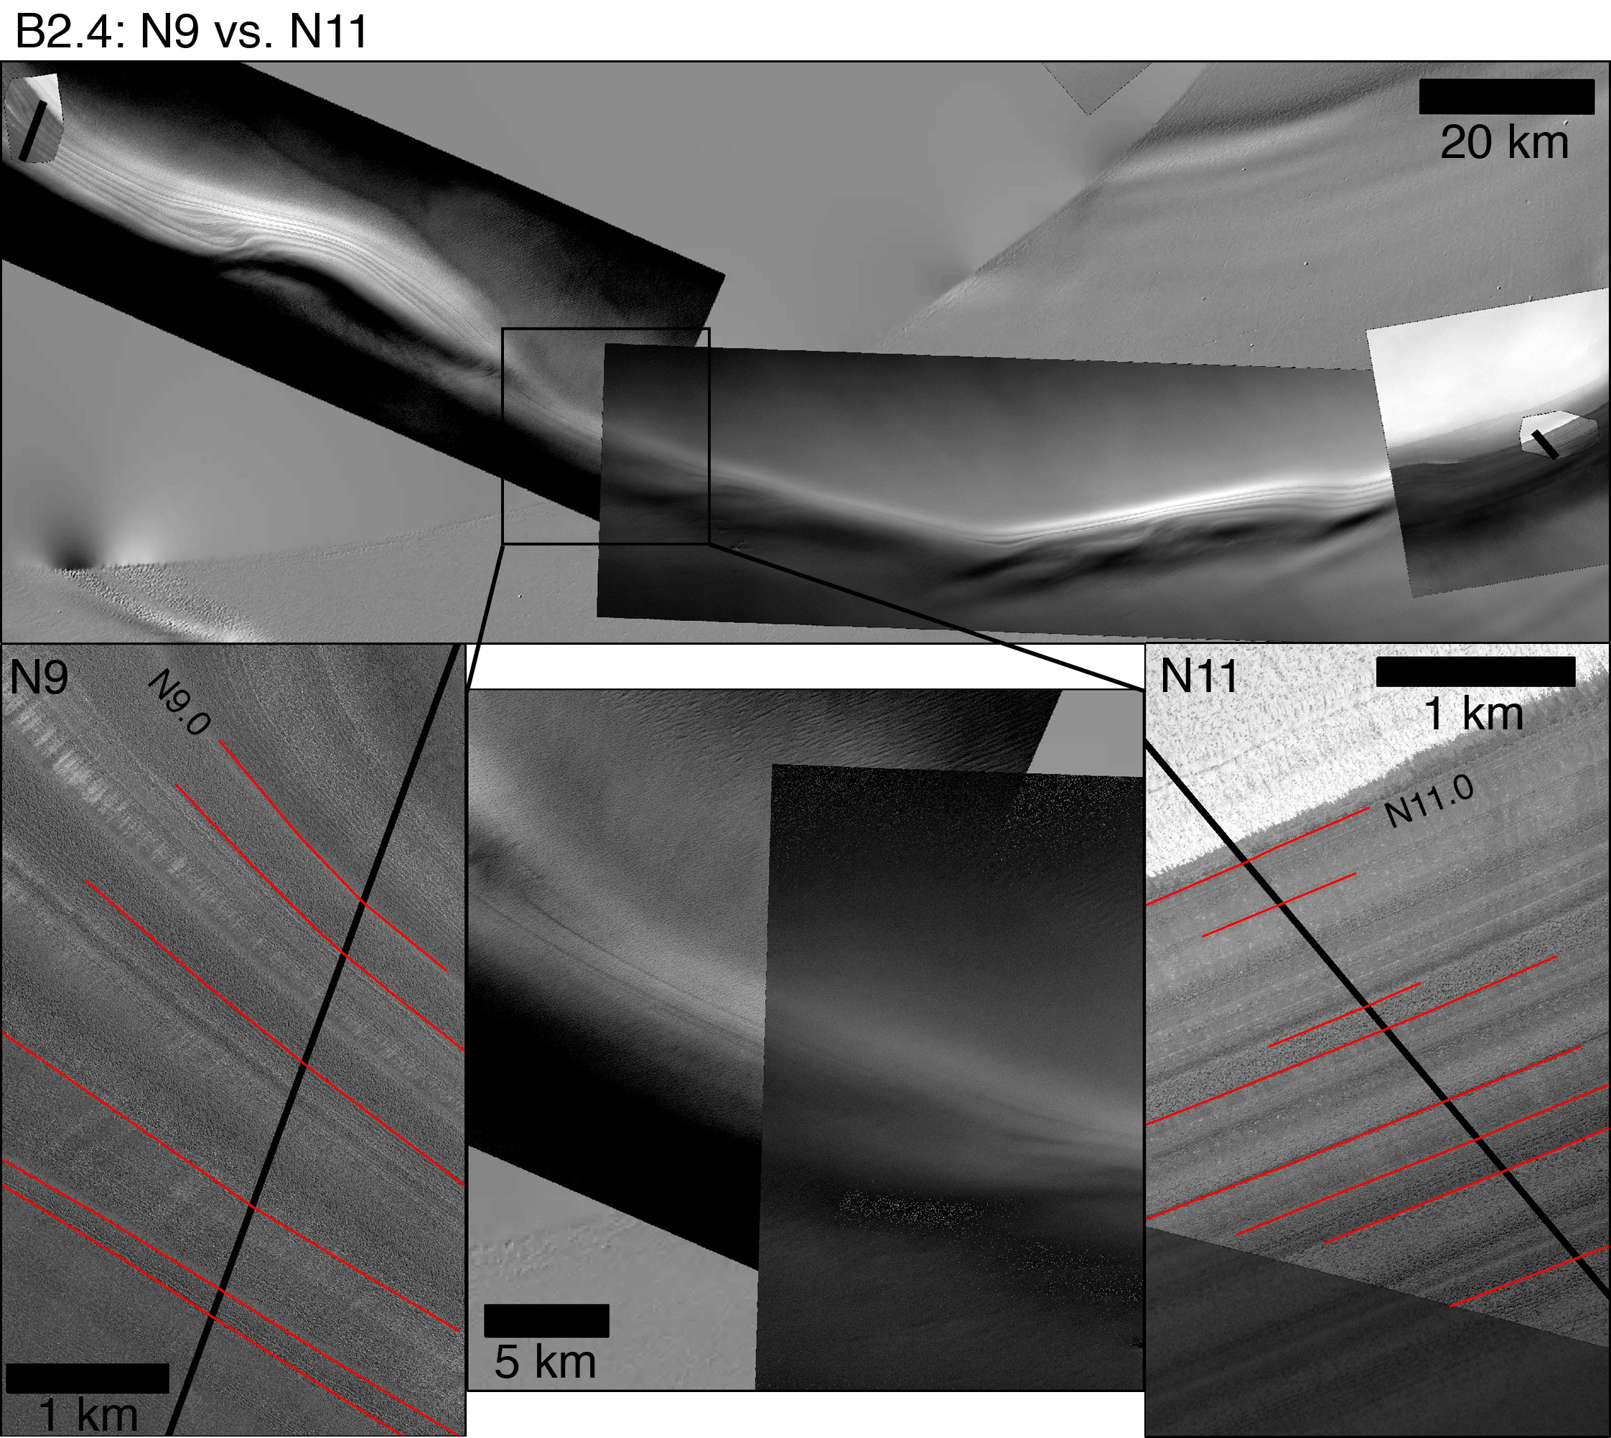

Figure B2.4. N9 vs. N11. The bottom center panel is a zoomed-in view of the area halfway between both sites, showing a heavily modified scarp surface, preventing a reliable trace between layers in the two sites.

Figure B3. The following six sub-figures show the tie-point constrained DTW cost maps for each pair correlated and explained in the main text. These figures are the same as Figure 5a of the main text. In each case, we indicate the location of the peaks that we matched with black arrows and the site-specific nomenclature (except for N0, in which we use MB ± n. Here, we show just the maximum covariance of the correlation in the top left corner. We ran no statistical test in this case since the maximum covariances are affected by the whole cost matrix and not just the individual submatrices, so in some cases they will be low even though the parts of the profiles that do match may have a high correlation. Based on a detailed observation of these cost-maps, we decide the manner in which we truncate the profiles for the second run of the DTW correlation and the subsequent Monte Carlo statistical test.

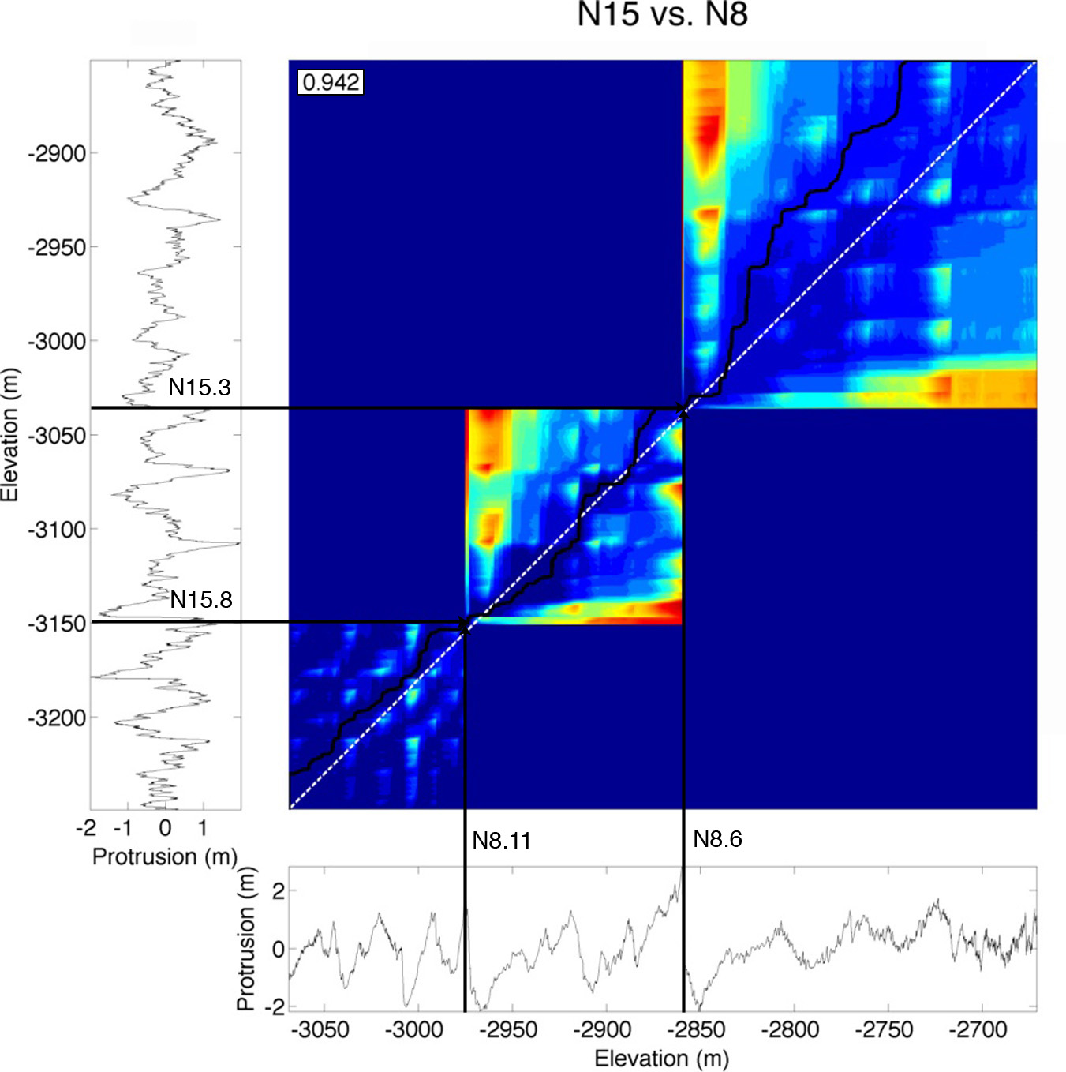

Figure B3.1. Same as Figure 5a in the main text but for N15 vs. N8.

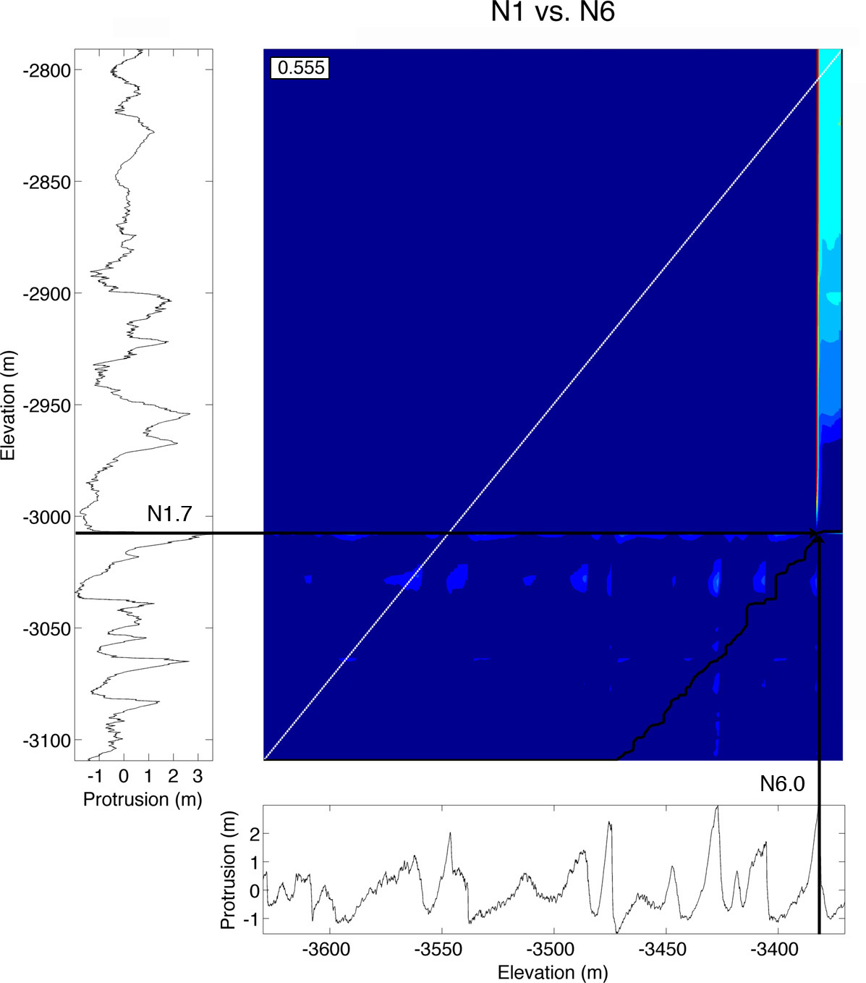

Figure B3.2. Same as Figure 5a in the main text but for N1 vs. N6. These tie-points were based on the past correlation of Fishbaugh and Hvidberg [2006], which was corroborated after the second run of the correlation algorithm with the truncated profiles, as shown in Figure 10a of the main text.

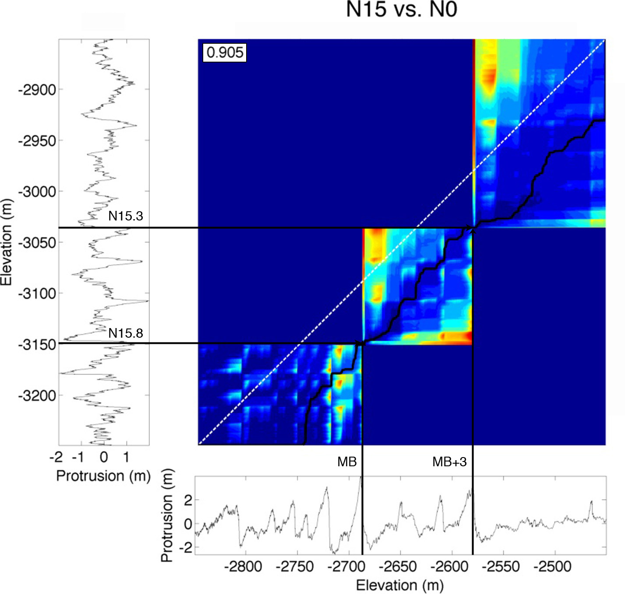

Figure B3.3. Same as Figure 5a in the main text but for N15 vs. N0. These tie-points were based on the past correlation of Fishbaugh and Hvidberg [2006].

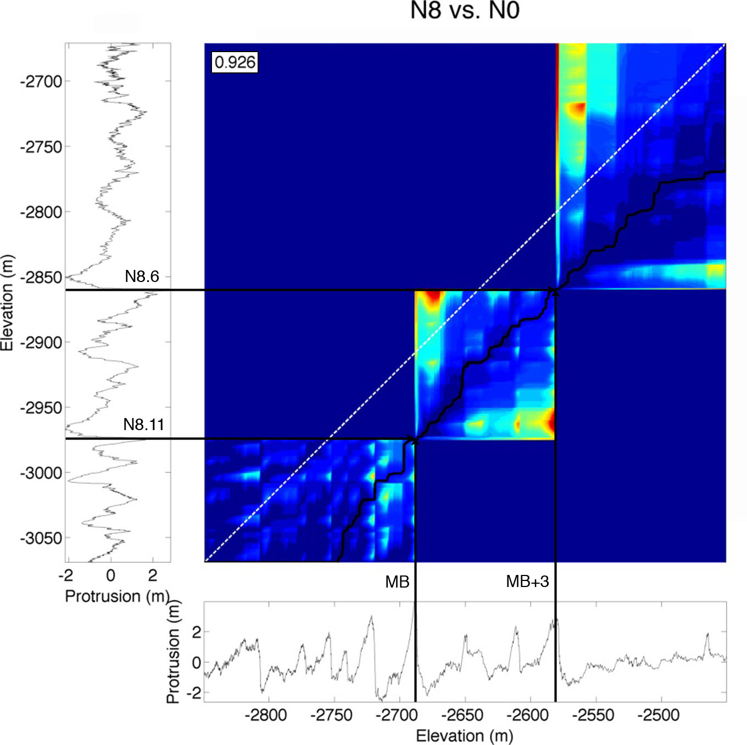

Figure B3.4. Same as Figure 5a in the main text but for N8 vs. N0. These tie-points were based on the past correlation of Fishbaugh and Hvidberg [2006].

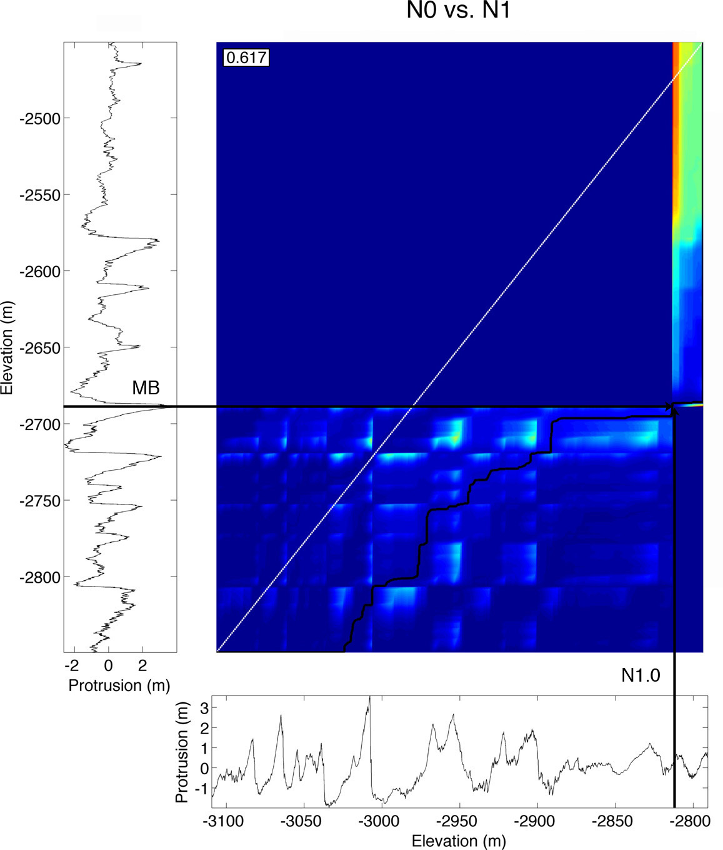

Figure B3.5. Same as Figure 5a in the main text but for N0 vs. N1. These tie-points were based on the past correlation of Fishbaugh and Hvidberg [2006], which was rejected after the second run of the algorithm with the truncated profiles, as shown in Figure 13a of the main text.

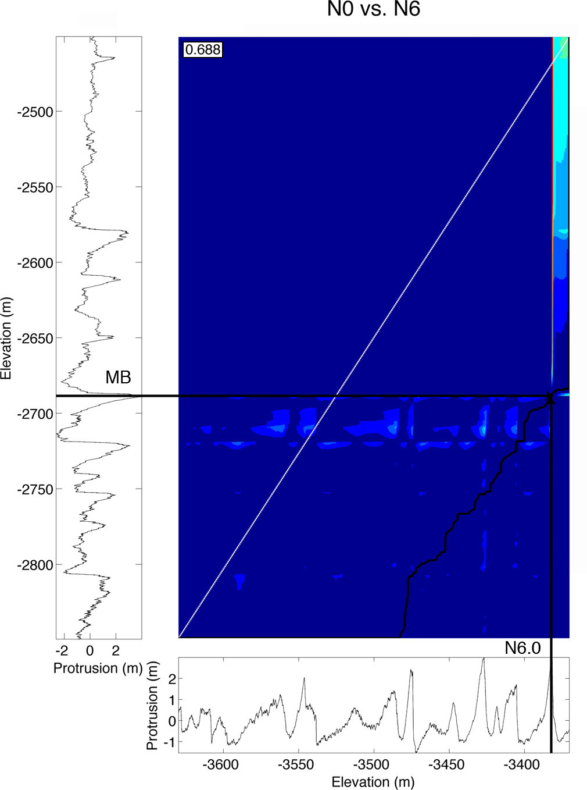

Figure B3.6. Same as Figure 5a in the main text but for N0 vs. N6. These tie-points were based on the results of the correlations of N0 vs. N1, and N1 vs. N6.

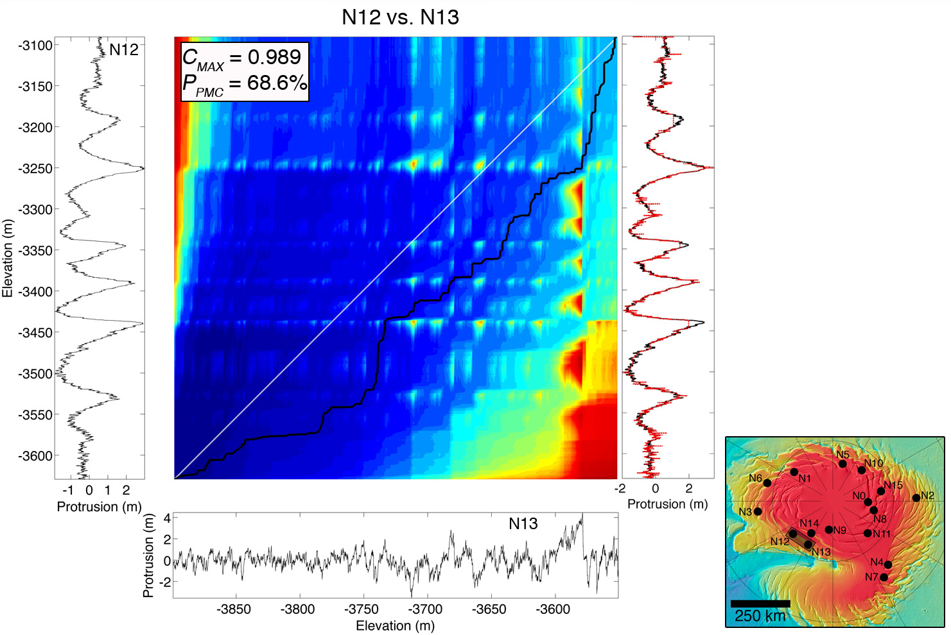

Figure B4.1. DTW cost map for the correlation of N12 vs. N13 including the complete profiles with no prior information about the relationship of one site to the other. The maximum covariance and Monte Carlo parameter for this correlation are shown on the top right corner. This correlation is unreliable.

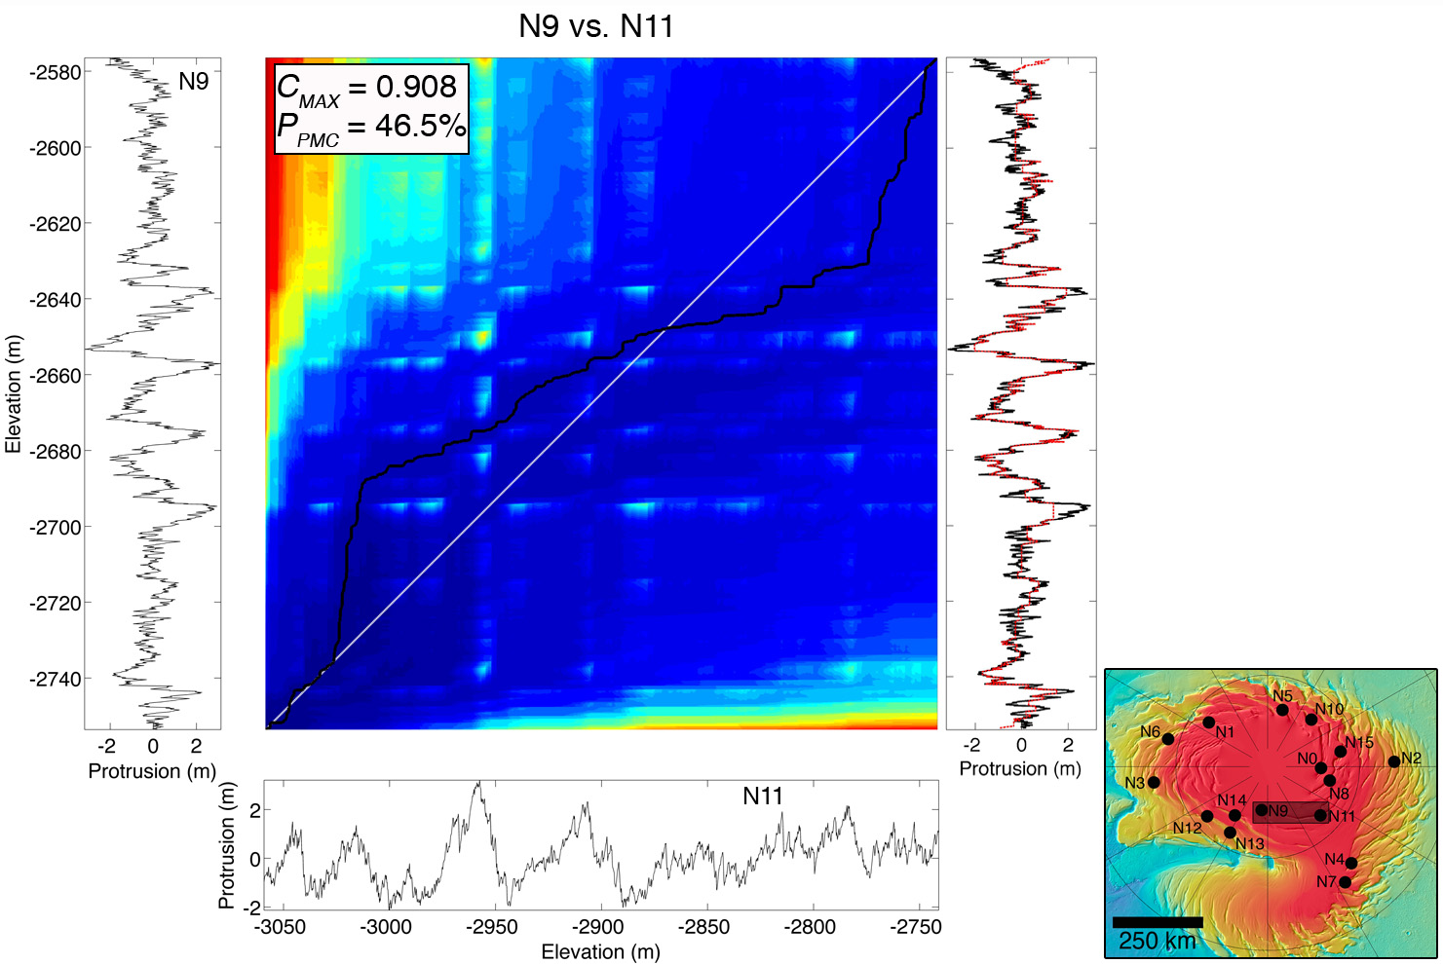

Figure B4.2. Same as B4.1 but for N9 vs. N11.

Figure B5. Each subfigure in this set shows the comparison of protrusion correlations (‘a’ in each subfigure) to brightness correations (‘b’ in each subfigure) for the remaining six pairs not shown in the main text (same as Figure 15). We also expand on the explanation of these results here.

In both pairs for which layer tracing was possible (N0/N10 – Figure 15 in main text - and N15/N8 – Figure S5.1), the correlation of protrusion profiles with the algorithm found the same matches that we traced with high statistical confidence, while that with brightness profiles found different matches with low confidence. In pairs for which we used the correlations of Fishbaugh and Hvidberg [2006] (N1/N6, N8/N0, N15/N0), the correlations between protrusion profiles again found the expected matches.

N1 vs. N6 (Figure S5.2) found a correlation that was different than the expected result from the constraints and attributed low confidence to the match, so we can safely rule it out as a bad correlation.

In the case of N8 vs. N0 (Figure S5.3), the brightness-based correlation partially matches that obtained with protrusion at the scale of the marker beds. In addition, the brightness correlation has a high P_{BMC} = 99%. However, the cost map for the brightness correlation reveals an unrealistically large jump in the accumulation of N8 relative to N0 near the point at which the brightness correlation diverges from the protrusion correlation. This means that brightness and protrusion in these two sites are highly correlated to each other up until this point, above which brightness suggests a different but unrealistic correlation, that does not match the previously established correlation of Fishbaugh and Hvidberg, [2006], which we use to truncate the profiles and constrain the analysis. The brightness correlation of N15 vs. N0 achieves a match different from the one expected from constraints (Figure S5.4b), but with high confidence (98%). This is a case in which our method may be failing, and is not able to constrain a unique correlation between specific protrusion beds. A brightness-based correlation here appears just as likely as one based on protrusion. For the purposes of this paper, and because the correlations obtained with protrusion in both N8 vs. N0 and N15 vs. N0 match the ones previously established Fishbaugh and Hvidberg, [2006], we choose to trust the protrusion-based correlation over the one found with brightness.

The remaining two correlations (N0/N1 – Figure S5.5 – and N0/N6 – Figure S5.6) are based on our proposed alternative correlation between N0 and N1 (Figure 10c in the main text). While brightness and protrusion again output two different matches in both of these pairs, we are forced to consider just the difference in Monte Carlo parameters between both metrics to evaluate which is more reliable, as we have no “virtual ground truth” that we know should be correct. Although the values of P_{PMC} and P_{BMC} in these pairs do suggest a more reliable correlation with protrusion, we cannot say with the same amount of confidence as the other pairs that the protrusion-based correlation is correct here, for reasons we have explained in the main text.

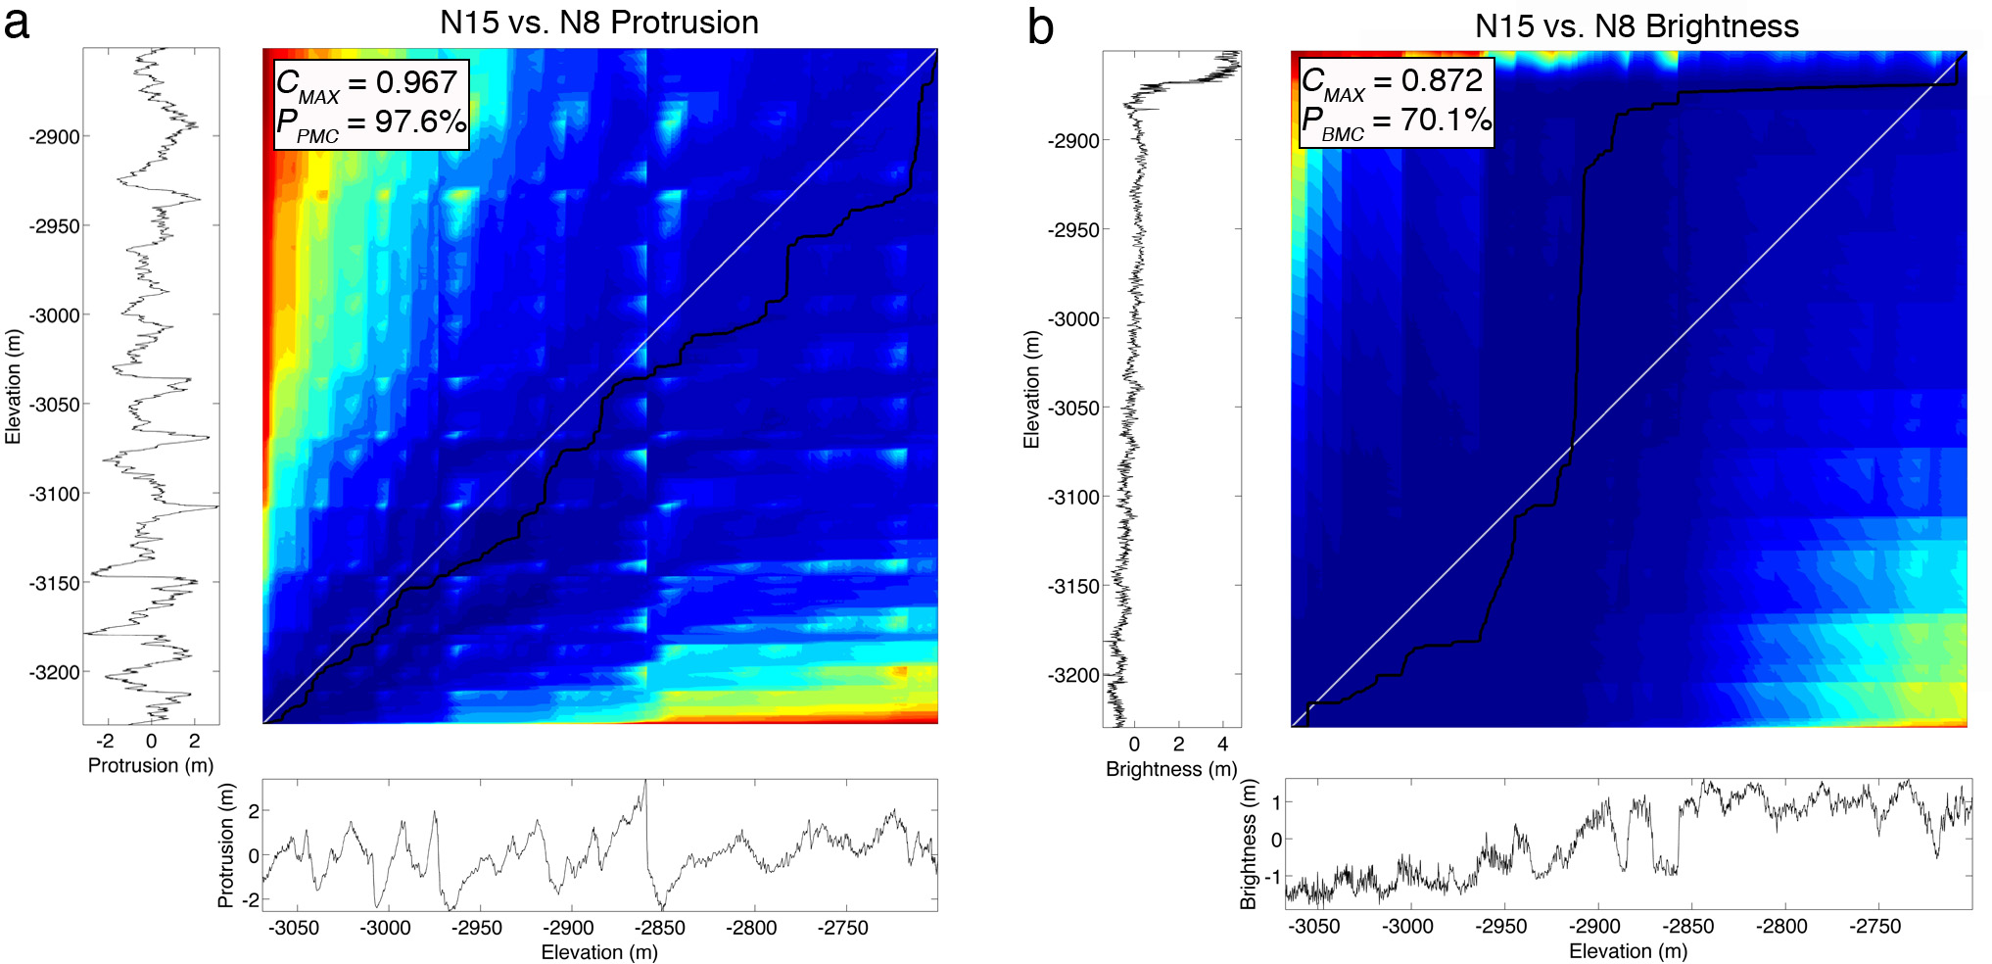

Figure B5.1 Same as figure 17 in the manuscript but for N15 vs. N8.

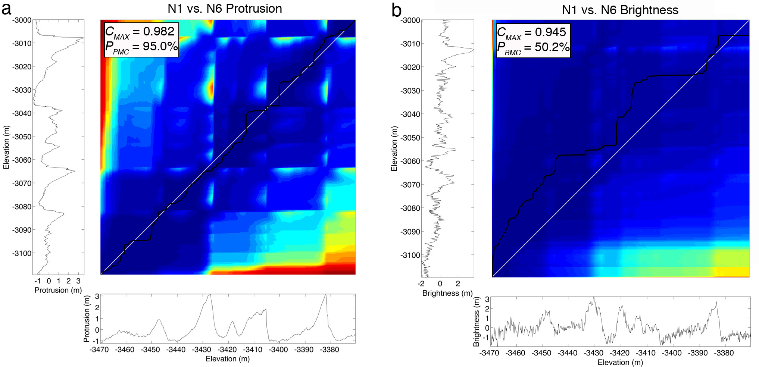

Figure B5.2 N1 vs. N6.

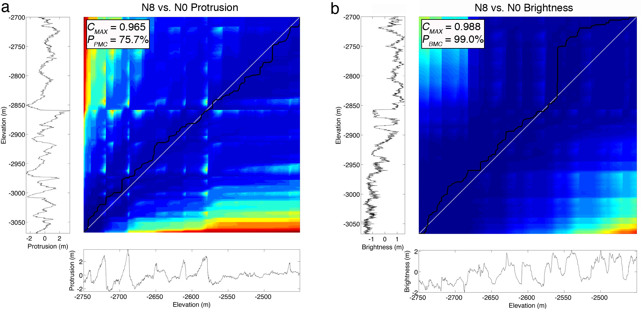

Figure B5.3 N8 vs. N0.

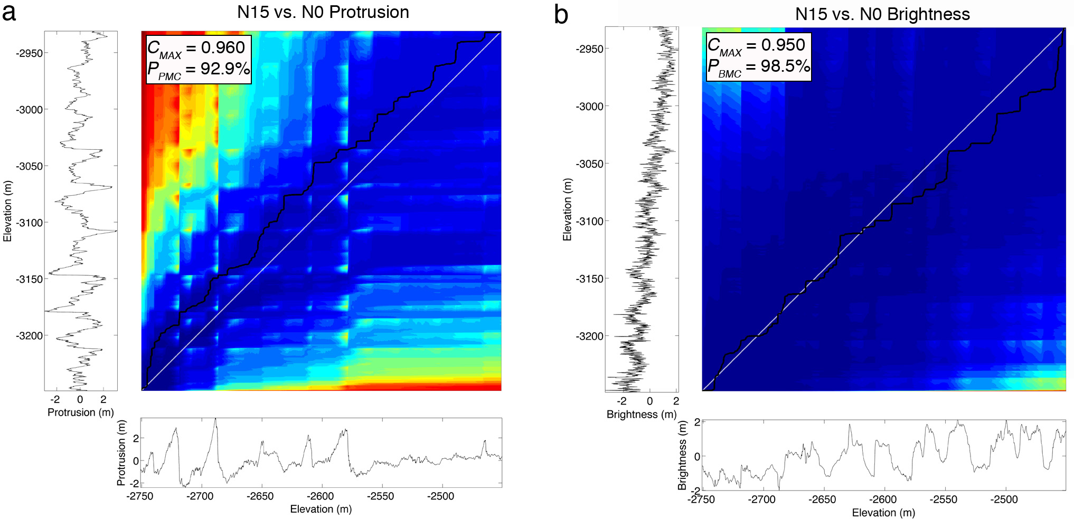

Figure B5.4 N15 vs. N0.

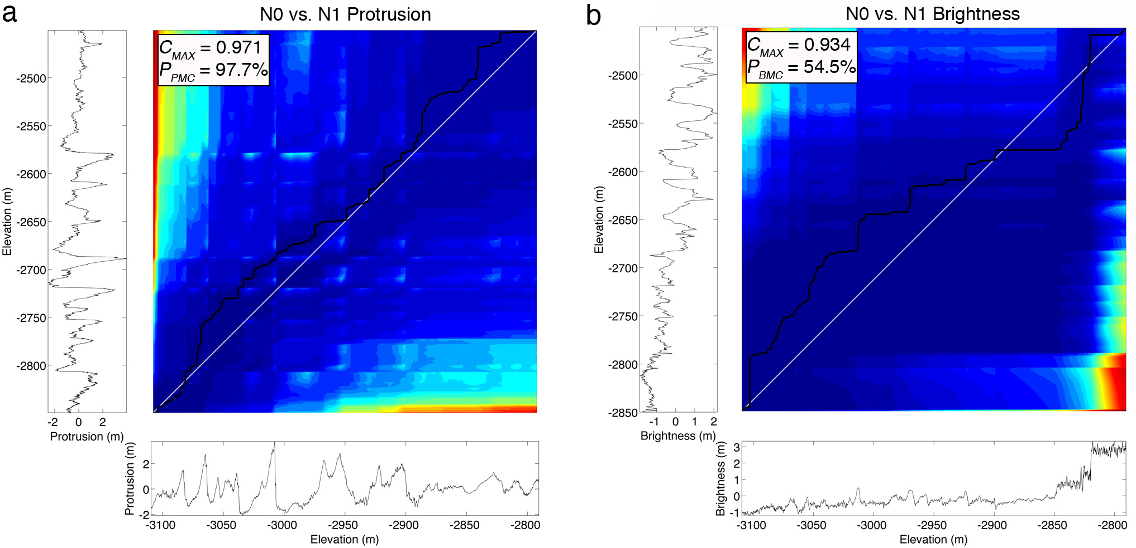

Figure B5.5 N0 vs. N1.

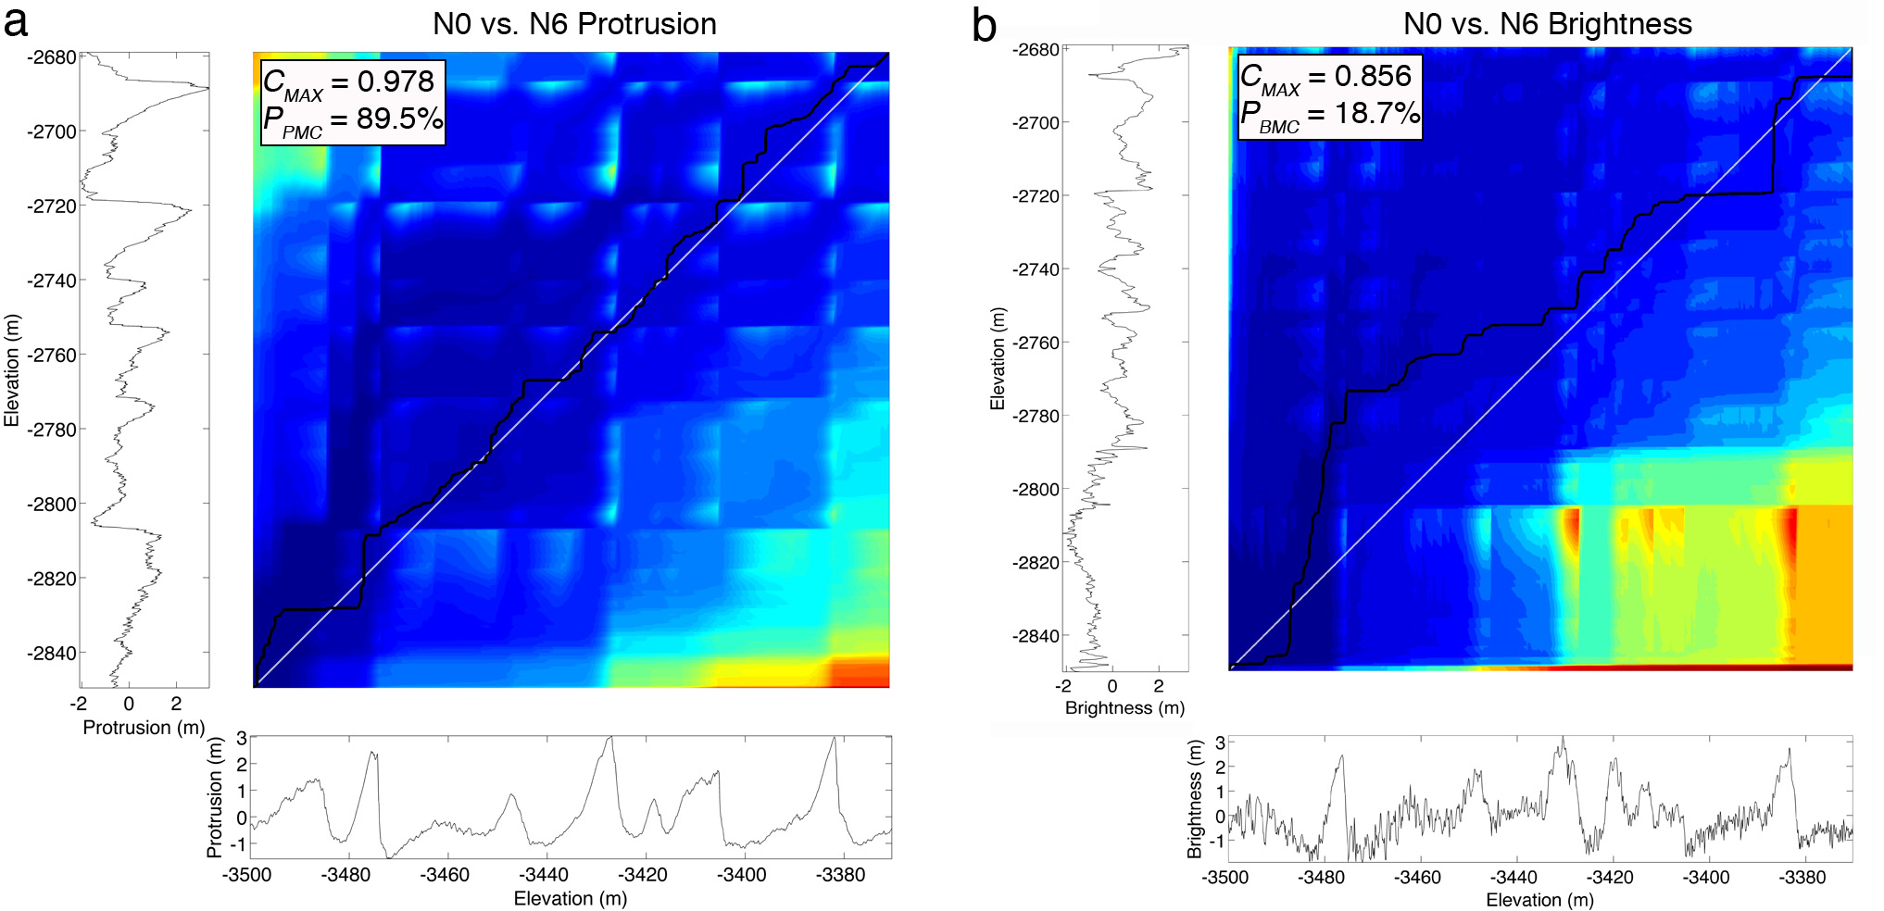

Figure B5.6 N0 vs. N6.

APPENDIX C1
Further details on the use of Wavelet Analysis

There are many commonly used wavelet functions, each suited to answer different questions. All wavelets are functions of a non-dimensional time/depth parameter that have zero mean and are localized in both time/depth and frequency space [Torrence and Compo, 1998]. For our analysis, we used the Morlet wavelet, which consists of a sine wave modulated by a Gaussian. We chose this wavelet primarily due to its high resolution in frequency space, which is necessary in order to distinguish changes in dominant wavelengths along the depth of the protrusion profile. The non-dimensional frequency parameter of the wave is chosen so that the average of the wavelet itself is zero, which for a Morlet wavelet has a value of 6 [Farge, 1992; Torrence and Compo, 1998]. The continuous wavelet transform of a discrete signal xn is defined as the convolution of xn with a scaled and translated version of ψ0(η) [Torrence and Compo, 1998]. If one varies the wavelet scale (s) and translates the convolution along the depth dimension, the result is 2D amplitude (power) vs. the scale and vs. depth (e.g. Fig. 2b). Thus, a range of scaling parameters must be chosen such that all frequencies present in the record are sampled. This is accomplished by choosing the smallest resolvable scale to be a multiple of the time/depth resolution. Here, the time resolution of the insolation signal dt is 1000 yr, which is adequate to resolve all known orbital periodicities [Laskar et al., 2004a]. The depth resolution of the stratigraphic profiles dz is 0.1 m (we resampled the DTM vertical resolution to 0.1 m to obtain a larger number of points in the signal). The smallest resolvable scale (at the Nyquist frequency of the signal) is twice this value, and the largest scale is chosen as the power-of-two multiple of this that is closest to the number of elements in the time/depth series. A detailed explanation of wavelet analysis can be found in [Torrence and Compo, 1998].

APPENDIX C2
Model of a climate-controlled stratigraphy

We compared the results of the wavelet analysis of the stratigraphic profiles to a similar analysis of synthetic stratigraphies created using the model of Hvidberg et al., [2012] in addition to comparing them directly to the WPS of the insolation signal. The model simulates the formation of the NPLD through a climate controlled stratigraphy (CCS) algorithm based on the co-deposition of ice and dust at rates (dice and ddust) that depend on the insolation solution of [Laskar et al., 2004a], and which vary independently of each other.
The synthetic stratigraphic columns that result from this model are expressed as the change in fractional dust content with depth. This dust fraction is calculated as d_{dust}/(d_{ice} + d_{dust}). The time-varying ice and dust deposition rates are calculated with equations (3) and (6) of Hvidberg et al. [2012] respectively, and the thickness of a layer is (d_{ice} + d_{dust})•Δt, where Δt = 1000 years in the solution of Laskar et al., [2004a]. The layer thickness is therefore dominated by the ice deposition rate, as ice is the main component of the NPLD, but it can be dominated by the dust deposition rate and even remove previously deposited ice during times of little to no ice deposition as controlled by the climate. The free parameters of the model are the average annual net deposition rate of ice over the last 1 Myr (D_{ice}), two dimensionless parameters that determine the importance of sublimation (A_{ice}) and insolation forcing (A_{dust}), and the average fractional dust content (X). For a detailed explanation of the model we refer the reader to the paper of Hvidberg et al. [2012].
We created synthetic stratigraphic columns based on three accumulation scenarios:
Scenario 1: We assume a constant ice deposition rate equal to D_{ice}, and let the dust deposition rate vary with time according to equation (6) of Hvidberg et al., [2012].
Scenario 2: We assume a constant dust deposition rate equal to D_{dust} = X/(1 – X) • D_{ice}, and let the ice deposition rate vary with time according to equation (3) of Hvidberg et al., [2012].
Scenario 3: We let both ice and dust deposition rates vary with time according to the equations mentioned above. The stratigraphy from this scenario is equivalent to that shown in Fig. 10c of Hvidberg et al. [2012].
In all scenarios we use the preferred parameters of Hvidberg et al., [2012] (D_{ice} = 0.53 mm/yr, A_{ice} = -1.7, A_{dust} = -0.4, X = 3%), which were selected from a best fit of their model to the stratigraphic column of Fishbaugh et al., [2010], which corresponds to our site N0 (Fig. 4.1 in the main text).

APPENDIX C3
Supplementary Figures for Chapter 4

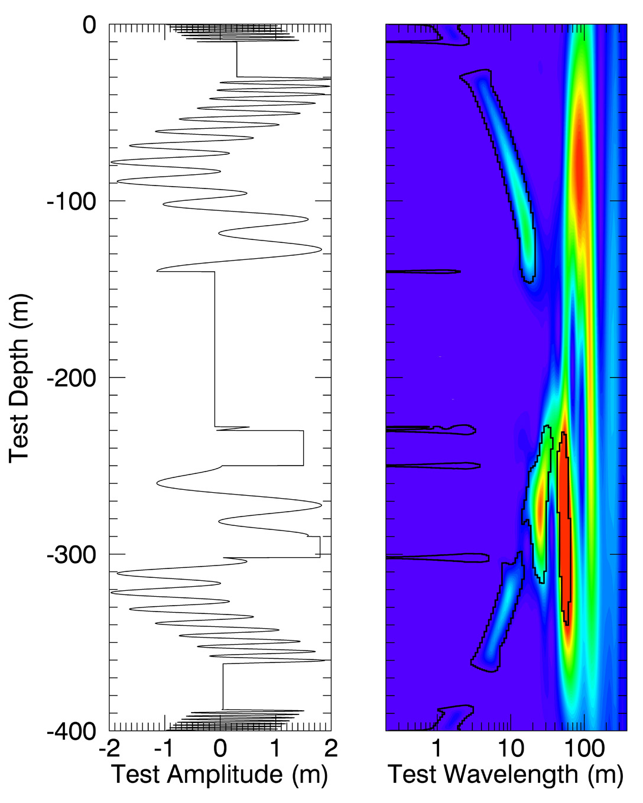
Figure C3.1. (Left) Artificial sinusoid signal with “straight” peaks of amplitude added to simulate similar features in the stratigraphic data. (Right) WPS of the artificial signal. Warmer colors signify higher power and the black curves delineate the 95% confidence contours for red noise. Real significant power appears at the top and bottom of the WPS at 1-3 m in wavelength, representing the high frequency oscillations in the corresponding portion of the signal. The same is true for wavelengths of 3 – 30 m closer to the middle of the WPS, and for 50 m, representing the modulating frequency between 250 and 360 m in depth. Wherever there is a sharp jump in the signal that is non-unique in amplitude, “false significance” at a large range in wavelengths appears in the WPS (-10 m, -140 m, -230 m, -250 m, -302 m, -388 m). This led to our interpretation of similar horizontal bands of significance in the data as being due to an artificial effect of the algorithm and not to real periodicities.

Figure C3.2. The figures below show the individual stratigraphic profiles and their respective WPS for all of the sites studied (except N0 and N7, which are included in Figure 2 of the main text). In each figure, the two leftmost plots are the protrusion profile and its WPS, the middle plots are the slope profile and its WPS, and the rightmost plots are the brightness profile and its WPS.

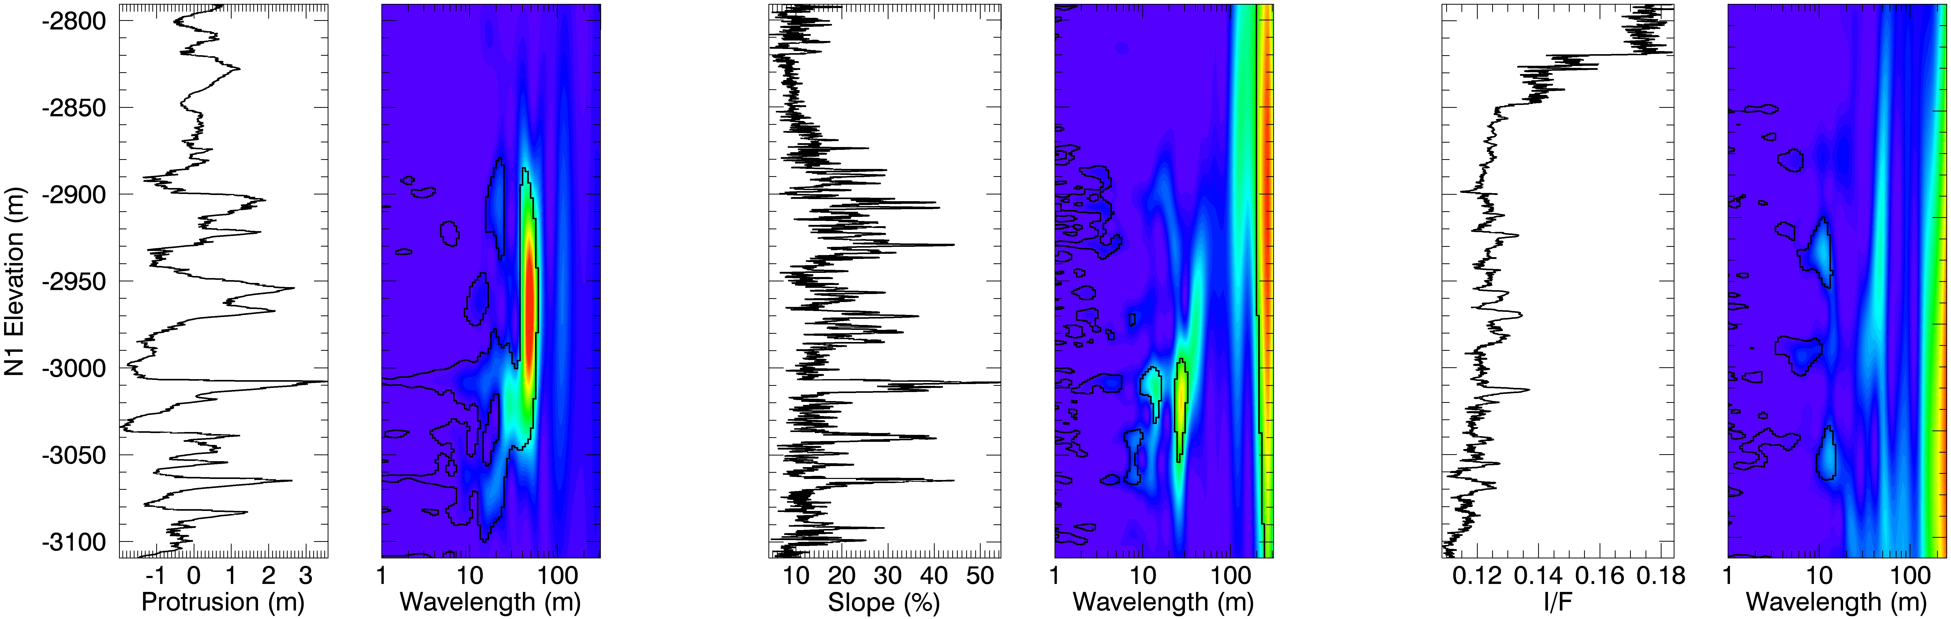
Site N1

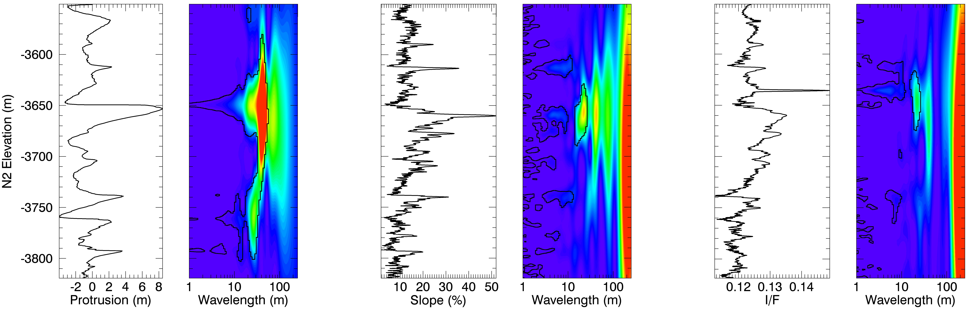
Site N2

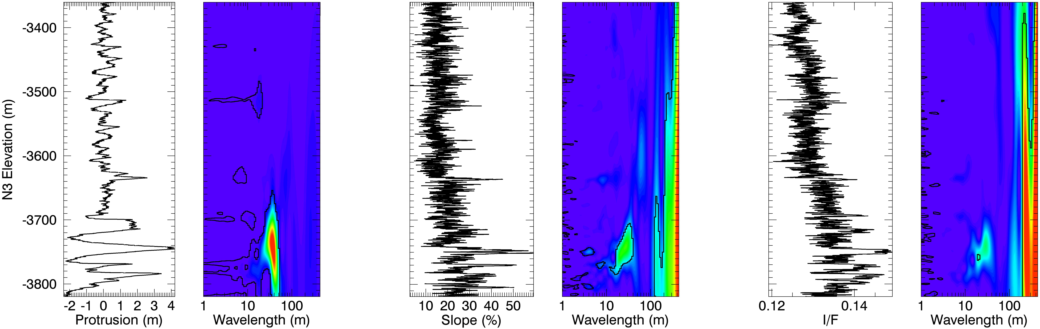
Site N3

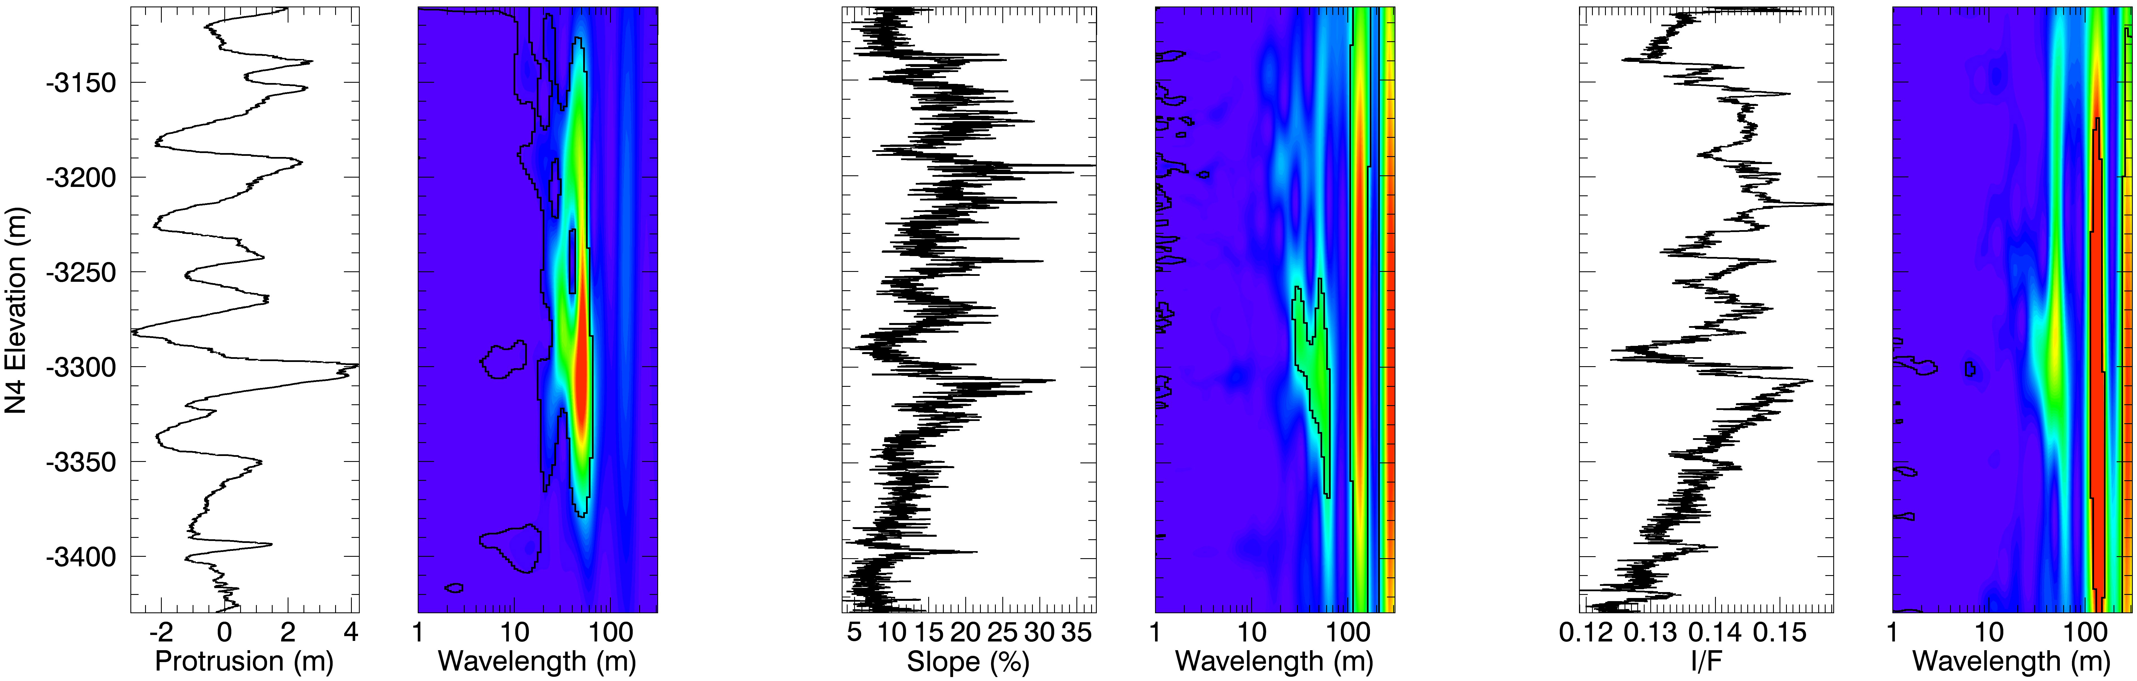
Site N4

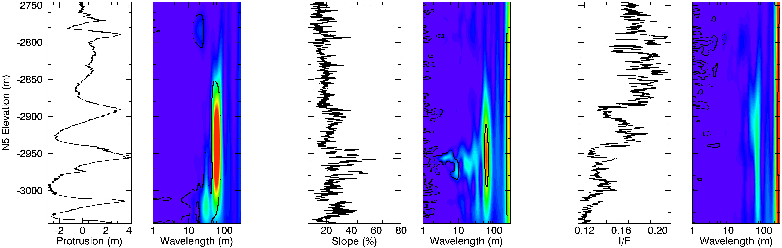
Site N5

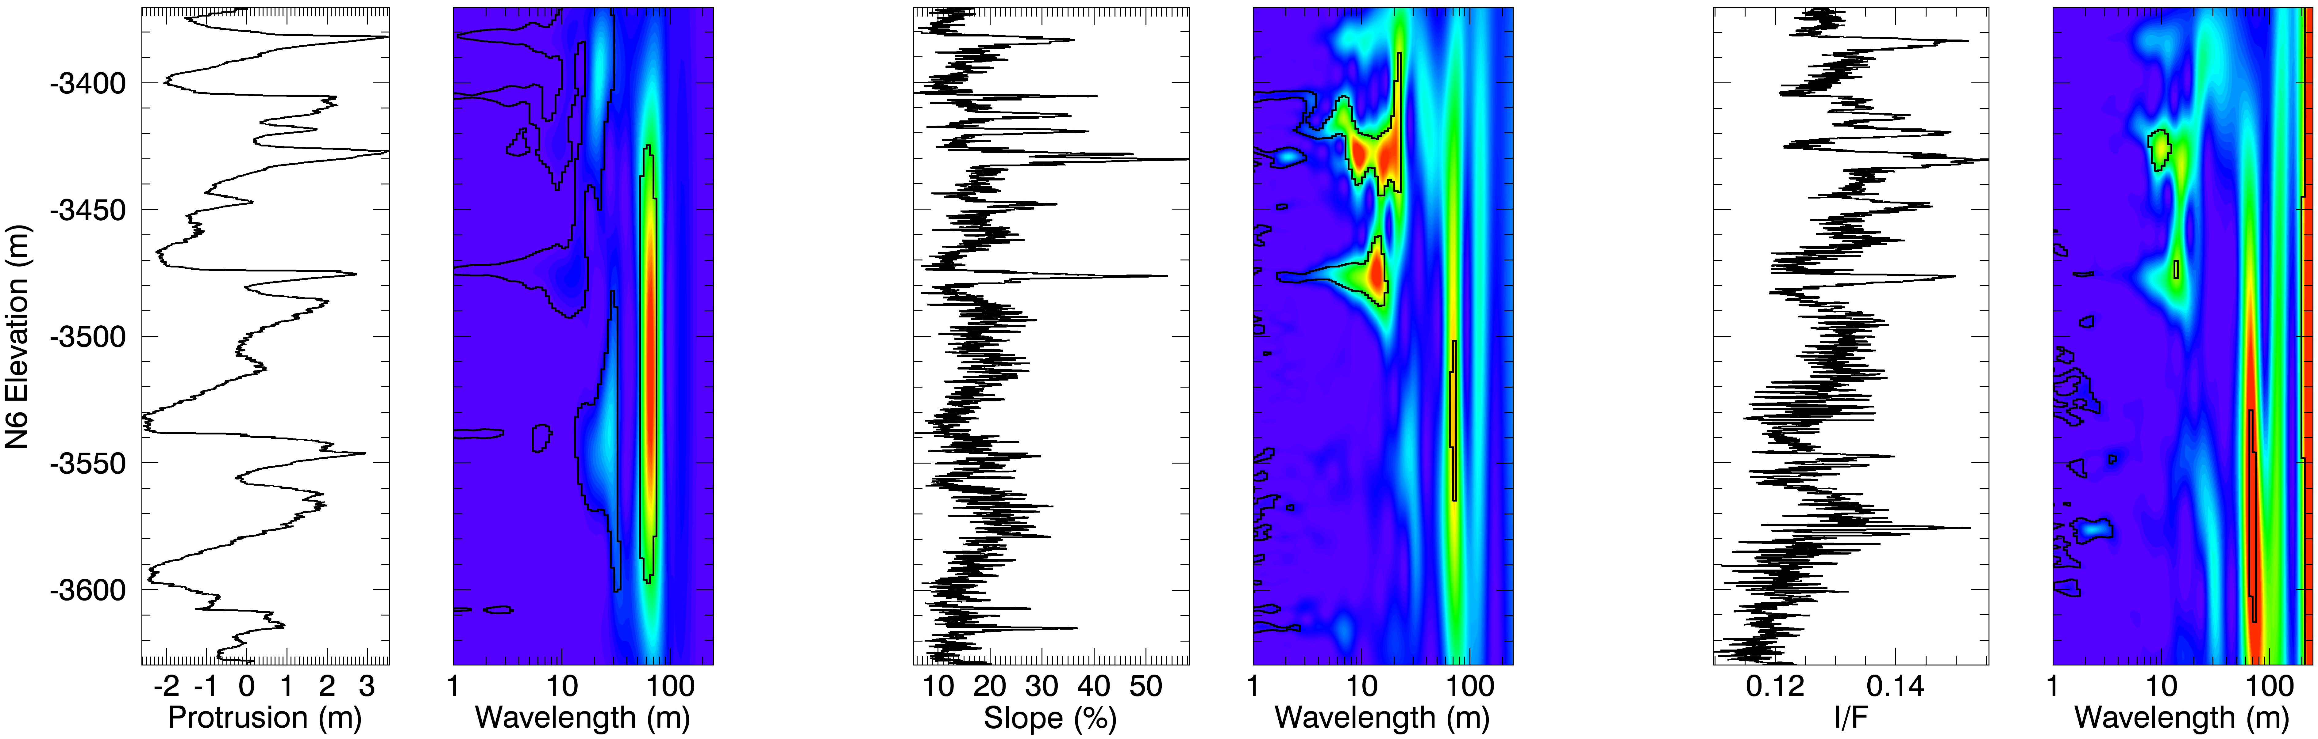
Site N6
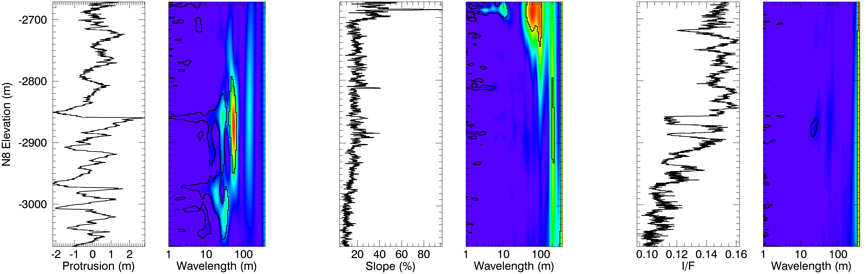
Site N8

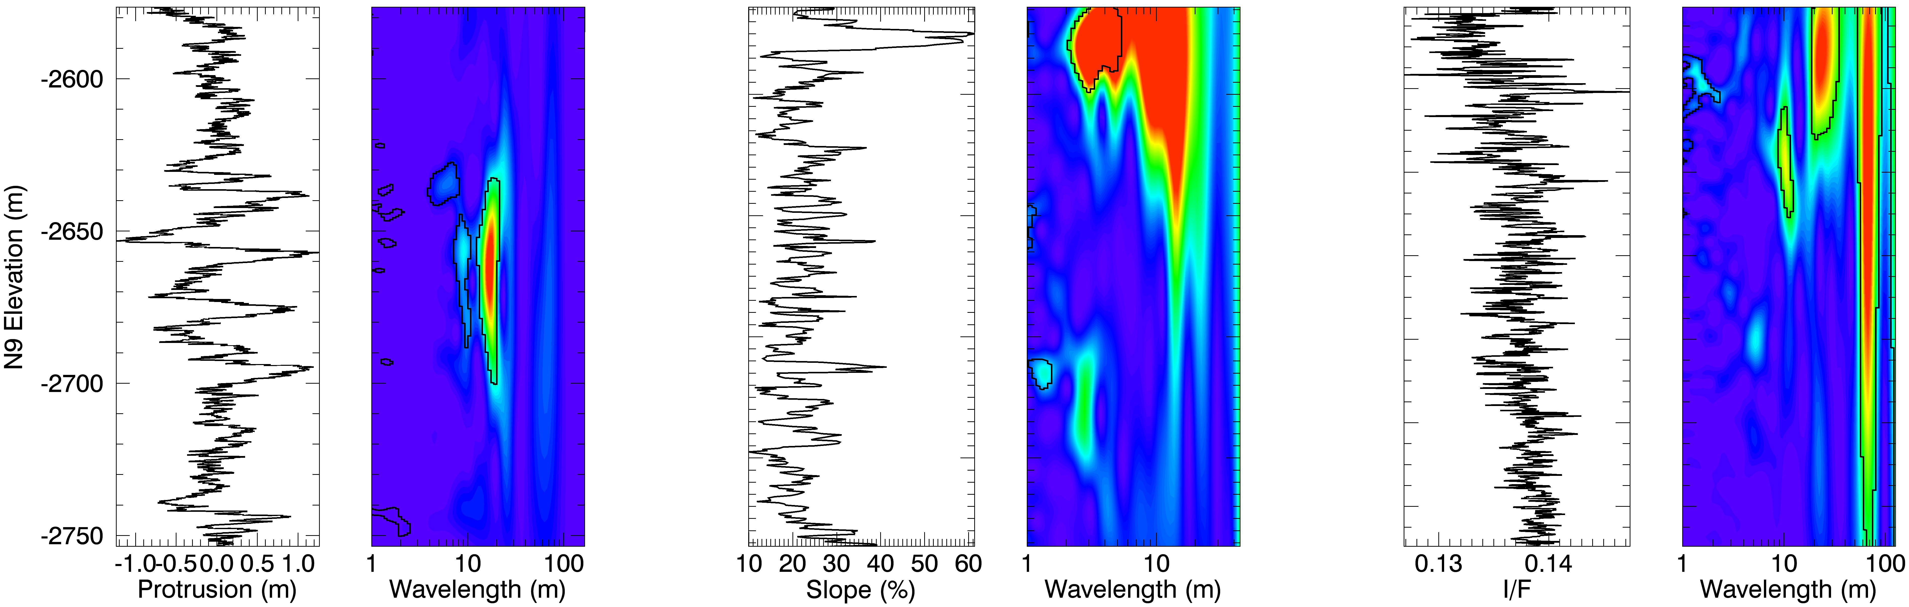
Site N9

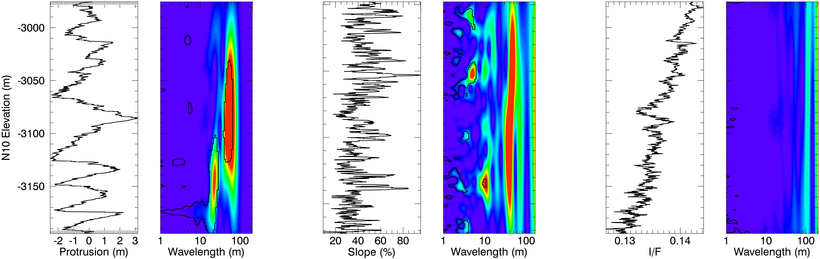
Site N10

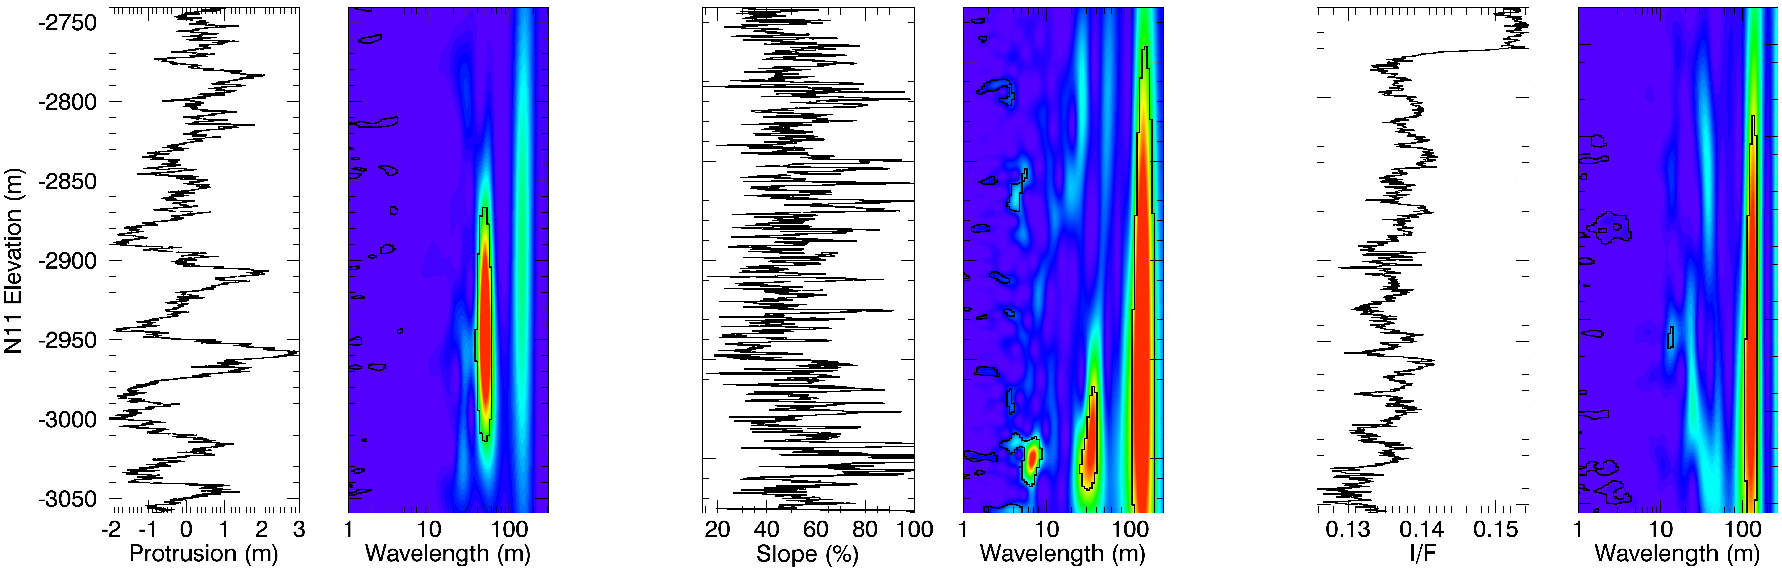
Site N11

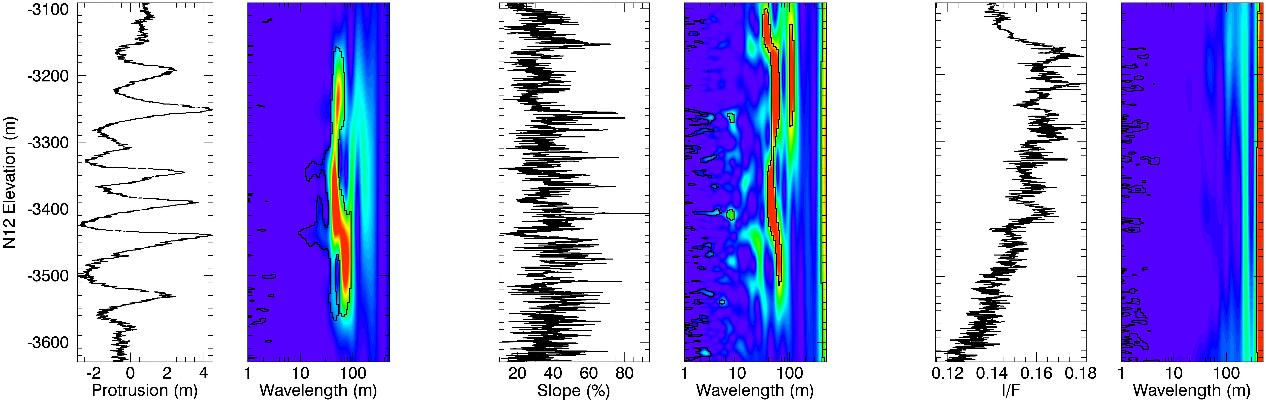
Site N12

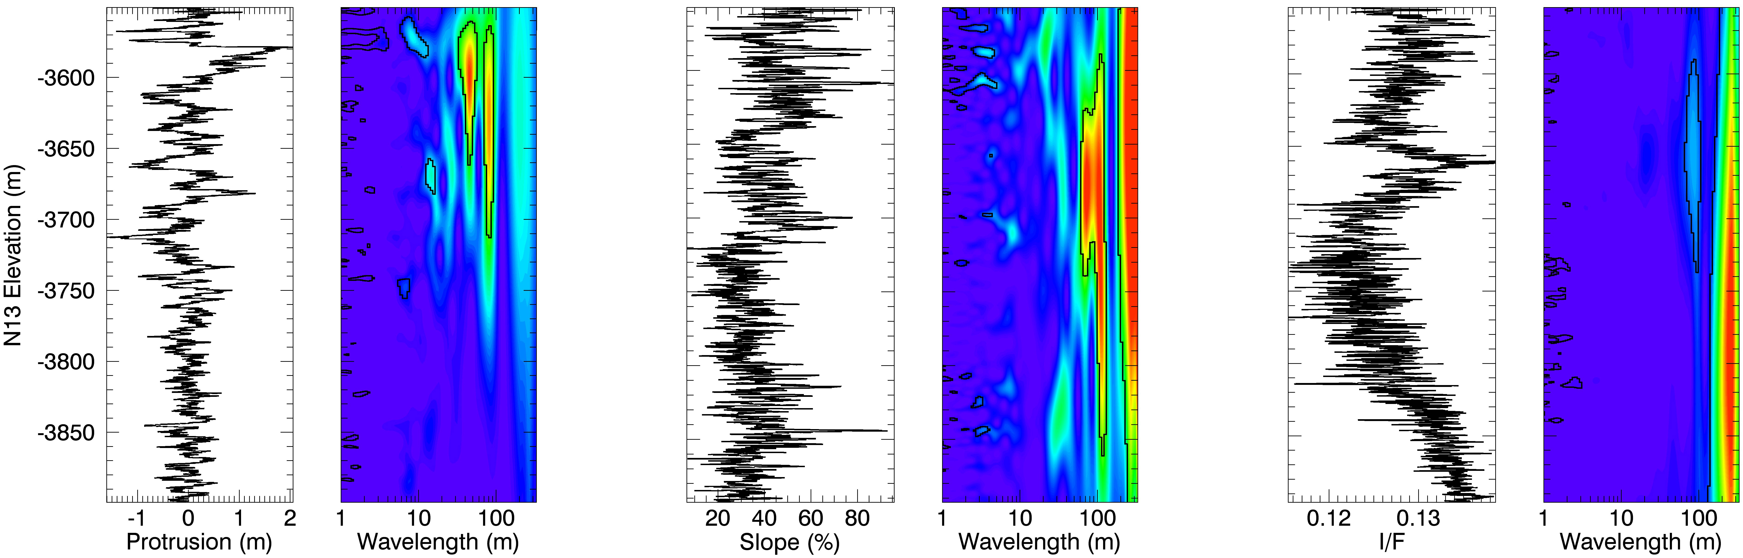
Site N13

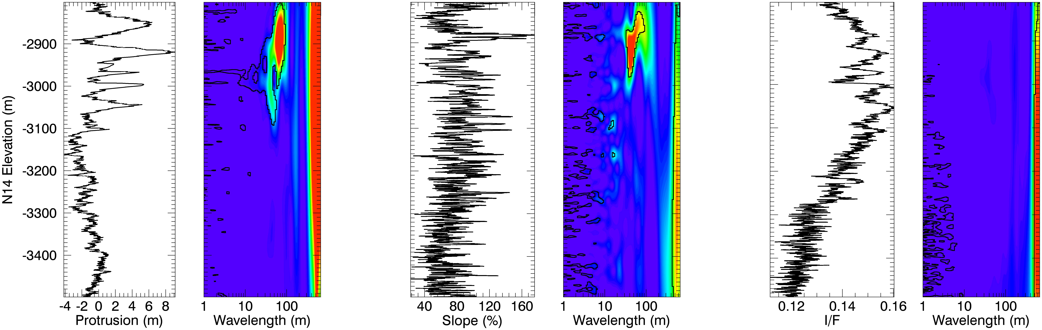
Site N14

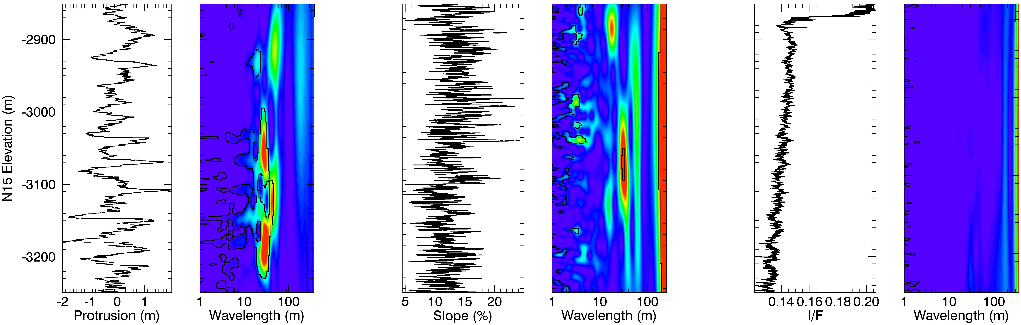
Site N15

REFERENCES

Banks, M. E., S. Byrne, K. Galla, A. S. McEwen, V. J. Bray, C. M. Dundas, K. E. Fishbaugh, K. E. Herkenhoff, and B. C. Murray (2010), Crater population and resurfacing of the Martian north polar layered deposits, J. Geophys. Res., 115, E08006, doi:10.1029/2009JE003523.
Becerra, P., Byrne, S., Brown, A.J., (2015). Transient bright ‘‘halos” on the south polar residual cap of Mars: Implications for mass-balance. Icarus 251, 211–225.
Becerra, P., Byrne, S., Sori, M.M., Sutton, S., Herkenhoff K.E. (2016a). Stratigraphy of the North Polar Layered Deposits of Mars from High-Resolution Topography. Under review in Journal of Geophysical Research.
Becerra, P., Byrne, S., Sori, (2016b). Searching for a climate signal in Mars’ North Polar Layered Deposits. Under review in Journal of Geophysical Research.
Berger, A., (1976), Obliquity and general precession for the last 5 000 000 years. Astronomy & Astrophysics, v. 51, p. 127–135.
Berger, A., (1977), Support for the astronomical theory of climatic change. Nature, v. 269, p. 44–45, doi: 10.1038/269044a0.
Berger, A., (1978), A Simple Algorithm to Compute Long Term Variations of Daily or Monthly Insolation. Louvain-la-Neuve, Universite Catholique de Louvain, Institut d’Astronomie et de Geophysique G. Lemaıtre Contribution 18, 37 p.
Bibring, J.P. et al. (2004), Perennial water ice identified in the south polar cap of Mars, Nature, 428(6), 627–630, doi:10.1038/nature02461.
Bonev, B. P., G. B. Hansen, D. A. Glenar, P. B. James, and J. E. Bjorkman (2008), Albedo models for the residual south polar cap on Mars: Implications for the stability of the cap under near-perihelion global dust storm conditions, Planetary and Space Science, 56(2), 181–193, doi:10.1016/j.pss.2007.08.003.
Bretagnon, P., 1974, Termes a longues periodes dans le systeme solaire. Astronomy & Astrophysics, v. 30, p. 141–154.
Brown, A. J., W. M. Calvin, and S. L. Murchie (2012), Compact Reconnaissance Imaging Spectrometer for Mars (CRISM) north polar springtime recession mapping: First 3 Mars years of observations, J. Geophys. Res., 117, E00J20, doi:10.1029/2012JE004113.
Brown, A. J., S. Byrne, L. L. Tornabene, and T. Roush (2008), Louth crater: Evolution of a layered water ice mound, Icarus.
Brown, A. J., W. M. Calvin, P. C. Mcguire, and S. L. Murchie (2010), Compact Reconnaissance Imaging Spectrometer for Mars (CRISM) south polar mapping: First Mars year of observations, Journal of Geophysical Research, 115, E00D13, doi:10.1029/2009JE003333.
Byrne, S., and B. C. Murray (2002), North polar stratigraphy and the paleo‐erg of Mars, J. Geophys. Res., 107 (E6), doi:10.1029/2001JE001615.
Byrne, S., and A. Ingersoll (2003a), A sublimation model for Martian south polar ice features, Science, 299(5609), 1051.
Byrne S, Ingersoll AP. (2003b). Martian climatic events on timescales of centuries: Evidence from feature morphology in the residual south polar ice cap. Geophys. Res. Lett. 30:1696
Byrne, S. (2009), The Polar Deposits of Mars, Annual Review of Earth and Planetary Sciences, 37(1), 535–560, doi:10.1146/annurev.earth.031208.100101.
Byrne, S. (2011), Simulating the Landscape Evolution of the Martian Residual CO2 Ice Cap, Lunar and Planetary Institute Science Conference Abstracts, 42, 2728.
Byrne, S. et al. (2011), Exposure Analysis of Polar Stratigraphy from HiRISE Topography, Fifth Mars Polar Science Conference, 6012.
Chandrasekhar, S., 1960. Radiative Transfer. New York: Dover.
Christian, S., J. W. Holt, P. Choudhary, K. E. Fishbaugh, and J. J. Plaut (2013), Integrating radar stratigraphy with high resolution visible stratigraphy of the north polar layered deposits, Mars, Icarus, 226, 1241–1251.
Clancy, R. T., B. J. Sandor, M. J. Wolff, P. R. Christensen, M. D. Smith, J. C. Pearl, B. J. Conrath, and R. J. Wilson (2000), An intercomparison of ground-based millimeter, MGS TES, and Viking atmospheric temperature measurements: Seasonal and interannual variability of temperatures and dust loading in the global Mars atmosphere, Journal of Geophysical Research, 105(E), 9553–9572, doi:10.1029/1999JE001089.
Clark, R. N., and P. G. Lucey (1984), Spectral properties of ice-particulate mixtures and implications for remote sensing. I - Intimate mixtures, Journal of Geophysical Research (ISSN 0148-0227), 89, 6341–6348, doi:10.1029/JB089iB07p06341.
Clifford, S. M. et al. (2013), Introduction to the fifth Mars Polar Science special issue: Key questions, needed observations, and recommended investigations, Icarus, 225 (2), 864–868, doi:10.1016/j.icarus.2013.04.005.
Cornwall, C., and T. N. Titus (2010), A comparison of Martian north and south polar cold spots and the long-term effects of the 2001 global dust storm, Journal of Geophysical Research, 115(E6), E06011, doi:10.1029/2009JE003514.
Cutts, J. A. (1973), Nature and origin of layered deposits of the Martian polar region, J. Geophys. Res., 78, 4231, doi:10.1029/JB078i020p04231.
Cutts, J. A., and B. H. Lewis (1982), Models of climate cycles recorded in Martian polar layered deposits, Icarus, 50, 216 - 244.
Cutts, J. A., K. R. Blasius, G. A. Briggs, M. H. Carr, R. Greeley, and H. Masursky (1976), North Polar Region of Mars: Imaging Results from Viking 2, Science, 194 (4271), 1329–1337, doi:10.1126/science.194.4271.1329.
Daubar, I. J., A. S. McEwen, S. Byrne, M. R. Kennedy, and B. Ivanov (2013), The current Martian cratering rate, Icarus, 225 (1), 506–516, doi:10.1016/j.icarus.2013.04.009.
Delamere, W. A. et al. (2010), Color imaging of Mars by the High Resolution Imaging Science Experiment (HiRISE), Icarus, 205(1), 38–52, doi:10.1016/j.icarus.2009.03.012.
Eluszkiewicz, J. (1993), On the microphysical state of the Martian seasonal caps, Icarus, 103(1), 43–48.
Eluszkiewicz, J., J. Moncet, T. Titus, and G. Hansen (2005), A microphysically-based approach to modeling emissivity and albedo of the martian seasonal caps, Icarus, 174(2), 524–534.
Emiliani, C., (1955), Pleistocene temperatures. The Journal of Geology, v. 63, p. 538–578, doi:10.1086/626295.
Emiliani, C., (1966), Paleotemperature analysis of Caribbean cores P6304–8 ad P6304–9 and a generalized temperature curve for the past 425,000 years. The Journal of Geology, v. 74, p. 109–124, doi:10.1086/627150.
Fischer, A.G., De Boer, P.L., and Premoli Silva, I., (1988), Cyclostratigraphy, in Beaudoin, B., and Ginsburg, R.N., eds., Global Sedimentary Geology Program: Cretaceous Resources, Events, and Rhythms. NATO ASI Series: Dordrecht, Netherlands, Kluwer, p. 139–172.
Fishbaugh, K. E., and C. S. Hvidberg (2006), Martian north polar layered deposits stratigraphy: Implications for accumulation rates and flow, J. Geophys. Res., 111 (E6), E06012, doi:10.1029/2005JE002571.
Fishbaugh, K. E., and J. W. Head (2005), Origin and characteristics of the Mars north polar basal unit and implications for polar geologic history, Icarus, 174, 444 - 474.
Fishbaugh, K. E., S. Byrne, K. E. Herkenhoff, R. L. Kirk, C. Fortezzo, P. S. Russell, and A. Mcewen (2010a), Evaluating the meaning of “layer” in the martian north polar layered deposits and the impact on the climate connection, Icarus, 205(1), 269–282, doi:10.1016/j.icarus.2009.04.011.
Fishbaugh, K. E., C. S. Hvidberg, S. Byrne, P. S. Russell, K. E. Herkenhoff, M. Winstrup, and R. Kirk (2010b), First high-resolution stratigraphic column of the Martian north polar layered deposits, Geophysical Research Letters, 37(7), 7201, doi:10.1029/2009GL041642.
Galla K, Byrne S, Murray BC, McEwen A, The HiRISE Team. (2008). Craters and resurfacing of the martian north polar cap. Presented at Am. Geophys. Union Fall Meet., Abstr 1360
Grima, C., W. Kofman, J. Mouginot, R. J. Phillips, A. Hérique, D. Biccari, R. Seu, and M. Cutigni (2009), North polar deposits of Mars: Extreme purity of the water ice, Geophysical Research Letters, 36(3), L03203, doi:10.1029/2008GL036326.
Haam, E., and P. Huybers (2010), A test for the presence of covariance between time‐uncertain series of data with application to the Dongge Cave speleothem and atmospheric radiocarbon records, Paleoceanography, 25(2), doi:10.1029/2008PA001713.
Haberle, R. M. (1986), Interannual variability of global dust storms on Mars, Science (ISSN 0036-8075), 234, 459–461, doi:10.1126/science.234.4775.459.
Hansen, G. B. (2005), Ultraviolet to near-infrared absorption spectrum of carbon dioxide ice from 0.174 to 1.8 μm, Journal of Geophysical Research, 110(E), 11003, doi:10.1029/2005JE002531.
Hapke, B., 1993. Theory of Reflectance and Emittance Spectroscopy. Cambridge University Press.
Hapke, B., 2012. Theory of Reflectance and Emittance Spectroscopy, Second Edition. Cambridge University Press.
Hayne, P. O., D. J. McCleese, W. A. Abdou, D. M. Kass, A. Kleinböhl, T. McDunn, S. Piqueux, J. H. Shirley, J. T. Schofield, and M. Team (2014), Polar CO2 ice clouds and energy budget from Mars Climate Sounder data, Mars Atmosphere: Modelling and Observation, 5th International Workshop, -1, 3102.
Hays, J. D., J. Imbrie, and N. J. Shackleton (1976), Variations in the Earth's Orbit: Pacemaker of the Ice Ages, Science, 194(4), 1121–1132, doi:10.1126/science.194.4270.1121.
Helfenstein, P., and M. K. Shepard (2011), Testing the Hapke photometric model: Improved inversion and the porosity correction, Icarus.
Herkenhoff, K. E., S. Byrne, P. S. Russell, K. E. Fishbaugh, and A. S. McEwen (2007), Meter-Scale Morphology of the North Polar Region of Mars, Science, 317 (5845), 1711–1715, doi:10.1126/science.1143544.
House, M. R. (1995), Orbital forcing timescales: an introduction, Geological Society, London, Special Publications, 85(1), 1–18, doi:10.1144/GSL.SP.1995.085.01.01.
Howard, A. D., J. A. Cutts, and K. R. Blasius (1982), Stratigraphic relationships within Martian polar cap deposits, Icarus, 50, 161 - 215.
Hinnov, L. (2013), Cyclostratigraphy and its revolutionizing applications in the earth and planetary sciences, GSA Bulletin, v. 125, no. 11/12; p. 1703-1734; doi:10.1130/B30934.1
Hvidberg, C.S., Fishbaugh, K.E., Winstrup, M., Svensson, A., Byrne, S., Herkenhoff, K.E. (2012), Reading the climate record of the martian polar layered deposits, Icarus, 221(1), 405-419, doi:10.1016/j.icarus.2012.08.009
Imbrie, J., Hays, J.D., Martinson, D.G., McIntyre, A., Mix, A.C., Morely, J.J., Pisias, N.G., Prell, W.L., and Shackleton, N.G., (1984), The orbital theory of Pleistocene climate: Support from a revised chronology of the marine δ18O record, in Berger, A.L., Imbrie, J., Hays, J.D., Kukla, G., and Saltzman, B., eds., Milankovitch and Climate, Part 1. Dordrecht, Netherlands, Reidel Publishing, p. 269–305.
Jakosky BM, Haberle RM. (1990), Year-to-year instability of the Mars south polar cap. J. Geophys. Res. 95:1359–65
Kieffer, H. H. (1979), Mars south polar spring and summer temperatures - A residual CO2 frost, Journal of Geophysical Research, 84, 8263–8288, doi:10.1029/JB084iB14p08263.
Kieffer H.H., Titus T.(2001). TES mapping of Mars’ north seasonal cap. Icarus 154:162–80
Kirk, R. L. et al. (2008), Ultrahigh resolution topographic mapping of Mars with MRO HiRISE stereo images: Meter-scale slopes of candidate Phoenix landing sites, J. Geophys. Res., 113, E00A24, doi:10.1029/2007JE003000.
Koutnik, M., S. Byrne, and B. Murray (2012), South Polar Layered Deposits of Mars: The cratering record, J. Geophys. Res., 107(E11), 5100, doi:10.1029/2001JE001805.
Landis, M. E., S. Byrne, I. J. Daubar, K. E. Herkenhoff, and C. M. Dundas (2016), A revised surface age for the North Polar Layered Deposits of Mars, Geophys. Res. Lett. 43, doi:10.1002/2016GL068434.
Langevin Y, Poulet F, Bibring J-P, Schmitt B, Doute S, et al. (2005). Summer evolution of the north polar cap of mars as observed by OMEGA/Mars express. Science 307:1581–84
Laskar, J., B. Levrard, and J. F. Mustard (2002), Orbital forcing of the martian polar layered deposits, Nature, 419, 375.
Laskar, J., A. Correia, M. Gastineau, and F. Joutel (2004a), Long term evolution and chaotic diffusion of the insolation quantities of Mars, Icarus, 170, 343 - 364.
Laskar, J., Robutel, P., Joutel, J., Gastineau, M., Correia, A.C.M., and Levrard, B., (2004b), A numerical solution for the insolation quantities of the Earth: Astronomy & Astrophysics, v. 428, p. 261–285, doi:10.1051 /0004-6361:20041335.
Laskar, J., Gastineau, M., Delisle, J.B., Farrés, A., and Fienga, A., (2011), Strong chaos induced by close encounters with Ceres and Vesta: Astronomy and Astrophysics, v. 532, L4, doi:10.1051/0004-6361/201117504.
Leighton, R. B., and B. C. Murray (1966), Behavior of Carbon Dioxide and Other Volatiles on Mars, Science, 153, 136, doi:10.1126/science.153.3732.136.
Levrard, B., F. Forget, F. Montmessin, and J. Laskar (2007), Recent formation and evolution of northern Martian polar layered deposits as inferred from a Global Climate Model, J. Geophys. Res., 112(E6), doi:10.1029/2006JE002772.
Lewis, K. W., O. Aharonson, J. P. Grotzinger, R. L. Kirk, A. S. McEwen, and T.-A. Suer (2008), Quasi-Periodic Bedding in the Sedimentary Rock Record of Mars, Science, 322(5), 1532–, doi:10.1126/science.1161870.
Limaye, A. B. S., O. Aharonson, and J. T. Perron (2012), Detailed stratigraphy and bed thickness of the Mars north and south polar layered deposits, J. Geophys. Res., 117(E), 06009, doi:10.1029/2011JE003961.
Lisiecki, L. E., and P. A. Lisiecki (2002), Application of dynamic programming to the correlation of paleoclimate records, Paleoceanography, 17 (4), 1-1 – 1-12, doi:10.1029/2001PA000733.
Malin, M. C. et al. (2007), Context Camera Investigation on board the Mars Reconnaissance Orbiter, Journal of Geophysical Research, 112, doi:10.1029/2006JE002808.
Malin, M. C., and K. S. Edgett (2001), Mars Global Surveyor Mars Orbiter Camera: Interplanetary cruise through primary mission, Journal of Geophysical Research, 106(E10), 23429, doi:10.1029/2000JE001455.
Malin, M., M. Caplinger, and S. Davis (2001), Observational evidence for an active surface reservoir of solid carbon dioxide on Mars, Science, 294(5549), 2146.
Mann, M. E., and J. M. Lees (1996), Robust estimation of background noise and signal detection in climatic time series - Springer, Climatic change.
Melosh, J.H., 2011. Planetary Surface Processes. Cambridge University Press.
McEwen, A. S. et al. (2007), Mars Reconnaissance Orbiter's High Resolution Imaging Science Experiment (HiRISE), Journal of Geophysical Research, 112, doi:10.1029/2005JE002605.
Murchie, S. et al. (2007), Compact Reconnaissance Imaging Spectrometer for Mars (CRISM) on Mars Reconnaissance Orbiter (MRO), Journal of Geophysical Research, 112(E), doi:10.1029/2006JE002682.
McEwen, A. S. et al. (2010), The High Resolution Imaging Science Experiment (HiRISE) during MRO’s Primary Science Phase (PSP), Icarus, 205 (1), 2–37, doi:10.1016/j.icarus.2009.04.023.
Milankovitch, M., (1941), Kanon der Erdbestrahlung und seine Anwendung auf das Eiszeitenproblem: Royal Serbian Academy, Section of Mathematical and Natural Sciences, Belgrade, 633 p. (and 1998 re- issue in English: Canon of Insolation and the Ice-Age Problem: Belgrade, Serbian Academy of Sciences and Arts, Section of Mathematical and Natural Sciences, 634 p.).
Milkovich, S. M., and J. W. Head (2005), North polar cap of Mars: Polar layered deposit characterization and identification of a fundamental climate signal, J. Geophys. Res., 110 (E1), E01005, doi:10.1029/2004JE002349.
Milkovich, S. M., J. W. Head III, and G. Neukum (2008), ScienceDirect.com - Planetary and Space Science - Stratigraphic analysis of the northern polar layered deposits of Mars: Implications for recent climate history, Planetary and Space Science, 56, 266 - 288.
Montmessin F, Haberle RM, Forget F, Langevin Y, Clancy RT, et al. 2007. On the origin of perennial water ice at the south pole of Mars: A precession-controlled mechanism? J. Geophys. Res. 112:8
Murray, B. C., L. A. Soderblom, J. A. Cutts, and R. P. Sharp (1972), Geological framework of the south polar region of Mars, Icarus, 17, 328 - 345.
Murray, B. C., W. R. Ward, and S. C. Yeung (1973), Periodic Insolation Variations on Mars, Science, 180 (4086), 638–640, doi:10.1126/science.180.4086.638.
Neugebauer, G., G. Miinch, H. H. Kieffer, S. C. Chase Jr., and E. Miner (1971) Mariner, 1969 Infrared Radiometer results: temperatures and thermal properties of the martian surface, Astron. J. 76, 719.
Nunes DC, Phillips RJ. (2006) Radar subsurface mapping of the polar layered deposits on Mars. J. Geophys. Res. 111:6
Perron, J. T., and P. Huybers (2009), Is there an orbital signal in the polar layered deposits on Mars? Geology, 37 (2), 155–158, doi:10.1130/G25143A.1.
Phillips, R. J. et al. (2008), Mars North Polar Deposits: Stratigraphy, Age, and Geodynamical Response, Science, 320 (5880), 1182–1185, doi:10.1126/science.1157546.
Plaut JJ, Picardi G, Safaeinili A, Ivanov AB, Milkovich SM, et al. (2007), Subsurface radar sounding of the south polar layered deposits of Mars. Science, 316, 92–96.
Pollack, J. B. (1979), Climatic change on the terrestrial planets, Icarus 37, 3, 479-553.
Prettyman TH, Feldman WC, Mellon MT, McKinney GW, Boynton WV, et al. (2004). Composition and structure of the Martian surface at high southern latitudes from neutron spectroscopy. J. Geophys. Res. 109:5001
Putzig, N. E., R. J. Phillips, B. A. Campbell, J. W. Holt, J. J. Plaut, L. M. Carter, A. F. Egan, F. Bernardini, A. Safaeinili, and R. Seu (2009), Subsurface structure of Planum Boreum from Mars Reconnaissance Orbiter Shallow Radar soundings, Icarus, 204 (2), 443–457, doi:10.1016/j.icarus.2009.07.034.
Ritter, D.F., Kochel, R.C., Miller, J.R., (2002) Process Geomorphology, Fourth Edition, Waveland Press Inc., Long Grove, Illinois.
Roush, T. (1994), Charon: more than water ice? Icarus, 108(2), 243–254.
Sakoe, H., and S. Chiba (1978), Dynamic programming algorithm optimization for spoken word recognition, IEEE Trans. Acoust., Speech, Signal Process., 26(1), 43–49, doi:10.1109/TASSP.1978.1163055.
Schwarzacher, W. (2000), Repetitions and cycles in stratigraphy, Earth-Science Reviews.
Seu, R. et al. (2007), SHARAD sounding radar on the Mars Reconnaissance Orbiter, J. Geophys. Res., 112(E), E05S05, doi:10.1029/2006JE002745.
Smith, D. E. et al. (2001), Mars Orbiter Laser Altimeter: Experiment summary after the first year of global mapping of Mars, J. Geophys. Res., 106(E10), 23689, doi:10.1029/2000JE001364.
Smith, I. B., J. W. Holt, A. Spiga, A. D. Howard, and G. Parker (2013), The spiral troughs of Mars as cyclic steps, J. Geophys. Res. Planets, 118, 1835–1857, doi:10.1002/jgre.20142.
Smith, I. B., A. Spiga, and J. W. Holt (2014), Aeolian processes as drivers of landform evolution at the south pole of Mars, Geomorphology, doi:10.1016/j.geomorph.2014.08.026.
Smith, I. B., and J. W. Holt (2015), Spiral trough diversity on the north pole of Mars, as seen by Shallow Radar (SHARAD), J. Geophys. Res. Planets, 120, 362–387, doi:10.1002/2014JE004720.
Soderblom, L.A., Malin, M.C., Cutts, J.A., and Murray, B.C., (1973). Mariner 9 observations of the surface of Mars in the north polar region: Journal of Geophysical Research, 78, p. 4197–4210, doi:10.1029 /JB078i020p04197.
Som, S. M., Greenberg, H. M., and Montgomery, D. R., (2008) The Mars Orbiter Laser Altimeter dataset: Limitations and improvements, Mars 4, 14-26, doi:10.1555/mars.2008.0002.
Sori, M. M., J. T. Perron, P. Huybers, and O. Aharonson (2014), A procedure for testing the significance of orbital tuning of the martian polar layered deposits, Icarus, 235(C), 136–146, doi:10.1016/j.icarus.2014.03.009.
Strasser, A., Hilgen, F.J., and Heckel, P.H., (2006) Cyclostratigraphy, Concepts, definitions and applications. Newsletters in Stratigraphy, v. 42, p. 75–114, doi: 10.1127/0078-0421/2006/0042-0075.
Sutton, S., Chojnacki, M., Kilgallon, A. and the HiRISE Team, (2015), Precision and Accuracy of Simultaneously Collected HiRISE DTMs, 46th Lunar and Planetary Science Conference, 3010.
Tanaka, K. L., and C. M. Fortezzo (2012), Geologic Map of the North Polar Region of Mars, U.S. Geological Survey Scientific Investigations Map 3177, scale 1:2,000,000.
Tanaka, K. L., J. A. P. Rodriguez, J. A. Skinner, M. C. Bourke, C. M. Fortezzo, K. E. Herkenhoff, E. J. Kolb, and C. H. Okubo (2008), North polar region of Mars: Advances in stratigraphy, structure, and erosional modification, Icarus, 196, 318, doi:10.1016/j.icarus.2008.01.021.
Thomas, P., Squyres, S., Herkenhoff, K., Howard, A., Murray, B. (1992) Polar Deposits of Mars in Mars, The University of Arizona Press, 767 - 795.
Thomas, P. C., M. C. Malin, K. S. Edgett, M. H. Carr, W. K. Hartmann, A. P. Ingersoll, P. B. James, L. A. Soderblom, J. Veverka, and R. Sullivan (2000), North-south geological differences between the residual polar caps on Mars, Nature, 404, 161.
Thomas, P. C., M. C. Malin, P. B. James, B. A. Cantor, R. M. E. Williams, and P. Gierasch (2005), South polar residual cap of Mars: Features, stratigraphy, and changes, Icarus, 174, 535, doi:10.1016/j.icarus.2004.07.028.
Thomas, P., P. James, W. Calvin, R. Haberle, and M. Malin (2009), Residual south polar cap of Mars: Stratigraphy, history, and implications of recent changes, Icarus, 203(2), 352–375, doi:10.1016/j.icarus.2009.05.014.
Thomas, P. C., W. M. Calvin, P. Gierasch, R. Haberle, P. B. James, and S. Sholes (2013), Time scales of erosion and deposition recorded in the residual south polar cap of Mars, Icarus, 225, 923–932.
Thomas, P.C., W. Calvin, B. Cantor, R. Haberle, P.B. James, S.W. Lee, (2016), Mass balance of Mars’ residual south polar cap from CTX images and other data. Icarus 268, 118-130. doi: 10.1016/j.icarus.2015.12.038
Titus, T. N., H. H. Kieffer, and P. R. Christensen (2003), Exposed Water Ice Discovered near the South Pole of Mars, Science, 299(5), 1048–1051, doi:10.1126/science.299.5609.1048.
Titus TN. (2005). Thermal infrared and visual observations of a water ice lag in the Mars southern summer. Geophys. Res. Lett. 32:24204
Titus TN, Calvin WM, Kieffer HH, Langevin Y, Prettyman TH. (2008). Martian polar processes. in The Martian Surface: Composition, Mineralogy, and Physical Properties, ed. JF Bell III, p. 25. New York: Cambridge Univ. Press
Tokar RL, Elphic RC, Feldman WC, Funsten HO, Moore KR, et al. (2003). Mars odyssey neutron sensing of the south residual polar cap. Geophys. Res. Lett. 30:1677
Tomasi, G., F. van den Berg, and C. Andersson (2004), Correlation optimized warping and dynamic time warping as preprocessing methods for chromatographic data, J. Chemometrics, 18(5), 231–241, doi:10.1002/cem.859.
Toon, O. B., J. B. Pollack, W. Ward, J. A. Burns, and K. Bilski (1980), The astronomical theory of climatic change on Mars, Icarus 44, 3, 552 – 607.
Torrence, C., and G. P. Compo (1998), A Practical Guide to Wavelet Analysis, Bulletin of the American Meteorological Society, 79(1), 61.
Vernekar, A.D., 1972, Long-Period Global Variations of Incoming Solar Radiation. American Meteorological Society Meteorological Monograph 12(34), 21 p.
Wagstaff KL, Titus TN, Ivanov AB, Castano R, Bandfield JL. (2008). Observations of the north polar water ice annulus on Mars using THEMIS and TES. Planet. Space Sci. 56:256–65
Ward W.R. (1973). Large-scale variations in the obliquity of Mars. Science 181:260–62
Warell, J., and B. J. R. Davidsson (2010), A Hapke model implementation for compositional analysis of VNIR spectra of Mercury, Icarus, 209(1), 164–178, doi:10.1016/j.icarus.2009.11.037.
Warren, S. G. (1984), Optical constants of ice from the ultraviolet to the, Applied Optics.
Wieczorek, M.A. (2008). Constraints on the composition of the martian south polar cap from gravity and topography, Icarus 196, 506–517, doi:10.1016/j.icarus.2007.10.026.
Wolff, M. J., M. D. Smith, R. T. Clancy, R. Arvidson, M. Kahre, F. Seelos, S. Murchie, and H. Savijärvi (2009), Wavelength dependence of dust aerosol single scattering albedo as observed by the Compact Reconnaissance Imaging Spectrometer, Journal of Geophysical Research, 114(E), doi:10.1029/2009JE003350.
Zhang, H., and K. J. Voss (2011), On Hapke photometric model predictions on reflectance of closely packed particulate surfaces, Icarus 215 (1), 27-33.

Zuber, M.T., Phillips, R.J., Andrews-Hanna, J.C., Asmar, S.W., Konopliv, A.S., Lemoine, F.G., Plaut, J.J., Smith, D.E., Smrekar, S.E. (2007). Density of Mars’ south polar layered deposits. Science 317 (5845), 1718–1719.
Zurek, R. W., and L. J. Martin (1993), Interannual variability of planet-encircling dust storms on Mars, J. Geophys. Res., 98, 3247–3259, doi:10.1029/92JE02936.

